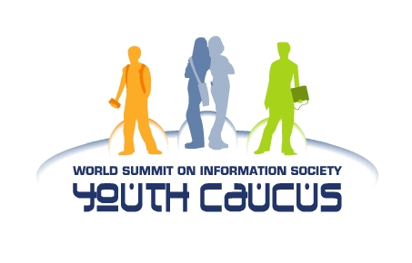

Statement of the WSIS Youth Caucus
7th GFC Meeting, 5-6 September 2005
Geneva, Switzerland

Dear Ambassador Karklins, distinguished members of the GFC and representatives of Civil Society and Private Sector,

We express our gratitude and appreciation, despite our non-representation in this Meeting, to your leadership in the drafting process of the Tunis Political Chapeau and Operational Document.

We likewise commend the outstanding work of the Working Group on Internet Governance – the result of a genuine process to include the perspectives of Civil Society and Private Sector. The operational framework in which it carried out its work must no less be replicated in the current GFC drafting process.

Today, we continue to put forward our inputs to both documents, with a focus on Paras. 10, 11 and 29 as we are amply satisfied in your recognition of our previous inputs to Chapters 1 and 4, though much of the present draft is bracketed.

However, we are deeply concern of the relegation of a commitment to “establish an implementation mechanism for the Geneva and Tunis Plans of Action” (refer to 11 January 2005 version of Para. 10) to simply “a process of follow-up” (refer to Para. 11 of the 16 August 2005 Possible Revised Draft . Thus we propose a re-drafting of your proposed Para. 11 to

“In order to assure the sustainability of the WSIS process after the completion of its Tunis phase, we agree to establish a process of action-oriented and time-bound implementation of and follow-up to the outcomes of the [Geneva and Tunis phases of] WSIS, at national, regional and international levels.”

And for purposes of consistency of commitment to achieving Information Society goals, we further propose to change the “coulds” to “shoulds” in Para. 14.b. There must be no room for guessing neither in this paragraph nor anywhere else in the final Tunis documents.

As for your proposed replacements to Para. 29, we wish to highlight two proposed new paragraphs:

We request the Secretary-General of the United Nations, in partnership with pertinent United Nations agencies, international development institutions, civil society and the business community, to re-convene WSIS stakeholders in 2010 and 2015 and review the status of the Geneva Plan of Action and Tunis Plan of Implementation and, where efforts are lacking, to call for increased commitment and support.

and

We encourage all stakeholders, importantly governments, to sustainably support the Digital Solidarity Fund and commit to realizing multi-stakeholder partnerships in closing the digital divide.

We likewise offer our support to the proposal of the Government of Spain to “establish a World Internet Day”. However, building an inclusive Information Society, bridging the digital divide and raising awareness on the issues of WSIS are beyond the scope of the Internet alone thus must include traditional and modern ICTs such as television, radio, PCs and mobile phones. Our proposal then, respecting the language of Para 30 put forward by the Government of Spain, is to:

“establish a World ICT (or ICT4D) Day. This Day could help to raise awareness, on an annual basis, of the importance of ICTs as enabling tools for sustainable development and poverty reduction, and more broadly on the issues dealt with in the Summit as well as of ways to close the digital divide.”

Parallel to this, we are worried that the discussions on Internet Governance, though equivalently important, is overshadowing more pressing issues such as financing ICTs for Development and a post-WSIS implementation mechanism. As for the Youth Caucus, there is much to discuss on these issues than on Internet Governance – the Information Society is not centrally about wiring or connecting every PC or mobile phone to the Internet, it must, most of all, be about empowering the “have-nots” with access to basic ICT tools such as radio and TV.

Lastly, as put forward in the past, the WSIS Youth Caucus strongly support that the Operational Document be titled as “Tunis Plan of Implementation”. By doing so, we are reaffirming that all the stakeholders of the Information Society have firmer commitment and determination to rally institutional and financial support to realizing the Geneva Plan of Action. The last thing we need is another Plan or Agenda of Action emerging out of the Tunis Summit.

Thank you very much and we look forward to working with all of you towards finalizing a stronger Tunis Political Chapeau and Plan of Implementation.

