Information Services Provided by ITU Service Desk

Date of modification: February 1, 2005

This document briefly outlines the facilities provided by ITU Service Desk and constraints under which the services are provided. When the event is taking place outside the ITU premises and hosted by another organization, ITU does not have the full flexibility in solving all IT problems as it depends on the hosting organization’s availability of IT facilities, IT staff and IT policy.

Please also read the following:
    - Appendix A: Anti-viral Precautions
    - Appendix B: Wireless LAN Facilities in ITU
    - Appendix C: Accessing Network Printers

Services Provided
The Service Desk will provide general support services to help delegates
  - accessing the fixed or wireless local area network in the premises where such services are available;
  - accessing the Internet;
  - accessing meeting sessions broadcast via the Internet, when such arrangements are available;
  - connecting to and using networked printing facilities in the delegates area.

In addition, the Service Desk will provide general guidance and advice on how to keep PCs free of viral infection. Delegates will be responsible for applying all necessary updates and patches on their notebook computers.

Services Not Provided
The Service Desk cannot be responsible for:
  - installing or re-installing the operating system such as Windows, Linux, Mac operating systems;
  - installing updates for operating systems or anti-virus software;
  - providing or installing application software, commercial or otherwise;
  - protecting or recovering personal data.

Usage Policy on Sharing of IT Resources
  - Users should be considerate towards other users when using shared resources such as Internet connection bandwidth, network drives and network printers. Such IT resources should be used in such a manner that other users are not affected adversely. Transfer or sharing of massive files, including but not limited to music and video files, that affects bandwidth in a significant manner is expressly prohibited.
  - Circumventing existing security mechanisms by any means, intercepting data or information not meant for one, decoding passwords or encryption phrases is expressly prohibited.
  - Harmful activities such as hacking, IP spoofing, port scanning, altering configuration files, unauthorized monitoring are expressly prohibited.
  - Such inconsiderate or harmful activities as described above could result in termination of the user connection without any notification or warning even when these activities occur without the user's knowledge (e.g., because of a virus or spyware).

Service Desk Hours
Normal service hours for the Service Desk in ITU premises located in Room V.29 is 08:30 am – 5:30 pm. For the WSIS Prepcom meetings, the service desk will be staffed from 8:00 am to 6:00 pm.

Problem Management and Procedures
- Delegates requiring support should come to the ITU Service Desk. All incidents will/may be logged in the Incident Management system to facilitate the management of further requests. One member of the ITU Service Desk staff will/may circulate in the premises and at the conference rooms to manage second level support and to troubleshoot urgent problems.
- The Service Desk will make every effort to resolve problems as quickly as possible. However, problems that cannot be resolved within 15 minutes during peak periods will be re-allocated to off-peak support hours so that we can help the maximum number of delegates.
- Please read the Appendices for issues relating to anti-virus, wireless and printer connections.

Appendix A: Anti-viral Precautions

If a computer virus or worm is present on your notebook computer this may propagate across the LAN and infect other PCs.

When you connect your notebook to the network you are responsible for:
- taking precautions to ensure your own protection from viral infection from other users;
- detecting and removing any virus on your notebook that may infect other users;
- detecting and removing any spyware on your computer.

When you first connect to the local area network it is imperative that you:
- download and install the latest security patches from the Microsoft update site. (This is necessary to protect yourself against viruses and worms);
- download and install the latest update to your virus scan software and virus definitions;
- run a full virus scan on your laptop at regular intervals to detect and remove any worms and viruses.

The Service Desk will make every effort to provide you with the necessary information and advice with respect to viral protection. However you are responsible for taking the necessary steps to keep your laptop free of infection and for the security of your own data. The IS Department reserves the right to deny network access to notebook computers that are displaying virus-like behavior.

Useful Sites
Microsoft Update Site | http://windowsupdate.microsoft.com/
McAfee Stinger software for detecting and removing most common viruses | http://vil.nai.com/vil/stinger/
Trend HouseCall Anti-Virus Software | http://housecall.trendmicro.com/

* * *
Appendix B: Wireless LAN Facilities in ITU

Standards Supported:
- IEEE 802.11b and IEEE 802.11g (Wi-Fi compliant) in general
- IEEE 802.11a (Wi-Fi compliant) in selected Conference Rooms inside ITU premises
- Please check www.wi-fi.com under Certified Products to see if your card is supported

Configuring Wireless Cards (in brief):
- SSID: ITUdelg
- WEP: Off

LAN Settings (Valid for both wireless and fixed connections):
- TCP/IP: Enable DHCP to obtain an IP address automatically
- Disable any VPN connections in the beginning (you can use VPN after you get a normal connection)
- Disable any SOCKS configuration
- Note: Firewall software installed on a PC client will restrict or deny access to network resources

If prompted for network authentication:
- USER: ITU_DELEGATE\delegate
- PASSWORD: delegate

Wireless Troubleshooting:
Here is a brief guide to troubleshoot wireless network problems.
- Make sure that your card is 802.11a/b/g compliant and Wi-Fi Forum certified by visiting the www.wi-fi.com site and choosing Certified Products. Wi-Fi Certified means the card should be interoperable between different vendors products.
- Make sure you have the latest software driver for the wireless card by visiting the manufacturer’s support site. If not, install the new driver.
- You should have ITUdelg as your SSID, which is case-sensitive.
- DHCP for the wireless card should be turned on. Make sure that your IP parameters all come from DHCP server and not from fixed settings - you can display it with the ipconfig /all command. If your IP address looks like 169.254.x.x, please restart your DHCP client.
- Check the routing table with the netstat -rn command. If you see some strange default routes it may be because of some fixed IP settings and you will have to take off these fixed settings.
- Please make sure that you have disabled WEP. If you have received an IP address but cannot connect, this may be because WEP might have been enabled by mistake.
- Check that the client is in "infrastructure" mode and not in "ad-hoc" (peer-to-peer) mode.
- If you are using a multiband wireless card, please do not use "auto" mode.
- If your laptop has Bluetooth enabled then your 802.11b card will not work well - please disable Bluetooth.
- Make sure that your web proxy configuration is set to off.
- Make sure you do not have a local proxy server running on your machine (such as Microsoft Proxy Client). Turn IIS service, Web Publishing service off. If you can ping a web server but cannot browse this site, this step should fix this problem.
- Make sure a local firewall, such as Zone Alarm and BlackICE, is not blocking the connection.
- Some cards don't work unless a station ID is set (station ID cannot be blank).
- If a separate wireless config manager is being used (or if IBM Access is being used for the purpose) to configure wireless, please turn Wireless Zero Config service off.
Appendix C: Accessing Network Printers

To connect to a network printer:
- Print server: \\HYACINTH
- The printer/queue name is clearly marked on each printer

Basic troubleshooting.

Problem: Unable to browse the network for a printer.

Workaround: Type the full printer path directly.
To do this from Windows XP. Click on Start / Printers and Faxes / Add a Printer.
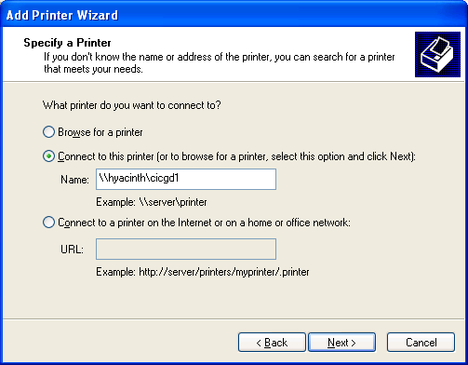

Problem: I have typed in the full printer path but I can still not print to this printer.

Workaround: Install the network printer as a local printer. To do this from Windows XP, click on Start / Printers and Faxes / Add Printer / Local Printer / Create new port / TcP/IP Port. You will be prompted to enter the IP Address of Printer. The IP address can be found clearly marked on each network printer.

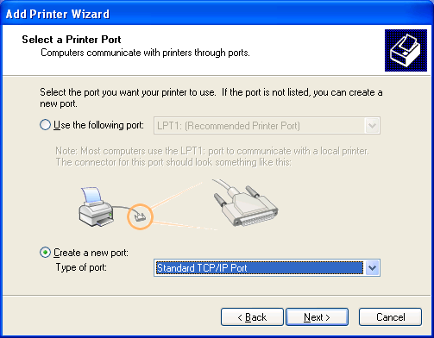

Problem: The server reports that it can find no suitable driver.

Workaround: Install the printer as a local printer. This is a permission problem.

Problem: No driver (for local printer):

Workaround: Download driver from HP web site from the ITU Service Desk support site. (Any HP4000 or 4050 driver will work on the HP2330).

