 |  |  |  |  | 

This cover letter and the joined “non paper”
Replace the cover letter and the draft “non paper” edited on 24 October 2003
Ref: | President of the WSIS PrepCom |  | To all PrepCom-3 participants
Contact: | Pierre Gagné, Executive Director of WSIS
Tel: | +41 22 730 63 60
Fax: | +41 22 730 6393
E-Mail: | Adama.samassekou@ties.itu.int
 |  | Geneva, 5 November 2003
Excellencies, Ladies and Gentlemen,
Further to the decision of PrepCom-3 and as I announced at the end of the open-ended meeting on 31 October 2003, please find attached my "non-paper" on the Declaration, which I submit to you for the forthcoming negotiations at the resumed PrepCom-3 session from 10 to 14 November 2003.
As you know, the President of PrepCom was mandated to prepare this document, overseeing informal consultations in order to facilitate the negotiation process at the resumed PrepCom-3. To this end, I conducted a series of informal consultations with delegations, which led to a schedule of informal open-ended meetings and a working method aimed at building consensus, which we all hope will be reached on the draft Declaration and draft Plan of Action. I asked His Excellency Ambassador Asko Numminen, Chairman of Subcommittee 2 of PrepCom-3, to chair these meetings, and the host countries of the Summit, Switzerland and Tunisia, to act as facilitators.
Following an initial consultation of the countries concerned, the points on which views diverge were analysed in preparation for the open-ended meetings held on 20, 30 and 31 October 2003. Under the brilliant chairmanship of Ambassador Numminen, these meetings: identified the main points in the Declaration which required further negotiation; determined the type of approach most likely to lead to a consensus; and established informal consultation groups on most of the issues in question. The groups that completed their work before 5 November 2003 have transmitted draft language, which I have incorporated in the text attached.
The “non-paper” that I am submitting is the direct result of this participatory process of consultation. I have made every effort take into account, in a balanced manner, the views of participating delegations.

I believe that we have made significant progress in recent weeks. To my mind, this emerging consensus is extremely positive, and I hope that this consultation process and the “non-paper” that has been produced as a result will make a substantial contribution to the successful completion of negotiations during PrepCom-3.
I believe that this text, which takes into account the contributions of some eighty governmental delegations, reflects to the greatest extent possible, the criteria that I proposed earlier, namely that it
1) expresses at the highest level a political commitment to place information and communication technologies at the service of humanity;
2) offers a common vision on issues inherent in the information and shared knowledge society;
3) asserts the political will to implement the commitments undertaken;
4) reflects a consensus among all stakeholders;
5) will be read by national political authorities and understood by all citizens;
6) achieves an equitable balance between the concerns and interests of the countries of the South and of the North;
7) strikes a satisfactory balance between technological and societal issues.

I would like to draw your attention to the fact that as I noted during the open-ended consultation meeting of 31 October 2003, I have solicited the remarks of observers on this “non-paper”. Inputs from the Civil Society Bureau and the CCBI will be posted on the WSIS website so that governments can take these comments into account during the negotiations of Prep-Com-3. I have asked the President of Sub-Committee 2 to pay special attention to these contributions, in light of the fourth criteria noted above.

In submitting my proposed text, I would like to express my sincere appreciation for the great work of the President of Sub-Committee 2, participating government delegations and the two host countries throughout the last three weeks, as well as representatives of the observer communities for their valuable contributions. I am confident that the efforts of all concerned will help us successfully conclude the negotiations set to begin next week. I hope that we can continue in this same spirit of positive collaboration and work towards a true consensus to the benefit of all.
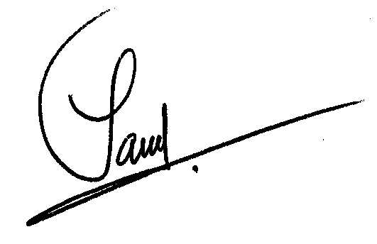
Please accept, Excellences, Ladies and Gentlemen, the expression of my high consideration.
Adama Samassékou
President of PrepCom

