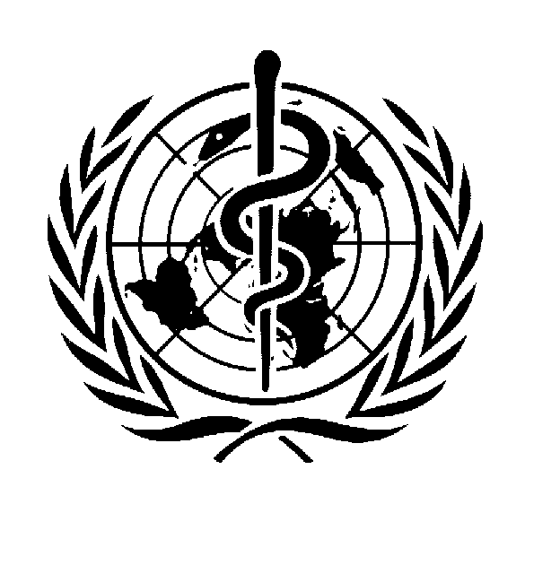

World Summit on the Information Society

Prep-Com Meeting, 1-5 July 2002: WHO intervention

Information is vital for health and development, but the world’s scientific knowledge remains largely out of reach for many countries. Just as the world today is divided between those who have access to health services and those who do not, a similar divide affects the flow of information and communications.

While new technologies hold great potential for improving health care, in many countries this potential is still far from being realized. This is due in part to financial, technological, and infrastructure challenges as the term “digital divide” suggests. But just as important, the real needs of users – which vary greatly due to educational, social, and cultural differences – are often overlooked.

To attain global health equity, relevant information and the technologies to deliver it must be widely available and effectively used. This requires paying attention to three main elements: connectivity, content, and the capacity to use them both.

Connectivity
Despite the conventional wisdom that the internet allows anyone with a computer and modem to connect to a global network, the reality of the unequal development of the internet infrastructure undermines the myth of universal access and poses a challenge to us all. It is of real concern to the World Health Organization that a significant number of public health institutions in low-income countries are still unable even to physically connect to reliable phone lines. Of those that can, many research institutions, schools of medicine and nursing, and health centres cannot afford the cost of communications. We are concerned about the high connectivity and communications costs in these countries, which limit access to information to a few affluent people. Internet infrastructure and services, while growing, have a long way to go.

Content
While it is a challenge for health professionals in wealthy countries to cope with the sheer volume of information, in many developing countries, essential information to provide even the basic health services is still largely unavailable.

Today “content” and “technology” go hand-in-hand. In addition to supporting medical diagnosis and therapy, advances in information and communications technologies can provide the foundation for important improvements in health care delivery, such as more cost-effective monitoring and follow-up of patients, and optimal targeting of vulnerable sectors of the population for special education, screening and prevention measures.

There are obvious challenges to generate, integrate, manage and make available the vast stores of information and knowledge related to health. Additional challenges lie in assuring its quality, timeliness and relevance to users. Information developed in the Americas or Europe may not be suitable for audiences elsewhere; language or cultural perspective being only part of the problem. While the widespread use of the Internet by the general public for obtaining health information has been an enormous public benefit, it has also encouraged the proliferation of misleading, fraudulent or promotional sites with potential for harm. These are the types of challenges the World Health Organization is addressing through its various programs.

Capacity building
While content and connectivity are essential elements to improving the flow of health information, the human factor cannot be ignored. Improving the capacities – that is, the skills and abilities of health personnel throughout the health system, including the public health institutions and government agencies – must be a priority in order to make the best use of information and knowledge. Support by governments, international organizations and their partners in training institutions should reflect the need for ongoing and comprehensive capacity building in information management and use. The combination of new technologies and different demographic and epidemiological challenges requires that health workers’ skills are regularly upgraded and that they are enabled to network with peers. The Internet offers new opportunities for distance learning and diagnostic support, as well as making global and local knowledge widely accessible.

Putting it all together: the Health InterNetwork
In September 2000 the United Nations Secretary-General launched a public-private initiative to bridge the digital divide in health. Spearheaded by the World Health Organization, the Health InterNetwork brings together international agencies, the private sector, foundations, non-governmental organizations and country partners under the principle of ensuring equitable access to health information. The aim is to improve public health by facilitating the flow of health information, using the Internet.

The focus of the Health InterNetwork is on improving the information environment of health personnel in developing countries: professionals, researchers and scientists, and policy makers. The core elements of the project are content, internet connectivity, and capacity building.

What needs to be done?
The extraordinary value of information and communications technology stems from the fact that it brings people together to build partnerships and a joint program of action on common themes, enabling them to make decisions and act from a more informed perspective and to mobilize their efforts more broadly and cost-effectively.

The World Health Organization is joining the ITU in calling on developing country governments to adopt appropriate national ICT strategies – based on private sector participation, market liberalisation and independent regulation – and committing to universal access to ICT.

We are calling on the development community, aid agencies, donors and non-governmental organizations to ensure that public health institutions and health care professionals in developing countries receive the necessary equipment and connectivity to share vital information for health.

The World Health Organization calls on the private sector to assist governments in their task by sharing their expertise and providing goods and services at affordable prices.

The World Summit of the Information Society in Geneva next year is an excellent opportunity to address the issues related to unequal access to reliable, relevant health information and to define the place of ICT as an integral part of health systems. WHO is prepared to provide its expertise in shaping the agenda for a “ICT for Health” session as part of the WSIS next year.

