1) Select: Start menu Settings Printers and Faxes

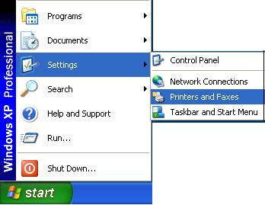
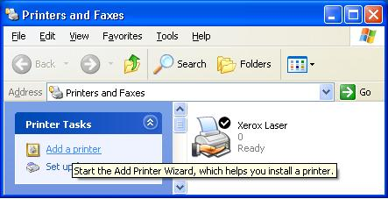

2) Select “Add a printer”

3) The “Welcome to the Add Printer Wizard “ window will appears, then click on the “Next” button.
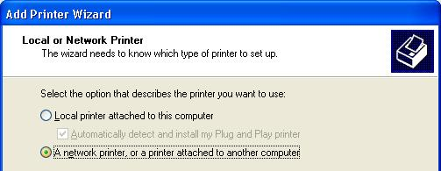
4) On the next window, select “A Network, or a printer attached to another computer”
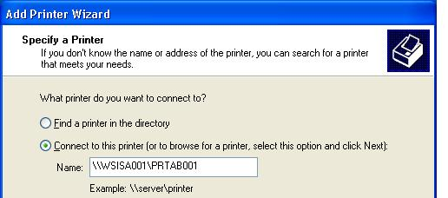

5) Enter the Printer name in the field bellow
- Name as indicated on each printer “shared as :\\WSISA001\PRTAB001”
- Enter exactly the same as indicated in the quotation mark!
Example: \\WSISA001\PRT201
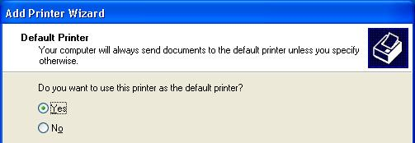

6) Select “Yes” to define this printer as default during the WSIS and then click “Next”.
7) Click on the “Finish” button to end the operation.

