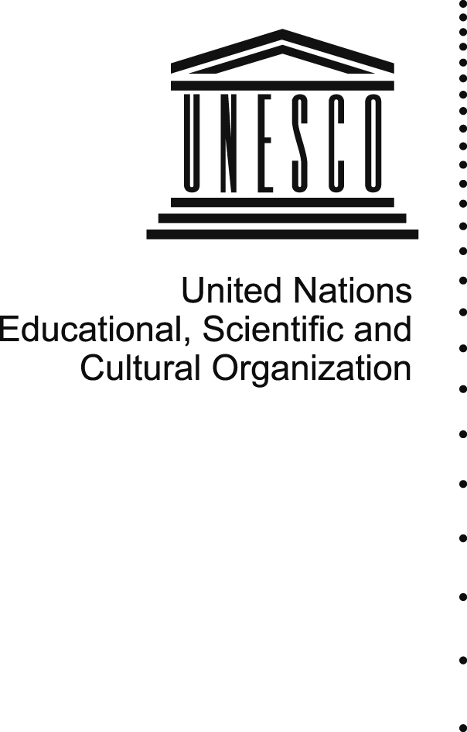 | 

UNESCO’s position on

Proprietary and Free and Open Source Software

As endorsed by the Intergovernmental Council for
the Information for All Programme

Presented at the consultation meeting
on facilitation of Action Line C3 “Access to information and knowledge”

Room C2, International Telecommunication Union (ITU)
19 May 2008
Background
- Today computers and software are used to create, store, manage and archive in digital format the entire memory of organizations and institutions – governmental bodies, international organizations, non-governmental organizations (NGOs), schools and universities, small and large businesses – and of individuals. All information that is produced and exchanged electronically is represented in digital form - text, images, books, voice, and video - and is coded, stored and transmitted as digital objects. All the data are stored on computers (hardware) that come in many shapes and sizes: mobile phones, music players, transportation vehicles, home appliances, global positioning systems (GPS), etc. The data are managed by programmed intelligence (software) that can be used to facilitate access as well as restrict or control access.

- New software applications have recently emerged that have considerable impact on UNESCO’s areas of competence in education, science, culture, communication and information; and creative software applications are changing social interaction, for example:
- Electronic “office suites” have now replaced typewriters and electronic documents are transferred through networks as digital objects.
- Client and server software applications over the Internet Protocol are used for communicating through e-mails, voice and video, browsing, and collaborating, thus allowing the creation and sharing of knowledge.
- Learning management systems and authoring tools are essential for Open Distance Learning.
- Software applications for library automation; creating, sharing and publishing digital libraries; digital preservation, numerical data management and analysis are important tools for capacity-building of information professionals.
- Tools such as community networks, social bookmarking, wikis and blogs, podcasting, digital story-telling, project based learning initiatives, video blogging and other new technologies enable people to be producers of information. People everywhere are using the Internet for civic engagement, education, cultural prosperity and community development.
- The emerging technologies give interactive power to its users. Yet an issue that has raised debate concerns the cost and the restrictions of software. This paper explains the three basic models of software development that are subject to debate on a variety of levels – proprietary, open source and free – and describes UNESCO’s position.

Models of software development
- There are basically three different models of software development that are subject to debate on a variety of levels, including technical, commercial, philosophical, political and development oriented. Examples of some common proprietary programs and their free and open source alternatives are in Annex II.
- Proprietary software is a term for computer software with restrictions on use, and private modification, or with restrictions on copying or publishing of modified or unmodified versions. These restrictions are placed on it by one of its proprietors. Similarly, closed source is a term for software whose licence does not meet the Open Source Definition.
- Open source software is computer software for which the human-readable source code is made available under a copyright licence (or arrangement such as the public domain) that meets the Open Source Definition. This permits users to use, change, and improve the software, and to redistribute it in modified or unmodified form. Open source software is often developed in a public, collaborative manner. Open source software is the most prominent example of open source development and often compared to user generated content. (Wikipedia)
- Free software is software that can be used, studied, and modified without restriction. Free software can be copied and redistributed in modified or unmodified form, either without restriction, or with restrictions only to ensure that further recipients can also do these things. To make these acts possible, the human-readable form of the program (called the source code) must be made available. The source code may be either accompanied by a software license stating that the copyright holder permits these acts (a free software licence), or be released into public domain, so that these rights automatically hold.

The World Summit on the Information Society and the software debate
- The World Summit on the Information Society (WSIS) (Geneva, 2003 and Tunis 2005) has recognized the importance of the issue of the use of software, mostly in relation to the crucial role that software plays in access to information and knowledge. The WSIS adopted the following positions on the issue, focusing on the need to ensure diversity of choice (Annex VII):
- The Declaration of Principles adopted in Geneva, in 2003, stresses the possibilities offered by different software models, including proprietary, open-source and free software, in order to increase competition, access by users, diversity of choice, and to enable all users to develop solutions which best meet their requirements.
- The Plan of Action, also adopted in Geneva, in 2003, calls for action to ensure an optimal choice of appropriate software that will best contribute to achieving development goals.
- The Tunis Commitment adopted in Tunis, in 2005, recommends the development of applications based on open and interoperable standards, and the utilization of technologies developed under open-source and free modalities. The Tunis Commitment also encourages and fosters collaborative development, interoperative platforms and free and open-source software.
- The Tunis Agenda for the Information Society also adopted in Tunis, in 2005, reiterates the support to the “development of software that renders itself easily to localization, and enables users to choose appropriate solutions from different software models including open-source, free and proprietary software.”

UNESCO’s mandate and principles and the link to software
- UNESCO’s basic functions are those of a laboratory of ideas and a standard-setter to forge universal agreements on emerging ethical issues. The Organization also serves as a clearinghouse – for the dissemination and sharing of information and knowledge – while helping Member States to build their human and institutional capacities in diverse fields. In addition, UNESCO promotes international co-operation among its Member States in the fields of education, science, culture and communication.
- In the area of software, UNESCO fulfills these basic tasks in supporting the “development and use of open, interoperable, non-discriminatory standards for information handling and access” as important elements in developing effective infostructures that contribute to democratic practices, accountability and good governance.
- From worldwide libraries and documentation centres to science laboratories and administrative offices, UNESCO has been a pioneer in supporting the development of advanced multilingual software distributed free-of-charge around the world for more than two decades. Starting with the development of a generalized information storage and retrieval system for bibliographic information in the 1980s, activities have now expanded to include support for the development of free and open source software with the launch of UNESCO's Free and Open Software Portal in 2001.
- These software tools, including documentation and training materials are available in many languages, with a focus on allowing Member States to access and apply new technology while being active and equitable partners in its development. This is particularly important for those who cannot afford to buy commercial software.
- Examples for UNESCO’s action in this area include:
- Of all the software tools developed by UNESCO, the most popular has been the CDS/ISIS software for creating, updating and searching textual databases. While project managers have an official register of 130,000 institutions and individuals using this software, the real number of beneficiaries can be multiplied exponentially.

- IDAMS (Internationally Developed Data Analysis and Management Software) is another influential software package developed by UNESCO. It serves as a powerful professional tool for scientific, educational and administrative environments in handling and analysing numerical data. More than 12000 users - institutions and individuals - have been registered so far, but again these are conservative estimates of the real reach of the software.

- UNESCO also supports the development of the popular open source Greenstone Digital Library system, which is helping educational, cultural and scientific institutions worldwide to build and share compatible digital libraries of open access and public domain information. Greenstone is a suite of software tools developed jointly by UNESCO, the University of Waikato (New Zealand) and the Human Info NGO (Belgium) for creating digital libraries. In numerous statements, digital libraries have been identified as key tools in supporting the implementation of the MDGs, in implementing the decisions made at the WSIS, and in achieving Education for All.

- With the launch of its FOSS (Free and Open Source Software) portal in 2001, UNESCO has demonstrated its support to FOSS.

- At the same time, UNESCO works with partnership with a number of companies whose products are proprietary. For example, in November 2004, UNESCO and Microsoft started their cooperation through an agreement to accelerate social and economic development around the world. (17 November 2004 (Paris). UNESCO and Microsoft Corp, in cooperation with the Youth Observatory of the Tunisian Ministry of Youth, in November 2005 launched the InfoYouth Centre, a regional community technology centre for North Africa, designed to provide youth with access to, and skills training in, the information technologies (IT). In the framework of the Community Multimedia Centers (CMC) project, UNESCO in collaboration with Microsoft organized in Dakar from 24 to 29 July 2006 a workshop for training trainers in the use of Microsoft courseware. Preferential tariffs for UNESCO CMC scale-up project in Senegal were offered.

UNESCO’s position
- The Intergovernmental Council for the Information for All Programme, at its fifth session in April 2008, endorsed the following statement in a view to promote UNESCO’s position vis-à-vis different software models (see Annex for the full text of the decision adopted):
UNESCO recognizes that:
- Software plays a crucial role in access to information and knowledge;
- Different software models, including proprietary, open-source and free software, have many possibilities to increase competition, access by users, diversity of choice and to enable all users to develop solutions which best meet their requirements;
- The development and use of open, interoperable, non-discriminatory standards for information handling and access are important elements in the development of effective infostructures;
- The community approaches to software development has great potential to contribute to operationalize the concept of Knowledge Societies;
- The Free and Open Software (FOSS) model accelerates technonology transfer and enables individuals in developing countries to be true partner in software development;
- The Free and Open Source Software (FOSS) model provides interesting tools and processes with which people can create, exchange, share and exploit software and knowledge efficiently and effectively;
- FOSS can play an important role as a practical instrument for development as its free and open aspirations make it a natural component of development efforts in the context of the Millennium Development Goals (MDGs);
- Consistent support plays an important role in the success and sustainability of FOSS solutions;
- All software choices should be based upon the solution's ability to achieve the best overall return on technology investments and knowledge acquisition.
Annex
Text of the decision adopted by the Intergovernmental Council for the Information for All Programme at its fifth session in April 2008

The Intergovernmental Council for the Information for All Programme:
- Having examined document IFAP-2008/COUNCIL.V/6;
- Fully endorses the positions taken by the World Summit on the Information Society (WSIS) recognizing the possibilities offered by different software models, including proprietary, open-source and free software, in order to increase competition, access by users, diversity of choice, and to enable all users to develop solutions which best meet their requirements;
- Reiterates the position of the Medium-Term Strategy 2008-2013 that the development and use of open, interoperable, non-discriminatory standards for information handling and access are important elements in the building of effective infostructures and economic development;
- Welcomes the principles of freedom and openness, as well as the community approach underpinning the development of Free and Open Source Software;
- Recognizes the significant role that Free and Open Source Software can make to operationalize the concept of Knowledge Societies and to attain the Millennium Development Goals;
- Also recognizes that the ultimate software choices should be based upon the ability to achieve the best long term return on financial and intellectual investments;
- Supports the proposed statement for UNESCO to promote well documented Free and Open Source Software solutions including training in their use;
- Requests the Director-General to support the promotion of Free and Open Source Software solutions in all Member States.

Comprising 26 UNESCO Member States that are elected by UNESCO’s General Conference.
Wikipedia: Proprietary software
Wikipedia: Open source software
Wikipedia: Free software
Medium-Term Strategy 2008 – 2013 (34 C/4), paragraph 125
http://www.unesco.org/webworld/portal_freesoft
http://www.unesco.org/idams
http://www.greenstone.org
The Global Agreement: UNESCO and Microsoft use Information and Communication Technologies (ICT) to promote education)
New regional centre in Tunisia to help youth participate in the knowledge economy
Preferential tariffs for UNESCO CMC scale-up project in Senegal

