
BUILDING THE INFORMATION SOCIETY
Joint Facilitation Meeting on WSIS Action Line C2, C4, C6 | Document ALC2C4C6/3/09-E
Joint Facilitation Meeting on WSIS Action Line C2, C4, C6 | 28 April 2007
Joint Facilitation Meeting on WSIS Action Line C2, C4, C6 | Original: English
Presentation of the West Africa Fiber Optic Project

submitted by

Infinity Worldwide Telecommunications Group of Companies (IWTGC)

Joint Facilitation Meeting on Action Line C2- Geneva- May 16, 2007

Presentation of the West Africa fiber optic Project

Company: | Infinity Worldwide Telecommunications Group of Companies, Inc. (IWTGC)
Project: | Infinity West Africa -- Infinity Worldwide Telecommunications Group of Companies, Inc. (“Infinity”) intends to offer integrated Information and Telecommunications services to the West African region over an interconnected submarine fiber optic cable and terrestrial wireless broadband network.
Project Overview: | Infinity intends to develop, deploy, and operate this network in a two phased project plan:  Phase 1: Infinity will construct a 14,000 kilometer international sub-sea fiber optic backbone communications network along West Africa with direct links into Southern Europe and South Africa. The network will run from Lisbon, Portugal to South Africa with branching units to land in the West African coastal countries of Senegal, Ghana, Nigeria, Cameroon and Angola. Additionally, the network will be designed to allow for seamless expansion throughout the fifteen ECOWAS countries plus other complimentary opportunities.  Phase 2: Infinity will construct broadband networks in targeted cites, utilizing state of the art technologies, to offer end-user broadband voice, video, and data services. The “Initial Cities” include Lagos, Abuja, Ibadan, and Port Harcourt in Nigeria; Accra in Ghana; Dakar in Senegal; Douala in Cameroon; and Luanda in Angola.  Phase 1 is projected to require $750 million in capital.
Company Highlights: | Infinity has entered into a Memorandum of Understanding with VSNL for engineering and design support; use of its global infrastructure; network services; and operational support. VSNL’s International Global Network spans across 4 continents and comprises major ownership in 206,356km of terrestrial network fiber and subsea cable.  - ECOWAS (Economic Community of West African States) issued a formal endorsement of Infinity as the leading solution for telecommunications connectivity and ICT development throughout the entire region.  - Infinity is cooperating with ECOWAS concerning construction and management of Centers of Excellence for the region offering world-class connectivity, distribution, storage, customer support, security, content, processing capability and applications as the foundation of growth beyond traditional telecommunications services for full-service ICT deployment in the region.  - NEPAD (New Economic Partnership for African Development) has endorsed the project as crucial for regional economic development (Dakar, July 2005). Strong recommendation of NEPAD support was also included in a report distributed to leading development institutions such as the World Bank, the West African Development Bank and regional regulatory and operator organizations.  - Presented to WATRA (West African Telecommunications Regulatory Association) conference in September, 2005 in Accra, the project goals and desired regulatory environment to allow for region-wide deployment. Significant interest expressed by numerous countries resulted in Infinity’s decision to expand the potential coverage area of its project throughout the ECOWAS region.  - The ITU coordinator of the group mandated to oversee the implementation of the Information and Communication Infrastructure of the Geneva Plan of Action adopted by the World Summit on the Information Society (WSIS) has included the Infinity West Africa project in the list of projects which will be facilitated for implementation in the framework of the WSIS decisions.
Market Opportunity: | Infinity plans to offer wholesale (Phase 1) and retail communications services (Phase 2).  The Wholesale Market is aimed at responding to the growing bandwidth requirements of national carriers, mobile operators, Internet service providers (ISPs) multi-national corporations and other commercial and private end-users.  Infinity will offer Intra-regional and inter-regional communications facilitating high-quality and economical communications which is the primary objective of national governments, regional telecom and development authorities and are viewed as the foundation for economic development.  The Retail Market – Infinity plans to deploy alternative technologies, such as WiMax fixed wireless, in order to cost-effectively facilitate the distribution of broadband communications services to the residential and business market.
The Network: | Infinity intends to deploy an optimal network configuration consisting of a 4 fiber pair sub-sea fiber optic cable backbone (Phase 1) and alternative (e.g. fixed wireless, broadband over power lines (BPL) / etc.) distribution technologies (Phase 2) in targeted cities to deliver the most robust service offering in a capital efficient manner  - The network will be an “all IP” network to optimize inter-operability  - The network will provide country-to-country regional connectivity  - The network will allow Infinity to offer its products and services cost-effectively
Products and Services: | Wholesale services:  - End-to-end intra-regional and inter-regional bandwidth services and Internet capacity including global traffic connections directly to Western Europe & London, North America and Asia. Service to national telecom operators, mobile operators, and ISPs.  - Interconnection services: National and international long-distance voice interconnection. In-region hubbing of voice, Internet and other data traffic.  - IXP and Peering Facilities: co-location and interconnection of ISPs in targeted cities with high capacity connectivity between will create a virtual West African Internet Exchange.  - Collocation, business process outsourcing facilities and media centers will be created within Infinity’s PoPs in each target market for third party operation  Retail services:  - Triple play services – bundled voice, data (Internet access) and video in high-density, up-scale urban centers.  - Managed services, web hosting and call centers will be available to the small business community  - Computing, storage and security services will be offered to the small and large enterprise market  - Customized products and services for specific vertical customer sets including: the Oil & Gas sector and the Government sector.
Financing  Management Team: | High level discussions with various financial institutions are being conducted for the funding of the first phase of the project. It is highly anticipated that the negotiations will result very soon in obtaining the funds necessary to launch the manufacturing of the cable system.  Senior management team is made up of telecommunications veterans, each with 10-35+ years of direct industry experience in international wholesale and retail telecom services with significant development experience in African markets.  - Have successfully built and developed similar businesses and networks worldwide.  - External advisors supplement management skill sets with industry, political and technical expertise and relationships.  - Founders are US and Africa-based businessmen from West Africa.
 |  | Management  Adedoyin Ademilola, Founder, Chairman, & CEO  Robert D. Woog, Managing Director & COO  Mademba Cisse, Senior VP - Regulatory & Business Affairs  Stephen Prendergast, Senior VP - Operations & Customer Service  Jim Roberts, Senior Marketing Executive  James Mack, Financial Controller  Bolade Agboola, General Manager- Nigeria | Advisors  Nicole Kaplan, Finance Director  JP Ziegler, Senior Financial Advisor  Joseph Idowu, Senior Financial Advisor  Olubusola Obasanjo, Sr. Advisor, African Affairs  Andrew D. Lipman, Partner, Bingham McCutchen LLP, Chief Legal Advisor
Further Contact: | Mademba Cisse  SVP Regulatory & Business Affairs  Tel: 1 301 789 1250  Cell: 1 571 265 9652  Fax: 1 212 957 1912  Email: mcisse@iwtgc.com

Infinity’s Sub-sea Cable Network Serving West Africa
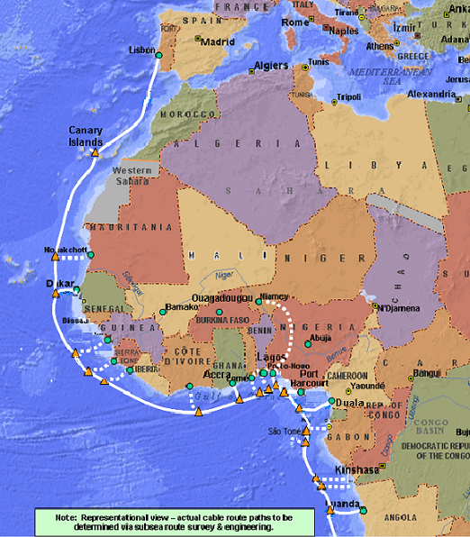
TO: Namibia & South Africa

Infinity’s Extended Reach Through VSNL Partnership
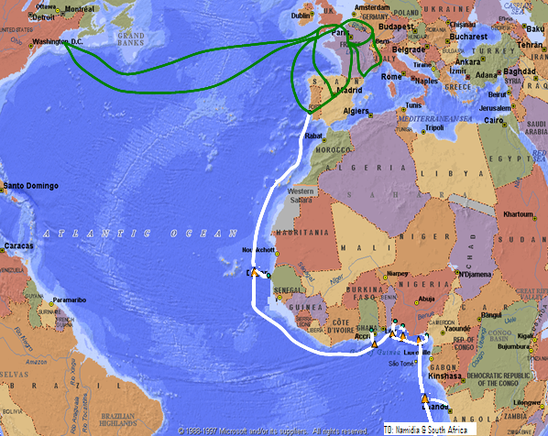

Infinity’s Proposed Centers of Excellence in partnership with ECOWAS

