|  |  |
| --- | --- |
| **Telecommunication Standardization Bureau** |  |
|  |  |

Geneva, 10 June 2014

|  |  |  |
| --- | --- | --- |
| Ref: | **TSB Collective letter 2/SG3RG-AO** |  |
| Tel: Fax:  E-mail: | +41 22 730 6311 +41 22 730 5853 [tsbsg3@itu.int](mailto:tsbsg3@itu.int) | * To the members of the Study Group 3 Regional Group for Asia and Oceania (SG3RG-AO) |

|  |  |
| --- | --- |
| **Subject:** | **Meeting of the Study Group 3 Regional Group for Asia and Oceania (SG3RG-AO), Yangon, Republic of the Union of Myanmar,**  **2-3 September 2014** |

Dear Sir/Madam,

We are pleased to inform you that, at the kind invitation of the Ministry of Communications and Information Technology of the Republic of the Union of Myanmar, ITU-T Study Group 3 Regional Group for Asia and Oceania (SG3RG-AO) will hold its meeting at the Taw Win Garden Hotel, Yangon, Myanmar, on 2 and 3 September 2014.

The meeting will be preceded by a one and a half day Regional Economic and Financial Forum of Telecommunications/ICTs for Asia and Pacific Region organized by the Telecommunication Development Bureau (BDT), which will take place on 1 and 2 of September 2014.

The BDT Forum will start at 0900 hours on Monday 1 September 2014. The meeting of ITU-T SG3RG-AO will start at 1430 hours on Tuesday 2 September. The event will be restricted to delegates and representatives of administrations and operating agencies of the region, in conformity with §2.3.2 of Section 2 of Resolution 1 of the WTSA-12.

Participant registration will begin at 0830 hours at the Taw Win Garden Hotel. Detailed information concerning the meeting rooms will be displayed at the entrances of the venue. Additional information about the meeting is set forth in **Annex A.**

The draft **Agenda** of the meeting, as prepared by the Chairman of SG3RG-AO, is set out in **Annex B**.

Practical information relating to the venue is enclosed as **Annex C.**

Please note that continuity of representation would be helpful to the group’s work.  
I wish you a productive and enjoyable meeting.

Yours faithfully,

Malcolm Johnson  
Director of the Telecommunication  
Standardization Bureau

Annexes: 3

**ANNEX A**(to TSB Collective letter 2/SG3RG-AO)

**MAKING CONTRIBUTIONS**

**DEADLINES FOR CONTRIBUTIONS:** We invite you to submit your contributions by electronic mail to the following address [tsbsg3@itu.int](mailto:tsbsg3@itu.int). The deadline for contributions is 12 (twelve) calendar days before the meeting. Such contributions will be published on the Study Group 3RG-AO website and must therefore be received by TSB **not later than 20 August 2014**.

**TEMPLATES:** Please use the provided set of templates to prepare your contribution. The templates are accessible at <http://itu.int/ITU-T/studygroups/templates>. The name, fax and telephone numbers and e-mail address of the person to be contacted about the contribution should be indicated on the cover page of all documents.

**WORK METHODS AND FACILITIES**

**INTERPRETATION:** In agreement with the Chairman of the SG3RG-AO, the Forum and the meeting will be conducted in English, without interpretation.

**WIRELESS LAN:** Facilities and Internet access will be available at the venue of the event.

**PAPERLESS MEETINGS:** In agreement with its Chairman, Study Group 3 RG-AO will take further steps towards working in a fully electronic environment. The meeting will therefore be run paperless.

**REGISTRATION and FELLOWSHIPS**

**REGISTRATION:** To enable the organisers to make the necessary arrangements, please send by letter, fax (+41 22 730 5853) or e-mail ([tsbreg@itu.int](mailto:tsbreg@itu.int)) **not later than 1 August 2014**, the list of people who will be representing your Administration, Sector Member, Associate, Academic Institution, regional and/or international organization or other entity. Administrations are requested also to indicate the name of their head of delegation (and deputy head, if applicable).

**Please note that pre-registration of participants to ITU-T meetings is carried out *online* at the ITU-T website   
(**[**http://www.itu.int/en/ITU-T/studygroups/2013-2016/03/sg3rgao/Pages/default.aspx**](http://www.itu.int/en/ITU-T/studygroups/2013-2016/03/sg3rgao/Pages/default.aspx) **).**

**FELLOWSHIPS:** We are pleased to inform you that one partial fellowship per administration will be awarded, **within the Asia and Oceania region only**, subject to available funding, to facilitate participation from Least Developed or Low Income Developing Countries (<http://itu.int/en/ITU-T/info/Pages/resources.aspx>). An application for a fellowship must be authorized by the relevant Administration of the ITU Member State. Fellowship requests (please use enclosed **Form 1)**, must be returned to ITU not later than **20 July 2014**. Please note that the decision criteria to grant a fellowship include: the available ITU budget; contributions by the applicant to the meeting; equitable distribution among countries; and gender balance.

**KEY DEADLINES (before meeting)**

20 July: - fellowship requests

20 August: - contributions

1 August: - registration

**FORM 1 - FELLOWSHIP REQUEST**

(to TSB Collective letter 2/SG3RG-AO)

|  |  |  |  |  |  |  |  |
| --- | --- | --- | --- | --- | --- | --- | --- |
|  | **ITU-T Study Group 3RG-AO meeting** and **Associated BDT Forum**  Yangon, Myanmar, 1-3 September 2014 | | | | | |  |
| **Please return to:** | | | **ITU**  **Geneva (Switzerland)** | | **E-mail :** [**bdtfellowships@itu.int**](mailto:bdtfellowships@itu.int)  **Tel: +41 22 730 5227**  **Fax: +41 22 730 5778** | | | |
| **Request for one partial fellowship to be submitted before  20 July 2014** | | | | | | | |
|  | | | | Participation of women is encouraged | | |  | |
| Registration Confirmation I.D. No: …………………………………………………………………………… (Note: It is imperative for fellowship holders to pre-register via the on-line registration form at <http://www.itu.int/en/ITU-T/studygroups/2013-2016/03/sg3rgao/Pages/default.aspx> )  **Country: _____________________________________________________________________________________________________**  **Name of the Administration or Organization: ______________________________________________________________________**  **Mr. / Ms. _______________________________________(family name) ______________________________________(given name)**  **Title: ____________________________________________________________________________________________________** | | | | | | | | |
| **Address: ____________________________________________________________________________________________________**  **______________________________________________________________________________________________________________**  **Tel.: ____________________________ Fax: ____________________________ E-Mail:_________________________________**  **PASSPORT INFORMATION :**  **Date of birth: _______________________________________________________________________________________________**  **Nationality: __________________________________________ Passport number: ________________________________________**  **Date of issue: ___________________ In (place) : _____________________________Valid until (date): _______________________** | | | | | | | | |
| **Please select your preference for one of the two options below:** | | | | | | | | |
|  | | | | | | | | |
| **□ Economy class air ticket (duty station / Yangon / duty station).**  **□ Daily subsistence allowance intended to cover accommodation, meals & misc. expenses.** | | | | | | | | |
|  | | | | | | | | |
| **Signature of fellowship candidate:** | | | | | | **Date:** | | |
| **TO VALIDATE FELLOWSHIP REQUEST, NAME, TITLE AND SIGNATURE OF CERTIFYING OFFICIAL DESIGNATING PARTICIPANT MUST BE COMPLETED BELOW WITH OFFICIAL STAMP.**  **N.B. IT IS IMPERATIVE THAT FELLOWS BE PRESENT FROM THE FIRST DAY TO THE END OF THE MEETING.** | | | | | | | | |
| **Signature** | | | | | | **Date** | | |

**ANNEX B**(to TSB Collective letter 2/SG3RG-AO)

**Draft Agenda**

|  |
| --- |
| 1. Opening of the meeting |
| 1. Adoption of the agenda |
| 1. Available documents |
| 1. Review of SG3RG-AO and ITU activities |
| 1. SG3RG-AO/TAS cost model enhancements (LRIC) |
| 1. Results of WCIT-12 |
| 1. Results of WTSA-12 |
| 1. Accounting rate issues: |
| 8.1 Mobile termination rate and international mobile roaming |
| 8.2 NGN Charging |
| 1. International Internet Connectivity |
| 1. Definitions and Economic Effects of Alternative calling procedures, misappropriation and calling line identification |
| 1. Commercial agreements, dispute resolution, and invoicing |
| 1. Future work programme |
| 1. Discussions on working methods and structure of ITU-T Study Group 3 |
| 1. Other business |
| 1. Next meeting |
| 1. Closure of the meeting |

**ANNEX C**(to TSB Collective letter 2/SG3RG-AO)

**Practical information for participants**

1. **Venue**

Taw Win Garden Hotel

Address: No.45, Pyay Road, Dagon Township, Yangon, Myanmar  
Tel: + 95-1-8600080

Website: [www.tawwingardenhotel.com](http://www.tawwingardenhotel.com)

**2. About Myanmar**

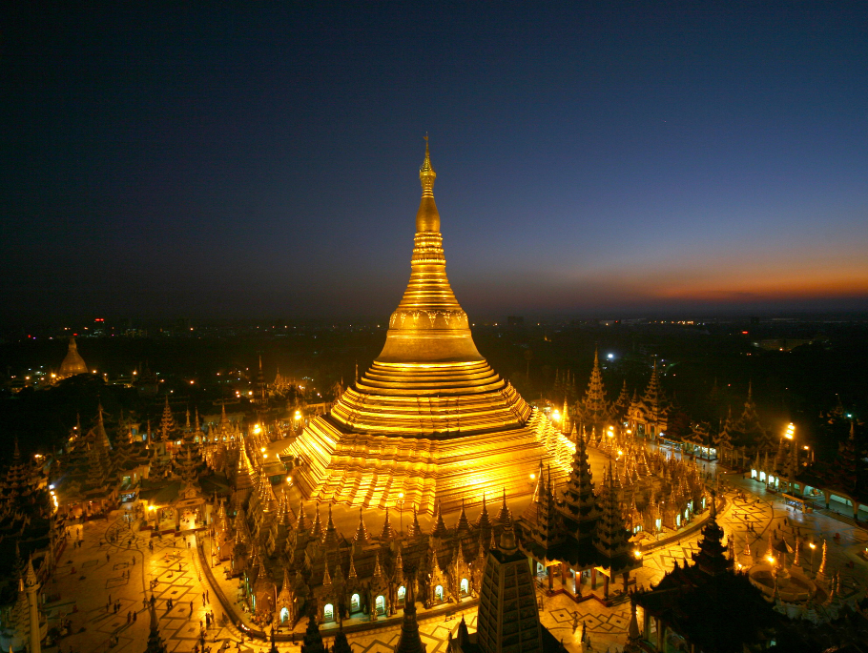Myanmar is located on the Indochina peninsula of South East Asia, which is a place where you can not only see the culture of the people, but also a place to explore the natural environmental beauty. Geographically, Myanmar is the largest country in South East Asia sharing borders with Bangladesh, China, India, Laos and Thailand. The country has a total land area of 675,577 square kilometres. Myanmar is also known as the Golden Land not only for its golden pagodas but also for its rich lands and the wealth of its agriculture and precious minerals. It is a land of different nationalities and tribes. The country comprises 7 States and 7 Regions. The largest city and seaport is Yangon. Mandalay, the last royal capital in the heart of Myanmar is an important trade centre. Nay Pyi Taw (which literally means Royal Capital), is the administrative capital located in central Myanmar 320 km north of Yangon.

Yangon, the commercial city, is the main gateway to Myanmar. It was founded by King Alaungpaya in 1775 on the site of a small settlement called Dagon. The name Yangon means “End of Strives”. At present, Yangon covers an area of about 350 km2 with a population of nearly 6 million. Almost all International Airlines serving Myanmar fly to Yangon International airport. Yangon is also a growing bustling business centre. The city today still maintains its colonial charm and gracious turn-of-the century architecture.

**3. Weather**

The climate of Myanmar follows a monsoon pattern and a year is more or less equally divided into three weather patterns; namely summer, rainy and winter. The month of September marks the end of the wet season and the beginning of the winter season. The average temperature is between 25-30 Degrees Celsius.

**4. Hotel Accommodation**

**Taw Win Garden (also meeting venue for the events)**

Taw Win Garden Hotel is ideally located for business and leisure travellers. The Hotel is on the most prominent road in Yangon - Pyay Road, Dagon Township near the City Centre and major cultural attractions of Yangon, Myanmar. The Hotel is just 30 minutes’ drive from Yangon International Airport and a five-minute drive to the City Centre and to the Shwedagon Pagoda.

All truly exclusive 513 guestrooms and suites, from the 4th to the 8th floor, offer stunning views of Shwedagon Pagoda, the city view and the garden view. These guestrooms and suites are designed and provided with all important features for modern life in order to soothe guests with ultimate luxury and convenience.

The guests will firstly be impressed with the hotel’s elegant entrance on the ground floor, then led to the lobby on the 4th floor in only a minute with its hi-tech flying lift that can smoothly transport guests.

The lobby, decorated with a classic Myanma Saing (the traditional instrument), welcomes all guests into a most relaxing and friendly atmosphere. Throughout the hotel, the concept of blending modern and traditional Myanmar style can be seen. The design and decoration provides a unique ambience and a sense of warmth and intimacy. Furthermore, the hotel's host of recreational offerings ensures there is plenty to do during your stay. Discover an engaging blend of professional service and a wide array of features at Taw Win Garden Hotel.

Website: [www.tawwingardenhotel.com](http://www.tawwingardenhotel.com)

Address: No.45, Pyay Road, Dagon Township, Yangon, Myanmar

Room reservation: Ms. Moe Moe Khaing

Assistant Reservation Manager

Tel: + 95-1-8600080

Fax: + 95-1 8600082

E-mail: [reservation@tawwingardenhotel.com](mailto:reservation@tawwingardenhotel.com)

|  |  |
| --- | --- |
| ROOM RATE | SINGLE/DOUBLE |
| Deluxe Room (sqm-45) | **US$ 130 net per night** |
| Premier Room (sqm-45) | **US$ 170 net per night** |

Check In Time: **14:00 hours**

Check Out Time: **12:00 noon**

Credit Cards Accepted: **Visa and Master**

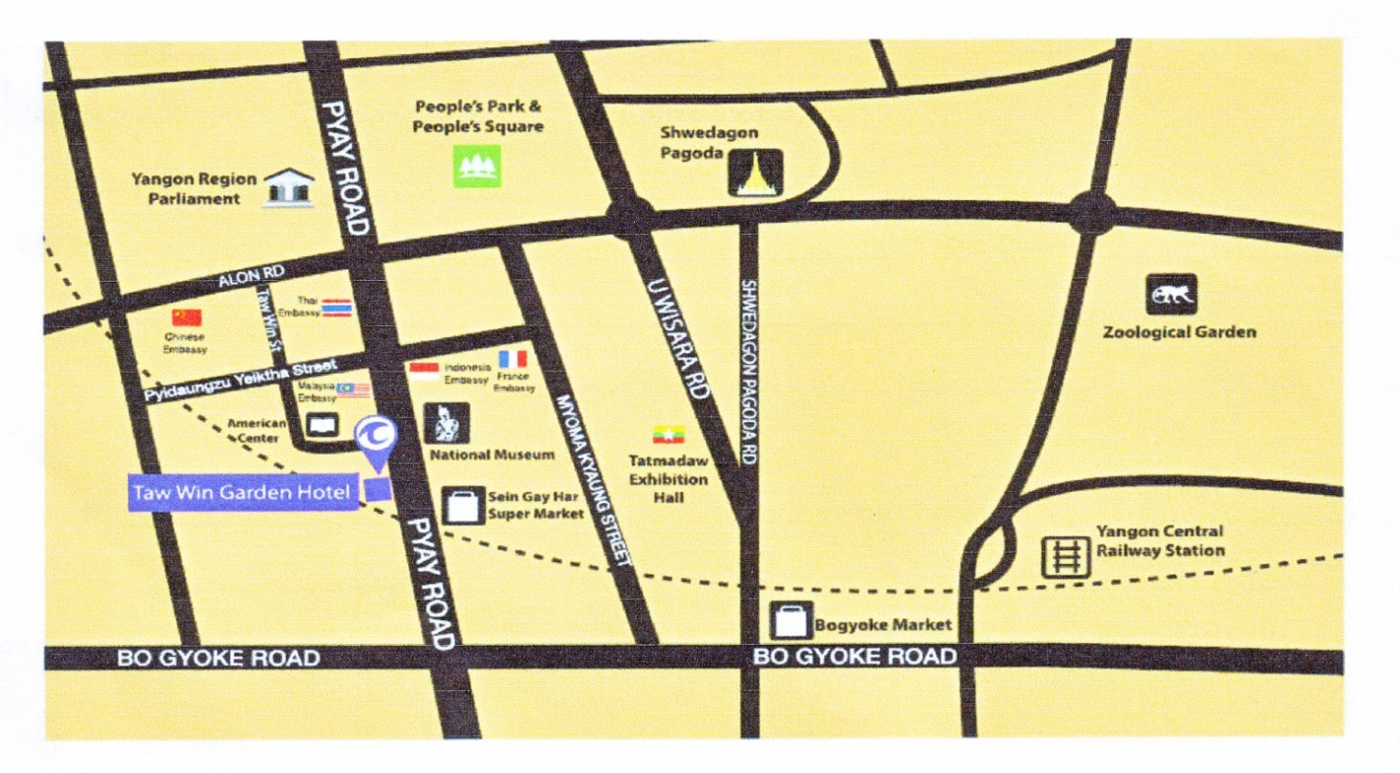

**Other Recommended Hotels**

|  |  |  |
| --- | --- | --- |
| Hotel Name | Room Rate (Single/Double) | Hotel Reservation |
| Chatrium Hotel Royal Lake  *****  No.40, Natmauk Road, Tamwe Township, Yangon  www.chatrium.com | Deluxe Room $ 180 net | Ms. Khine Wint Phyu  Senior Sales Manager  Ph: 95 1 544500  Fax: 95 1 544400  Email: [rsvn.chry@chatrium.com](mailto:rsvn.chry@chatrium.com)  Email: [khinewintphyu@chatrium.com](mailto:khinewintphyu@chatrium.com) |
| Central Hotel  ***  No.335-337, Bogyoke Aung San Road, Pabedan Township, Yangon  www.centralhotelyangon.com | Deluxe Room $ 80 net | Mr. Kyaw Zin Oo  Sales and Marketing Manager  Ph: 95 1 241001  Fax: 95 1 248003  Email: [centralreservationygn@gmail.com](mailto:centralreservationygn@gmail.com) |

Hotel reservations need to be made directly to the hotel with Cc to [dg.ptd@mptmail.net.mm](mailto:dg.ptd@mptmail.net.mm) and [winminaung01@gmail.com](mailto:winminaung01@gmail.com) in order to facilitate the process. Delegates who are booking other hotels are requested to state the meeting name when they make their hotel reservation.

**5. Visa Information**

Visa requirements for Myanmar may vary for the citizens of different countries. Please check the visa requirements with your nearest Myanmar Embassy or consulate general. Kindly visit the link <http://www.mofa.gov.mm> for more details. Your request for issuing a visa supporting letter should be sent by e-mail to the following contact person **no later than 11 August 2014** to issue timely delivery of the visa and a scanned copy of your passport should also accompany your request:

**Mr. Win Min Aung**

**Assistant Director**

**Posts and Telecommunications Department**

**Ministry of Communications and Information Technology**

**E-mail :** [**dg.ptd@mptmail.net.mm**](mailto:dg.ptd@mptmail.net.mm) **;** [**winminaung01@gmail.com**](mailto:winminaung01@gmail.com)

**Tel: +95 9 448 0000 98**

**Fax: +95 67 407 216**

**6. Transportation from Airport to Hotel**

Delegates are requested to provide their travel information to the local secretariat no later than 11 August 2014. The local secretariat will provide transportation arrangements from the Airport to selected hotels from August 31 and transfer from the hotel to the Airport from 4 September. Participants should fill out the arrival and transportation Form 3 and send the it by e-mail to Mr Win Min Aung ([dg.ptd@mptmail.net.mm](mailto:dg.ptd@mptmail.net.mm); [winminaung01@gmail.com](mailto:winminaung01@gmail.com)) **.**

A public Taxi Meter is also located in front of the arrival hall, entrance no. 3 and 4. It takes about 45 minutes by car from the airport to the hotel where the meeting will take place.

**7. Time zone**

GMT + 6:30 hours

**8. Banking facilities**

Myanmar’s official currency is Myanmar Kyats (MMK). The exchange rate is roughly 960 Kyats equivalent to 1 USD as of May 2014.Kindly visit the below link for more detailed information: <http://www.cbm.gov.mm/>. Foreign currency can be exchanged at any authorized money changer counter. Normal banking hours are 09:00am to 16:30pm on weekdays. Credit cards including Visa Card, Master Card, JCB and China Union Pay Card are accepted in many major hotels, shopping malls and restaurants.

**9. Electricity (voltage used)**

Supply voltage is 220V, 50Hz (see picture). Please bring the right adapter for your equipment.



**FORM 2 – Taw Win Garden hotel reservation form**

(To TSB Collective letter 2/SG3RG-AO)

Guest Name:___________________________________________________________________________

______________________________________________________________________________________

______________________________________________________________________________________

Organization Name:________________________________________________________________________

Arrival Date: ________________Flight Time :________________ Transportation Yes No

Departure Date: _____________Flight Time :________________ Transportation Yes No

No of Rooms: ___________________(Single / Double) Smoking Non Smoking

Room Rate____________________________________________________________________________

**Room Types:**

Superior Room Executive Suite Taw Win Family

Deluxe Room Princess Suite

Premier Room Taw Win Suite

**Method of Payment**

Pay Own Account Cash Credit Card

Company Pay

Credit Card No. : ________________________________________ Exp Date: ____________________

Remarks: ____________________________________________________________________________

____________________________________________________________________________________

Contact Person: ________________________Reservation Taken By : ___________________________

Contact No: ____________________________ Confirmation No : ______________________________

Email Address: ______________________________________Date :____________________________

Approved by: _______________________

**FORM 3 – ARRIVAL AND TRANSPORTATION TO HOTEL**

(to TSB Collective letter 2/SG3RG-AO)

|  |  |  |  |  |
| --- | --- | --- | --- | --- |
|  | **ITU-T Study Group 3 RG-AO meeting** and **Associated BDT Forum**  **Yangon, Myanmar, 1-3 September 2014** | | |  |
|  | | |  |  | |
| **To ensure transfer to and from the airport, participants are requested to complete and return this form to Mr Win Min Aung** **by E-mail to** [dg.ptd@mptmail.net.mm](mailto:dg.ptd@mptmail.net.mm) ; [winminaung01@gmail.com](mailto:winminaung01@gmail.com) | | | | |

Family name…………………………………………………………………………………………

First name……………………………………………………………………………………………

Job Title ……………………………………………………………………………………………..

Organization……………………………………………………………… Country …………..........

Telephone: :……………………………………………….

Email:………………………………………………………

Hotel where you are residing:

Hotel Name ……………………………………………………………

Address …………………………………………………………

**Transportation will be provided from the airport to the hotels and to the meeting venue. Please provide your arrival and departure flight information to facilitate arrangements for transportation.**

|  |  |  |  |  |  |  |
| --- | --- | --- | --- | --- | --- | --- |
| Date of Arrival |  |  | Time of Flight Arrival |  | FLIGHT NO. |  |
| Date ofDeparture |  |  | Time of Flight Departure |  | FLIGHT NO. |  |

*___________________*