|  |  |
| --- | --- |
| **Plenipotentiary Conference (PP-14) Busan, 20 October – 7 November 2014** |  |
|  |  |
|  |  |
| **PLENARY MEETING** | **Document 36-E** |
| **13 March 2014** |
| **Original: English** |
| Note by the Secretary-General | |
| CANDIDACY FOR THE POST OF MEMBER OF THE RADIO REGULATIONS BOARD | |
|  | |
|  | |

Further to the information published in Document 3, I have pleasure in transmitting to the Conference, in annex, the candidacy of:

**Mr Alireza DARVISHI (Islamic Republic of Iran)**

for the post of member of the Radio Regulations Board.

Dr Hamadoun I. TOURÉ  
 Secretary-General

**Annex**: 1

ANNEX 1

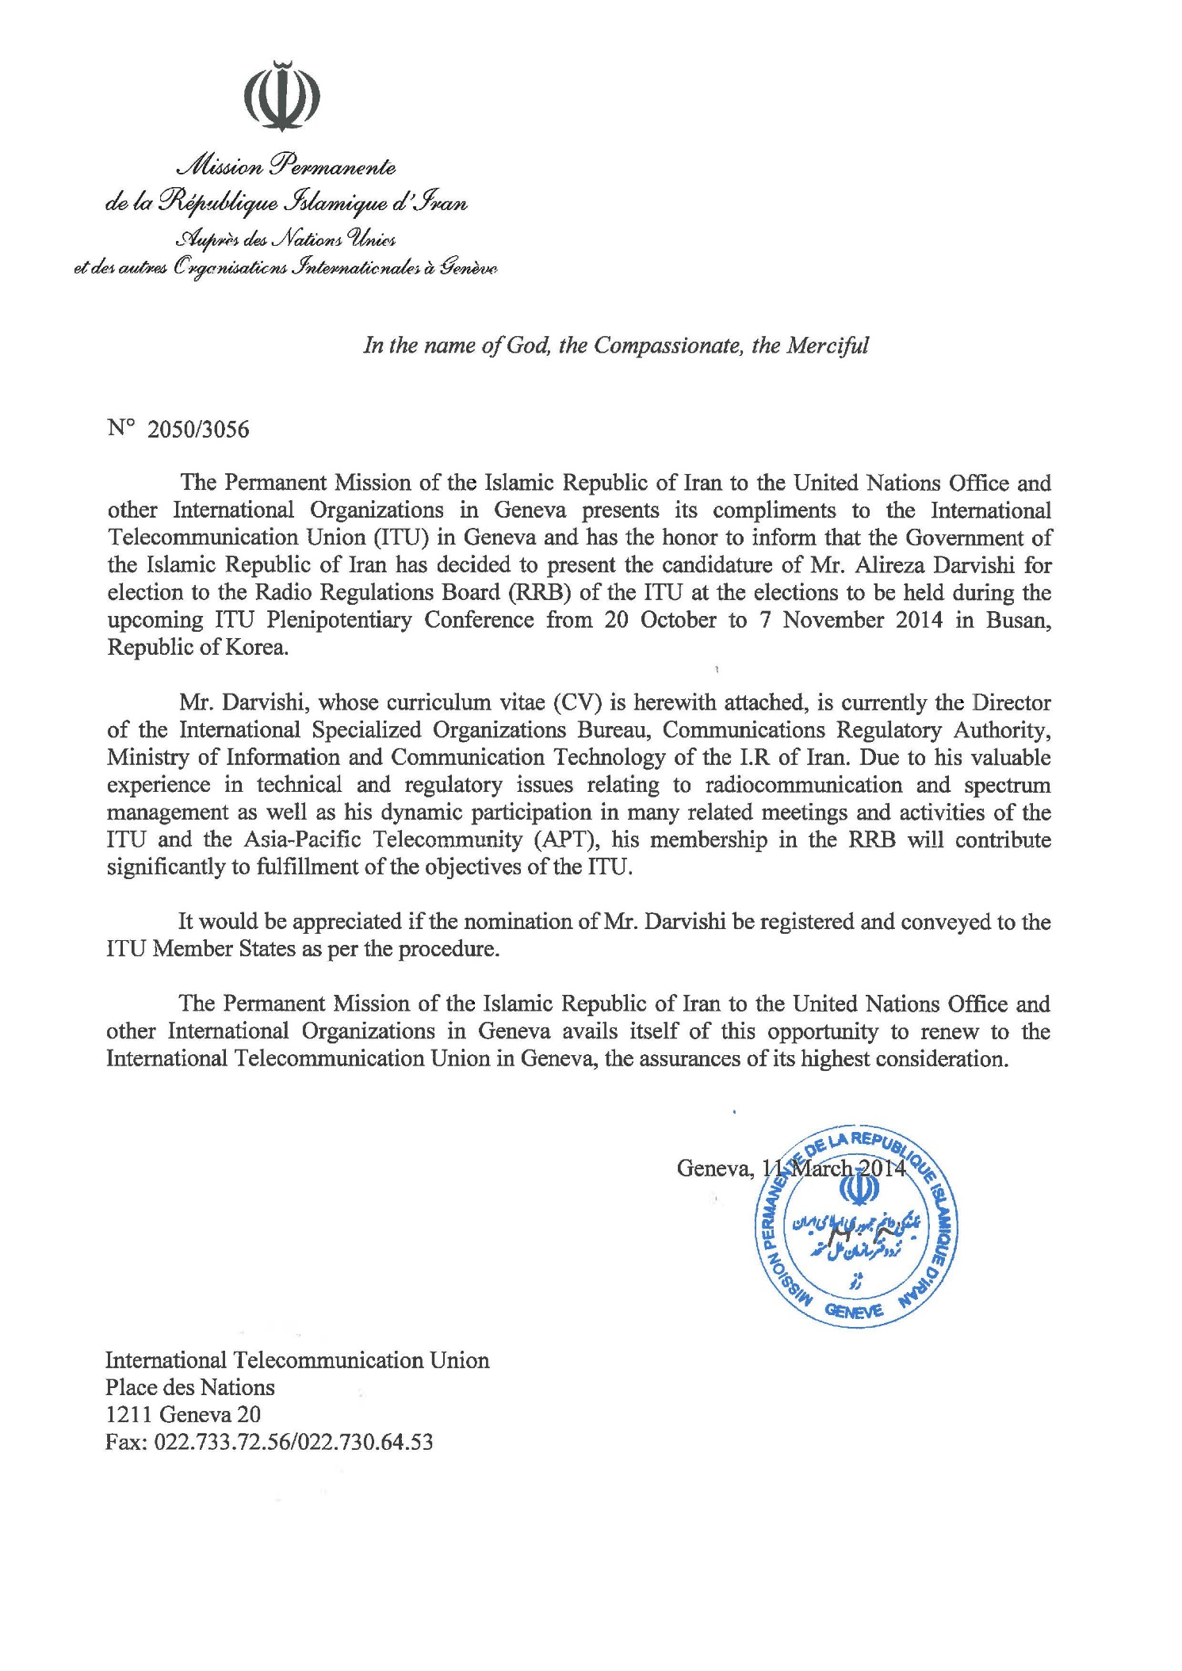

|  |  |  |
| --- | --- | --- |
| **Alireza Darvishi**  **Candidate of the I.R of Iran**  **for the Radio Regulations Board (RRB)** | |  |
| **GENERAL INFORMATION** |  | |
|  |  | |
| Name | Alireza Darvishi | |
| Nationality | Iranian | |
| Date of Birth | 09 July 1971 | |
| Civil status | Married, one child | |
| Position held | Director, International Specialized Organizations Bureau, Communications Regulatory Authority (CRA), Ministry of Information and Communication Technology (MICT) | |
| Official address | P.O. Box 15875-4415, Tehran, I.R. Iran  Tel: +98 21 88501221 / 88114230 Fax: +98 21 8846 8999  Email: darvishi@cra.ir | |
|  |  | |

|  |  |
| --- | --- |
| **EDUCATION** |  |
| 1995-1997 | M. Sc. Communications Engineering Amirkabir (Polytechnic of Tehran) University of Technology, Tehran  Department of Electrical Engineering |
| 1990-1994 | B.Sc. Communications Engineering  Science & Technology University , Tehran  Department of Electrical Engineering |

|  |  |
| --- | --- |
| **PROFESSIONAL CAREER** |  |
| 2008-Present | Director  International Specialized Organizations Bureau, Communications Regulatory Authority |
| 1999-2008 | Senior Expert  International Specialized Organizations Bureau, Communications Regulatory Authority |
| 1997-1999 | Expert Spectrum Management Department, Communications Regulatory Authority |

|  |
| --- |
| **NATIONAL ACTIVITIES** |
| * Focal point of Communications Regulatory Authority (CRA) of the I.R. of Iran on regulatory issues and contact point with ITU-R * In charge with technical international affairs in CRA |
| * In charge of international frequency coordination and notification issues |
| * Responsible for consideration of draft Rules of Procedures and providing comments on these draft Rules for submission to the RRB |
| * Member of delegation of the I. R. of Iran in WRC-2000, WRC-07, PP-10, WTDC-12, WTSA-12 * Deputy/Alternate head of delegation of the I.R. of Iran in WRC-12, WCIT-12 |
| * Head of study groups committee in Communications Regulatory Authority |
| * Leading the Iranian delegations in various regional and international meetings * Leading the Iranian delegations in various bilateral and multilateral frequency coordination meetings |
| * Member of the group responsible for preparing the national frequency allocation table |
| * Member of the group responsible for preparing the national radio regulations and frequency assignment plan |
| * Member of the pricing regulation reforming group |
|  |
| **REGIONAL AND INTERNATIONAL ACTIVITIES** |
| Vice-Chairman of ITU-R Study Group 4, Satellite Services  * Chairman of SWG on Radiocommunication Sector Issues, the APT Preparatory Meetings for ITU Plenipotentiary Conference 2014 (PP-14) * Rapporteur of CG4, Radiocommunication Sector Issues, the APT Preparatory Meetings for ITU Plenipotentiary Conference 2010 (PP-10) |
| * Member of developer team for the ITU Spectrum Management Software for Developing Countries (SMS4DC) * Member of developer team for the ITU Spectrum Management Training Programme (SMTP) |
| * Teaching in several countries as the ITU consultant on SMS4DC functions, frequency allocation, frequency assignment, and coordination and interference calculations |
| * Tutor of Centre of Excellence node of the ITU in the Asia and pacific region on spectrum management issues |
|  |
| * Participation in the activities of the regional and international meetings and conferences from 1999 till now, including: * **World Conference on International Telecommunications (WCIT-12), Dubai, United Arab Emirates, 3-14 December 2012** * **World Telecommunication Standardization Assembly** (WTSA-12),Dubai, United Arab Emirates, 20-29 November 2012 * World Radiocommunication Conference 2012 (WRC-2012), Geneva (Switzerland), 2012 * Conference Preparatory Meeting for WRC-2012 (CPM to WRC-12), Geneva (Switzerland), Feb. 2011 * [Plenipotentiary Conference 2010 (PP-10)](http://www.itu.int/plenipotentiary/2010/index.html), 4-22 October 2010, Guadalajara, Mexico * World Telecommunication Development Conference (WTDC-10), 24 May to 4 June 2010, India * World Radiocommunication Conference 2007 (WRC-2007), Geneva (Switzerland), 2007 * Conference Preparatory Meeting (CPM to WRC-07), Geneva (Switzerland), 2006. * World Radiocommunication Conference 2003 (WRC-2003), Geneva (Switzerland), 2003 * World Radiocommunication Conference 2000 (WRC-2000), Istanbul (Turkey), 2000 * Conference Preparatory Meeting for WRC-2000 (CPM to WRC-2000), Geneva (Switzerland), 1999 |
| **Commitment** |
| Mr. Alireza Darvishi is benefiting from many years of experiences on technical and regulatory issues relating to Radiocommunications and spectrum management. He is focal point for matters related to Radiocommunications and frequency coordination of the I.R. of Iran. He has also actively participated and contributed to the various regional and international Radiocommunications conferences and activities.  He is a member of developer team for the ITU Spectrum Management Software for Developing Countries (SMS4DC) and ITU Spectrum Management Training Programme (SMTP) and tutor of Centre of Excellence node of the ITU in the Asia and pacific region on spectrum management issues in face to face or E-learning meetings.  He is well suited to apply his technical and Radio Regulations knowledge and experiences to serve the ITU membership as a member of the Radio Regulations Board. He is and will remain committed to the high goals of advancing wellbeing of the people wherever they are through employing information and communication technologies.  ________________ |