|  |  |
| --- | --- |
| **Radiocommunication Study Groups** |  |
|  |  |
|  |  |
| Source: Document [5A/TEMP/27](http://www.itu.int/md/R12-WP5A-120522-TD-0027/en) | **Annex 11 to Document 5A/79-E** |
| **1 June 2012** |
| **English only** |
| Annex 11 to Working Party 5A Chairman’s Report | |
| WORKING DOCUMENT TOWARD A PRELIMINARY DRAFT NEW REPORT ITU-R М.[AMATEUR] | |
| Compatibility analysis of possible amateur systems with fixed, land mobile and maritime mobile services in the frequency band 5 250-5 450 kHz | |

# 1 Introduction

The high frequency (HF) band is the highest frequency band that supports propagation of radio signals via a reflected path incident on the ionosphere. This is called ionospheric or sky-wave propagation. Because of this unique characteristic, an important feature of the HF spectrum is its ability to support long range communications via sky-wave propagation. However, one disadvantage of long range propagation is the likelihood that noise and interference from distant sources may affect a desired communication. Therefore, the usability of HF sky-wave communication channels depends on both signal propagation and the absence of excess noise and interference. While propagation conditions have been studied extensively over several decades, there are relatively few published studies that have looked at noise and interference in the HF band.

This Report examines congestion and occupancy statistics in frequency allocations for fixed and mobile services in the vicinity of the frequency range 5 250-5 450 kHz to determine how channel availability varies with frequency, hour of the day, and channel bandwidth. Allocations for maritime and aeronautical mobile users were not included as wideband HF has not been approved by the ITU for use in these allocations.

# 2 Specific operation of the frequency band 5 250-5 450 MHz

In accordance with Frequency Allocation Table of Radio Regulations the frequency band 5 250‑5 450 kHz is allocated to fixed and mobile (except aeronautical mobile) services on global primary basis.

The analysis of International Frequency Master Register showed that currently 17 143 frequency assignments are notified in this frequency band. The location of these frequency assignments, as produced by the TerRaQ program, is shown in Figure 1. [The TerRaQ program is updated periodically by the BR.] The notified frequency assignments operate mainly in the fixed, land mobile and maritime mobile services. They provide voice and data transmission in telephone and telegraphy modes and can be used for different services including providing [safety of navigation] and communication in sparsely populated areas and in difficult to access areas.

In Russia this frequency band is heavily used by systems of high, medium and low output power. It is due to territory size where communication shall be provided (in Russia radio path length can be several thousand km). In addition in the territory of the Russian Federation there are large sparsely populated areas, difficult to access and remote areas and also areas of Far North where it is not reasonable to develop traditional mobile network and also satellite communication systems.

FigURE 1

Location of stations operating in the frequency band 5 250-5 450 kHz

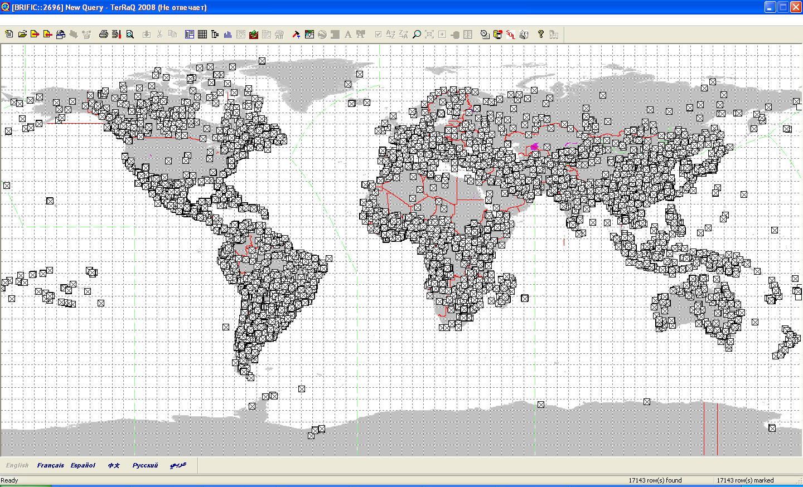

An effective (and in several cases single) solution of providing radiocommunication between these areas can be multihop link in the fixed and land mobile services. At such radio path signal transmission is provided by multiple reflection of electromagnetic wave from the earth surface and ionosphere.

An example of such a communication link is shown in Figure 2.

FigURE 2

An example of multihop link

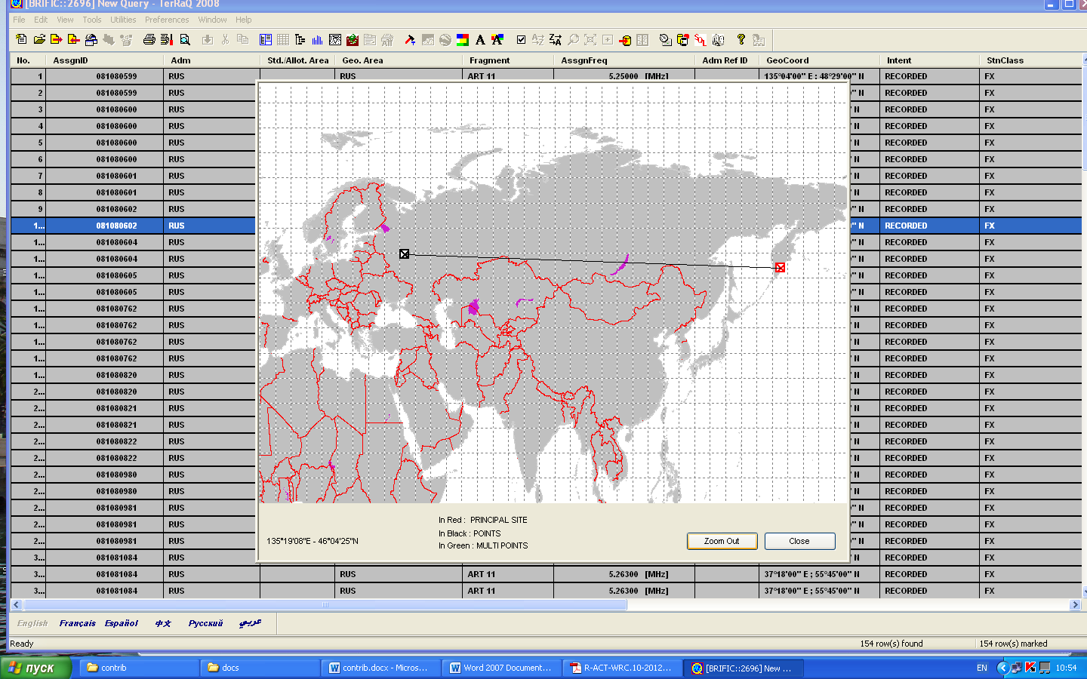

Currently 557 frequency assignments are notified in Russia in this frequency band. Though this number of assignments does not reflect the actual occupancy of the frequency band 5 250‑5 450 kHz.

The Administration of the Russian Federation continues to submit the existing systems of the fixed and land mobile service to ITU Radiocommunication Bureau to provide protection of the existing frequency assignments.

Taking into account systems of the fixed and mobile services planning for submission the average density of the frequency assignments of medium and high power stations in the considered frequency band is 105 assignments per 10 kHz. It allows to conclude that in Russia approximately 2 000 frequency assignments of medium and high power stations providing communication at distance 3 000-7 000 km are used in the fixed and land mobile services.

Even more frequency assignments are used by stations of low power. According to preliminary evaluation more than 68 000 frequency assignments to stations of low power are operated in the considered frequency band.

# 3 Technical characteristics and protection criteria of fixed/mobile systems operating in the frequency band 5 250-5 450 MHz

## *[Editor’s Note: The following text is from a liaison statement under consideration by Working Party 5C during its May 2012 meeting. It is offered to provide guidance for studies with respect to the fixed service.*

*Fixed service characteristics*

*Appropriate fixed service characteristics for sharing studies between fixed service and amateur service stations can be found in Recommendations ITU-R F.1761, ITU-R F.1762 and ITU‑R F.1821. WP 5C would request that compatibility should be established with the example systems found in these Recommendations to determine the viability of an amateur allocation at 5 MHz.*

*Protection criteria*

*Protection criteria for fixed HF systems can be found in Recommendations ITU-R F.339 and ITU‑R F.240.*

*Modelling*

*Recommendation ITU-R P.533 and the associated software model should be used for performing required sharing and compatibility studies.*

*Fixed HF systems typically use directional antennas but are not limited to such design. Therefore studies should take into account a mixture of directional systems using yagi antennas at the maximum gain listed, and omni-directional whip antennas using a gain of 0 dB.*

*The impact from the amateur station transmission reference link should be calculated by determining the reference link S/N ratio (in dB) for the worst month for the amateur station using a relative sunspot number for portions of the sunspot cycle corresponding to both low sunspot activity and high sunspot activity.*

*A reference link signal level should also be determined for the fixed service link as an actual S/N level (in dB). The amateur reference link signal level should be used to reduce the fixed service reference link S/N ratio to determine S/I and compared to the required S/N levels found in Recommendations ITU-R F.1761, ITU-R F.1762 and ITU R F.1821 for all three transmission types to determine if it can still meet the required S/N level for all three types of service. This will determine the long-term effects of any amateur allocation.*

*This would provide results for 4 scenarios as shown in the table below:*

*Fixed reference links for evaluating potential interference from amateur allocations at 5 MHz*

|  |  |  |
| --- | --- | --- |
| *Fixed reference link* | *Antenna* | *Sunspot number* |
| *<Transmit> to <Receive>* | *Yagi* | *<Minimum value>* |
| *<Transmit> to <Receive>* | *Yagi* | *<Maximum value>* |
| *<Transmit> to <Receive>* | *Omni-Directional* | *<Minimum value>* |
| *<Transmit> to <Receive>* | *Omni-Directional* | *<Maximum value>* |

*Systems from all three characteristic recommendations should be evaluated.]*

## 3.1 Technical characteristics and protection criteria of fixed systems

Antenna patterns used by fixed service systems are presented in Recommendation ITU-R F.162-3 “Use of directional transmitting antennas in the fixed service operating in bands below about 30 MHz”.

Protection criteria of the fixed service systems operating in the considered frequency band are presented in Recommendation ITU-R F.240-7 “Signal-to-interference protection ratios for various classes of emission in the fixed service below about 30 MHz”.The analysis of this Recommendation showed that depending from the system type and class of emission the required protection ratio can be changed from 1 dB to 60 dB.

Technical characteristics of several fixed systems operating in the frequency range 2-30 MHz are presented in Recommendation ITU-R F.1761 “Characteristics of HF fixed radiocommunication systems”. They are shown in Table 1 below.

TABLE 1

Typical technical characteristics of HF systems

|  |  |
| --- | --- |
| Frequency band (MHz) | 2-30 |
| Type of emission | Analogue/digital |
| *System* |  |
| Channel bandwidth (kHz) | 2-6 |
| Modulation type | Single channel suppressed carrier, telephony and telegraphy |
| Type of operation | Simplex/duplex |
| Typical data rates | 2.4-9.6 kbit/s |
| Typical SINAD | 12 dB (voice only) |
| *Transmitter* |  |
| Tx power (dBW) | 22 |
| Path length (km) | 2 400 |
| Antenna gain (dBi) | 6 |
| Antenna height (m) (Relative to ground level) | 10-60 |
| Radiation pattern | Omnidirectional/directional |
| Antenna polarization | Vertical/horizontal |
| Total loss (dB) | 1 |
| *Receiver* |  |
| IF filter bandwidth (kHz) | 3-7 |
| Sensitivity (dBm) | –112 |
| Antenna gain (dBd) | 6 |
| Antenna pattern | Omnidirectional/directional (30° beamwidth) |

The data presented in Table 1 refer to radio paths of 2 400 km. In case of longer radio path it is required to increase transmitter power or to use higher antenna gain in order to provide operation of the system. For example for radio paths of 7 000 km (see Figure 2) transmitter output power in the fixed service station can reach 38 dBW. The receiver sensitivity is the same and determined by external noise.

The data shown in Table 1 were used to determine the minimum field strength value in the receiver location. The calculations showed that in this case the minimum permissible signal field strength is minus 25.1 dB µV/m.

Protection criteria for fixed systems depend from signal and interference emission class. Taking into account the fact that for the most sensitive A1A, A1B and A3E signals that are often used the required protection ratio change from 13 dB to 60 dB (see Recommendation ITU-R F.240-7) the maximum permissible interference field strength is minus 38.1 dB (µV/m) to minus 85.1 dB (µV/m).

## 3.2 Technical characteristics of land mobile systems

The typical technical characteristics of the land mobile systems operating in the considered frequency band are shown in Recommendation ITU-R M.1795 “Technical and operational characteristics of land mobile MF/HF systems”. The characteristics of base stations and mobile components of the HF systems in the considered frequency range are presented in Tables 2 and 3 below.

TABLE 2

Representative technical characteristics of land mobile systems   
in the bands between 2 and 30 MHz

|  |  |  |  |  |  |
| --- | --- | --- | --- | --- | --- |
|  | Group A | Group B | Group C | Group D | Group E |
| Type | Base station | Base station | Base station | Base station | Base station |
| Frequency (MHz) | 1.5-30 | 1.5-30 | 1.5-30 | 1.5-30 | 2-30 |
| Bandwidth (kHz) | 2.8 | 2.8 | 2.8 | 2.8 | 2-3 |
| Transmitter power (dBW) | 30-40 | 1-10 | 20-25 | 1-10 | 1-20 |
| Antenna gain (dBi) | 0 | 0 | 0 | 0 | –2.5-2.5 |
| Antenna height (m) | 10-60 | 10-60 | 10-60 | 10-60 | 10-60 |
| Antenna type | Co-linear, whip, dipole | | | Vee | Fan dipole |
| Polarization | Horizontal and vertical | | | | |
| Modulation | Analogue or digital, single-sideband suppressed carrier | | | | |
| Typical minimum path lengths (km) | 300-350 | | | | |

TABLE 3

Representative technical characteristics of mobile component of the land mobile system   
in the bands between 2 and 30 MHz

|  |  |  |  |  |  |  |  |
| --- | --- | --- | --- | --- | --- | --- | --- |
|  | Group F | Group G | | Group H | | Group I | Group J |
| Type | Mobile unit | Mobile unit | | Mobile unit | | Mobile unit | Mobile unit |
| Frequency (MHz) | 1.6-30 | 1.5-30 | | 1-30 | | 1.6-30 | 2-30 |
| Bandwidth (kHz) | 2-2.3 | 2.8-3 | | 2.7-3.6 | | 2-3 | 2-3 |
| Transmitter power (dBW) | 1-13 | 10-30 | | 7 | | 10-27 | 1-10 |
| Antenna gain (dBi) | –10-0 | 0-2 | | 2 | | 0-2 | –10-2 |
| Antenna height (m) | 3-10 | 3-10 | | 15 | | 3-10 | 10-20 |
| Antenna type | Whip | | | | | Vee | Whip |
| Polarization | Vertical | | Vertical and horizontal | | Vertical | Vertical and horizontal | Horizontal |
| Modulation | Analogue or digital, single-sideband suppressed carrier | | | | | | |
| Typical minimum path lengths (km) | 300-350 | | | | | | |

[TBD]

## 3.3 Technical characteristics of the maritime mobile systems

[TBD]

# 4 Technical characteristics of the amateur systems

[TBD]

# 5 Compatibility analysis of the amateur systems with the fixed, land mobile and maritime mobile systems

## 5.1 Compatibility of the amateur systems with the fixed systems

[TBD]

## 5.2 Compatibility of the amateur systems with the land mobile systems

[TBD]

## 5.3 Compatibility of the amateur systems with the maritime mobile systems

[TBD]

# 6 Conclusions

[TBD]