Bureau de la normalisation
des télécommunications
Genève, le 27 juillet 2011

Réf.:  Tél.:  Fax:  E-mail: | Addendum 1 à la  Circulaire TSB 204  +41 22 730 6301  +41 22 730 5853  cristina.bueti@itu.int | - Aux administrations des Etats Membres de l'Union;  - Aux Membres du Secteur UIT-T;  - Aux Associés de l'UIT-T;  - Aux établissements universitaires participant aux travaux de l'UIT-T
Copie:
- Aux Président et Vice-Président de la Commission d'études 5 de l'UIT-T;
- Au Directeur du Bureau de développement des télécommunications;
- Au Directeur du Bureau des radiocommunications

Objet: | Colloque: Faire avancer le programme d'action pour le climat  par l'adoption de normes sur les TIC vertes  Séoul (République de Corée) - 19 septembre 2011

Madame, Monsieur,
Vous trouverez ci-joint dans l'Annexe 1 des informations sur d'autres hôtels communiquées par l'organisation hôte pour le Colloque: Faire avancer le programme d'action pour le climat par l'adoption de normes sur les TIC vertes, qui aura lieu à Séoul (République de Corée), le 19 septembre 2011.
Veuillez agréer, Madame, Monsieur, l'assurance de ma considération distinguée.
Malcolm Johnson
Directeur du Bureau
de la normalisation des télécommunications
Annexe: 1
ANNEX 1
(to Addendum 1 to TSB Circular 204)
Please find below information on additional accommodation for delegates attending the SG5 meeting in Seoul, Korea. The map indicates each hotel’s proximity to the meeting venue together with a chart including the corresponding hotel rates.

HOTEL | CATEG. |  | ROOM | RATE | NOTES
(1) Uljiro Coop Residence  32 Uljiro 6ga Jung-gu Seoul  Tel: +82. 2-2269-8411  Fax: +82. 2-2269-4209  Check-In: 2:00 PM  Check-Out: 12:00 PM  (Reservation only as a fax)  http://residences.co-op.co.kr/accommodations_17_4.htm  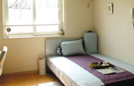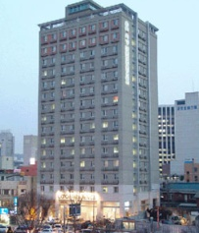 | Standard |  | Twin  Double | KRW 90,000 (≒USD 85) | Included Taxes  buffet breakfast  : KRW 6,600 (≒USD 6)
 | Distance from  Lotte Hotel (Venue) |  |  | 2 km, 10 min by taxi
 | Deadline of Reservation |  |  | 19th of August
 | Cancelation Policy |  |  | Notice to the hotel of any cancellations 2 days before on the date of arrival or be charged for one night.
(2) Western Coop Residence  77-2Uljiro 5ga Jung-gu Seoul  Tel: +82. 2-2269-8411  Fax: +82. 2-2269-4209  Check-In: 2:00 PM  Check-Out: 12:00 PM  (Reservation only as a fax)  http://residences.co-op.co.kr/accommodations_23_4.htm  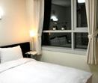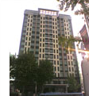 | Standard | Twin  Double |  | KRW 90,000 (≒USD 85) | Included Taxes  buffet breakfast  : KRW 6,600  (≒USD 6)
 | Distance from  Lotte Hotel (Venue) |  |  | 2.5 km, 10 min by taxi
 | Deadline of Reservation |  |  | 19th of August
 | Cancelation Policy |  |  | Notice to the hotel of any cancellations 2 days before on the date of arrival or be charged for one night.
(3) Hyundae Residence  22-5 Chungmooro 5ga Jung-gu Seoul  Tel: +82. 2-3406-8000  Fax: +82. 2-3406-8003  Check-In: 2:00 PM  Check-Out: 12:00 PM  reservation@hyundairs.com  http://hyundairs.com/rooms.htm  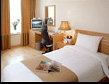 | Standard |  | Weekly  Double  Twin | KRW 100,000  KRW 103,000 | Included Taxes  buffet breakfast  : KRW 8,800 (≒USD 8)
 |  |  | Weekend  Double  Twin | KRW 135,000  KRW 138,000
 | Distance from  Lotte Hotel (Venue) |  |  | 2.5 km, 10 min by taxi
 | Deadline of Reservation |  |  | 19th of August
 | Cancelation Policy |  |  | 50% penalty fee from 28th of August  75% penalty fee from 5th of September  100% penalty fee from 12nd of September
(4) The SOHO Residence  90, Pirun-dong, Jongno-gu, Seoul  Tel: +82. 2-722-1999  Fax: +82. 2-722-3920  Check-In: 2:00 PM  Check-Out: 12:00 PM  hotelmoa@naver.com  http://www.thesoho.co.kr/  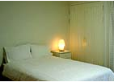 | Standard | Single |  | KRW 150,000 (≒USD 136) | None
 | Distance from  Lotte Hotel (Venue) |  |  | 3 km, 15 min by taxi
 | Deadline of Reservation |  |  | 19th of August
 | Cancelation Policy |  |  | 100% penalty fee from 7days prior to check in date.
(5) Tea Guest House  15-6 Gye-dong Jongno-gu Seoul  Tel: +82. 2-3675-9877  Check-In: 3:00 PM  Check-Out: 11:00 PM  tea@teaguesthouse.com  http://www.teaguesthouse.com/index.php  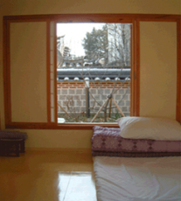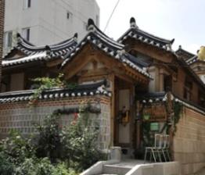 | Standard | Double |  | KRW 90,000  (≒USD 88) | buffet breakfast  : complimentary
 | Distance from  Lotte Hotel (Venue) |  |  | 2.5 km, 10 min by taxi
 | Deadline of Reservation |  |  | Booking is first-come-first-served due to a limit of the number of available rooms of accommodations.
 | Cancelation Policy |  |  | 100% penalty fee from 7days prior to check in date.
(6) Eugene Guest House  5-43 Hyewha-dong Jongno-gu Seoul  Tel: +82. 2-741-3338  Fax: +82. 70-4149-3308  Check-In: 15:00 PM  Check-Out: 11:00 AM  Yykim65@hotmail.com  http://www.eugenehouse.co.kr/index_en.php  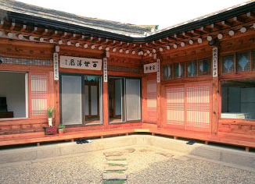 | Standard | Single |  | KRW 115,000 (≒USD 110) | buffet breakfast  : complimentary
 |  | Twin or Double |  | KRW 190,000 (≒USD 170)
 | Distance from  Lotte Hotel (Venue) |  |  | 5 km, 20 min by taxi
 | Deadline of Reservation |  |  | Booking is first-come-first-served due to a limit of the number of available rooms of accommodations.
 | Cancelation Policy |  |  | - NO-SHOW : Customers have to pay 100% of the whole payment.  - On the starting day : Customers have to pay 100% of the whole payment.  - 7 days before : Customers have to pay  70% of the whole payment.  - 12 days before : Customers have to pay  60% of the whole payment.  - 25 days before : Customers have to pay  50% of the whole payment.
(7) Sophia Guest House  59-5 Myeongdong 1ga Jung-gu Seoul  Tel: +82. 2-720-5467  Fax: +82. 2-6280-5469  Check-In: 15:00 PM  Check-Out: 12:00 PM  Sophia-house@hanmail.net  http://www.sophiagh.com/index.php  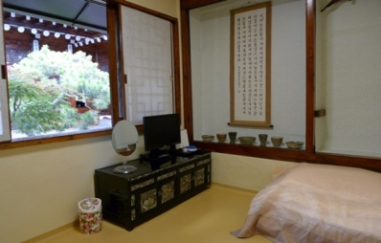 | Standard | Double |  | KRW 60,000 (≒USD 58) | buffet breakfast  : complimentary
 | Distance from  Lotte Hotel (Venue) |  |  | 2.5 km, 10 min by taxi
 | Deadline of Reservation |  |  | Booking is first-come-first-served due to a limit of the number of available rooms of accommodations.
 | Cancelation Policy |  |  | 50% penalty fee from 5 days prior to check in date.  100% penalty fee from 3days prior to check in date.
______________

