|  |  |
| --- | --- |
| **Radiocommunication Study Groups** |  |
|  |  |
|  |  |
| Source: Document 5A/TEMP/264  Subject: Question ITU-R 205-5/5 | **Annex 13 to**  **Document 5A/636-E** |
| **10 November 2014** |
| **English only** |
| Annex 13 to Working Party 5A Chairman’s Report | |
| WORKING DOCUMENT TOWARDS A PRELIMINARY DRAFT  NEW REPORT ITU-R M.[RAIL.LINK] | |
| Systems for public mobile communications with train | |

# 1 Introduction

This Report deals with the general principles, technical characteristics and operational features of terrestrial systems for public mobile communications with train.

# 2 General technical and operational considerations

**2.1** The system requires full compatibility and capability of interfacing with the international public data network, the Internet, or any combinations thereof.

**2.2** The system requires adequate bandwidth to meet the foreseeable demand for the services.

**2.3** The Quality of Service (QoS) is to be considered to meet the objectives of the system. For example, if the objective is to provide high quality voice service, then the QoS should be comparable to that of the public switched network (voice and data). If the objective is to provide best-effort Internet type traffic, then typically there are no QoS mechanisms being used, at least for the best-effort traffic.

**2.4** The radioequipment installed in the train needs to be electromagnetically compatible with other wireless train systems in accordance with appropriate regulatory requirements and have minimal impact on these systems.

# 3 System technical characteristics and operational features

As example analyses, propagation characteristics of wireless communication links between train and ground stations are given in Annex1.

Technical characteristics and operational features of the system for public mobile communications with train in some countries are given in Annex 2.

**Annexes:** 2

Annex 1

Propagation characteristics between train and ground stations   
in the millimetre wave frequency range

# 1 Introduction

Considering future demand of mobile phone and wireless local area network (LAN) access, wireless link between ground station and train should be broadband and require more bandwidth, e.g. the order of 40-500 MHz. Meanwhile, the millimetre wave band, such as the over-40 GHz band, is not used heavily in commercial mobile applications and is expected to facilitate the broadband communication systems.

Fig. 1 shows a conceptional image of the broadband wireless transmission system between moving trains and the backbone network using over-40 GHz band where the situations of the communication links include open area site and tunnel channel. The propagation characteristics are generally critical for establishing the wireless communication link. Therefore, this section deals with the characteristics of millimetre wave propagation for public mobile communications with train, focusing on wireless links between ground station and train.

Figure 1

Conceptional image of the broadband wireless transmission system

Backhaul network

# 2 Propagation data in open-site

## 2.1 Measurements of millimetre wave propagation on a line-of-sight link

### 2.1.1 Descriptions of test conditions

A propagation measurement was conducted between two train stations, which was a 2 km long typical line-of-sight (LoS) straight section as shown in Fig. 2.

FigUre 2

Sectional view of line-of-sight straight section

(a) Horizontal view, (b) Vertical view



A transmitter with a horn antenna on the train transmitted a signal with beam width of 17 degrees in vertical polarization and the transmitted signal was received by a Cassegrain antenna at the ground station placed beside the railway line. The height of the receiving antenna was set at 2 m above the ground. Table 1 shows the other measurement conditions.

Table 1

Measurement conditions

|  |  |  |  |
| --- | --- | --- | --- |
| **Station** | **Parameter** | **Value** | **Note** |
|  | Frequency | 50 GHz |  |
| Polarization | Vertical |  |
| Train station  (transmitting side) | On-board transmitter power | 12 dBm | 15 mW |
| Antenna gain | 40 dBi | 30 cm diameter Cassegrain,  1.5 degrees beam width |
| 20 dBi | 2.5 cm diameter conical horn,  17 degrees beam width |
| Ground station  (receiving side) | Threshold input level | -70 dBm | BER = 10-7 [2 Mbit/s,] |
| Antenna gain | 40 dBi | 30 cm diameter Cassegrain,  1.5degrees beam width |

### 2.1.2 Measurement results

Fig. 3(a) shows the results of the obtained propagation behaviour in this measurement, and Fig. 3(b) shows the result of theoretical calculations using a 2-wave interference model under the same conditions as this measurements.

FigUre 3

Propagation behaviour in line-of-sight link

(a) measurement results, (b) calculated result using 2-wave interference model



Comparison of Figs. 3(a) and (b) show that the results of the reception level obtained in this measurements give close agreement with the calculated regular fading pattern. A deep drop in the receiving level described by “↓” in Fig. 3(a) is thought to be the effect of the null pattern of the antenna mounted on the train due to the meandering path of the railway track.

## 2.2 Measurements of millimetre wave propagation on an non line-of-sight link

### 2.2.1 Descriptions of measurement conditions

Propagation over curved sections or in situations when there is an obstruction (like mountain, etc.) between the transmitter and receiver, are typical cases of non line-of-sight (NLoS) links.   
A propagation measurement was conducted on a railway track including a slope change as shown in Fig. 4. The other measurement conditions were same as Table 1.

FigUre 4

Sectional view of non line-of-sight area



### 2.2.2 Measurement results

Fig. 5 shows the results of the obtained propagation behaviour in this measurement. This result shows that the reception level in this measurement agrees with the calculated values with knife-edge diffraction propagation at the 800 m mark or farther from the receiver, described by “↑” in Fig. 5.

A large amount of propagation loss at the area indicated by the point “ “ in Fig. 5 was thought to be the effect of diffracted waves.

FigUre 5

Measurement results of propagation behaviour in out-of-sight link



## 2.3 Measurements of millimetre wave propagation on curved line

### 2.3.1 Descriptions of measurement conditions

On the curved sections, diffraction and reflectance are major factors in considering the propagation. The propagation measurement was conducted in a curved section with side walls, as shown in   
Fig. 6. The other measurement conditions were same as Table 1.

FigUre 6

Sectional view of curved line



### 2.3.2 Measurement results

Fig. 7 shows the results of the obtained propagation behaviour in this measurement. This result shows that the reception level in this measurement are still enough for establishing the communication link over LoS condition. This is because diffraction by electrical poles and reflectance by the ground and the side walls prevented the propagation loss.

FigUre 7

Measurement results about propagation behaviour in out-of-sight link



## 2.4 Summary of measurement results

[this part is subject to further review]

The results of these measurements mainly present propagation characteristics of millimetre wave, which are important elements for system design of railway mobile communication.

In considering keeping the quality, further efforts would be required against the deep drops, such as use of diversity for transmit and received antenna, optimized arrangement of distance between base stations, increasing transmit power, etc.

In the case of NLoS link with gradient changed points and/or curved line, diffraction propagation over curved sections or slope changed sections and reflection by side-wall should be considered for the arrangement of base station. In curved section, there is little influence of   
LoS because of those reflectance. However, in the case of gradient changed section, drop of received power by diffraction loss can’t be negligible for link quality. In order to avoid this phenomena, base station should be located on the gradient changed points.

# 3 Propagation data in tunnel

## 3.1 Measurements of millimetre wave propagation

### 3.1.1 Descriptions of system architecture and communication equipment

[this part is subject to change]

A propagation measurement was conducted in a tunnel site[1]. The deep fading effects are expected due to the multipath signals in tunnel. Therefore, in order to mitigate the deterioration of transmitting and receiving signals from this multipath effects, antenna diversity or similar techniques are required. Therefore, two-antenna arrays were used for both the transmitter (Tx) and receiver (Rx) in these measurements in tunnel in order to evaluate antenna diversity effect.

Fig. 8 shows the configuration of the measurements. The antenna units of Tx and Rx were oriented to be faced each other. The Tx was mounted on a road-rail vehicle and moved in the broadside direction linearly. Between Tx and Rx, 100 Mbit/s signals were consecutively transmitted.   
The measurement conditions are shown in Table 2.

FigUre 8

Measurement Setup of Tx and Rx



Table 2

Measurement parameters

|  |  |  |  |
| --- | --- | --- | --- |
| **Station** | **Parameter** | **Value** | **Note** |
|  | Frequency | 46.8 GHz |  |
| Polarization | Circular |  |
| Modulation scheme | 64QAM-OFDM |  |
| Maximum throughput | 100 Mbit/s |  |
| Train station  (transmitting side) | On-board transmitter power | 10 dBm | 10 mW |
| Antenna gain | 32 dBi | Cassegrain,  1.0~1.5degrees beam width |
| Ground station  (receiving side) | Antenna gain | 32 dBi | Cassegrain,  1.0~1.5degrees beam width |

The measurements in a tunnel scenario were carried out in Iiyama Tunnel of Hokuriku Shinkansen, Nagano, Japan, of which the sectional view is shown in Fig. 9. The Tx (transmitter on a road-rail vehicle) moved at a velocity of 15 km/h on the rail, and received signal strength indicator (RSSI) and bit error ratio (BER) were measured at the Rx (receiver at a side of the rail). The distance between the Rx and the Tx was measured by Radio-Frequency Identification (RFID) tags uniformly located alongside the rail and pulse signals from an axle shaft of the vehicle per one wheel rotation. Two antennas at the BS were installed vertically. On the other hand, two antennas at the MS were set vertically or horizontally depending on the measurement case, where the former and the latter are hereafter referred to as "vertical case" (Fig. 10) and "horizontal case" (Fig. 11), respectively. The test parameters for the tunnel scenario was shown in Table 3.

Figure 9

Sectional view of Iiyama tunnel



Figure 10

Antenna setup in tunnel scenario (vertical case)



Figure 11

Antenna setup in tunnel scenario (horizontal case)



Table 3

Test parameters (tunnel scenario)

|  |  |
| --- | --- |
| **Parameter** | **Value** |
| Carrier frequency | 46.8 GHz |
| Number of antennas | Tx: 2, Rx: 2 |
| Moving range | 3,500 m from Rx |
| Velocity | 15 km/h |
| How to get Tx’s location | RFID and pulse signals from an axle shaft |

### 3.1.2 Measurement results

This subsection shows the results in the tunnel scenario.

#### 3.1.2.1 Performance of diversity effect

Figs. 12-15 show the results of RSSI and BER performance for the vertical case depending on the number of antennas; the performance without any diversity schemes (1 Tx & 1 Rx) in Fig. 12, that with transmit diversity (2 Tx & 1 Rx) in Fig. 13, that with receive diversity (1 Tx & 2 Rx) in   
Fig. 14, and that with both transmit diversity and receive diversity (2 Tx & 2 Rx) in Fig. 15, respectively. As a reference, the free-space propagation loss is also shown in each RSSI figure. Here, the Tx moved away from the Rx. It can be seen that in the tunnel scenario all RSSI performances are similar to or less than the free-space propagation loss within transmission distance of 3 500 m. Furthermore, it can also be seen that BER performance is drastically improved with   
an increase of the number of antennas, because of the alleviation of received power degradation by diversity effect.

Figure 12

The RSSI and BER performance for the vertical case depending on the number of antennas in the tunnel scenario (Tx = 1, Rx = 1)

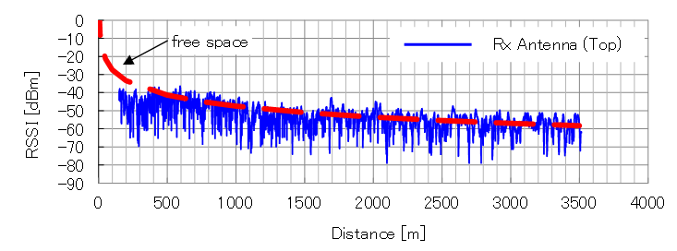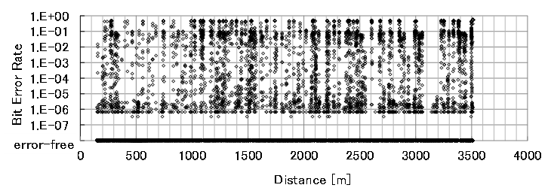

Figure 13

The RSSI and BER performance for the vertical case depending on the number of antennas in the tunnel scenario (Tx = 2, Rx = 1).

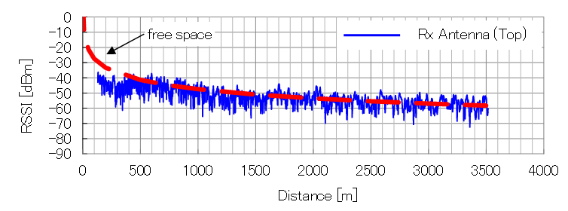

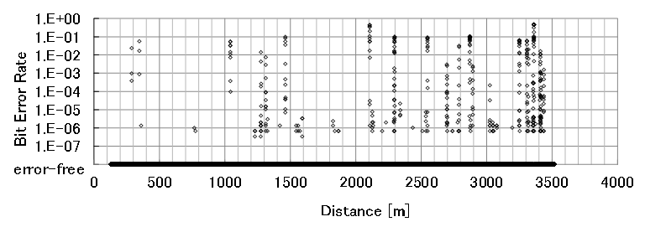

FigURE 14

The RSSI and BER performance for the vertical case depending on the number of antennas in the tunnel scenario (Tx = 1, Rx = 2)

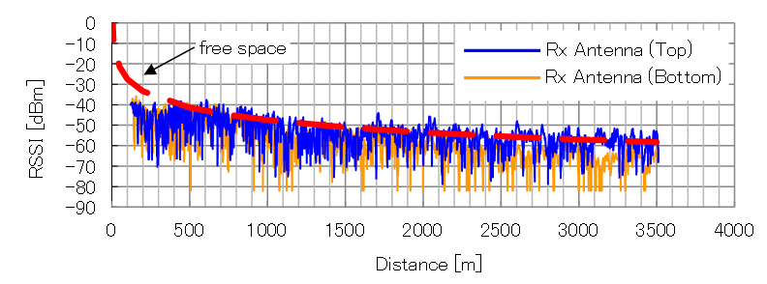

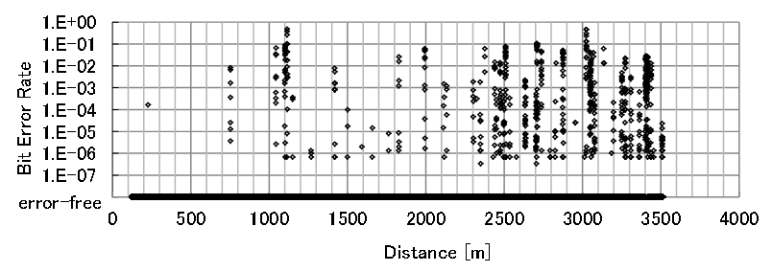

Figure 15

The RSSI and BER performance for the vertical case depending on the number of antennas in the tunnel scenario (Tx = 2, Rx = 2)

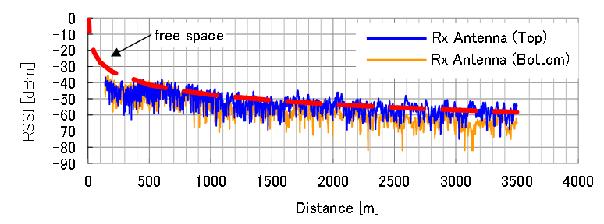

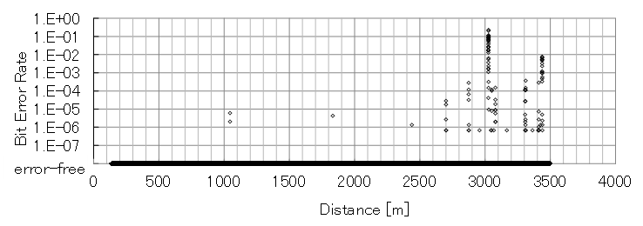

#### 3.1.2.2 Comparison between vertical and horizontal Cases

The performance for the different installations of Tx antennas is evaluated. Here, the number of antennas at the Rx and the Tx is commonly set to 2. Fig. 16 shows the RSSI and BER performance of the horizontal case (Fig. 11) while the performance of the vertical case is already shown in Fig.15. It can be noticed that the performance of both the cases are similar despite the difference in antenna configurations. This tendency irrespective of the antenna configuration may be due to rich multipath and a wave-guide phenomenon in the tunnel.

Figure 16

Measurement results (horizontal case) in the tunnel scenario

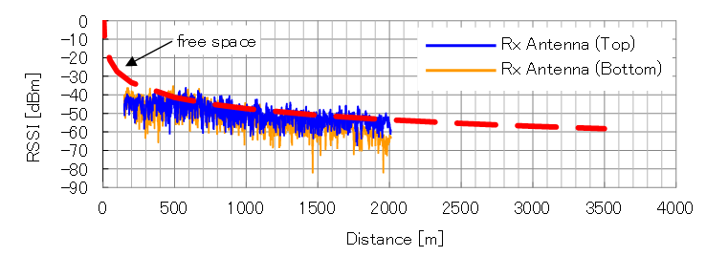

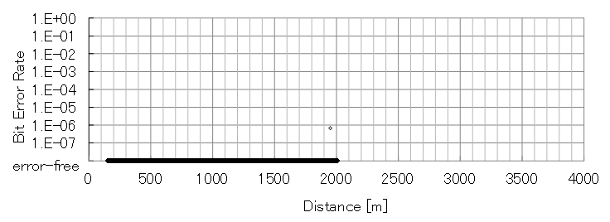

## 3.2 Summary of measurement results

These results present that it has been verified that the maximum throughput of 100 Mbit/s in almost all the measurement area of the tunnel can be achieved and been exploiting transmit and receive diversity effects. The transmit distance with keeping enough link quality was over 3 500 m distance from base station, which is longer than the distance in similar case in open area. This shows the millimetre wave propagation is suit for condition of tunnel. Moreover, the use of antenna diversity technique can mitigate the deep drop of received power from interference and/or multipath effects.

Annex 2

Systems for public mobile communications with train  
 in some countries

# 1 Introduction

In some countries, there are public mobile communication systems with train currently in operation. These are described in the sections below.

# 2 Communication systems in Japan

## 2.1 Introduction

Demand has increased for mobile phone and wireless local area network (LAN) access for passengers on trains in particular for broadband applications. In general, the telecommunication infrastructure for public network for broadband cellular phones and Wi-Fi network has not been sufficiently equipped in tunnels, and the more high speed communication links between ground and trains would be required for adapting various types of wireless communications. Now, several train companies have started Wi-Fi network service inside the train cabin in order to provide stable and high-speed network service for the passengers. This section describes the existing public communication systems between ground and trains for passenger use in Japan.

## 2.2 Leaky coaxial cables (LCX)

The Shinkansen, or Bullet trains in Japan are equipped with a radio communications since the very first services in 1964, however, mountainous topography in Japan avoids radio communications in some locations and the small number of available radio channels were given to the Shinkansen in early days. To ensure better reliability and to increase the number of communications channels, Leaky coaxial cables (LCX) were laid along the full length of railways. Firstly, LCX was used for transmitting data and messages of command and track telephones and on-board public telephones. Furthermore, internet access service is offered at 384 kbit/s in the 400 MHz band using LCX radio lines, recently 2 Mbit/s is offered on Tokaido Shinkansen. The transmission range of LCX is   
1.5 km. Fig.1 shows an example of the installation of LCX along the Shinkansen track[2].

Figure 1

LCX position along Shinkansen tracks

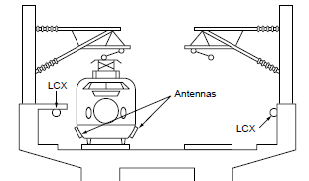

## 2.3 WiMAX

Narita Express trains connecting between Narita international airport and the Tokyo metropolitan areas provides Internet access service that communicates with WiMAX base stations using antennas on the train roof and converts data into that for Wi-Fi at on-board repeaters to communicate with passengers’ terminals. WiMAX already has many base stations in operation along railway lines in the greater Tokyo area, and small base stations and relay station are installed in railway stations. On the other hand, use of WiMAX on Shinkansen trains faces the issues of transmission in tunnels and the number of base stations required along the lines. The transmission speed is 40 Mbit/s in the   
2.5 GHz band, and the transmission range is 1 km[3].

## 2.4 Wi-Fi Access

Tsukuba Express railway line connecting Tokyo and Tsukuba, Ibaraki prefecture at 130 km/h uses Wi-Fi access system inside the car. A base station installed in each compartment of the train provides internet services to passengers, and a base station at each end of the train communicates with relay base stations installed at stations or along the railroad. The detailed information on this system is provided in Report ITU-R F.2086-1. Fig. 2 shows the overview of this Wi-Fi access system.

Figure 2

Wireless LAN services for train



## 2.5 Train communication system using millimetre wave in Japan

In Japan, the 50 GHz band has been used for a convenience radio station of Shinkansen systems, and the 60 GHz band was examined in some measurements for the operation of Shinkansen. On the other hand, recently verification measurements of mass volume wireless communication using   
40 GHz band for high speed train has been conducted considering public mobile communication for passengers in the near future. These measurements verified high connectivity in the range of over 3 500 m from base station in 100 Mbit/s in tunnel. This millimetre communication system can have high degree of expectation for application in Japan, which has many tunnel area on the line of high speed trains because there are many uphills, downhills, and mountains all over Japan.

1. K. Tsukamoto, et al., “Field-test Results of Mobile Communication Systems over 40 GHz Frequency Band,” *IEEE VTS APWCS2014*, Taiwan (China), Aug. 2014.
2. Takashige, Tetsuo. "Signaling systems for safe railway transport." *Japan Railway and Transport Review* 21 (1999): 44-50.
3. Takashige, Tetsuo. "Signaling systems for safe railway transport." *Japan Railway and Transport Review* 21 (1999): 44-50.