|  |  |
| --- | --- |
| **Plenipotentiary Conference (PP-14)**  **Busan, 20 October – 7 November 2014** | logo_Eyyy |
|  |  |
|  |  |
| PLENARY MEETING | Document 6-E |
|  | **21 October 2013** |
|  | **Original: English** |
| Note by the Secretary-General | |
| CANDIDACY FOR THE POST OF DIREctor of the  telecommunication standardization bureau (tsb) | |

Further to the information contained in Document 3, I have pleasure in transmitting to the conference, in annex, the candidacy of:

**Dr Ahmet Erdinç ÇAVUŞOĞLU (Turkey)**

for the post of Director of the Telecommunication Standardization Bureau (TSB) of the International Telecommunication Union.

Dr Hamadoun I. TOURE  
 Secretary-General

**Annex**: 1

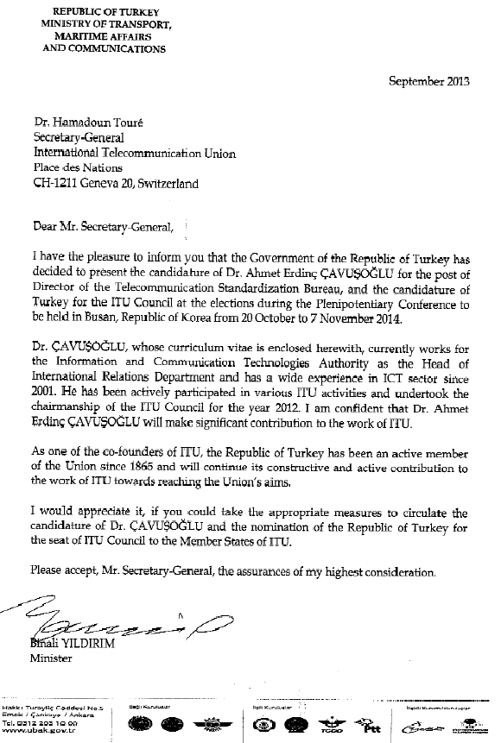

**Candidate for the Post of  
Director of Telecommunication Standardization Bureau (TSB)  
of the International Telecommunication Union**

**CURRICULUM VITAE**

**Dr. Ahmet Erdinç ÇAVUŞOĞLU**



**Personal Information**

|  |  |
| --- | --- |
| **Name** | Ahmet Erdinç ÇAVUŞOĞLU |
| **Date of Birth** | 18/05/1969 |
| **Current Position** | Head of International Relations Department, Information and Communication Technologies Authority |
| **Languages** | Turkish (native), English (fluent), German (reading), French (slight) |
| **Contacts** | Bilgi Teknolojileri ve İletisim Kurumu, Yesilirmak Sok. No: 16, 06430  Ankara, TURKEY  Tel: +90 312 294 7290  Fax: +90 312 2947155  Email: [acavusoglu@btk.gov.tr](mailto:acavusoglu@btk.gov.tr) |
| **Marital Status** | Married with 2 children |

**Education**

|  |  |  |
| --- | --- | --- |
| **PhD** | Istanbul University, Institute of Social Sciences, Thesis on *“Arbitration in the Disputes Arising out of Concession Contracts Related with Telecommunication Authorizations”*, 2007 |  |
| **Master (LLM) Degree** | Istanbul University, Institute of Social Sciences, European Union (Legal Structure), 2002 |  |
| **University** | Istanbul University, Faculty of Law, 1991 |  |

**Professional Experience**

**February 2010-Present** Head of International Relations Department, Information and Communication Technologies Authority (ICTA)

**Responsibilities** Coordinating, leading and developing strategies in international relations of ICTA, following the activities of all international organizations related with ICT issues, representing the ICTA in international meetings, organizing international meetings which are held in Turkey, organizing international training seminars in Turkey, drafting and implementing bilateral and multilateral agreements and MoUs

**March 2008-March 2009** Regulatory Coordination Expert, International Telecommunications Union (ITU)

**Responsibilities** Drafting research reports cybersecurity issues, drafting guidelines on cybersecurity issues for developing countries to implement relevant regulation**,** drafting the documents relevant with the projects of RME/BDT**,** reviewing the documents drafted by regulation experts and declaring a view on them, researching the new improvements in telecommunications sector relevant with regulation issues and drafting text to provide them to take place in the relevant documents and publications, reviewing the awards rendered by the regulatory authorities and the relevant authorities who are charged to settle disputes and providing those awards to be accessible by everyone interested in

**March 2001-Feb. 2010** Telecommunications Expert, Lawyer, ICTA

**Responsibilities** Planning, implementation and dealing with regulation issues and regulatory projects on telecommunications issues**,** drafting law, ordinance, communiqué etc. related with telecommunications regulation, negotiating, drafting and applying concession contracts for telecommunication licenses, management of Spectrum Allocation Projects, preparing tender documents of spectrum allocations, telecommunication licenses and procurement projects, taking part in the tender commissions, disputes resolution between ICTA and operators through negotiation and arbitration, representing the ICTA at international arbitration cases arising out of concession contracts with power of attorney, drafting the briefs of ICTA in the cases brought before court or arbitral tribunal, investigating competition and consumer rights abuses in telecommunications sector, drafting reports about them, auditing operators, performing national and international research studies and projects on telecommunications, representing the Authority at national and international meetings.

**Feb. 1993-March 2001** Legal Expert, Lawyer, Undersecretariat for Defense Industries, Ministry of Defense

**Responsibilities** Project management, contract management, drafting and negotiating contracts, memorandum of understandings (MoU), agreements, implementation of contracts, conflict resolution through negotiation and arbitration, attending to trials as UDI's Attorney at Law, deliberations on bilateral and/or multilateral international conventions, treaties and agreements concerning defense and defense industry issues, researching, about legal issues related with defense industry contracts, providing support and guiding assistant colleagues

**As Chairman, Vice Chairman and Key Discussion Leader**

* **Chairman** of ITU Council Meeting, Geneva, 04-13 July 2012
* **Vice-Chairman of** ITU Council Meeting**,** Geneva, 11-21 October 2011
* **Outgoing Chairman** of ITU Council Meeting, Geneva, 11-21 June 2013
* **Vice-Chairman** of CEPT Committee for ITU Policy (Com-ITU)
* **Vice-Chairman** of ITU Council Working Group on a Stable Constitution
* **Vice-Chairman** of ITU's 150th Anniversary: Council Committee
* International Chamber of Commerce (ICC) Seminar on International Contracts and Conflict Resolution **(Key Discussion Leader)**, Paris, 9-12 February 2004

**Publications**

1. Turkey Report of International Arbitration, International Council For Commercial Arbitration, International Handbook On Commercial Arbitration, Kluwer Law International, March 2005, The Hague
2. Turkish Arbitration Law in the Light of Recent Legislation, ICC International Court of Arbitration Bulletin Vol. 13/No.2, Fall, 2002, Paris
3. Whether Strikes can be considered as Force Majeure, Social Security World Magazine, July-August 1998, Ankara