|  |  |
| --- | --- |
| **Plenipotentiary Conference (PP-14)**  **Busan, 20 October – 7 November 2014** | logo_Eyyy |
|  |  |
|  |  |
| PLENARY MEETING | Document 5-E |
|  | **6 September 2013** |
|  | **Original: English** |
| Note by the Secretary-General | |
| CANDIDACY FOR THE POST OF DEPUTY SECRETARY-GENERAL | |

Further to the information contained in Document 3, I have pleasure in transmitting to the conference, in annex, the candidacy of:

**Ms Magdalena GAJ (Republic of Poland)**

for the post of Deputy Secretary-General of the International Telecommunication Union.

Dr Hamadoun I. TOURE  
 Secretary-General

**Annex**: 1

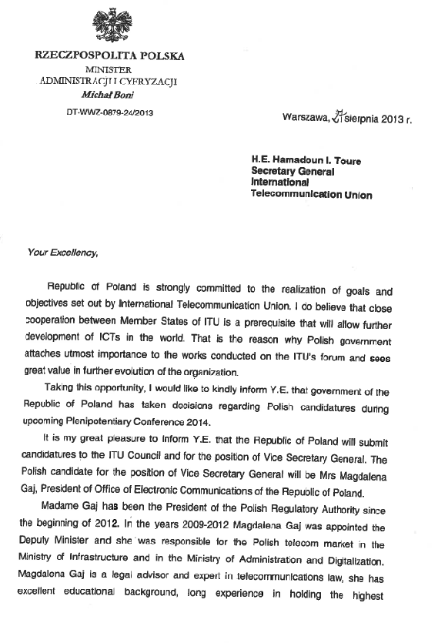

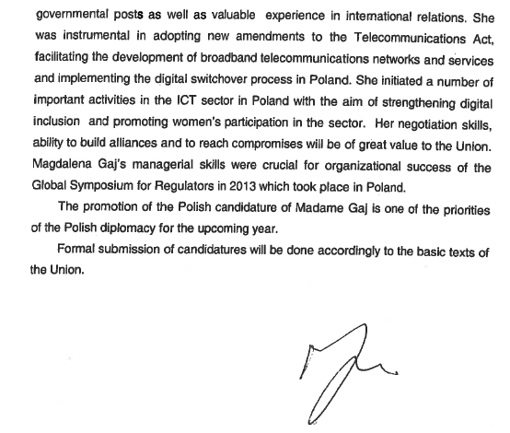

|  |  |
| --- | --- |
|  | Candidacy for the post of  Deputy Secretary-General  **Ms Magdalena GAJ (Republic of Poland)** |

**Magdalena Gaj’s career**

Magdalena Gaj is currently the President of the Office of Electronic Communications (UKE) – National Regulatory Authority in Poland.

Magdalena Gaj, a qualified legal adviser, an expert in telecommunication law has been working in public administration for over 12 years. She has a long experience of holding the highest state posts. Linked to the telecommunications sector from the beginning, she has gradually climbed the career ladder.

Since the beginning of 2012 she has been the President of the Polish Regulatory Authority (Office of Electronic Communications – UKE). From 2009 to 2012 Magdalena Gaj was the Undersecretary of State appointed by the Minister of Infrastructure and later by the Minister of Administration and Digitization responsible for the Polish telecom market.

Both in the Ministry and in the Regulatory Authority, she has dealt with investment barriers in the telecommunications sector. Her work has led to the preparation and passing of an Act on supporting the development of telecommunications networks and services which facilitated investment in the telecommunications infrastructure by the companies and local governments; and enhanced the process of spending EU funds designed for the extension of the Internet network.

Ms. Gaj was the key leader in the digitization process in Poland. Thanks to her commitment and determination the switch-over process was carried out smoothly and efficiently. She prepared and implemented the national strategy in this sector, prepared legal bills, information campaigns, and oversaw technical supervision related to the verification of DVB-T signal propagation.

She was responsible for the preparation and adoption of amendments to the Polish law which brought it in compliance with the European Union law. She was also in charge of the work of the Council of the European Union in the field of telecommunications during the Polish Presidency in 2011. Ms. Gaj has enhanced the Polish involvement in the ITU’s activities, including the hosting in Poland of the Global Symposium for Regulators in 2013 with great organizational success. The event attracted almost 700 participants from 130 countries.

Also, Magdalena Gaj is the author of a number of important activities in the ICT sector in Poland, with the aim of strengthening digital inclusion and promoting women’s participation in the sector. Among her recent projects underscoring are the National project of “Digital Light-keepers”, “Girls in ICT” and “Digital School”. First project involves thousands of special teachers of the Internet tasked to fight digital exclusion (capacity building), especially among people 50+. “Girls in ICT” is promoting women in jobs in the ICT sector in Poland by close cooperation with technical universities and ICT companies. “Digital School” is dedicated to primary schools for the development of students' and teachers’ ICT skills (the project covered more than 400 primary schools in Poland.

Magdalena Gaj graduated from the Faculty of Law at the Maria Curie-Skłodowska University in Lublin. She speaks English, Russian and Polish.

**Prizes and distinctions awarded to Magdalena Gaj**

1. State distinction granted by the government - "Person of merit in communications" Medal - for contribution to the development of communications / telecommunications / TV in Poland.
2. Man of 2012 and Crystal Antenna of the Media World awarded during the 12th Symposium of the Telecommunications and Media World.
3. Golden Cyborg for IT Leaders.
4. INFOSTAT 2012 for contribution to the development and adoption of the First Radio Spectrum Policy Programme in Europe.
5. Medal for efforts in favour of consumer rights on the occasion of the 50th anniversary of Consumer Rights.
6. Girls in ICT - ITU prize awarded during the World Summit on the Information Society in Geneva in 2012.
7. ITU Certificate for contribution to the WSIS Fund in Trust 2012.
8. Honorary Diploma of Intersputnik.
9. Distinction of the National Chamber of Electronic and Telecommunication Industry (KIGEiT) for long-lasting cooperation and effective enforcement of competition rules in telecommunications.