|  |  |
| --- | --- |
| **Radiocommunication Study Groups** |  |
|  |  |
|  |  |
| Source: Document [5A/TEMP/16](http://www.itu.int/md/R12-WP5A-120522-TD-0016/en) | **Annex 18 to**  **Document 5A/79-E** |
| **1 June 2012** |
| **English only** |
| **Annex 18 to Working Party 5A Chairman’s Report** | |
| Working Document toward a Preliminary Draft Revision of RECOMMENDATION ITU-R M.2015 | |
| Frequency arrangements for public protection and disaster relief radiocommunication systems in UHF bands in accordance  with Resolution 646 (Rev.WRC-12) | |

Scope of this revision

[To be added upon completion of revision]

Scope

This Recommendation provides guidance on frequency arrangements for public protection and disaster relief radiocommunications in certain regions in some of the bands below 1 GHz identified in Resolution 646 (Rev.WRC-12). Currently, the Recommendation addresses arrangements in the ranges 380‑470 MHz in certain countries in Region 1, 746-806 MHz and 806‑869 MHz in Region 2, and 806‑824/851-869 MHz in some countries in Region 3 in accordance with Resolutions ITU-R 53, ITU‑R 55 and WRC Resolutions 644 (Rev.WRC-12), 646 (Rev.WRC-12), and 647 (Rev.WRC-12).

The ITU Radiocommunication Assembly,

considering

*a)* that growing telecommunication and radiocommunication needs of public protection and disaster relief (PPDR) agencies and organizations are vital to the maintenance of law and order, protection of life and property, disaster relief and emergency response;

*b)* that many administrations wish to facilitate interoperability and interworking between systems used for PPDR radiocommunication, both nationally and for cross-border operations in emergency situations and for disaster relief;

*c)* that there will continue to be narrow-band, wideband and broadband requirements for future applications;

*d)* that continuing development of new technologies such as International Mobile Telecommunications (IMT) and Intelligent Transport Systems (ITS) may be able to serve, support or supplement advanced public protection and disaster relief applications;

*e)* that some administrations may have different operational needs and spectrum requirements from their user organizations for PPDR applications depending on the circumstances;

*f)* that national spectrum planning for PPDR radiocommunication systems needs to have regard for cooperation and bilateral consultation with other concerned administrations, in order to facilitate greater levels of spectrum harmonization;

*g)* that usage of the same frequencies of the same allocation will enable administrations to benefit from harmonization while continuing to meet national planning requirements,

noting

*a)* that the benefits of spectrum harmonization are:

– increased potential for interoperability;

– a broader manufacturing base and increased volume of equipment resulting in economies of scale and expanded equipment availability;

– improved spectrum management and planning;

– enhanced cross-border coordination and circulation of equipment;

*b)* that spectrum planning for PPDR radiocommunications is performed at the national level, taking into account the need for interoperability and benefits of neighbouring administrations using harmonized or common frequency bands;

*c)* the benefits of cooperation between countries for the provision of effective and appropriate humanitarian assistance during disasters;

*d)* the needs of countries, particularly the developing countries, for low-cost communication equipment;

*e)* that not all frequencies within an identified common frequency range will be available within each country of the relevant ITU Region;

*f)* that flexibility must be afforded to administrations:

– to determine, at the national level, how much spectrum to make available for PPDR from the band identified in Resolution 646 (Rev.WRC-12) in order to meet their particular national requirements;

– to have the ability for the bands identified in Resolution 646 (Rev.WRC-12) to be used by all services having allocations according to the provisions of the Radio Regulations, taking into account the existing applications and their evolution; and

– to determine the need and timing of availability, as well as the conditions of usage of the bands identified in Resolution 646 (Rev.WRC-12) for PPDR in order to meet specific national situations;

*g)* that information on technologies that may be appropriate for use in these frequency arrangements is provided in Recommendation ITU‑R M.2009, “Radio interface standards for use by public protection and disaster relief operations in some parts of the UHF band in accordance with Resolution 646 (WRC-03)”;

*h)* the relation of Resolution 646 (Rev.WRC-12) on public protection and disaster relief, which invites the development of this Recommendation, with Resolution 647 (Rev.WRC-12) on spectrum management guidelines for emergency and disaster relief Radiocommunication and

Resolution 644 (Rev.WRC-12) on radiocommunication resources for early warning, disaster mitigation and relief operations, which also address the need to coordinate activities under these Resolutions in order to prevent any possible overlap,

recognizing

*a)* Resolution 646 (Rev.WRC-12) encourages administrations to consider the following identified frequency bands/ranges or parts thereof when undertaking their national planning for the purposes of achieving regionally harmonized frequency bands/ranges for advanced public protection and disaster relief solutions:

– in Region 1: 380-470 MHz as the frequency range within which the band 380‑385/390‑395 MHz is a preferred core harmonized band for permanent public protection activities within certain countries of Region 1 which have given their agreement;

– in Region 2[1]: 746-806 MHz, 806-869 MHz, 4 940-4 990 MHz;

– in Region 3[2]: 406.1-430 MHz, 440-470 MHz, 806-824/851-869 MHz, 4 940‑4 990 MHz and 5 850-5 925 MHz;

*b)* the urgent need for development of regionally harmonized frequency arrangements in the frequency range 380‑470 MHz in Region 1, the range 746-806 MHz in Region 2, the frequency range 806-869 MHz in Region 2, and the frequency range 806-824/851-869 MHz in some countries in Region 3 for the purposes of implementing advanced PPDR solutions;

*c)* that, in the context of Resolution 646 (Rev.WRC-12), the term “frequency range” means a range of frequencies over which a radio equipment is envisaged to be capable of operating, but limited to specific frequency band(s) according to national conditions and requirements;

*d)* that the identification of these frequency bands/ranges or parts thereof for PPDR radiocommunications does not preclude the use of, nor establish priority over, any other frequencies for PPDR in accordance with the Radio Regulations including the provisions of Resolution 646 (Rev.WRC-12), and does not preclude the use of these bands/frequencies by any application within the services to which these bands/frequencies are allocated;

*e)* that the frequency bands identified in Resolution 646 (Rev.WRC-12) and covered by this Recommendation are allocated to a variety of services in accordance with the relevant provisions of the Radio Regulations;

*f)* that the frequency arrangements in the Annexes are provided for PPDR applications in the mobile service at the national level;

*g)* that compatibility of stations using these frequency arrangements with other services operating in other countries is studied in the ITU at the service level and not at the application level;

*h)* that Resolution ITU-R 53 instructs the Director of the Radiocommunication Bureau to assist Member States with their emergency radiocommunication preparedness activities, such as listing of currently available frequencies for use in emergency situations for inclusion in a database maintained by the Bureau;

*j)* that WRC‑07 identified bands, including 450-470 MHz, and part or all of the bands 698‑960 MHz in certain Regions and countries, for use by administrations wishing to implement IMT, as detailed in Nos. 5.286AA, 5.317A, 5.313A, 5.316, 5.316A and 5.316B, Resolution 224 (Rev.WRC‑12) and Resolution 749 (Rev.WRC‑12);

*k)* that the Regional Radiocommunication Conference (Geneva, 2006) established Regional Agreement relating to the planning of the digital terrestrial broadcasting service in Region 1 (parts of Region 1 *situated to the west of meridian 170° E and to the north of parallel 40° S*, except the territory of Mongolia) and in the Islamic Republic of Iran, in the frequency bands 174‑230 MHz and 470-862 MHz (GE-06);

*l)* that commercial terrestrial wireless systems may effectively complement dedicated systems in support of PPDR, particularly where advantage can be taken of the availability, high-bit rate, and reliability features of these commercial systems. There may be a need for suitable upgrading of such commercial systems to meet the specific needs of PPDR agencies,

recommends

1 that administrations implementing the frequency arrangements in the Annexes should make all necessary efforts to ensure compatibility between PPDR and stations of other services in neighbouring countries;

2 that the frequency arrangements in the Annexes should be used by administrations as guidance when making spectrum available for PPDR applications in the frequency bands described in *recognizing* b).

Annex 1

Examples of frequency arrangements for the band 380-470 MHz   
in certain countries in Region 1 for narrow-band and wideband   
public protection and disaster relief operations

The frequency range 380-470 MHz has been identified as a tuning range for PPDR in Region 1. The frequency band 380-385 MHz (uplink)/390-395 MHz (downlink) is the harmonized core band for permanent use for PPDR. For more information relating to countries within Europe, see ECC/DEC/(08)05 and ECC Report 102.

Wideband PPDR applications use channels within available parts of the frequency range 380‑470 MHz.

Additionally certain channels have been identified for DMO (Direct mode operation) and AGA (Air‑ground-air operation) purposes.

DMO (Direct mode operation)

Simplex channels within the frequency bands 380-380.150 MHz and 390-390.150 MHz should be used as harmonized channels for DMO. For more information relating to countries within Europe see ERC/DEC/(01)19.

AGA (Air-ground-air operation)

Duplex channels within the frequency bands 384.800 MHz-385 MHz/394.800-395 MHz should be used as the core band for harmonized channels for AGA. Duplex channels within the frequency bands 384.750 MHz-384.800 MHz/394.750-394.800 MHz may be used as the preferred extension band for AGA when additional channels are required. For more information relating to countries within Europe, see ECC/DEC/(06)05.

Centre frequencies:

a) For systems with a channel bandwidth of up to 150 kHz

*FCH* = band edge – (channel bandwidth/2) + *n* * channel bandwidth

where:

*FCH* = centre frequency;

*n* = channel number (1, 2, 3, ...);

band edge: is lower edge of frequency band.

b) For systems with a channel bandwidth of 200 kHz

The centre frequencies should be selected according to the formula under *a)* with an option to offset these centre frequencies by 100 kHz.

c) For systems with a channel bandwidth of 1.25 MHz

The centre frequencies should be selected according to the formula under *a)* with an option to offset these centre frequencies by multiples of 12.5 kHz, in order to provide flexibility to locate the centre frequencies in the optimum position within the band.

Annex 2  
  
Examples of frequency arrangements within the bands 763 to 776 MHz and  
793 to 806 MHz in certain countries in Region 2 for narrow-band,   
wideband and broadband public protection and disaster   
relief operations

# 1 Region 2

The frequency range 764-776 MHz and 794-806 MHz has been identified for PPDR in the CITEL PCC.II/REC. 18 (VII-06). Within this frequency range, administrations could consider a number of possible frequency arrangements examples as indicated below.

## 1.1 Example frequency arrangement “A”[3]

|  |  |  |
| --- | --- | --- |
| Base station transmit (MHz) | Mobile station transmit (MHz) | Frequency block |
| 764-768 | 794-798 | PPDR 1 |
| 768-776 | 798-806 | PPDR 2 |



## 1.2 Example frequency arrangement “B”[4]

|  |  |  |
| --- | --- | --- |
| Base station transmit (MHz) | Mobile station transmit (MHz) | Frequency block |
| 758-768 | 788-798 | PPDR 11 |
| 769-775 | 799-805 | PPDR 22 |
| 768-769 | 798-799 | PPDR internal guardband |
|  |  |  |

|  |
| --- |
| NOTE 1 – This frequency block is used for broadband PPDR applications[5]. Broadband PPDR applications include web browsing, tactical video, surveillance video, high resolution imaging, database access, and virtual private networks.  NOTE 2 – This frequency block is used for PPDR applications that provide narrow-band voice and low-speed data services. In the context of PPDR, narrow-band is defined in Resolution 646 (Rev.WRC‑12) as “supporting voice and low data-rate applications, typically in channel bandwidths of 25 kHz or less”. Narrowband channels may also be consolidated into wideband channels (50 to 150 kHz) if approval by the licensing administration is obtained through a limited waiver process. |

*Editor’s Note: Delete existing figure and replace with new figure. Remove title of new figure.*

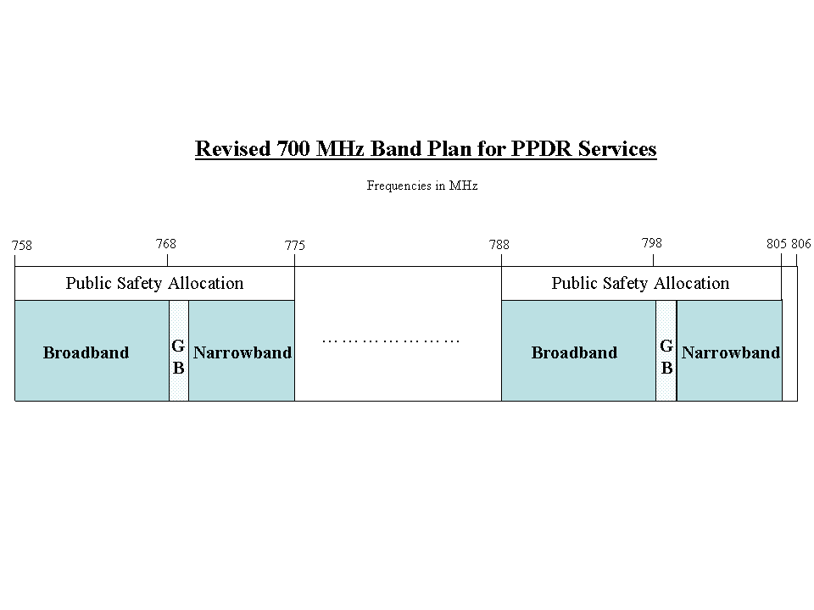

Annex 3  
  
Examples of frequency arrangements for the band 806 to 869 MHz in   
certain countries in Region 2 for narrow-band public protection   
and disaster relief operations

# 1 General band plan – 806-824/851-869 MHz

In a number of countries in the Region 2, the band 806-824/851-869 MHz is allocated to the mobile service, and designated for Land Mobile Radio (LMR) applications. The duplex spacing is 45 MHz, with the base stations transmitting in the 851-869 MHz, and the mobile stations in the 806‑824 MHz range. PPDR channels may be assigned throughout this band and specific blocks may be designated exclusively for PPDR applications. (See § 1.1) Radio equipment is capable of tuning to all channels in the band ensuring interoperability. To simplify cross-border coordination and to ensure that public safety agencies have access to a stable and predictable pool of radio frequency channels, neighbouring administrations could implement complementary frequency arrangements, an example being shown in the figure below.

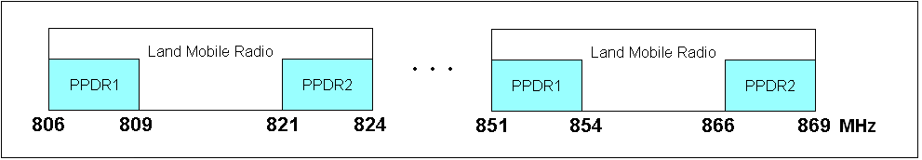

## 1.1 Example frequency arrangement

### 1.1.1 Designation of frequency blocks

|  |  |  |
| --- | --- | --- |
| Mobile station/Control station transmit (MHz) | Base station transmit (MHz) | Frequency block |
| 806-809 | 851-854 | PPDR1[6] |
| 821-824 | 866-869 | PPDR2[7] |

### 1.1.2 Channelization

The frequencies corresponding to the centre frequency of the channel number are defined by the following formulas, where *n* is the channel number:

|  |  |  |  |
| --- | --- | --- | --- |
| Channel number | Mobile station transmit Channel centre frequency (MHz) | Base station transmit Channel centre frequency (MHz) | Channel bandwidth (kHz) |
| n = 1 to 600 | fn = 806.0125 + (0.025) × (n − 1) | fn = 851.0125 + (0.025) × (n-1) | 25 |
| n = 602 to 790 except 639, 677, 715, 753 | fn = 821.0375 + 0.0125 × (n − 602) + 0.025 × floor[(n − 601) / 38] | fn = 866.0375 + 0.0125 × (n − 602) + 0.025 × floor[(n − 601) / 38] | 12.5 |
| n = 601, 639, 677, 715, 753 | fn = 821.0125 + 0.5 × floor[(n − 601) / 38] | fn = 866.0125 + 0.5 × floor[(n − 601) / 38] | 25 |
| n = 791 to 830 | fn = 823.5 + (0.0125) × (n − 791) | fn = 868.5 + (0.0125) × (n − 791) | 25 |

Annex 4  
  
Examples of frequency arrangements for the bands 806 to 824 MHz  
and 851 to 869 MHz in some countries in Region 3 for narrowband  
and broadband public protection and disaster relief operations

# 1 Example narrowband Plan – 806-824/851-869 MHz

The entire band could be used for channel bandwidths of 25 kHz for digital trunked radio systems. However some administrations may want to use different channel bandwidths according to their policy. This sub-section provides examples of three channelling schemes. In the sub-band of 806‑811/851-856 MHz the channel bandwidth is 25 kHz, in the sub-band of 811‑813.5/856‑858.5 MHz the channel bandwidth is 12.5 kHz, and in the sub-band 813.5‑816/858.5‑861 MHz the channel bandwidth is 6.25 kHz. Normally, the lower block 806‑824 MHz is assigned for mobile station transmitters (uplink) and the upper block is assigned for base station transmitters (downlink).

806

824

Land Mobile Radio

811

813.5

816

851

869

Land Mobile Radio

856

858.5

861

Formulae to calculate centre-frequency of each channel are as follows:

– In sub-band of 806-811/851-856 MHz:

The band is divided into 25 kHz channels.

Centre frequency of N‑th base station transmitting channel (MHz):

FN = 851.0125 + (N − 1) × 0.025 N = 1, 2, 3, …, 200

Centre frequency of Nth base station receiving channel (MHz):

FN′ = 806.0125 + (N − 1) × 0.025 N = 1, 2, 3, …, 200

– In sub-band of 811-813.5/856-858.5 MHz:

This sub-band is divided into 12.5 kHz channels.

Centre frequency of N‑th base station transmitting channel (MHz):

FN = 856.00625 + (N − 1) × 0.0125 N = 1, 2, 3, …, 200

Centre frequency of N‑th base station receiving channel (MHz):

FN′ = 811.00625 + (N − 1) × 0.0125 N = 1, 2, 3, …, 200

– In sub-band of 813.5-816/858.5-861 MHz:

This sub-band is divided into 6.25 kHz channels.

Centre frequency of N‑th base station transmitting channel (MHz):

FN = 858.503125 + (N − 1) × 0.00625 N = 1, 2, 3, …, 400

Centre frequency of N‑th base station receiving channel (MHz):

FN′ = 813.503125 + (N − 1) × 0.00625 N = 1,2, 3, …, 400.

# 2 Example broadband Plan – 806-824/851-869 MHz

The broadband channel plan is based on paired frequencies with mobile station transmitters assigned in the frequency band 807-824 MHz (uplink) and base station transmitters assign in the frequency band 852-869 MHz (downlink).

To allow for possible co-existence with legacy narrowband systems, two alternative basic channel plans are suggested:

5 MHz

5 MHz

5 MHz

5 MHz

5 MHz

5 MHz

869

854

824

809

***Plan ‘A’****:*

*Downlink*

*Legacy narrowband systems*

851 MHz

806 MHz

*Uplink*

*Legacy narrowband systems*

852 MHz

867

5 MHz

5 MHz

5 MHz

822

5 MHz

5 MHz

5 MHz

***Plan ‘B’****:*

869 MHz

824 MHz

807 MHz

The broadband channel raster is 100 kHz, which means that the channel centre frequencies are   
an integer multiple of 100 kHz. The broadband channel bandwidth is an integer multiple of 5 MHz. This provides maximum flexibility for administrations to implement appropriate channel arrangements in accordance with the above Plans ‘A’ or ‘B’, or some subset thereof, to suit specific national circumstances, i.e., some administrations may want to use different amounts of broadband and narrowband spectrum than the examples in Plan ‘A’ or ‘B’ to allow for transition.

1. Venezuela has identified the band 380-400 MHz for public protection and disaster relief applications.
2. Some countries in Region 3 have also identified the bands 380-400 MHz and 746-806 MHz for public protection and disaster relief applications.
3. This frequency arrangement is from the Canadian rules. For more details, see Industry Canada’s Gazette Notice No. DGTP-007-09 – Narrowband and Wideband Public Safety Radiocommunication Systems in the bands 768-776 MHz and 798-806 MHz (<http://www.ic.gc.ca/eic/site/smt-gst.nsf/eng/sf09553.html>).
4. This band plan is from the United States’ FCC Rules. For more details, see Part 90 of the FCC Rules at <http://wireless.fcc.gov/index.htm?job=rules_and_regulations>.
5. The use of the term “broadband” in this Annex means indicative data rates in the order of 1‑100 Mbit/s with channel bandwidths dependent on the use of spectrally efficient technologies (from Resolution 646 (Rev.WRC‑12) and Report ITU-R M.2033). It is recognized that other definitions of these terms exist in other ITU texts (such as Recommendation ITU‑R F.1399) or in the rules of various individual administrations.
6. This frequency arrangement is from the United States’ FCC Rules. For more details, see Part 90 of the FCC Rules at <http://wireless.fcc.gov/index.htm?job=rules_and_regulations>.
7. This frequency arrangement is from the Canadian rules. For more details, see Standard Radio System Plan 502 at <http://www.ic.gc.ca/eic/site/smt-gst.nsf/eng/sf00050.html>.