电信标准化局
2010年10月22日，日内瓦

文号： | 电信标准化局第146号通函  COM 13/TK | - 致国际电联各成员国主管部门
电话：  传真：  电子邮件： | +41 22 730 5126  +41 22 730 5853  tsbsg13@itu.int | 抄送：  - ITU-T部门成员；  - ITU-T部门准成员；  - 第13研究组正副主席；  - 电信发展局主任；  - 无线电通信局主任

事由： | 未来网络焦点组（FG-FN）第八次会议  2010年11月29日至12月3日，斯洛文尼亚卢布尔雅那

尊敬的先生/女士：
1 我很高兴地通知您，应斯洛文尼亚标准学会（SIST）的盛情邀请，未来网络焦点组（FG-FN）第八次会议定于2010年11月29日至12月3日在斯洛文尼亚卢布尔雅那Slon酒店召开。
会议将于2010年11月29日09:00开始，地点Slon酒店一楼Kavarna会议厅。
有关会议厅和注册工作的详尽信息将在会场显示。出席本次会议无需交纳注册费。
2 讨论将仅用英文进行。请注意，此次会议不提供纸质文件。
3 我谨提醒您，FG-FN向国际电联成员国、部门成员和部门准成员开放，也接纳国际电联成员国所有愿推进此项工作的个人参与，其中也包括相关标准制定组织的成员或代表。
4 根据与焦点组主席Takashi Egawa先生达成的共识，附件1列出了初步时间计划。有关会议的最新信息和所有收到的文稿，见焦点组网页http://www.itu.int/ITU-T/focusgroups/fn/
index.html。
5 所有提交第八次会议的文稿均应发送至下列电子邮件地址：tsbsg13@itu.int。您在草拟文件时，请使用http://www.itu.int/oth/T0A0F00000F/en和FG-FN网页提供的FG文件基本模版。
根据FG-FN的工作程序，提交文件的截止日期为2010年11月21日。
6 会场内设有无线局域网设施，供代表使用。可在现场了解详细信息。
7 附件2提供了更多有关会场和酒店的信息，附件3则是一份Slon酒店的预订单。
8 为便于电信标准化局和主办方就该焦点组会议的组织做出必要安排，我希望您能通过
http://www.itu.int/ITU-T/focusgroups/fn/index.html以在线形式尽早、但不迟于2010年11月15日进行注册。请注意，会议与会者的预注册仅以在线方式进行。为便于向您提供有关会议计划的最新信息，请在注册表上填写有效电子邮件地址。
9 我们谨在此提醒您，一些国家的公民需要获得签证才能入境斯洛文尼亚并在此逗留（见附件2）。签证必须向驻贵国的斯洛文尼亚代表机构（使馆或领事馆）申请和领取。如果贵国没有此类机构，则请向驻离贵国最近的国家的此类机构申请并领取。请注意，办理签证可能需要一些时间，因此请尽快提出邀请函申请。
需要邀请函和/或签证证明函以入境斯洛文尼亚的与会代表请与该国的联系人联系，详细信息如下：
Alojz Hudobivnik先生
电话：+386 (0)4 207 24 46
移动电话：+386 (0)40 27 24 46
传真：+386 (0)4 207 394 46
电子邮件：hudobivnik@iskratel.si
Iskratel, d.o.o., Kranj, Ljubljanska c. 24a, SI 4000 Kranj, Slovenia

Vesna Klofutar女士
电话：+386 (0)1 478 3075
电子邮件：VesnaKlofutar@sist.si
Slovenski inštitut za standardizacijo Šmartinska 152, 1000 Ljubljana, Slovenia

顺致敬意！

电信标准化局主任
马尔科姆•琼森

附件：3件
ANNEX 1
(to TSB Circular 146)
Time plan for the eighth meeting
29 November to 3 December 2010

Monday  29 November | Tuesday  30 November | Wednesday  1 December | Thursday  2 December | Friday  3 December
9:00-12:30 | 9:00-12:30 | 9:00-12:30 | 9:00-12:30 | 9:00-12:30
ITU-T  FG-FN  Meeting arrangements and Contributions review | ITU-T  FG-FN  Contributions review | ITU-T  FG-FN  Contributions review | ITU-T  FG-FN  Contributions review | ITU-T  FG-FN  Drafting activities and Wrap up with future planning
14:00-18:00 | 14:00-18:00 | 14:00-18:00 | 14:00-18:00 | 14:00-18:00
ITU-T  FG-FN  Contributions review | ITU-T  FG-FN  Contributions review | Mini workshop:  "FG results and future steps" | ITU-T  FG-FN  Contributions review | ITU-T  FG-FN  Drafting activities and Wrap up with future planning

ANNEX 2
(to TSB Circular 146)
General Information
Meeting Venue
Best Western Premier Hotel Slon
Slovenska cesta 34, 1000 Ljubljana, Slovenia
T. +386 (0) 1 470 11 30/31/54
F. +386 (0) 1 470 11 70
e-mail: sales@hotelslon.com
http://www.hotelslon.com/index_en.php
Location: http://www.hotelslon.com/index_en.php?id=50

Hotel Reservation
Special room rates for participants of the ’’ITU-T FG Future Networks’’ meeting have been negotiated with the Hotel Slon. To take advantage of these rates 102 € (single person room) or 123 € (double person room) and to ensure your accommodation, please, return the booking form by 5 November 2010. Please note that after 5 November 2010 rooms will be confirmed upon availability.
Above rates include buffet breakfast, VAT and city tax.
Please see Annex 3 for the booking form.
Check in time: 13:00 pm (early check-in upon request)
Check out time: 12:00 pm (late check-out upon request)
Payment: cash, Visa, Mastercard, American Express, Diners, Maestro.
For cancellation policy please refer to the last page on this document.

Transportation to the hotel
From Ljubljana airport – distance is 25 km.
Reservation of shuttle transfer (Airport / hotel and vice-versa) can be done with room reservation and the payment is settled at reception desk. Price per person is 9 € for one-way.
Reservation of taxi transfer (Airport / hotel and vice-versa) can be done with room reservation and the payment is settled at reception desk. Price for one-way is 33 €.
Arriving by Car:
Meeting participants travelling by car have a possibility of parking in the garage nearby hotel. Preliminary reservation is required and the cost is 18 € per day.

Other hotels nearby: Grand hotel Union
More hotels in town: http://www.visitljubljana.si/en/accommodation/
VISA Requirements
All foreigners need a Schengen visa to enter and stay in the schengen territory for tourist, business, personal or any other visits or similar purposes. Slovenia is part of Schengen territory.
- Please, check, if you need Schengen VISA for stay in Slovenia/EU.
- If you have valid multiple entry Schengen VISA you don’t need to request it again.
- Should you need a new VISA to attend this meeting please send your request immediately. Any such request must specify the name and functions, date of birth, passport number, dates of issue and expiry of passport of the individual(s) for whom the visa(s) is/are requested and be accompanied by a copy of the notification of confirmation of registration approved for the ITU-T meeting in question. Please submit your request to Mr. Alojz Hudobivnik, local contact point for this meeting (see his contact information below).
Further information about the VISA:
http://www.mzz.gov.si/en/visa_information/entry_to_slovenia/
Local Contacts:
Mr. Alojz Hudobivnik
Tel.: +386 (0)4 207 24 46
Mobile: +386 (0)40 27 24 46
Fax: +386 (0)4 207 394 46
Email: hudobivnik@iskratel.si
Iskratel, d.o.o., Kranj, Ljubljanska c. 24a, SI 4000 Kranj, Slovenia

Mrs.Vesna Klofutar
Tel.: +386 (0)1 478 3075
Email: VesnaKlofutar@sist.si
Slovenski inštitut za standardizacijo Šmartinska 152, 1000 Ljubljana, Slovenia
Meeting room situation
Best Western Premier Hotel Slon
1st floor, Kavarna 1 extended

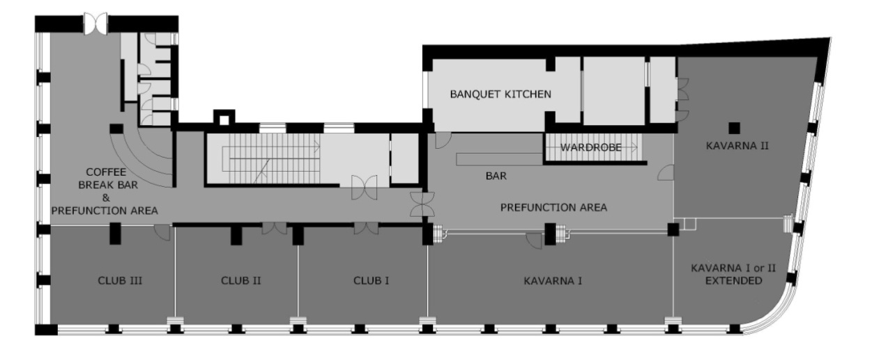
Meeting room equipped with:
- Internet access via Wi-Fi
- LCD projector
- Boards with paper and markers, write-erase board
- Microphones
- Speech desk

Social Event
A social event is planned to take place on one of the evenings of the week of the meeting.

Workshop
The afternoon of Wednesday, 1 December, will be dedicated to the mini-workshop to review the FG results. The presentations will be given by editors and FG management. The workshop is open to local experts. More information on this workshop will be made available on the FG FN homepage http://www.itu.int/ITU-T/focusgroups/fn/index.html
Slovenia in Brief
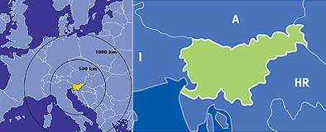
Slovenia, officially the Republic of Slovenia, is a country in Central Europe touching the Alps and bordering the Mediterranean. Slovenia borders Italy on the west, the Adriatic Sea on the southwest, Croatia on the south and east, Hungary on the northeast, and Austria on the north. The capital and the largest city of Slovenia is Ljubljana.
Slovenia covers an area of 20,273 square kilometres and has a population of 2.06 million. Around 40% of Slovenia's land mass is elevated land—mostly in the form of mountains and plateaus—which is located in the interior regions of the country. The highest point of Slovenia is the 2,864 metre (9,396 ft) high Mount Triglav. The majority of the population speaks Slovene, which is also the country's official language. Other local official languages are Hungarian and Italian.
Slovenia is a member of the European Union, the Eurozone, the Schengen area, the Organization for Security and Co-operation in Europe, the Council of Europe, NATO, UNESCO, WTO, OECD, ITU and UN. Per capita, it is the richest Slavic nation-state, and is 85.5% of the EU27 average GDP (PPP) per capita. (more information at http://en.wikipedia.org/wiki/Slovenia)
As a small picturesque country, Slovenia makes a great tourist destination. You can ski in the morning and surrender yourself to the luxury of the Adriatic Sea in the afternoon.
The country is also known for its great wines and delicious traditional food.
Ljubljana, the capital of Slovenia, is a vibrant central European city lying between the Alps and the Adriatic Sea, in a basin where the Ljubljanica river flows into the Sava, at a height of 295 metres above sea level. It covers 273 square kilometres and has a population of 276,000 inhabitants. Its climate is basically continental, with January temperatures averaging - 0.3 and July temperatures 20.7 degrees Celsius
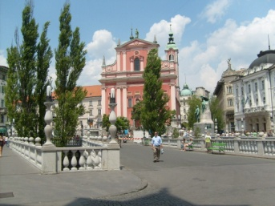. 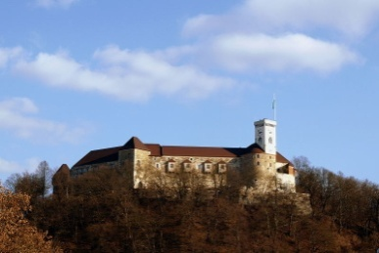 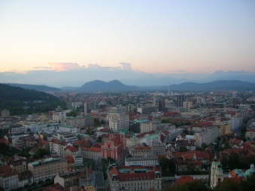
SIGHTSEEING & ACTIVITIES
Within walking distance:
• Ljubljana’s Old Town
• Ljubljana castle
• The three bridges
• Town Hall
• Market
• Tivoli park
• National Museum & National Gallery
• Opera House, National Philharmonic Hall
Visit also: http://www.visitljubljana.si/
Up to 1 hour drive away:
• Bled – a stunning Alpine lakeside resort 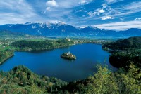
• Postojnska cave
• Lipica stud farm
• Piran & other costal city’s 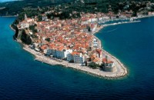

Other practical information
http://www.slovenia.info/en/Praktične-informacije.htm?practical_informations=0&lng=2

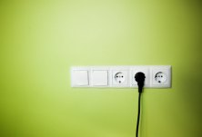
Currency: EURO (€)

Electricity supply
Mains electricity in Slovenia is a 230 Volts 50 Hz system. Slovenia uses the Europlug (CEE 7/16). This is the plug used in most other European countries.

Annual temperatures
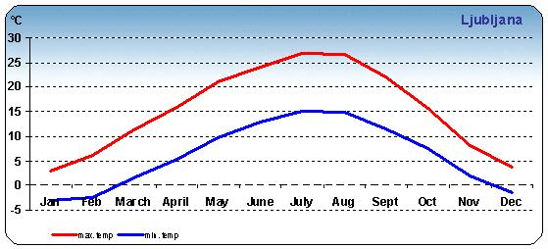
ANNEX 3
(to TSB Circular 146)
Hotel reservation form for Best Western Premier Hotel Slon, Ljubljana, Slovenia

