|  |  |  |  |
| --- | --- | --- | --- |
|  | **Radiocommunication Study Groups** | |  |
| **INTERNATIONAL TELECOMMUNICATION UNION** | |  | |
|  | |  | |
| Source: Document 5A/TEMP/98 | | **Annex 15 to**  **Document 5A/298-E** | |
| **18 November 2016** | |
| **English only** | |
| Annex 15 to Working Party 5A Chairman’s Report | | | |
| WORKING DOCUMENT TOWARDS A PRELIMINARY  DRAFT NEW REPORT ITU-R M.[DPLMR] | | | |
| Digital private land mobile radios systems | | | |

# 1 Scope

This Report deals with the technical and operational characteristics of digital private land mobile radios systems that provide capabilities required for specific user groups/applications, such as governmental, mining, health, hospitality, transportations, disaster relief , industrial, manufacturing, etc.

Issues relating to PPDR are covered in Report ITU-R M.2009, Report ITU-R M.2377 and Recommendation ITU-R M.2015.

Issues relating to PLMR for dispatch applications are covered in Report ITU-R M.2014.

*Editor notes:*

*– Keep in mind to make appropriate references to other specific docs related to PPDR and Machine to Machine communications.*

*– It should be discussed further where the frequency bands and channel arrangements would be included, either in this PDNR or in a separate report.*

*– Make clear in the body of this PDNR that IMT is covered in other documents.*

– *Based on the discussions in the WP 5A November meeting, the scope of the report DLMSA is limited to DPLMR.*

– *Review and make reference to documents related to disaster relief*

Acronyms

LMR Land Mobile Radio

PPDR Public Protection and Disaster Relief

PLMR Private Land Mobile Radio

**Private Land Mobile Radios (PLMR).** In this report, PLMR are land mobile stations that are utilized by closed groups of users to meet their own specific radiocommunication requirements.

# 2 Introduction

Private land mobile adios have been providing two way communications for many industries for decades and continue to empower millions of businesses and industries around the world. From schools to seaports, construction sites to convention halls, factories to delivery services, they are synonymous with reliability, durability and convenience.

*Editor´s note: Is necessary to develop some paragraph regarding to the analog to digital transition*

In the recent years, private land mobile Radios have been transitioning from analog to digital to meet the needs of greater spectrum efficiency. Digital land mobile radios are highly bandwidth-efficient and can accommodate two completely separate “channels” in one 12.5 kHz channel making more efficient use of precious radio spectrum. Digital land mobile radios therefore provide double the capacity of existing 12.5 kHz channel and enable many more people to communicate in the same spectrum.

Many administrations around the world have therefore mandated the use of digital private land mobile radios when authorizing any new licenses and that new designs of two-way radios must be based on digital standards.

In addition, digital private land mobile radios offer many advantages over analog, including improved voice quality with greater coverage, better privacy, better battery life and more. In a normal analog radio, every sound that’s picked up by the microphone is transmitted. If there’s a lot of background noise, it can be very difficult to understand the message. Digital technology uses software that focuses purely on voice or data, paying no attention to the machine clatter or the crowd noise around the users. The result is exceptional voice clarity. Radio interference creates static on an analog radio and makes the conversation less intelligible. Voice gets garbled and the message must be repeated. Because a digital radio has automatic error correction, it rebuilds voice sounds and maintains the clarity of the voice, even if a signal is badly corrupted. And since speech is digitally-encoded, the users benefit from smarter capabilities, such as advanced software algorithms that can deliver clear voice in the most extreme conditions. See figure 1 below.

*Editor´s note: The above information could be used in the Item 7*

Figure 1

Conceptual diagram showing improvements in audio quality with digital PLMR

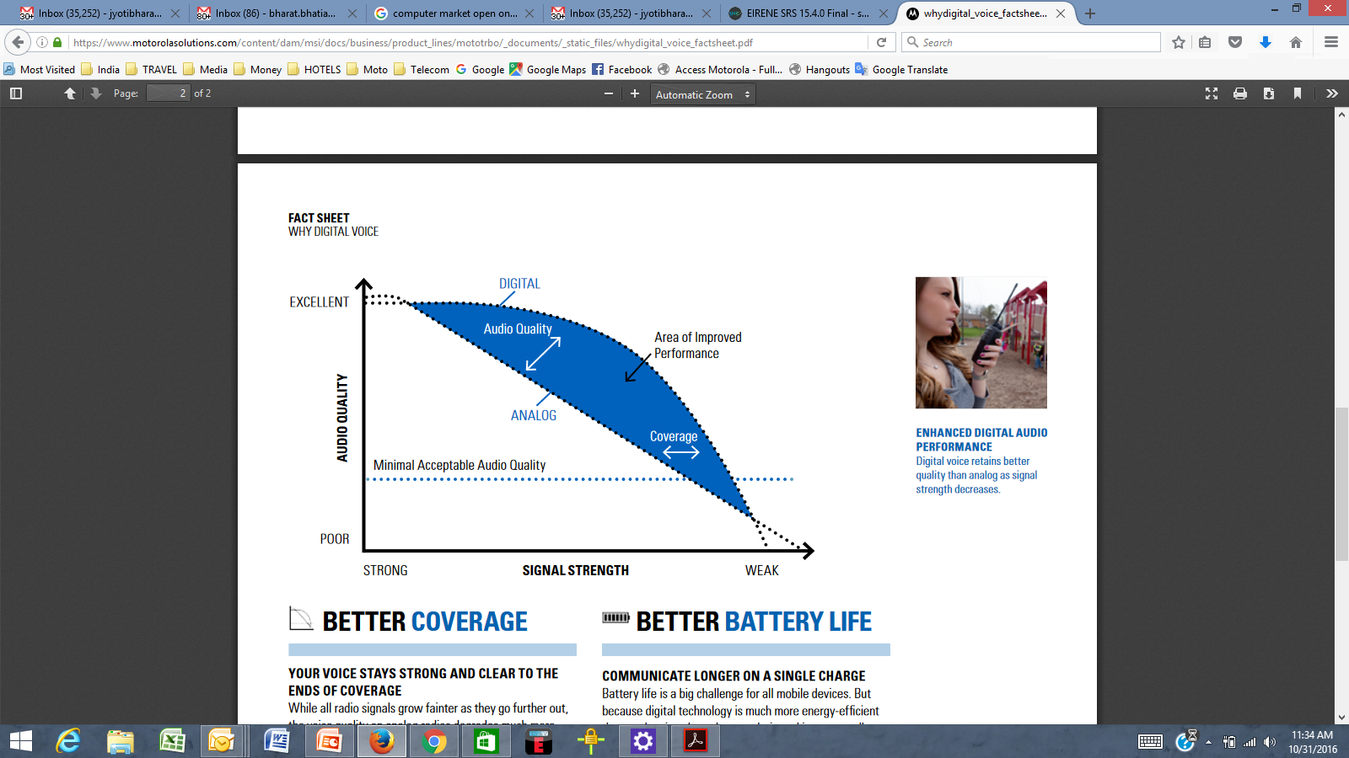

# 3 General technical and operational considerations

**3.1**

**3.2** The systems require using digital techniques and have better spectrum efficiency than existing analog private land mobile radio systems.

**3.3** The systems will be based on open standards for the benefit of end users.

*Editor´s note: To be enhanced and complemented*

# 4 Systems technical characteristics and operational features

*Editor´s note: To be enhanced and complemented*

# 5 Frequency bands

**5.1**

PLMR utilizes various frequency bands across regions in the mobile service, subject to provisions in the Radio Regulations, regional harmonization measures and national conditions[1].

*Editor´s note: To be enhanced and complemented*

# 6 Channelization

[Channel raster should be compatible with existing channelization and must be technology inclusive].

*Editor´s note: To be enhanced and complemented*

# 7 Analog to digital transition

When planning to introduce digital PLMR for the first time, considerations for both data and voice, spectrum channeling plans, type approval and regulatory requirements need to be considered and to ensure the operation of digital radio in existing (or planned) LMR frequency bands.

## 7.1 Digital Voice and Data

Digital PLMR systems support both voice and data services, in time or in frequency domain. Data applications in PLMR are becoming an important aspect of PLMR applications. In scenarios where analog only radio interface are included in the national PLMR requirements, PLMR systems that support both data and voice or improved voice channel will have to wait for changes to benefit from the improved channel usage or to benefit from both data and voice capabilities.

## 7.2 Spectrum

Digital radio equipment that use 25 kHz and 12.5 kHz can operate in existing LMR frequency bands using existing channel arrangements (transmit power, channel assignment plan, channel raster, etc.).

## 7.3 Standards

There are a number of standards and technologies that support digital PLMR applications and detail conformity requirements. A list of some of standards has been provided in Annex 1 as a guide for users, administrations and industry.

*Note to editor: This section can be relocated to improve the layout/flow of the report. Material for Annex 1 will be provided in the next revision of this working document*

...

______________

1. For example, in some countries the following bands are used for PLMR: 136 to 144 MHz, 148 to 174 MHz, 350 to 470 MHz, 806 to 869 MHz.