国 际 电 信 联 盟
电信标准化局
2015年3月11日，日内瓦

 | 文号：  电话：  传真： |  | 电信标准化局第3/9号通函  +41 22 730 5858  +41 22 730 5853 | 致：  – 国际电联各成员国主管部门，  – ITU-T部门成员，  – 参加第9研究组工作的ITU-T  部门准成员和  – ITU-T学术成员
 | 电子  邮件： |  | tsbsg9@itu.int
事由： |  | 第9研究组会议  2015年6月10-17日，中国北京
尊敬的先生/女士：
我高兴地通知您，应中国国家新闻出版广电总局广播科学研究院的盛情邀请，第9研究组（宽带有线与电视）将自2015年6月10日至17日（含）在中国北京召开会议。
我谨通知您，第一天的会议将自9时30分开始。与会者的注册工作将自8时30分开始。有关会议厅安排的具体信息将在会场显示并在注册台提供。有关该会议的一般信息见本函附件A，实用信息见附件B。
经研究组主席（Arthur Webster先生，美国）及管理团队同意起草的会议议程草案及时间表草案分别见附件E和F。
在第9研究组会议的最初两天可能将举办一个展览。承办方希望邀请第9研究组的专家展示在第9研究组标准化领域近期开展的研究，这将增加人们对研究组工作的兴趣，有助于推进研究组的未来工作。由于展览场地有限，将根据先到者优先的原则，仅批准少量申请。请各申请方填写附件D中的表格并尽早在2015年4月10日之前将其提交承办方（gebing@abs.ac.cn）。
祝您与会顺利且富有成效。

顺致敬意！

电信标准化局主任
李在摄
附件：6件
附件A
文稿
提交文稿的截止日期：提交文稿的截止日期为会议召开的12（十二）个日历日之前。此类文稿将在第9研究组的网站上发布，因而必须在2015年5月28日之前寄达电信标准化局。在会议开始日至少两个月之前收到的文稿，可以应要求予以翻译。
文件直接传送/文件提交：现已在线提供文稿直传系统（DDP）。该系统允许ITU-T成员保留文稿编号，并将文稿直接上传至ITU-T的网络服务器或进行修改。直传系统的更过信息和导则见以下网址：http://itu.int/net/ITU-T/ddp/。
模板：请使用提供的一系列模板起草您的文稿。可通过各ITU-T研究组网页的“Delegate resources”（代表资源）（http://itu.int/ITU-T/studygroups/templates）项访问模板。需在文稿首页上注明文稿联系人的姓名、传真号码、电话号码和电子邮件地址。
工作方法与设施
口译服务：根据与ITU-T第9研究组管理团队达成的一致意见，本次会议仅以英文进行。
无纸会议：会议将为无纸会议。
无线局域网设施：将在会场提供，供代表使用。详尽信息见附件B第6项。
打印机：将在会场提供，供代表使用。
注册和与会补贴
注册：为便于电信标准化局做出必要安排，请您通过信函、传真（+41 22 730 5853）或电子邮件（tsbreg@itu.int）的方式在2015年4月15日之前将代表贵主管部门、部门成员、部门准成员、学术机构、区域性组织和/或国际组织或其它实体出席会议的人员名单发至我处。同时亦请各主管部门注明其代表团团长的姓名（如果有副团长，亦盼一并注明）。
请注意，ITU-T会议的与会者只能通过ITU-T网址进行网上预注册：（http://www.itu.int/en/ITU-T/studygroups/2013-2016/09/Pages/default.aspx）。
与会补贴：我们高兴地通知您，为促进最不发达国家或低收入发展中国家代表的与会，国际电联将视可用资金情况，向一相关主管部门提供两份非全额与会补贴（http://itu.int/en/ITU-T/info/Pages/resources.aspx）。申请与会补贴时必须得到相关国际电联成员国主管部门的授权。与会补贴申请表（请使用所附表1）必须在2015年4月29日之前填妥并交回国际电联。请注意，决定是否颁发与会补贴的标准包括：电信标准化局的可用预算情况；申请人向会议提交文稿的情况；国家与区域间的平均分配；性别平衡。

签证：入境中国，您可能需要承办方（SAPPRFT）的一封邀请函。您需将其提交驻贵地区的中国使馆/领事馆，以办理签证（邀请函见附件C）。签证必须向驻贵国的中国代表机构（使馆或领事馆）申请，并随后领取。如果贵国没有此类机构，则请向驻出发国最近的国家的此类机构申请并领取。请注意，签证的审批需要时间，因此请尽早提出签证申请。

（会前）重要截止日期
2015年4月10日： -提交需进行翻译的文稿
2015年4月10日： -申请签证协办函
2015年4月10日： -提出参展申请
2015年4月15日： -预注册
2015年4月29日： -申请与会补贴
2015年5月28日： -提交文稿的最后截止日期

附件B（仅有英文）

PRACTICAL INFORMATION
- Meeting Venue
Merchantel Hotel,
No.2 Xibianmen Outer Street, Xicheng District, Beijing, China.
http://www.cytshotels.com/gdgj/merchantel/index.shtml
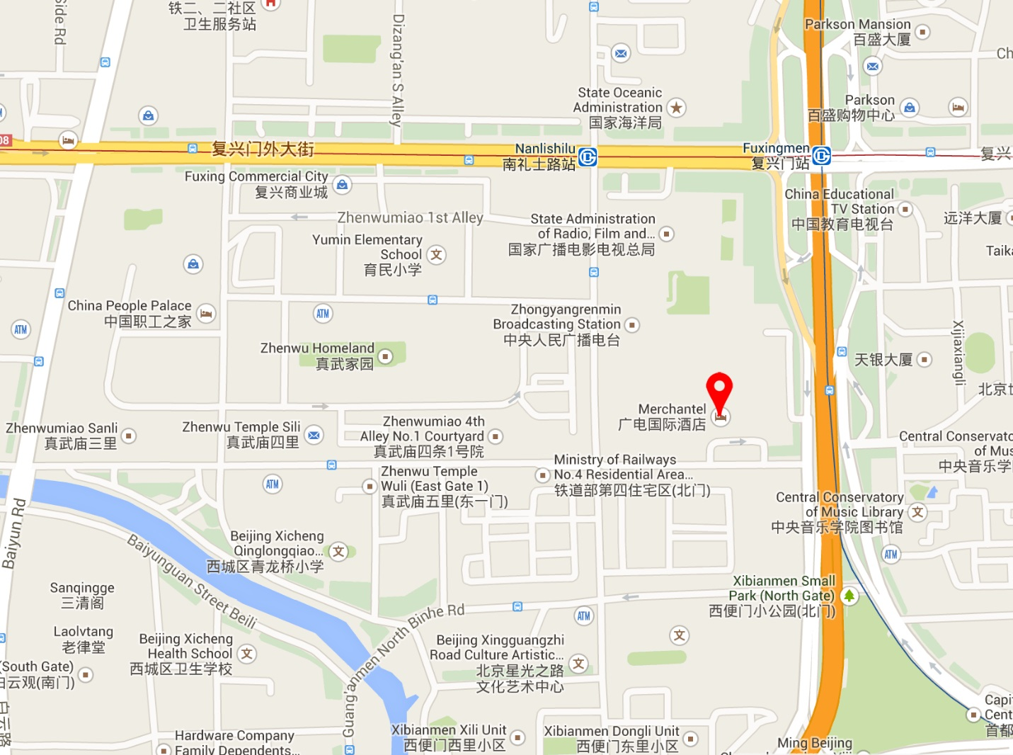
- Transportation and site information
Transportation:
About 34.2KM from Beijing Capital International Airport, Beijing. Taxi about 110RMB.
- Passports and Visas
All foreign visitors entering China must have a valid passport. Visitors from countries whose citizens require a visa should at the earliest time and well in advance of travel apply for a visa at a Chinese Embassy or consulate. The following provides information relating to entry into China.
For an invitation letter, please see Annex C.

- Climate – during June
Monthly Average values of the temperature and precipitation in Beijing, China are given in the table below:
 | June
Average Max Temperature | 30C / 86F
Average Minimum Temperature | 19C / 66F
Average Precipitation | 78 mm
http://en.weather.com.cn/weather/101010100.shtml
- Hotels
VENUE: Merchantel Hotel, No.2 Xibianmen Outer Street, Xicheng District, Beijing
http://www.cytshotels.com/gdgj/merchantel/index.shtml
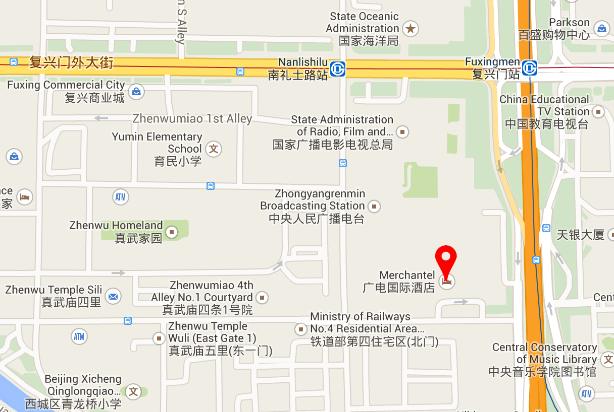

Other hotels close to the venue:
InterContinental Beijing Financial Street Hotel, No.11 Financial Street, Xicheng District, Beijing
http://www.ihg.com/intercontinental/hotels/gb/en/beijing/pegha/hoteldetail
The Westin Beijing Financial Street, 9B Financial Street, XiCheng District, Beijing,
http://www.starwoodhotels.com/westin/property/overview/index.html?propertyID=1704&language=en_US&localeCode=en_US

The way to the meeting venue from “InterContinental Beijing Financial Street Hotel” and “The Westin Beijing Financial Street Hotel”:
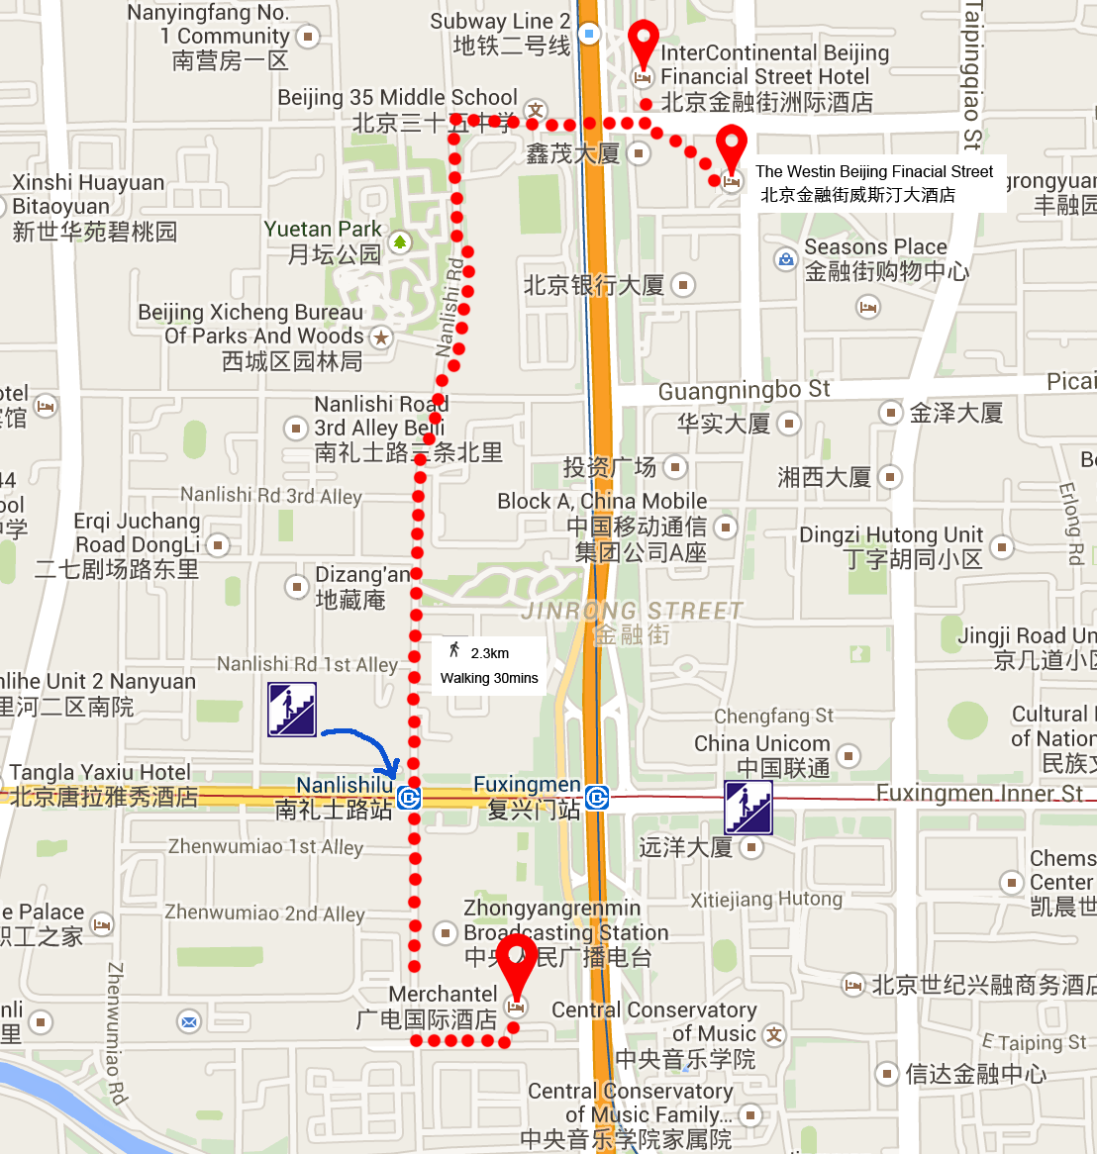
China People Palace, No.1 Zhenwumiao Street, Xicheng District, Beijing
http://www.zgzgzj.com/introduce_en-us.php
The way to the meetings venue from “China People Palace hotel”:
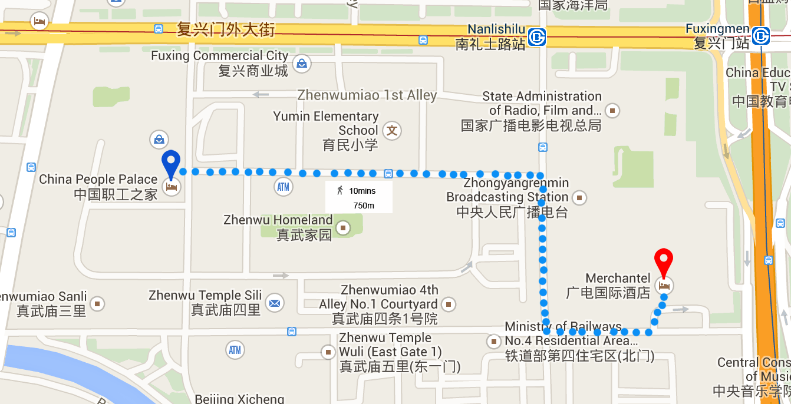

- Internet access and wireless coverage
All meeting rooms will have a wireless network with access to the Internet. Every guest room offers a high-speed Internet access for free. The access to Internet will be granted using the LAN technologies listed below:
- Wireless via WiFi: IEEE 802.11a/n on 5.2 GHz and 802.11g/n on 2.4 GHz.
- Technical assistance
In case you have any technical problem at the venue (e.g. connecting to internet, finding meeting rooms etc.) please contact for help:
Bing Ge, +86 13901281949, gebing@abs.ac.cn
Bo Li, +86 13811931714, libo@abs.ac.cn
- Electricity
The electricity in China is generally 220V, 50HZ. . Please make sure you have the proper adapter.
Chinese standard
Such a socket is common in China, Australia, New Zealand and many other countries.
- Useful information
Currency exchange

The currency in China is the RMB Yuan (￥); please check the currency exchange rate in the local bank system or use the following link as a reference: http://www.xe.com/
- Additional information
General Information for stay in Beijing:
Mobile phone: GSM and CDMA, WCDMA, TD-SCDMA, TD-LTE services provided by China Mobile, China Unicom and China Telecom.
Currency: local currency RMB Yuan (￥), the exchange rate of US$ and RMB is around 6.2.
Tipping: Tipping is not necessary.
Time Zone: GMT+8:00.
Emergency Number: In case of emergency please dial 110.
Sight Seeing:
The Temple of Heaven, Mansion of Prince Gong, etc.
For more information by http://english.visitbeijing.com.cn
- Contact persons
Bing Ge (gebing@abs.ac.cn)
Jingfei Cui (cuijingfei@abs.ac.cn)
Feng Ouyang (ouyangfeng@abs.ac.cn)
Liyue Zhu (zhuliyue@abs.ac.cn)

附件C（仅有英文）
INVITATION LETTER REQUEST FORM
All foreign visitors entering China must have a valid passport. Visitors from countries whose citizens require a visa should at the earliest time and well in advance of travel apply for a visa at a Chinese Embassy or consulate. You may need a letter of invitation from the Chinese host, which you will need to present to the Chinese Embassy/Consulate in your area in order to obtain your visa. The visa must be requested as soon as possible and at least four (4) weeks before the start date of the meeting and obtained from the office (embassy or consulate) representing China in your country or, if there is no such office in your country, from the one that is closest to the country of departure. In order to obtain the invitation letter, please:
- Fill out the form below
- Provide the electronic copy of your passport (the name, date of birth, nationality, passport number, valid date of passport, etc. must be seen clearly)
- Provide the electronic copy of previous Chinese visa and records (if you have been to China before)
- Send the info in a), b) and c) as email attachments to Bing Ge gebing@abs.ac.cn and Jingfei Cui cuijingfei@abs.ac.cn ; please mark as reference in the subject “Invitation letter request for ITU-T SG9 Plenary meetings”:
(It is recommended to scan your passport page and email it to us so that it is discernible and can be used).
Company
Applicant Information |  |  |  | Mr Miss Ms Mrs
 |  |  |  | Date of birth :
 |  |  |  | Place of Issue:
 | Date of Issue: |  |  | Date of Expiry:
 | Marital Status:
 | If the country in which you'll obtain your visa is different from your nationality, please indicate it here:
Address | Telephone Number:  Fax Number:  E-mail:
Note
Date of arrive at China |  |  | Date of departure from China
(Please do not forget to attach a copy of your passport photograph page before sending.)
In order to receive an invitation letter, your information should be provided to the host before 10 April 2015.

FORM 1 - FELLOWSHIP REQUEST（仅有英文）
(to TSB Collective letter 3/9)
ITU-T Study Group 9 meeting
Beijing, China, 10-17 June 2015
Please return to: |  | ITU  Geneva (Switzerland) |  | E-mail: bdtfellowships@itu.int  Tel: +41 22 730 5227  Fax: +41 22 730 5778
Request for one partial fellowship to be submitted before 29 April 2015
 |  |  | Participation of women is encouraged
Registration Confirmation I.D. No: ……………………………………………………………………………
(Note: It is imperative for fellowship holders to pre-register via the online registration form at: http://www.itu.int/en/ITU-T/studygroups/2013-2016/09/Pages/default.aspx)
Country: _____________________________________________________________________________________________
Name of the Administration or Organization: ______________________________________________________
Mr / Ms _______________________________(family name) ________________________________(given name)
Title: _________________________________________________________________________________________________
Address: _____________________________________________________________________________________________________
_____________________________________________________________________________________________________
Tel.: _________________________ Fax: _________________________ E-Mail: __________________________________
PASSPORT INFORMATION:
Date of birth: ________________________________________________________________________________________
Nationality: ______________________________ Passport number: _______________________________________
Date of issue: ______________ In (place): _________________________Valid until (date): __________________
Please select your preference
(which ITU will do its best to accommodate)
□ Economy class air ticket (duty station / Beijing / duty station)
□ Daily subsistence allowance intended to cover accommodation, meals & misc. expenses
Signature of fellowship candidate: |  |  |  |  | Date:
TO VALIDATE FELLOWSHIP REQUEST, NAME, TITLE AND SIGNATURE OF CERTIFYING OFFICIAL DESIGNATING PARTICIPANT MUST BE COMPLETED BELOW WITH OFFICIAL STAMP.
N.B. IT IS IMPERATIVE THAT FELLOWS BE PRESENT FROM THE FIRST DAY TO THE END OF THE MEETING.
Signature: |  |  |  |  | Date:

附件D（仅有英文）
Exhibitors’ Requirement Form
(Note: Please complete and return to gebing@abs.ac.cn by 10 April 2015 to reserve a booth. Considering the limited space and options, all participants should provide their own computers and storage, and please keep them to a minimum.)

Company Name | Contact person including contact details | Email address

Type of equip. to be displayed

Item(s) required | Description | Quantity
Tables
Chairs
Flat Screens
Network switch
Power supply
Space required
Panels
Power consumption expected for equipment:
Dimension, weight of equipment
Additional notes
(if any)

附件E（仅有英文）
Draft Agenda
# | Agenda items
 | Opening of the meeting
 | Feedback on interim activities since last meeting
 | TSAG/RevCom (June 2015) results relevant to SG9
 | Rapporteurs, Associates and other roles
 | Contributions for opening Plenary
 | Report from other Groups/Workshops
 | AOB for opening Plenary
 | Intellectual Property Rights inquiry
 | “Consent” on draft Recommendations proposed for approval in accordance with Recommendation A.8
 | Approval of Working Parties reports and Question meetings report
 | New/amended Questions (if any)
 | New appointment and change of appointment of Rapporteur(s), Associate Rapporteur(s), liaison officers
 | Update of SG9 Work Programme
 | Outgoing Liaison Statements
 | Date and place of the next SG9 meeting
 | Future Interim activities (Rapporteurs, WPs)
 | AOB
 | Closing
Note: Items 1 to 7 are expected to be addressed in the opening Plenary (10 June 2015) and items 8 to 18 are expected to be addressed in the closing Plenary (17 June 2015).

ANNEX F
Draft Timetable
SG9 draft meeting plan (10-17 June 2015, Beijing, China)

 | Wednesday 10  June |  |  |  | Thursday 11  June |  |  |  | Friday 12  June |  |  |  | Sat 13  June | Sun 14  June | Monday 15  June |  |  |  | Tuesday 16  June |  |  |  | Wednesday 17  June
Sessions | 1 | 2 | 3 | 4 | 1 | 2 | 3 | 4 | 1 | 2 | 3 | 4 |  |  | 1 | 2 | 3 | 4 | 1 | 2 | 3 | 4 | 1 | 2 | 3 | 4
PLEN | X | 2 |  |  |  |  |  |  |  |  |  |  |  |  |  |  |  |  |  |  |  |  | X | X | X | X
WPs |  | 2 |  |  |  |  |  |  |  |  |  |  |  |  |  |  |  |  |  | X | X | X
Q1/9 |  |  | 3 |  | X |  |  |  |  |  |  | 3 |  |  | X |  |  | 3
Q2/9 |  |  | X |  | 4 |  |  | X | 4 | X |  |  |  |  | X |  |  | 4
Q3/9 |  |  | X |  |  |  | X | X |  |  | X | X |  |  |  | X |  | X
Q4/9 |  |  |  | X | X | X | X |  | X | X |  |  |  |  | X |  |  | X | X
Q5/9 |  |  | 5 | X | 5 | X |  |  | 5 | X |  |  |  |  | 5 | X |  |  | X
Q6/9 |  |  | X |  | X |  |  |  |  | X
Q7/9 |  |  | 3 |  |  | X |  | X |  |  | X | 3 |  |  |  |  | X | 3 | X
Q8/9 |  |  | 5 |  | 5 |  | X |  | 5 |  | X |  |  |  | 5 |  | X
Q9/9 |  |  | 5 |  | 5 |  |  | X | 5 |  |  | X |  |  | 5 |  |  | X
Q10/9 |  |  |  |  |  |  | X | X |  |  | X | X |  |  |  |  | X |  | X
Q11/9 |  |  |  |  |  | X |  |  |  |  |  |  |  |  |  | X
Q12/9 |  |  |  | X | 4 |  | X |  | 4 |  | X |  |  |  |  | X | X | 4
Q13/9 |  |  |  | X |  | X |  |  | X |  |  | X |  |  | X | X | X |  | X
Newcomers |  | 1
Session 1: 0930 – 1045; Session 2: 1115-1230; Session 3: 1430-1545; Session 4: 1615-1730;

PLEN | Plenary sessions
WPs | Working Parties 1 and 2 Plenary sessions
X | Represents a meeting session
 | Indicates a lunch/evening session
1 | A newcomers orientation session will follow the WPs/9 opening plenary sessions (1230-1330)
2 | WP1/9 and WP2/9 Plenary sessions will be held sequentially and will follow SG9 Plenary
3 | Joint session of Q1 and Q7/9
4 | Joint session of Q2 and Q12/9
5 | Joint session Q5, Q8, Q9

______________

