|  |  |
| --- | --- |
| **Plenipotentiary Conference (PP-14)**  **Busan, 20 October – 7 November 2014** | logo_Eyyy |
|  |  |
|  |  |
| PLENARY MEETING | Document 11-E |
|  | **7 November 2013** |
|  | **Original: English** |
| Note by the Secretary-General | |
| CANDIDACY FOR THE POST OF DIREctor of the  telecommunication standardization bureau (tsb) | |

Further to the information contained in Document 3, I have pleasure in transmitting to the conference, in annex, the candidacy of:

**Mr Chaesub LEE (Republic of Korea)**

for the post of Director of the Telecommunication Standardization Bureau (TSB) of the International Telecommunication Union.

Dr Hamadoun I. TOURE  
 Secretary-General

**Annex**: 1

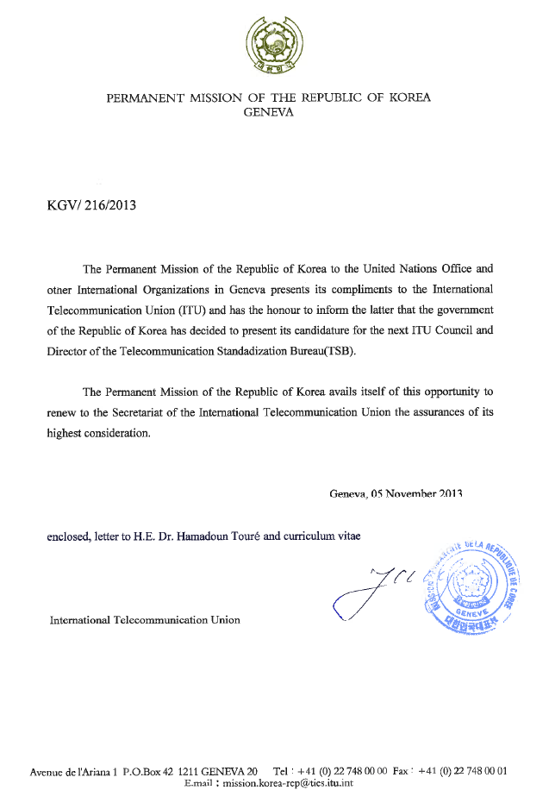

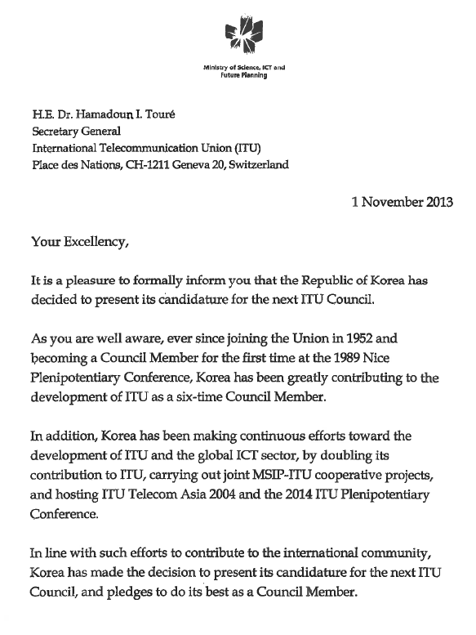

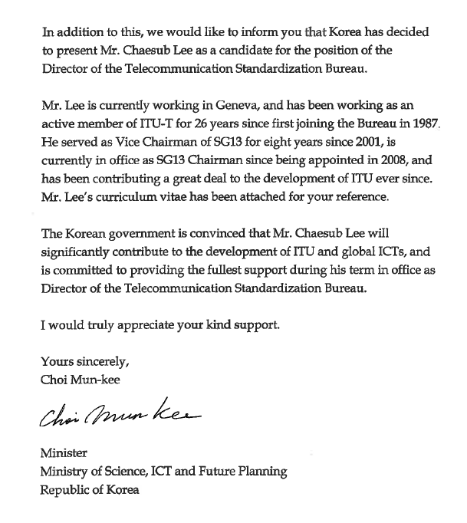

Curriculum Vitae

|  |  |
| --- | --- |
|  | **Name: Chaesub LEE**  **Birth Date: 6 March 1960**  **Nationality: Korea (Rep. of)**  **Expert Area: Network Architectures, Capabilities and Design on ISDN, IP, MPLS, GII, NGN, Wired and Wireless Broadband, FMC/Mobility Management, IPTV, IdM, Smart Networks, Cloud Computing and Future Networks etc.** |

**Education:**

February 1983: KONKUK University (Bachelor, Electronics)

February 1985: KONKUK University Graduate School (Master, Electronics)

**Professional Experience:**

1986 ~ 1992: Joined KOREA TELECOM R&D GROUP as Researching Engineer and Involved in Network planning and development of N-ISDN

1993 ~ 1994: Joined B-ISDN development national project

1994 ~ 1995: Detached to Ministry of Communication for Korea Information Infrastructure (KII) development

1995 ~ 1996: Director of Technical Strategic Planning Department at KOREA TELECOM

1997 ~ 1999: Director of High Speed Broadband Access Network development at KOREA TELECOM

2000 ~ 2002: Director of KOREA TELECOM GENEVA OFFICE

2003 ~ 2004: Director of KT Headquarters on Company Relations Department at KOREA TELECOM

2004 ~ 2012: President of HiSPOT sarl and Research Consultant at ETRI

2012 ~ Today: Research Consultant at KAIST Institute for IT Convergence on ICT/Telecommunication technology and their standard developments

**ITU Standard Related Experience:**

1987 ~ 1988: Joined ITU CCITT SG VIII (Telematic area) Activity

1989: Joined ITU CCITT SG XVIII (the predecessor of current ITU-T SG 13)

1989 ~ 1991: Representative of Korea Telecom in ITU-T SG 13 (Interworking areas)

1992 ~ 1996: Editor of various Interworking related issues of ITU-T SG13 (I.500 Series)

1997 ~ 1998: Rapporteur of Q 2/13 (GII and Network Architecture related Question)

1999 ~ 2000: Chairman of Working Party 1/13 (Network Architecture area) of ITU-T SG13

2001 ~ 2008: Vice Chairman of ITU-T SG 13 (NGN) and Chairman of ITU-T Working Party 2/13 (Network Architecture Area)

2003 ~ 2004: Technical Leader of ITU-T ‘JRG on NGN’ (led by SG13)

2004 ~ 2005: Chairman of ITU-T ‘FG NGN’ (Focus Group on NGN)

2006 ~ 2007: Vice-Chairman of ITU-T ‘FG IPTV’ (Focus Group on IPTV)

2008.10: Elected as Chairman of ITU-T Study Group 13 at WTSA 2008

2009 ~ 2012: Chairman of ITU-T Study Group 13 (1st Term)

2009 ~ 2012.6: Chairman of ITU-T NGN-JCA and IPTV-JCA (JCA: Joint Coordination Activity)

2012: Vice Chairman of Committee 3 of WTSA 2012

2012: Re-elected as Chairman of ITU-T SG13 at WTSA 2102

2013 ~ Today: Chairman of ITU-T SG13 (on Future Networks: 2nd Term)

**Other International Standard Related Experience:**

1988 ~ Today: GSC (Global Standard Collaboration) member and Leader on NGN and Broadband

1994 ~ 2011: CJK (China-Japan-Korea) standard collaboration (NGN and UNIOT WG Chairman)

2002 ~ Today: ASTAP member on NGN, IPTV and IdM

**Academic Involvement:**

2006: IEEE ComSoc Key Editor on “IPTV”

2004 ~ Today: IEEE Paper Reviewer on networks and IPTV

2010 ~ 2012: Steering member of Kaleidoscope by ITU TSB

2000 ~ Today: Involved in various international workshops in the world as a guest speaker

**Involved Consultation and Projects:**

06 ~ 11.2006: Consultation on “Study on Mobility control technologies”, by ETRI

06 ~ 07.2007: Consultation on “the preparation of the Version 05 of a Manual on Network Planning for Evolving Network Architectures”, by ITU BDT

05 ~ 12.2008: Consultation on “Development of Service requirements, use cases and features of NGN codec(s)”, by KGK Enterprise

05 ~ 06.2009: Consultation on “Study on transition from traditional networks to NGN”, by ITU BDT

12.2010: Consultation on “Transition from TDM to NGN of Lebanon Telecommunication”, by ITU BDT

07.2011: Consultation on “IP-based interconnection for Voice”, by Horrocks Technology Limited

08 ~ 12.2011: Consultation on “Telecommunication Infrastructure development in Serbia focused on Wireless Broadband”, by KISDI

05 ~ 09.2012: “Lead Editor on Correspondence Group of ITU-D Q.26/2” by BDT

04 ~ 12.2012: Consultation on “Cloud Computing and Telecommunication trend” with Microsoft

10 ~ 12.2012: Handbook on “How to increase QoS/QoE of IP-based Platform to regionally agreed standard” by TSB

10 ~ 12.2012: Handbook on “Migration Scenarios from Legacy Networks to NGN in developing countries” by TSB

04 ~ 12.2013: Consultation on “Telecommunication and IT Convergence” with Microsoft