Plenipotentiary Conference (PP-14)
Busan, 20 October – 7 November 2014
PLENARY MEETING | Document 13-E
 | 15 November 2013
 | Original: English
Note by the Secretary-General
CANDIDACY FOR THE POST OF DEPUTY SECRETARY-GENERAL

Further to the information contained in Document 3, I have pleasure in transmitting to the conference, in annex, the candidacy of:
Mr Bruce GRACIE (Canada)
for the post of Deputy Secretary-General of the International Telecommunication Union.

Dr Hamadoun I. TOURE
Secretary-General

Annex: 1

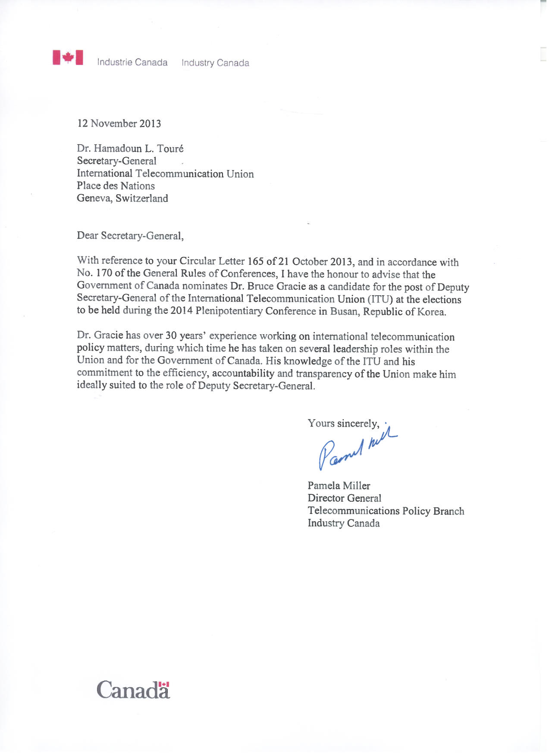

BRUCE ALAN GRACIE
Candidate for Deputy Secretary-General, ITU Elections 2014

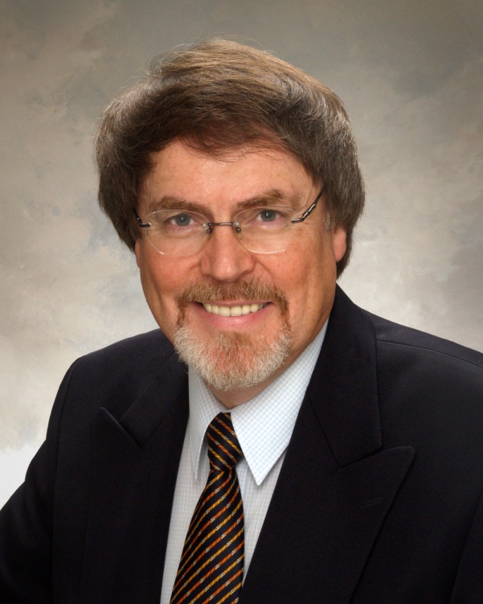
EDUCATIONAL BACKGROUND
- Doctor of Philosophy – McMaster University (1976).
- Master of Arts – McMaster University (1972).
- Bachelor of Arts (Honours) – Trent University (1969).
EMPLOYMENT EXPERIENCE
Since joining the Canadian Department of Communications/Industry Canada in 1975, including a two-year secondment to the Department of Communications, Government of Australia from 1984-86, responsibilities have included, to a significant extent, activities related to the preparations for, and participation in, ITU conferences, assemblies and meetings. These are outlined in Section on Domestic activities relating to the ITU.
International responsibilities relating to the work of the 3 ITU Sectors, as well as work associated with the governance of the organization, are outlined below.
INTERNATIONAL ACTIVITIES RELATING TO THE ITU
Governance-related Activities
- Councillor for Canada, 1997 to present, ITU Council
- Chairman, Council Working Group on Financial and Human Resources, 1999 to present
- Chairman, Administration and Management Committee, 2010 Plenipotentiary Conference
- Chairman, ITU Council, 2006
- Chairman, Finance Committee, 2002 Plenipotentiary Conference
- Chairman, Standing Committee on Finance, 1999-2002, ITU Council
- Vice-Chairman (Finance), Working Group on ITU Reform, 1999-2000
- Co-chairman, Committee 7 (General Management Issues), 1998 Plenipotentiary Conference
Radiocommunication Sector
- Chairman, Working Group of the Plenary, Article 15 (Interferences), 2012 World Radiocommunication Conference
- Chairman, Radiocommunication Assembly, 2007
- Chairman, Editorial Committee, 1988 Regional Radiocommunication Conference, Rio de Janeiro
- Chairman, Work Programme Committee, 1990 CCIR Plenary Assembly
- Vice-Chairman, 1997 Radiocommunication Assembly
- Chairman, Radiocommunication Advisory Group (RAG), 2000-2007
- Chairman, Budget Control Committee, selected Radiocommunication Assemblies and World Radiocommunication Conferences
Telecommunication Standardization Sector
- Chairman, Telecommunication Standardization Advisory Group (TSAG), 2010 to present
- Vice-Chairman, Committee 3 (Working Methods), 2012 World Telecommunication Standardization Assembly, and Chairman, Sub-Working Group on Resolution 67 (Use in the ITU Telecommunication Standardization Sector of the languages of the Union on an equal footing)
- Moderator, Session 4 (Collaboration), 2012 Global Standards Symposium
- Chairman, Budget Control Committee, selected World Telecommunication Standardization Assemblies
Telecommunication Development Sector
- Chairman, Working Group of the Plenary (ITU-D Strategic Plan and Doha Declaration), 2006 World Telecommunication Development Conference
- Chairman, Budget Control Committee, selected World Telecommunication Development Conferences
World Conference on International Telecommunications
- Chairman, Budget Control Committee
General
- Chairman, Commonwealth ITU Group, 2006 to 2012
- Chairman, Seventh ITU Symposium on ICTs, the Environment and Climate Change, 2012
DOMESTIC ACTIVITIES RELATING TO THE ITU
- Chairman, Canadian Preparatory Committees, ITU World Radiocommunication Conferences (WARC-92; WRC-93; WRC-95; WRC-97; WRC-2000; WRC-03; WRC-07; WRC-12)
- Chairman, Canadian Preparatory Committees, ITU Radiocommunication Assemblies (RA-93; RA-95; RA-97; RA-2000; RA-03; RA-07; RA-12)
- Chairman, Canadian National Organization (CNO), ITU Radiocommunication Sector (ITU-R) Executive Committee
- Chairman, CNO/ITU-T Telecommunication Standardization Sector Steering Committee
- Chairman, CNO/ITU-D Telecommunication Development Sector Consultative Committee
- Chairman, Canadian Preparatory Committees, ITU World Telecommunication Development Conferences (WTDC-98, WTDC-02, WTDC-06, WTDC-10)
- Chairman, CNO/ITU Plenipotentiary Conference Preparatory Committee (PP-98, PP-02, PP-06, PP-10)
- Chairman, Canadian Preparatory Committee, World Conference on International Telecommunications
- Chairman, CNO/Government/Industry Preparatory Committee, World Telecommunication Policy Forum (WTPF-1998, WTPF-2001, WTPF-2009, WTPF-2013)
Delegation Management Responsibilities for ITU Conferences, Assemblies and Meetings
- Deputy Head of the Canadian Delegation, World Radiocommunication Conferences (WARC-88; RARC-88; WARC-92; WRC-93; WRC-95; WRC-97; WRC-2000; WRC-03; WRC-07; WRC-12)
- Head of Delegation, Radiocommunication Assemblies (RA-95; RA-97; RA-2000; RA-03; RA-07; RA-12)
- Deputy Head of Delegation, Plenipotentiary Conferences (PP-98; PP-02; PP-06; PP-10)
- Deputy Head of Delegation, World Telecommunication Development Conferences (WTDC-98; WTDC-02; WTDC-06; WTDC-10)
- Deputy Head of Delegation, World Telecommunication Standardization Conference (1996); World Telecommunication Standardization Assemblies (WTSA-2000; WTSA-2004; WTSA-2008; WTSA-2012)
LANGUAGE PROFICIENCY:
- English (writing, reading and speaking) – Excellent
- French (writing, reading and speaking) – High
- Spanish (writing, reading and speaking) – Evolving

AWARDS
- International Telecom Career Service Award, Canadian Telecom Hall of Fame, 2010
- ITU Gold Medal, Chairman, ITU Radiocommunication Assembly (2007)
- ITU Silver Medal, Chairman, ITU Council (2006)
- Various Industry Canada awards for leadership and participation in senior management teams relating to ITU conferences and assemblies
PERSONAL DATA:
Citizenship: Canadian
Civil Status: Married, 2 children

