Plenipotentiary Conference (PP-14)
Busan, 20 October – 7 November 2014
PLENARY MEETING | Document 21-E
 | 6 January 2014
 | Original: English
Note by the Secretary-General
CANDIDACY FOR THE POST OF MEMBER OF
THE RADIO REGULATIONS BOARD
Further to the information published in Document 3, I have pleasure in transmitting to the Conference, in annex, the candidacy of:
Mr Doan Quang HOAN (Socialist Republic of Viet Nam)
for the post of member of the Radio Regulations Board.

Dr Hamadoun I. TOURÉ
Secretary-General

Annex: 1

ANNEX 1
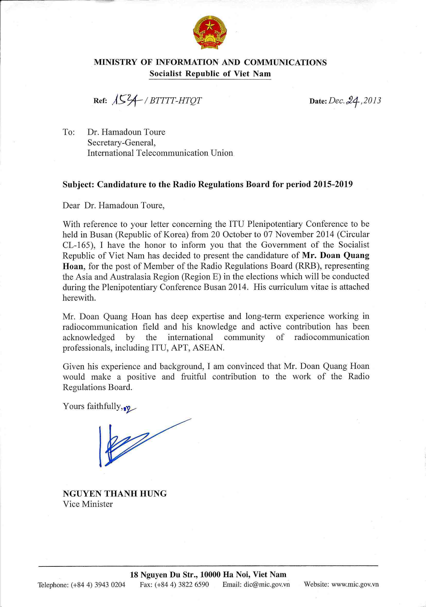
CURRICULUM VITAE
For
Mr. DOAN QUANG HOAN

PERSONAL INFORMATION
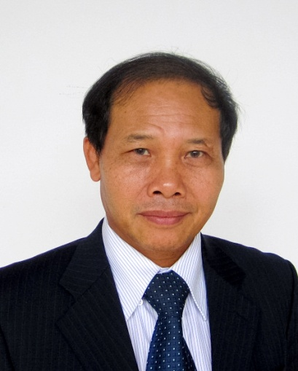
Full name : DOAN QUANG HOAN (Mr.)
Date of birth : 12 Jul 1958
Place of birth : Ha Tinh – Viet Nam
Nationality : Vietnamese
Marital status : Married with a daughter and a son
Language : Vietnamese, English
Official address : 115 Tran Duy Hung, Cau Giay
Ha Noi - 10000, Viet Nam.
Telephone number : +84-4-35564922
Fax. Number : +84-4-35564930
Email : dqhoan@rfd.gov.vn
Position
Director General of the Authority of Radio Frequency Management, Ministry of Information and Communications of S.R. of Viet Nam.
Standing Member of National Radio Frequency Committee.
Educational Qualification
2006 | Master in Electronics and Telecommunications, Ha Noi University of Technology
2009 | Bachelor of Politics, National Academy of Politics and Public Administration
1980 | Engineer in Radiocommunication, Ha Noi University of Technology
2002 | Course on Space Communication in Japan
2001 | Course on Radio Spectrum Monitoring and Measuring, Radio Frequency Spectrum Management and Spectrum Management in the Civil Sector in the United States Telecommunications Training Institute in the United States of America
2000 | Course on Space Telecommunications Program Management in France
1998 | Course on Technical Operations and Frequency Assigning in Australia
1995 | Course on Frequency Management in Japan
Professional Experience
Mr. Doan Quang Hoan is one of the leading experts in radio frequency management. Mr. Hoan has played a key role in the strong development of radiocommunication systems in Viet Nam. With the wide-ranging knowledge and experience on spectrum management, he has the ability to plan the long-term strategy and resolve complex issues in spectrum management and satellite orbit. He has conducted significant projects to regulate and chart the roadmap for future radio frequency management in Viet Nam, such as Radio Regulations, National spectrum plan, National digital TV switchover plan and spectrum plan for mobile broadband.
Mr. Hoan has revealed the comprehensive knowledge of ITU radiocommunication regulatory system and application of ITU Radio Regulations. He has led the satellite coordination group for successful satellite projects in Viet Nam. As the Head of Viet Nam Delegation attending the cross-border frequency coordination meeting with neighbouring countries, Mr. Doan Quang Hoan has enthusiastically worked to establish the technical solutions for the co-existence of radiocommunication networks to create an interference-free and cooperative environment on spectrum use with neighbouring countries.
His extensive experience in radiocommunication matters has been demonstrated by working with variety of organizations and international bodies namely ITU, ASEAN, APT, ITSO, INTERSPUTNIK and other international conferences. Mr. Hoan has made many contributions and proposals to enhance the efficiency of the Radio Regulations, ITU procedures as well as international organizations.
Working Process
2006 - Present | Director General – Authority of Radio Frequency Management of Viet Nam (ARFM)  Standing Member of National Radio Frequency Committee
1998 - 2006 | Deputy Director General –ARFM
1997 - 1998 | Director of Regional Radio Frequency Centre No. 3, ARFM
1995 - 1997 | Deputy Director of Regional Radio Frequency Centre No. 3, ARFM
International Activities
Mr. Hoan has been the Deputy/Alternate Head of Vietnamese Delegation in Word Radiocommunication Conference (WRC), Radiocommunication Assembly 2003, 2007 and 2012. He was also authorized to sign the Final Acts on behalf of Vietnamese Delegation. During these events, Mr. Doan Quang Hoan has led Vietnamese Delegation to propose a lot of contributions addressing conference agenda items on effective use of the radio frequency. Many of contributions resulted to the positive change in the Radio Regulations.
He has actively participated in many international meetings as the role of keynote speaker, panellist or vice-chair: such as the ITU Asia-Pacific Regulators’ Roundtable; ITU Asia-Pacific Regional Development Forum (RDF-ASP); The ITU Telecom World 2013 - Ministerial Round table on Digital Dividend in Thailand 2013; He is also the Chairman of ASEAN Sub-Working Group of Spectrum Management and Co-chairman of ASEAN Spectrum Policy Forum.
As the Director General of the Authority of Radio Frequency Management of Viet Nam, Mr. Hoan has been with ARFM to successfully host many international meetings of ITU-R, APT, ASEAN and ITU Regional.

Participating and contributing to international activities:
- Head/Alternate Head of Viet Nam Delegation in the Radiocommunication Assembly (RA) 2003 and 2012.
- Deputy/Alternate Head of Viet Nam Delegation in the World Radiocommunication Conference (WRC) 2003, 2007 and 2012.
- Head of Viet Nam Delegation, the Conference Preparatory Meetings for World Radiocommunication Conference (WRC) 2007, 2012 and 2015.
- Member of Delegation to the ITU Plenipotentiary Conference 2006 (PP-06) in Turkey.
- Head of Viet Nam Delegation, the meetings of Radiocommunication Advisory Group.
- Head of Viet Nam Delegation, the Twenty-Seventh Meeting of the Assembly of Parties (AP-27) - International Telecommunications Satellite Organization (ITSO) in USA 2002.
- Duly Accredited Alternate Head of Viet Nam Delegation, the Intelsat 25th Assembly of Parties in USA 2000.
- Head of Viet Nam Delegation attending the Meetings of the Asia Pacific Telecommunity (APT) Conference Preparatory Group and the APT Wireless Group (AWG) for WRCs.
- Deputy Head of Viet Nam Delegation to the 39th session of the Intersputnik Board and 13th session of the Intersputnik Operations Committee in Russia 2011.
- The ASEAN Telecommunications and IT Ministers (TELMIN) and Telecommunications and Information Technology Senior Officers (TELSOM) meetings.
- Chairman of ASEAN Sub-Working Group of Spectrum Management.
- Co-chairman of ASEAN-EU Spectrum Policy Forum.
- Head of Viet Nam satellite coordination group for Vietnamese satellite projects.
- Head of Viet Nam Delegation attending the annually bi-lateral and cross-border frequency coordination meeting with neighbouring countries.
Awards
- Medal awarded by the State President in 2003, 2010 and Certificates of Merit of Prime Minister in 2000, 2008, 2009 for achievements contributing to the social and economic development of Viet Nam.
- The Chief Information Officers award in the South East Asia region in 2011 of International Data Group.
Summary
Mr. Hoan is a highly qualified expert with practical experience in spectrum management. He has actively participated and contributed to numerous World Radiocommunication Conferences, regional radiocommunication conferences. His contributions have demonstrated the ability to apply the Radio Regulations and ITU procedures to resolve bi/multi-lateral issues. His recommendations and advices are always welcomed and highly appreciated in relevant international and regional events. His professional background and particularly the experience on international issues have proved the qualifications as a member of the Radio Regulations Board. To be the member of the Radio Regulations Board, Mr. Doan Quang Hoan will have more opportunities to contribute to the development of ITU and bring benefits to Member States.
________________________

