Telecommunication Standardization
Bureau

Geneva, 22 October 2010

Ref: | TSB Circular 146  COM 13/TK | - To Administrations of Member States of the Union
Tel:  Fax:  E-mail: | +41 22 730 5126  +41 22 730 5853  tsbsg13@itu.int | Copy:  - To ITU-T Sector Members;  - To ITU-T Associates;  - To the Chairman and Vice-Chairmen of  Study Group 13;  - To the Director of the Telecommunication Development Bureau;  - To the Director of the Radiocommunication Bureau

Subject: | Eighth meeting of the Focus Group on Future Networks (FG-FN)  Ljubljana, Slovenia, 29 November to 3 December 2010
Dear Sir/Madam,
1 I am pleased to announce that the eighth meeting of the FG-FN is scheduled to take place at the Hotel Slon, Ljubljana, Slovenia, from 29 November to 3 December 2010, inclusive, at the kind invitation of the Slovenian Institute for Standardization (SIST).
The meeting will open at 0900 hours on 29 November 2010 at the Kavarna meeting room, first floor of the Hotel Slon.
Detailed information concerning the meeting room and registration will be displayed at the meeting venue. No registration fee is required for participating in this meeting.
2 Discussions will be held in English only. Please also note that this is a paperless meeting.
3 I would like to remind you that the FG-FN is open to ITU Member States, Sector Members and Associates. This FG-FN is also open to any individual from a country which is a member of ITU and who is willing to contribute to the work, which includes individuals who are also members or representatives of interested Standards Development Organizations.
4 As agreed to with the Chairman of the Focus Group, Mr. Takashi Egawa, the initial time plan is given in Annex 1. Updates related to the meeting will be made available on the Focus Group web page: http://www.itu.int/ITU-T/focusgroups/fn/index.html, as well as any contributions received.
5 All contributions to the eighth meeting should be sent to the following electronic email address: tsbsg13@itu.int. In preparing your documents please use the basic template for the FG documents available at http://www.itu.int/oth/T0A0F00000F/en and FG-FN webpage.
As per the FG-FN working procedures the deadline for submission of documents is 21 November 2010.
6 Wireless LAN facilities are available for use by delegates at the venue. Detailed information will be available on site.
7 Additional information on the meeting venue and hotels is provided in Annex 2 and a hotel reservation form for the Hotel Slon can be found in Annex 3.
8 To enable TSB and the host to make the necessary arrangements concerning the organization of the Focus Group meeting, I should be grateful if you would register via the on-line form at http://www.itu.int/ITU-T/focusgroups/fn/index.html, as soon as possible, but not later than 15 November 2010. Please note that pre-registration of participants to the meeting is carried out exclusively online. To easily provide you with any updates concerning the meeting planning, please fill in your valid e-mail address on your registration form.
9 We would remind you that citizens of some countries are required to obtain a visa in order to enter and spend time in Slovenia (see Annex 2). The visa must be requested and obtained from the office (embassy or consulate) representing Slovenia in your country or, if there is no such office in your country, from the one that is closest to the country of departure. Please be aware that visa approval might take time so kindly make your request for the invitation letter as soon as possible.
Participants who require an invitation letter and/or a visa supporting letter for entering Slovenia are advised to get in touch with the contact persons in this country whose detailed information is as follows:
Mr. Alojz Hudobivnik
Tel.: +386 (0)4 207 24 46
Mobile: +386 (0)40 27 24 46
Fax: +386 (0)4 207 394 46
Email: hudobivnik@iskratel.si
Iskratel, d.o.o., Kranj, Ljubljanska c. 24a, SI 4000 Kranj, Slovenia
Mrs.Vesna Klofutar
Tel.: +386 (0)1 478 3075
Email: VesnaKlofutar@sist.si
Slovenski inštitut za standardizacijo Šmartinska 152, 1000 Ljubljana, Slovenia
Yours faithfully,
Malcolm Johnson
Director of the Telecommunication
Standardization Bureau
Annexes: 3
ANNEX 1
(to TSB Circular 146)
Time plan for the eighth meeting
29 November to 3 December 2010

Monday  29 November | Tuesday  30 November | Wednesday  1 December | Thursday  2 December | Friday  3 December
9:00-12:30 | 9:00-12:30 | 9:00-12:30 | 9:00-12:30 | 9:00-12:30
ITU-T  FG-FN  Meeting arrangements and Contributions review | ITU-T  FG-FN  Contributions review | ITU-T  FG-FN  Contributions review | ITU-T  FG-FN  Contributions review | ITU-T  FG-FN  Drafting activities and Wrap up with future planning
14:00-18:00 | 14:00-18:00 | 14:00-18:00 | 14:00-18:00 | 14:00-18:00
ITU-T  FG-FN  Contributions review | ITU-T  FG-FN  Contributions review | Mini workshop:  "FG results and future steps" | ITU-T  FG-FN  Contributions review | ITU-T  FG-FN  Drafting activities and Wrap up with future planning

ANNEX 2
(to TSB Circular 146)
General Information
Meeting Venue
Best Western Premier Hotel Slon
Slovenska cesta 34, 1000 Ljubljana, Slovenia
T. +386 (0) 1 470 11 30/31/54
F. +386 (0) 1 470 11 70
e-mail: sales@hotelslon.com
http://www.hotelslon.com/index_en.php
Location: http://www.hotelslon.com/index_en.php?id=50

Hotel Reservation
Special room rates for participants of the ’’ITU-T FG Future Networks’’ meeting have been negotiated with the Hotel Slon. To take advantage of these rates 102 € (single person room) or 123 € (double person room) and to ensure your accommodation, please, return the booking form by 5 November 2010. Please note that after 5 November 2010 rooms will be confirmed upon availability.
Above rates include buffet breakfast, VAT and city tax.
Please see Annex 3 for the booking form.
Check in time: 13:00 pm (early check-in upon request)
Check out time: 12:00 pm (late check-out upon request)
Payment: cash, Visa, Mastercard, American Express, Diners, Maestro.
For cancellation policy please refer to the last page on this document.

Transportation to the hotel
From Ljubljana airport – distance is 25 km.
Reservation of shuttle transfer (Airport / hotel and vice-versa) can be done with room reservation and the payment is settled at reception desk. Price per person is 9 € for one-way.
Reservation of taxi transfer (Airport / hotel and vice-versa) can be done with room reservation and the payment is settled at reception desk. Price for one-way is 33 €.
Arriving by Car:
Meeting participants travelling by car have a possibility of parking in the garage nearby hotel. Preliminary reservation is required and the cost is 18 € per day.

Other hotels nearby: Grand hotel Union
More hotels in town: http://www.visitljubljana.si/en/accommodation/
VISA Requirements
All foreigners need a Schengen visa to enter and stay in the schengen territory for tourist, business, personal or any other visits or similar purposes. Slovenia is part of Schengen territory.
- Please, check, if you need Schengen VISA for stay in Slovenia/EU.
- If you have valid multiple entry Schengen VISA you don’t need to request it again.
- Should you need a new VISA to attend this meeting please send your request immediately. Any such request must specify the name and functions, date of birth, passport number, dates of issue and expiry of passport of the individual(s) for whom the visa(s) is/are requested and be accompanied by a copy of the notification of confirmation of registration approved for the ITU-T meeting in question. Please submit your request to Mr. Alojz Hudobivnik, local contact point for this meeting (see his contact information below).
Further information about the VISA:
http://www.mzz.gov.si/en/visa_information/entry_to_slovenia/
Local Contacts:
Mr. Alojz Hudobivnik
Tel.: +386 (0)4 207 24 46
Mobile: +386 (0)40 27 24 46
Fax: +386 (0)4 207 394 46
Email: hudobivnik@iskratel.si
Iskratel, d.o.o., Kranj, Ljubljanska c. 24a, SI 4000 Kranj, Slovenia

Mrs.Vesna Klofutar
Tel.: +386 (0)1 478 3075
Email: VesnaKlofutar@sist.si
Slovenski inštitut za standardizacijo Šmartinska 152, 1000 Ljubljana, Slovenia
Meeting room situation
Best Western Premier Hotel Slon
1st floor, Kavarna 1 extended

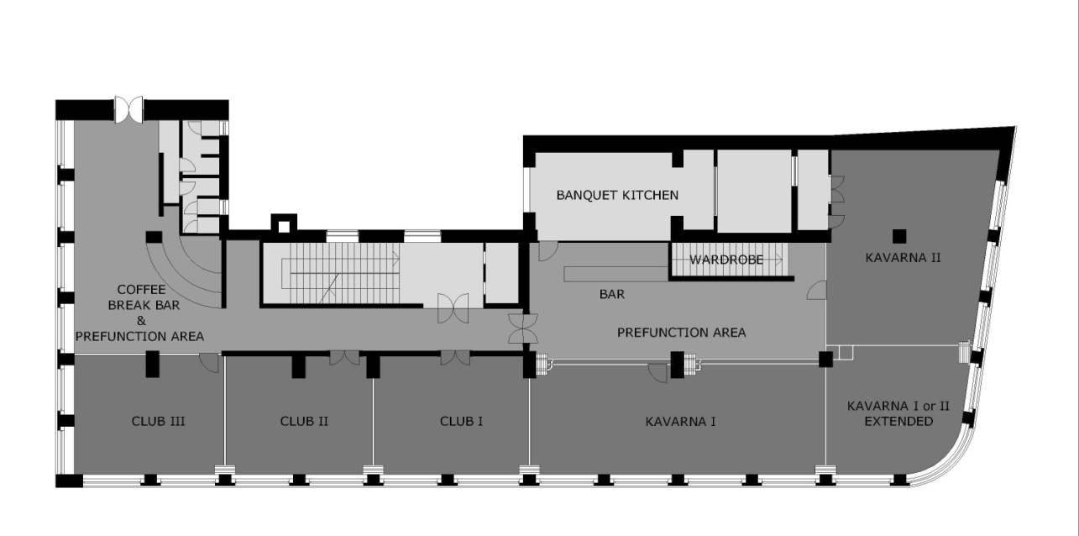
Meeting room equipped with:
- Internet access via Wi-Fi
- LCD projector
- Boards with paper and markers, write-erase board
- Microphones
- Speech desk

Social Event
A social event is planned to take place on one of the evenings of the week of the meeting.

Workshop
The afternoon of Wednesday, 1 December, will be dedicated to the mini-workshop to review the FG results. The presentations will be given by editors and FG management. The workshop is open to local experts. More information on this workshop will be made available on the FG FN homepage http://www.itu.int/ITU-T/focusgroups/fn/index.html
Slovenia in Brief
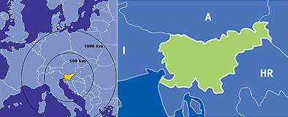
Slovenia, officially the Republic of Slovenia, is a country in Central Europe touching the Alps and bordering the Mediterranean. Slovenia borders Italy on the west, the Adriatic Sea on the southwest, Croatia on the south and east, Hungary on the northeast, and Austria on the north. The capital and the largest city of Slovenia is Ljubljana.
Slovenia covers an area of 20,273 square kilometres and has a population of 2.06 million. Around 40% of Slovenia's land mass is elevated land—mostly in the form of mountains and plateaus—which is located in the interior regions of the country. The highest point of Slovenia is the 2,864 metre (9,396 ft) high Mount Triglav. The majority of the population speaks Slovene, which is also the country's official language. Other local official languages are Hungarian and Italian.
Slovenia is a member of the European Union, the Eurozone, the Schengen area, the Organization for Security and Co-operation in Europe, the Council of Europe, NATO, UNESCO, WTO, OECD, ITU and UN. Per capita, it is the richest Slavic nation-state, and is 85.5% of the EU27 average GDP (PPP) per capita. (more information at http://en.wikipedia.org/wiki/Slovenia)
As a small picturesque country, Slovenia makes a great tourist destination. You can ski in the morning and surrender yourself to the luxury of the Adriatic Sea in the afternoon.
The country is also known for its great wines and delicious traditional food.
Ljubljana, the capital of Slovenia, is a vibrant central European city lying between the Alps and the Adriatic Sea, in a basin where the Ljubljanica river flows into the Sava, at a height of 295 metres above sea level. It covers 273 square kilometres and has a population of 276,000 inhabitants. Its climate is basically continental, with January temperatures averaging - 0.3 and July temperatures 20.7 degrees Celsius
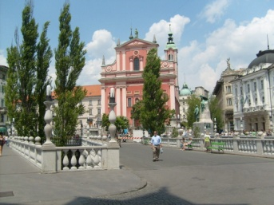. 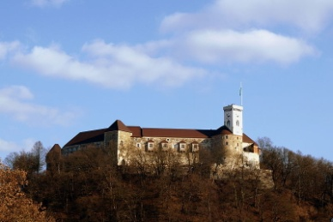 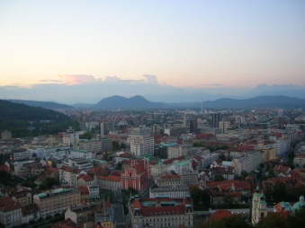
SIGHTSEEING & ACTIVITIES
Within walking distance:
• Ljubljana’s Old Town
• Ljubljana castle
• The three bridges
• Town Hall
• Market
• Tivoli park
• National Museum & National Gallery
• Opera House, National Philharmonic Hall
Visit also: http://www.visitljubljana.si/
Up to 1 hour drive away:
• Bled – a stunning Alpine lakeside resort 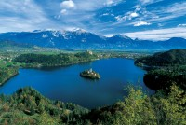
• Postojnska cave
• Lipica stud farm
• Piran & other costal city’s 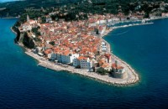

Other practical information
http://www.slovenia.info/en/Praktične-informacije.htm?practical_informations=0&lng=2

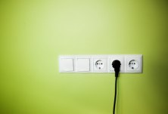Currency: EURO (€)

Electricity supply
Mains electricity in Slovenia is a 230 Volts 50 Hz system. Slovenia uses the Europlug (CEE 7/16). This is the plug used in most other European countries.

Annual temperatures
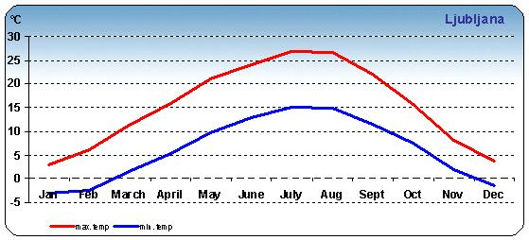
ANNEX 3
(to TSB Circular 146)
Hotel reservation form for Best Western Premier Hotel Slon, Ljubljana, Slovenia

