Telecommunication Standardization
Bureau
Geneva, 3 August 2011

Ref:  Tel:  Fax: | TSB Circular 216  TSB Workshops/T.J.  +41 22 730 5877  +41 22 730 5853 | - To Administrations of Member States of  the Union;  - To ITU-T Sector Members;  - To ITU-T Associates;  - To ITU-T Academia;
E-mail: | tsbworkshops@itu.int | Copy:  - To the Chairmen and Vice-Chairmen of ITU-T Study Groups;  - To the Director of the Telecommunication Development Bureau;  - To the Director of the Radiocommunication Bureau;  - To the Permanent Mission of Mexico in Geneva  - To the Acting Head of the ITU Regional Office for the Americas Region, Brasilia, Brazil

Subject: | ITU Tutorial on Optical Fibres, Cables and Systems  Recommendations (Mexico City, Mexico, 19-30 September 2011)
Dear Sir/Madam,
1 At the kind invitation of the Mexican Government, ITU and the National Polytechnic Institute, Mexico, are co-organizing a “Tutorial on Optical Fibres, Cables and Systems Recommendations” which will take place from 19 to 30 September 2011 at the “Dirección de Bibliotecas” of the National Polytechnic Institute in Mexico City.
On Monday, 26th September at 15:00, a half-day “crash” course on Optical Fibres, Cables and Systems Recommendations will also be held at the same venue. The target audience for this “crash” course will be university students and/or specialized schools from Mexico and other Latin America countries. It is intended to provide participants a general overview of Optical fibres and its characteristics. Discussions will be held in English only. A draft programme of this “crash” course can be found in Annex 2.
2 The Tutorial will begin at 0930 hours on the first day. Participants’ registration will begin at 0800 hours. Detailed information concerning the meeting room will be made available at the entrance of the meeting venue. Discussions will be held in English only.
3 Participation in the Tutorial is open to all. Priority will be given to countries within the Latin America region being the target audience for this event. A registration fee of
US $ 300 per participant is requested and payment should be made via bank transfer at the latest by 5th September 2011 to the account provided below:

UBS SA
Case postale, CH-1211 Genève 2
IBAN : CH54 0024 0240 C810 8252 2
Account No : 240-C8108252.2
SWIFT Code : UBSWCHZH80A
Beneficiary : Union Internationale des Télécommunications
Please send a scanned copy of your payment receipt to us by email to tsbworkshops@itu.int.
4 Based on the ITU-T handbook “Optical fibres, cables and systems”, this Tutorial which is intended to assist engineers, technicians, technologists, mid-level management and regulators in the implementation of optical-fibre-based systems, will provide an in-depth insight into the ITU-T Recommendations that have shaped the optical transport networks of the world.
Participants will gain a better understanding of the Recommendations, how to design and implement projects and how to make the best choices in the various parts of an optical link. In addition, participants will learn how to evaluate a power budget, to choose interfaces and accessories and to define the fundamental parameters for the preparation of technical and administrative specifications for supply contracts or RFPs.
5 A draft programme of the Tutorial is set out in Annex 1 hereto. The updated programme and relevant information will be made available at the ITU-T website at the following address: http://www.itu.int/ITU-T/worksem/optical-fibre/201109/index.html.
6 Practical information including hotel accommodation, transportation, visa and health requirements can be found in Annex 2 and is also available at the ITU-T website: http://www.itu.int/ITU-T/worksem/optical-fibre/201109/index.html.
7 Accommodation: See list of recommended hotels in Annex 2 or at the ITU-T website: http://www.itu.int/ITU-T/worksem/optical-fibre/201109/index.html. Delegates are requested to book their hotel room via the following travel agency:
Mr Víctor Vázquez/American Express
Travel Counselor/BusinessTravel
In-plant Sherwin Williams
Poniente 140 No. 595
Col. Industrial Vallejo
Deleg. Azcapotzalco
Mexico City, 02300
Tel.: (52) (55) 5333 1567
Fax: (52) (55) 5333 1527
E-mail: exsherwin@aexp.com
8 Registration for Tutorial and “crash” course: To enable TSB to make the necessary arrangements concerning the organization of the Tutorial and the “crash” course, I should be grateful if you would register via the on-line form at http://www.itu.int/ITU-T/worksem/optical-fibre/201109/index.html as soon as possible, but not later than 12 September 2011. Please note that pre-registration of participants to the Tutorial and “crash” course is carried out exclusively online.

9 Visa: We would also like to inform you that there may be visa requirements for citizens of some countries to enter Mexico. Where this is the case, visa applications can be made at any Mexican Embassy or Consular Office in your country.
Yours faithfully,

Malcolm Johnson
Director of the Telecommunication
Standardization Bureau
Annexes: 3

ANNEX 1
(to TSB Circular 216)
ITU Tutorial on Optical Fibres, Cables and Systems Recommendations
(Mexico City, Mexico, 19-30 September 2011)

Draft Programme

Week 1, Day 1, Monday, 19 September 2011
08:00 – 09:30 | Registration
09:30 – 10:30 | Opening  Welcome address:  - Mexico representative (TBC)*  - Paolo Rosa, Head, Workshops & Promotion Division, ITU/TSB  Keynote address:  - Principal or Deputy Director of University (Mexico) (TBC)*
Monday | Introduction to ITU-T and the objectives / structure of the Tutorial  Objectives: This session provides an overview of: the ITU and its Sectors and an introduction to ITU-T Study Group 15, to the Handbook and to the structure of the Tutorial.  Tutors:  - Paolo Rosa, Head, Workshops & Promotion Division, ITU/TSB: Introduction to ITU and its sectors;  - Gerard Kuyt, Drake Communications, The Netherlands: Introduction to  ITU-T Study Group 15, to the Handbook and to the structure of the Tutorial
Optical fibres characteristics (Note: Test methods are outside the scope of the Handbook. Moreover the description of the test methods (G.650.1, G.650.2, G.650.3) requires an advance knowledge of mathematics)
Objectives: This session will provide the participants with the description of the dimensional, optical, mechanical and transmission characteristics of the optical fibres. The ITU-T types of optical fibres will be described. This will give the elements to choose the type of fibre that best meets the needs of an optical plant based on the services and systems requirements.

Tutor:
- Gerard Kuyt, Drake Communications, The Netherlands

Week 1, Day 2, Tuesday, 20 September 2011
Tuesday | General characteristics of optical cables  Objectives: The optical cables must protect fibres from mechanical, chemical and human activities. In particular the structure of optical cables is to be designed to protect fibres to withstand the environment where the cable has to be installed: aerial, ducts, underground, shallow water, submarine.  Tutor:  - Gerard Kuyt, Drake Communications, The Netherlands
Week 1, Day 3, Wednesday, 21 September 2011
Wednesday | Optical cables installation [Note: Test methods are outside the scope of the Handbook]  Objectives: The installation is linked to the session before. Specific techniques, such as underground ducts, trenchless techniques, mini-trench, micro-trench, aerial, tunnels, bridges, along railways, in sewer ducts, shallow water and submarine, will be analysed.  Tutor:  - Paolo Rosa, Head, Workshops & Promotion Division, ITU/TSB
Week 1, Day 4, Thursday, 22 September 2011
Thursday | Optical splices, connectors and passive nodes [Note. Test methods are outside the scope of the Handbook.]  Objectives: Fibres and cables are produced according to factory lengths that need to be joined in order to realize the optical links. This session will provide a description of the best techniques for the interconnection of the optical fibres and in particular the optical fibre splices, optical connectors, optical distribution frames, fibre closures, fibre organizers, etc. All these elements are necessary to guarantee an optimized transmission of the optical signal along the fibre.  Tutor:  - Paolo Rosa, Head, Workshops & Promotion Division, ITU/TSB

Week 1, Day 5, Friday, 23 September 2011
Friday | Part I: Optical active and passive components / subsystems  Objectives: There are various passive and active components in an optical/plant: optical transmitters, optical receivers, optical amplifiers, chromatic dispersion compensators, regenerators, transponders, etc. This session will provide the description of these components, will outline how they are used in the optical systems / plants and will indicate the criteria for their choice.  Tutors:  - Makoto Murakami, NTT, Japan  - Gerard Kuyt, Drake Communications, The Netherlands
Week 2, Day 1, Monday, 26 September 2011
Monday |  | General characteristics of optical systems and their specification  Objectives: This part of the tutorial is of fundamental importance. Knowing the characteristics of the optical systems will give the participants the skills they need to make the right choice of equipment which are specified on the basis of applications, optical fibres, number of channels, wavelength of operation, future needs for new services, etc.  Tutor:  - Makoto Murakami, NTT, Japan
15:00- 18:15 |  | “Crash” Course on “Optical Fibres”  Tutors:  - Giancarlo De Marchis, TelCon srl, Italy  - Gerard Kuyt, Drake Communications, The Netherlands  - Makoto Murakami, NTT, Japan  - Paolo Rosa, Head, Workshops & Promotion Division, ITU/TSB
Week 2, Day 2, Tuesday, 27 September 2011
Tuesday | Optical systems design  Objectives: In this part there is the description of the various approaches which can be followed for the design of the optical systems. Moreover the impact of the various impairments on the length of the links and on their capacity are evaluated. The main elements necessary for the design of an optical system will be given.  Tutor:  - Makoto Murakami, NTT, Japan
Week 2, Day 3, Wednesday, 28 September 2011
Wednesday | Optical systems applications  Objectives: Ability to design an optical plant for a specific application will depend on the knowledge of the subjects dealt with in all the previous sessions. An optical system design based on a given Quality of Service and on a given life-time is a “must” for any engineer in order to choose the best optical system for each application in their network and for the needs of his country. Some information on submarine systems will also be provided.  Tutor:  - Giancarlo De Marchis, TelCon srl, Italy
Week 2, Day 4, Thursday, 29 September 2011
Thursday | B- and G-PONs - xDSL, Passive Optical Networks, Broadband PON, Gigabit-PON, Digital Subscriber Lines, Wireless broadband.  Objectives: This part will complete the training showing, from a general point of view, the user-side (last-mile) of a plant/system. This is the part closer to the end-users and to the needs of the service providers. The various techniques that are presently used will be described together with their advantages and drawbacks both for wired and wireless networks.  Tutor:  - Giancarlo De Marchis, TelCon srl, Italy
Week 2, Day 5, Friday, 30 September 2011
Friday | Part I: Operation & Maintenance, safety and environmental aspects  Objectives: Operation and maintenance are elements that the engineers have to learn in order to take actions to limit the effects of systems failures or low performance.  Tutor:  - Giancarlo De Marchis, TelCon srl, Italy  Part II: Quality Assurance, Conformity and Interoperability issues  Objectives:  The ISO 9000 family of standards relate to quality management systems and are designed to help organizations ensure they meet the needs of customers. Implementing ISO 9001 it is guaranteed that, thanks to measures put in place by a manufacturer, the process to produce goods according to certain standards and meeting the customer's requirements is under control. An example applicable to submarine cables will be given. Conformity to standards requirements is a first step that can help in achieving interoperability of products from different manufacturers. This session will show the main aspects of Quality Assurance and the Conformity and Interoperability Programme that set up by ITU is applicable to Optical Fibers Systems.  Tutor:  - Paolo Rosa, Head, Workshops & Promotion Division, ITU/TSB

ANNEX 2
(to TSB Circular 216)
“Crash” Course on Optical Fibres, Cables and Systems
26 September 2011 (15:00 – 18:15)

Draft Programme

Time | Topic | Speaker
15:00 - 15:15 | Opening Ceremony and welcome addresses:  UNI Representative  ITU Representative | TBC  Paolo Rosa,  Head, Workshops & Promotion Division, ITU/TSB
15:15 -15:45 | ITU: Keynote speech: ITU & ICTs, ITU and Academia | Paolo Rosa,  Head, Workshops & Promotion Division, ITU/TSB
15:45 -16:20 | Optical Fibres transmission properties, Optical technology past and future for broadband opportunities | Giancarlo De Marchis, TelCon srl, Italy
16:20 -16:45 | Optical Fibres and cables: mechanical properties, structures, performance, terrestrial and sub-marine applications | Paolo Rosa,  Head, Workshops & Promotion Division, ITU/TSB
16:45 - 17:15 | Coffee Break
17:15 - 17:45 | Optical Fibres systems: active and passive solutions for short and long distance, terrestrial and submarine applications | Makoto Murakami,  (NTT, Japan)
17:45 -18:15 | Conclusions and closing ceremony | Paolo Rosa,  Head, Workshops & Promotion Division, ITU/TSB  Representative from University, Mexico (TBC)

ANNEX 3
(to TSB Circular 216)
ITU Tutorial on Optical Fibres, Cables and Systems Recommendations
(Mexico City, Mexico, 19-30 September 2011)

INFORMATION ON MEXICO CITY
Climate in Mexico. The Federal District’s height above sea level means that its climate ranges from temperate to cold, humid and alpine tundra in the highest parts of the mountains in the south. The urban zone has a temperate, rainy climate, with temperatures that can exceed 28°C on some days in late spring and descend to as low as 0°C or less in January. The wet season in the Federal District lasts from May to November, with the heaviest rainfall between June and August.
Records give an average maximum temperature in September of 22°C, and a minimum of 11°C.
Local time. Time difference from GMT/UTC

Standard time: | UTC/GMT -6 hours
Summer time: | +1 hour
Current time zone difference: | UTC/GMT -5 hours
Time zone abbreviation: | CDT
Summer time
DST commenced at the official local time - Sunday, 3 April 2011, 02:00
DST ends at the official local time - Sunday, 30 October 2011, 02:00
Electricity. 110 volts
Currency. The Mexican peso is Mexico’s official currency.
As an indication, the exchange rate on 27 July 2011 was:
Purchase: 11.6148 Sale: 11.6204
Banks and credit cards. Visa and MasterCard are widely accepted. Banks open Monday to Friday, and although timetables vary they are generally open between 0900 and 1600 hours.
Vaccinations. Before travelling to Mexico, it may be necessary to have certain vaccinations or obtain certain medicines against ailments to which you may be at risk by travelling to this destination. (Note: Your doctor or medical carer will decide what is required, based on factors such as your health, immunization history, the areas of the country you are to visit, and the activities foreseen.)
Transport
a) Tutors
• Will be picked up at the airport and taken to the Residencia de Investigadores, where they will receive accommodation for the required number of days. They will be taken back to the airport on their day of departure.
• Will be taken from their place of lodging to the workshop venue every day of their stay.
b) ITU officials
• Will be entitled to use the airport/hotel/airport and hotel/workshop-venue/hotel transfer services.
c) Participants
• Will have to make their own way from the airport to the hotel of their choice.
• Will be entitled to use the hotel/workshop-venue/hotel transfer service.
Hotel bookings:
Reservations should be made through:
Víctor Vázquez/American Express
Travel Counselor/Business Travel
In-plant Sherwin Williams
Poniente 140 No. 595, col. Industrial Vallejo, Deleg. Azcapotzalco, México D.F. 02300
Telephone: (52) (55) 5333 1567
Fax: (52) (55) 5333 1527
E-mail: exsherwin@aexp.com
This is because the rates offered by the hotels are preferential through this travel agency.
Hotel information

1. HAMPTON INN - CENTRO HISTORICO
Price: MXN 850.00
Includes: Buffet continental breakfast
Address: Calle 5 de Febrero, N º 24 Centro H, Ciudad de México, C.P. 06060
Tel: 52-55-8000-5000 Fax: 52-55-8000-5001
Web. http://hamptoninn.hilton.com/en/hp/hotels/index.jhtml;jsessionid=SIUWXX5WNY3T2CSGBJNM22Q?ctyhocn=MEXCHHX
Approximate distance from workshop venue: 9 km

Map of hotel location

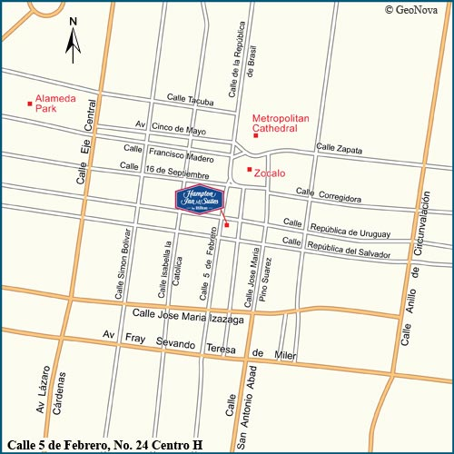
Local airports
• Benito Juárez International Airport
Distance from hotel: 5 miles.
Driving time: 15 min.
Directions: Exit Airport, turn left on Circuito Interior. Turn right onto Fray Servando, then right onto Moneda. Turn left on Seminario. Turn right on Pino Suárez Ave., then left onto Rep. de Uruguay. Hotel is on the left.
• "Licenciado Adolfo López Mateos" airport
Distance from hotel: 40 miles
Driving time: 1 hour
Directions: Exit Airport, turn left on Mexico/Toluca Rd. Drive to the Santa Fe toll. Continue onto Paseo de la Reforma, then turn right on Juarez Ave. Straight on Francisco I. Madero, San to Zócalo. Right onto 5 de Febrero. Hotel is on the left.

Directions to hotel from different points in the city
From the Intersection of Paseo de la Reforma Avenue and Juarez Avenue - Traveling north from Polanco turn right on Juarez Avenue and if travelling south from Garibaldi turn left on Juarez Avenue. Travel .4 mile and Juarez Avenue becomes Francisco I. Madero Street continue straight for .4 mile to the Zocalo, turn right onto 5 de Febrero and travel 2 blocks. The hotel entrance is on your left.
From Santa Fe - Polanco and Points Southwest. From Santa Fe take Prolongacion Paseo de la Reforma Avenue, then travel 3 miles to Polanco continue on Paseo de la Reforma Avenue for 3 miles and turn right on Juarez Avenue. Follow directions listed above from the Intersection of Paseo de le Reforma and Juarez Avenue.
From San Angel and Points Southeast - Exit San Angel on Insurgentes Avenue travel 6 miles and turn right on Paseo de la Reforma avenue, travel 2.3 miles and turn right on Juarez Avenue. Follow directions listed above from the intersection of Paseo de le Reforma and Juarez Avenue.
From Vallejo and Points Northwest - Exit Parque Industrial Vallejo on Vallejo Avenue travel 3 miles and turn right on Insurgentes Norte Avenue, travel 2 miles and turn left on Paseo de la Reforma avenue, travel 2.3 miles and turn right on Juarez Avenue. Follow directions listed above from the intersection of Paseo de le Reforma and Juarez Avenue.
From Xochimilco and Points South - Exit Xochimilco on Mexico-Xochimilco Avenue and travel 4 miles. Mexico-Xochimilco Avenue changes to Tlalpan Avenue. Continue straight 8 miles where Tlalpan Avenue changes to 20 de Noviembre Avenue. Continue straight .7 mile and turn left on Republica de Uruguay, travel 1 block and turn left on 5 de Febrero. The hotel entrance is on your left.
Cross Streets - 5 de Febrero and Republica de Uruguay

2. FIESTA INN CENTRO HISTORICO
Prices: MXN $1 090.00 SGL (ONE PERSON) MXN 1 141.00 DBL (TWO PEOPLE)
Includes: CONTINENTAL BREAKFAST
Address: Av. Juárez 76 Col. Centro, 06010, Ciudad de México, Distrito Federal, México
Tel: +52 01 (55) 51 30 29 00
Fax: +52 01 (55) 51 30 29 10
Web. http://www.fiestainn.com/es/mx-ciudad-de-mexico/hotel-centro-historico
http://www.pricetravel.com.mx/fiesta-inn-centro-historico/mapa
Approximate distance from workshop venue: 10.9 km
Map of hotel location
Located within the Parque Alameda Commercial Plaza, in the Historic Center, very close to Mexico City's main attractions, such as the Cathedral, the Casa de los Azulejos, Bellas Artes and countless museums. The hotel is situated just minutes from Reforma and Polanco Avenues, and important business, commercial and social districts.
The Fiesta Inn Centro Histórico is located in the Plaza Parque Alameda, opposite the Parque de la Alameda, close to the Plaza del Zócalo and Paseo de la Reforma. It offers immediate access to all forms of transport, and is one block away from the Secretariat of Foreign Relations. The international airport (MEX) is a mere 12 kilometres away.
The hotel offers 140 large rooms. Amenities include air conditioning, private bathrooms with bath and shower, cable television, coffee maker, minibar, large desktop and Internet access. There is a room specially equipped for differently abled persons.
The Fiesta Inn Centro Histórico has a restaurant that serves a wide variety of national and international dishes, as well as a lobby bar. For conferences, events and celebrations, it offers four event rooms and two meeting rooms able to host up to 210 people. Families with children can enjoy the Fiesta Kids Club during Sunday brunch. The Fiesta Inn Centro Histórico hotel also has a fully equipped business centre open 24 hours a day, a gym, 24-hour room service and wireless Internet access in the lobby. Transport to and from the airport is available at additional cost, as is parking in the nearby commercial centre (will be charged for).
Services included Business centre • Children’s club • Gym • Rooms for disabled people • Internet • Wireless Internet • Event rooms • Housekeeping service
Services at additional cost Nearby parking • Room service • Laundry • Airport transfer service
Restaurants (1) Café la Fiesta
Bars (1) Lobby Bar
Rooms
Capacity
Adults (13+ years old): max 2
Children (0–12 years old): max 1
Maximum capacity: 3 people
View: Street
Check-in: 15:00 | Check-out: 13:00
Children free: 0 to 12 years old
Amenities:
1 king-size or 2 double beds, air conditioning, coffee maker, direct-dial telephone with voice-mail, smart key, hair-drier, Internet access, iron and ironing board, private bathroom with shower, safe, desktop, cable/satellite TV.

3. CITY EXPRESS EL ANGEL
Prices: MXN 1 063.00 (ONE PERSON) MXN 1 163.00 (TWO PEOPLE)
Includes: BUFFET CONTINENTAL BREAKFAST
Address: Avenida Paseo de la Reforma No. 334, Col. Juárez, Del. Cuauhtemoc, México D.F. C.P. 06600. Adjacent to Ángel de la Independencia and 15 minutes from the historical centre.
Tel: (55) 5228-7800
01-800-248-9397
Web. http://www.cityexpress.com.mx/WebNew/prop_diseno/elangel.htm
Approximate distance from workshop venue: 11 kilometres
Map of hotel location
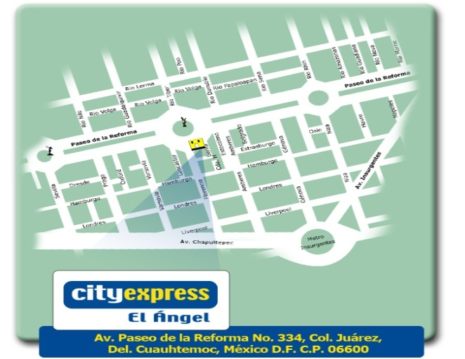

Hotel services
• 137 rooms
• Cable colour TV
• Air conditioning
• Meeting room
• Business centre
• Breakfast included
• Gym
• Terrace
• Free wire and wireless Internet
• Voice mail and Data Port.
• Restaurant
• Parking
• State of the art security systems and international standards
• Local and international calls
Distance from hotel to main interest points in the city
Benito Juárez airport 30 minutes
North coach station 30 minutes
South coach station 40 minutes
Alameda Central, 10 minutes
Zócalo Capitalino 15 minutes
World Trade Center 15 minutes
Torre Mayor 3 minutes
Anthropology Museum 5 minutes
Palacio de Bellas Artes 10 minutes
National Auditorium 7 minutes

4. CITY EXPRESS EBC REFORMA
Prices: MXN 753.00 (ONE PERSON) MXN 823.00 (TWO PEOPLE)
Includes: BUFFET CONTINENTAL BREAKFAST
Address: Havre No. 21 Col. Juárez, Ciudad de México, Distrito Federal (A block away from the corner of Reforma and Insurgentes, in front of the Reforma 222 shopping centre.)
Tel: (55) 1102-0280
01-800-248-9397
Web. www.cityexpress.com.mx
Approximate distance from workshop venue: 10 kilometres
Map of hotel location
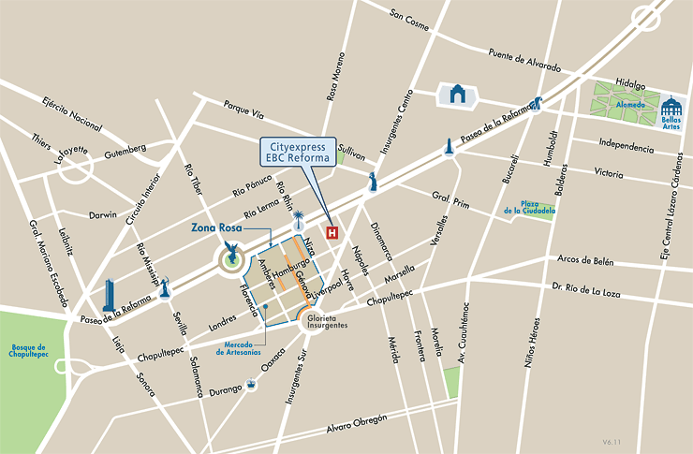

SERVICES
Continental breakfast included, free Internet, meeting room, restaurant, event room, business centre and gym.
ROOMS
Cable colour TV, long-distance telephone, Internet, air conditioning and automatic wake-up service.

5. QUALITY INN DE LINDAVISTA
Price: MXN 750.00
Includes: Continental breakfast
Address: Av. Miguel Bernard No 670, Col. La Escalera, CP. 07320, México D.F.
Tel: (0155) 5747-4520 Fax : (0155) 5747-4527
Web. http://www.qualityinnlindavista.com/principal.html
Approximate distance from workshop venue: 2.5 kilometres
Map of hotel location
http://maps.google.com.mx/maps?saddr=Instituto+Polit%C3%A9cnico+Nacional,+U.+Profesor+Adolfo+L%C3%B3pez+Mateos,+Gustavo+A.+Madero,+Ciudad+de+M%C3%A9xico&daddr=Avenida+Miguel+Bernard+670,+Col.+La+Escalera,+07320+Mexico+City,+DF+(Operadora+De+Hoteles+Lindavista,+S.A.+De+C.V.)&hl=es&ie=UTF8&sll=19.4369,-99.157841&sspn=0.369729,0.441513&geocode=FY9_KQEd-T4X-inVx9ZesfnRhTFpFTTSIUXGeg%3BFc2yKQEdND0X-iFNwHxnV_IMtiknsKIBzPnRhTGnMuoaDvZO0Q&mra=pd&t=h&z=15
Services
3 telephones with 2 lines.
Cable colour TV.
Free high-speed wireless Internet.
Room for differently abled persons.
Coffee maker with free coffee. Desktop.
Air conditioning and heating in rooms.
Iron and ironing board. Smokers’ rooms.
Room service/clock/alarm.
Hair-drier. Refrigerator.

_____________

