Radiocommunication Study Groups
Source: Document 5A/TEMP/274 | Annex 5 to  Document 5A/636-E
 | 10 November 2014
 | English only
Annex 5 to Working Party 5A Chairman’s Report
Working document towards a draft New
Report ITU-R M.[LOCAL_CoVERAGE]
Operational guidelines for the deployment of broadband wireless access systems
for local coverage operating below 6 GHz
TABLE OF CONTENTS
Page
Summary 2
1 Introduction 2
2 Definition and terminology 3
2.1 Definition 3
2.2 Terminology 4
2.3 Abbreviations 4
3 General concept and technical study framework 5
3.1 General concept of local coverage 5
3.2 Technical properties of local coverage 7
3.3 Deployment cases of local coverage 8
3.4 Use cases and categories 10
3.5 Scope and subjects of the studies 11
3.6 Currently available technologies 13
4 Operation of frequency band for local coverage 13
4.1 Operational scenarios 13
4.2 Modelling and analysis 15
4.3 Operational requirements 19
5 Technical and Functional Features for Radio Stations 22
5.1 Functional features for network operation and management of local
coverage 22
5.2 Functions and technical features for radio station 23
5.2.1 Network management functions 24
5.2.2 Radio resource management functions 24
5.2.2.1 Decision functions for local coverage 24
5.2.2.2 Management and control functions for operation of each RAN 25
6 Conclusion 25

Summary
This Report deals with a new operation concept of Broadband Wireless Access (BWA) systems in Recommendation ITU-R M.1801 for local coverage in frequency bands above those frequencies typically used for macro cell deployments. This Report is intended to provide non-exhaustive operational guidelines for the deployment of BWA systems for local coverage in the frequency bands below 6 GHz. The study in this Report addresses technical analysis of local coverage, modelling of some common operational scenarios and analysis to investigate possibilities of [relaxing operational constraints/developing operational flexibilities]. Taking advantage of properties of local coverage, the study focuses on flexible and efficient operation of BWA systems such as multi-standard radio operation and [[relaxation/reduction/ elimination] of constraints/flexibility] (e.g., for network synchronization). Possibilities are presented for less constrained operation of BWA systems under certain operational conditions of local coverage.
Recommendation ITU-R M.1801 defines BWA technologies, including IMT. However, this Report is intended to be technology-neutral and is not intended to promote any applicable Radio Access Technology (RAT) found in Recommendation ITU-R M.1801. This report is not intended to address any regulatory issues including the identification of suitable frequency ranges for BWA systems. Frequency sharing with other services is out of the scope of this study. Notwithstanding, sharing mechanisms may be necessary if local coverage is deployed in a license-exempt or shared-access band.

1 Introduction
This Report addresses a new concept of local coverage, which is intended for efficient and flexible operation of broadband wireless access (BWA) systems in Recommendation ITU-R M.1801 [1] operating in the frequency bands below 6 GHz. Traditionally, macro cell mobile networks have been deployed mainly in the bands below 3 GHz. In higher frequency bands, cell coverage tends to become smaller due to the propagation characteristics. Different from conventional macro-cell radio access networks, BWA systems in higher frequency bands are generally used to serve local coverage area using small cells and hot spot deployments. The study in this Report is not intended for the conventional macro cell deployments.
This Report first provides a new definition of local coverage to characterize the operation of BWA systems in limited geographical coverage in frequency bands below 6 GHz. It should be noted that this study does not assume any specific Radio Access Technology (RAT) as the study is intended for generally applicable methodology irrespective of RATs as found in Recommendation ITU-R M.1801. In section 2, the new concept of local coverage is clarified with focus on the difference from conventional macro cell operation. The objective of the analysis in this Report is to clarify technical properties of local coverage, to develop effective operational scenarios and to derive new, non-exhaustive operational management guidelines which would allow more efficient and flexible use of local coverage systems. The extent to which the local coverage deployment scenarios will be implemented depends upon compliance with national and ITU Radio Regulations.
The scope of the study is defined by the following items:
– Efficient use of frequency bands below 6 GHz for operation of BWA systems by developing flexible operational guidelines of local coverage under certain conditions
– Technical analysis of the characteristics of local coverage.
– Illustrative operational scenarios and modelling for analysis of local coverage operation.
– Illustrative operational requirements and management scheme for local coverage of BWA systems.
– Technical and functional features for radio stations to support local coverage operation of BWA systems.
In some cases, local coverage areas may be isolated from each other while in some other cases neighbouring local coverage areas may have mutual interaction.
It is expected that flexible approaches for operation of local coverage as well as use of frequency bands could apply where mutual interaction is limited.
In section 3, technical properties of local coverage are investigated in detail together with use cases of local coverage. Section 4 deals with operation scenarios of local coverage and use of notional frequency bands. Detailed modelling is presented for the categorized operation scenarios. Based on the proposed modelling, each operation scenarios is analysed to investigate to what extent operational flexibilities may be employed for local coverage. As an operational guideline, operational requirements and possible [intra-system network] management scheme are also discussed. Based on the analysis in section 4, technical characteristics of radio stations are introduced in section 5 to take full advantage of efficient and flexible operation of local coverage.

2 Definition and terminology

2.1 Definition
Local coverage: a type of radio system deployment that provides coverage limited to small areas (e.g. pico cells, traffic hot spots). Those areas may be isolated, adjacent or overlapping each other. However, those overlapping areas are not expected to result in seamless wide area coverage.
[Editor’s note: The term “Coverage area” is defined in Recommendation ITU-R V.573 as “coverage area (of a terrestrial transmitting station)… Area associated with a transmitting station for a given service and a specified frequency within which, under specified technical conditions, radiocommunications may be established with one or several receiving stations.”
Note 1 – Several coverage areas may be associated with one and the same station.
Note 2 – The technical conditions include the following: characteristics of the equipment used both at the transmitting and receiving stations, how it is installed, quality of transmission desired, e.g., protection ratios and operating conditions.
Note 3 – The following may be distinguishable:
– interference-free coverage area, i.e., that limited solely by natural or artificial noise;
– the nominal coverage area: it is defined, when establishing a frequency plan by taking into account the foreseen transmitters;
– the actual coverage area, i.e., with allowance made for the noise and interference which exists in practice.
Note 4 – Furthermore, the term “service area” should have the same technical basis as for “coverage area”, but also include administrative aspects.]

2.2 Terminology
[Editor’s note- need to check these terms against existing ITU-R publications including M.1797, F.1399, V.573, etc.]
– Base station (BS): The common name for all the radio equipment located at one and the same place used for serving one or several cells.
[Editor’s note: a note should be added to clarify the use of the term “call” in the “handover” definition instead of “session”.]
– Handover: The action of switching a call in progress from one cell to another (intercell) or between radio channels in the same cell (intracell) without interruption of the call.
NOTE 1 – Handover is used to allow established calls to continue when mobile stations move from one cell to another (or as a method to minimize co-channel interference). (REC. M.1224)
– Macro cells: Cells with a large cell radius, typically several km.
– Mobility: a terminal or a subscriber to access telecommunications services from different locations and while in motion, and the capability of the network to identify and locate that terminal or the associated subscriber.
– Nomadic Wireless Access: Wireless access application in which the location of the end-user termination may be in different places but it must be stationary while in use.
– Pico cells: small cells with a typical cell radius of less than 50 m that are predominantly situated indoors.
NOTE 1 – Pico cells are characterized by medium to high traffic density support for mobile low speed stations and wide band services.

2.3 Abbreviations
BWA: Broadband Wireless Access NLOS: Non-Line of Sight
NWA: Nomadic Wireless Access
RAN: Radio Access Network
RAT: Radio Access Technology
RLAN: Radio Local Area Network
RSSI: Received Signal Strength Indicator
TDD: Time Division Duplex
2.4 Related ITU-R Recommendations or Report
[1] Recommendation ITU-R M.1801 – “Radio interface standards for broadband wireless access systems, including mobile and nomadic applications, in the mobile service operating below 6 GHz”.
[2] Recommendation ITU-R M.1652 – “Dynamic frequency selection in wireless access systems including radio local area networks for the purpose of protecting the radiodetermination service in the 5 GHz band”.
[3] Report ITU-R M.2225 – “Introduction to cognitive radio systems in the land mobile service”.

3 General concept and technical study framework

3.1 General concept of local coverage
The following technical characteristics of radio access coverage are taken into consideration.
– Propagation losses at higher frequencies are generally greater than at the lower frequencies typically used for macro-cell deployments.
– In such frequency bands, small area coverage is typically provided by a low transmit power and low antenna height base station (so-called low power and low tower).
– Small area coverage creates areas of limited coverage, which may be isolated from each other, adjacent to each other or overlapping with each other.
– Such limited coverage may be used for localized or confined operation of Radio Access Network (RAN).
Figure 1 illustrates local coverage for smaller areas consistent with the explanation above. Note, however, that lower frequencies can also be used to create small cells.
Figure 1
Smaller area coverage
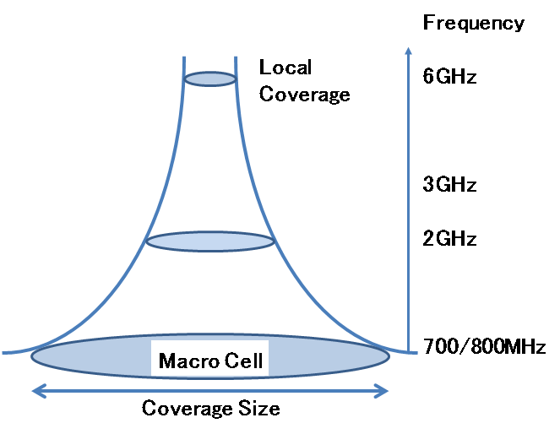
Figure 2 shows an example of local coverage in comparison with conventional seamless macro coverage. Refer to section 3.2 for detailed technical properties of local coverage.
Figure 2
Basic Concept of Local Coverage
Seamless Coverage
Examples of Local Coverage
Example of Macro Cell
(Case 1)
Isolated coverage
(Case 3)
Overlapping coverage
(Case 2)
Adjacent coverage
Table 1 provides comparison between seamless macro cell and local coverage.
[
Table 1
Comparison of Macro cell and Local coverage
 | Macro cell | Local coverage
Seamless coverage | Mandatory | Not required
Positioning of coverage | Adjacent or Overlapping without coverage gap | Isolated/Adjacent/Overlapping
Mobility | High mobility | Nomadic or Low mobility
Handover | Seamless Handover | Not required but may provide
]

3.2 Technical properties of local coverage
Broadband wireless access (BWA) systems included in Recommendation ITU-R M.1801 operate in the bands below 6 GHz. Due to radio propagation characteristics, conventional macro-cell radio access networks have been deployed mainly in the bands below 3 GHz.
As discussed in section 3.1, propagation losses at higher frequencies are generally greater than at the lower frequencies typically used for macro-cell deployments. This Report addresses three example scenarios for BWA systems operating in 3 GHz to 6 GHz. Their implementation and feasibility will depend upon the resolution of technical challenges and compliance with national and ITU Radio Regulations.
The technical properties of local coverage should be analysed for the study of effective operation of local coverage in deployment of BWA systems in bands below 6 GHz. The following properties should be taken into consideration:
(1) Characteristics of coverage
– Propagation losses at higher frequencies are generally greater than at the lower frequencies typically used for macro-cell deployments
– [Local coverage] may be provided by a low transmit power and low antenna height base station (so-called low power and low tower).
– [Local coverage] areas may be isolated in some cases such as indoor coverage with sufficiently large penetration loss by building walls.
– The size of coverage has not been rigidly defined for local coverage, which may include indoor pico cell, femto cell, access points of radio local area networks, outdoor pico cell or equivalent coverage.
– Local coverage does not assume seamless and full coverage for wide area.
– Local coverage allows coverage gap as mutual positioning of coverage may be isolated, adjacent or overlapping.
– Such isolated local coverage may be operated with minimal interference to and from other cells.
– Where macro cell coverage is already available, local coverage can provide additional localized capacity in different frequencies. This, however, does not preclude a use of local coverage without macro cell.
(2) Usage of local coverage
– Local coverage is intended to provide broadband wireless access for a limited area which may have very high density traffic demands.
– Such local coverage is mainly deployed in urban areas or for indoor usage.
– [Local coverage is used mainly for nomadic and low-mobility operation for both indoor and outdoor coverage.]
– Applications of local coverage focuses on high-efficiency broadband mobile data transmission in a limited area rather than seamless coverage for wide areas. Therefore, seamless handover capabilities are not mandatory for local coverage.
– Mobility management functions of high complexity for macro-cell mobile systems are not necessarily required.
– The proposed operational guidelines to be developed are not intended for a specific wireless access technology.
[
(3) Use of frequency bands]
– Local coverage may share the same frequency bands with other neighbouring local coverage. Local coverage may be deployed in licensed and/or license-exempt frequency bands.
– [It is not assumed that local coverage shares the same frequency band with a macro-cell, which is overlapping with local coverage. Operation of local coverage is therefore primarily intended for frequency bands higher than macro-cell frequency bands]. Local coverage however may share the same frequency bands with other neighbouring local coverage. Local coverage may be deployed in licensed and unlicensed frequency bands.
– Sufficiently large and contiguous bandwidth, when available, could be used for such local coverage in order to provide large transmission capacity and high throughput for practical broadband mobile applications. Higher frequencies, where large and contiguous bandwidths may be available, could be especially suitable for this type of high bandwidth local coverage.

3.3 Deployment cases of local coverage
Different from macro cell for seamless coverage, local coverage may be deployed in various ways due to its technical properties. Deployment of local coverage can be categorized into the following three cases.
Figure 3
Three Deployment Cases of Local Coverage
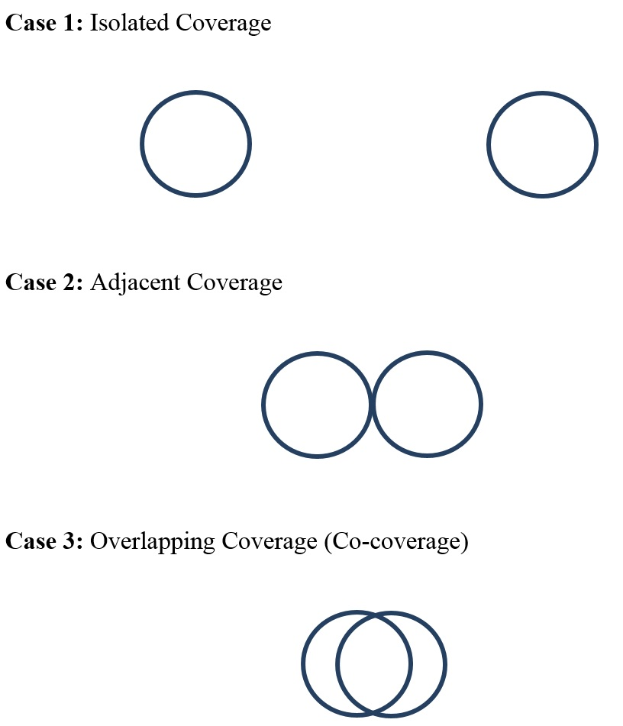
As local coverage has limited area coverage, mutual interaction between near-by local coverage depends on relative positioning of coverage as shown in the above three cases.
In Case 1, a pair of local coverage areas is isolated from each other. Figure 4 illustrates examples of isolated local coverage. Isolation between them is large enough to permit the disregard of interference from other coverage. This implies that each of the coverage may be operated independently without any constraints to protect and to coordinate with each other. This may lead to more flexible use of frequency band and less constrained operation of RAN systems. For example, two different radio access technologies may be operated in adjacent sub-bands without any guard band if the adjacent sub-bands are used in a pair of isolated local coverage respectively. Due to very little inter-coverage interference, the radio link design in Case 1 is generally free from transmission impairment by inter-network interference.
Figure 4
Examples of Isolated Local Coverage
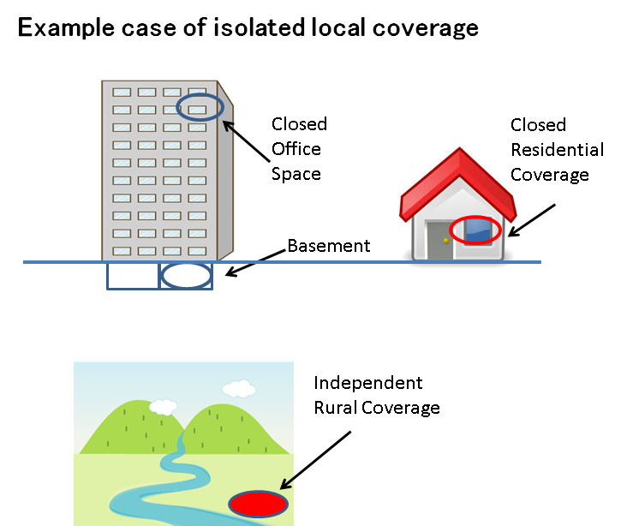
In Case 2, a pair of local coverage areas are adjacent to each other. There exists loose coupling between the adjacent coverage. As the edges of coverage area are in contact with each other, inter-coverage interference is observed only around the cell edge. The operation of adjacent coverage is not as flexible as in Case 1.
In Case 3, two local coverage areas overlap with each other. Interference is inevitable in the overlapping area. For Case 3, constraints would apply because of the co-coverage area. Thus, inter-network interference is a dominant transmission impairment factor in the radio link design in Case 2 and Case 3.

3.4 Use cases and categories
In general, broadband wireless access systems have been used for wide variety of applications, which include but are not limited to the following use cases.
– Local access to fixed broadband (corporate network and consumer network).
– Traffic offloading from mobile data networks.
– Outdoor hot spot.
– Public facilities (Railway stations, Airport, Stadium, Conference hall, etc.).
– Indoor local access (Office LAN and home network).
– Pico-cell and Femto-cell.
– Occasional use for a big event.
– Emergency applications.
Local coverage may be used for both indoor and outdoor coverage. Indoor coverage may be provided for public space (e.g., airport, station), office areas including basements and residential use. The use of local coverage may also be categorized into two types. The first type is closed access by limited users such as telecommunication network service subscribers and registered users for both corporate and consumer applications. The second type is open access for public users.
Local coverage may be used as a general means for use cases which may be categorized as follows:
– Gap filler for macro cell
– Traffic offloading from other mobile networks (particularly for high density traffic)
– Local access to broadband networks
– Others (e.g., emergency operation, occasional use, isolated rural area coverage, ship/aircraft).
In these general use cases, a specific radio access standard is not assumed and a BWA systems in Recommendation ITU-R M.1801 could apply. These use cases may be summarized in accordance with the above discussed categories as shown in the following table.
Table 2
Use Cases
Usage | Indoor | Outdoor
Gap filler for macro cell | Femtocell | Pico Cell
Traffic offloading from other mobile NWs | Pico Cell / RLAN  for Residential / Enterprise / Factory / Public Facility* | Pico Cell / RLAN  (Low Mobility)  for Hotspot / Public Facility*  for visitor to Enterprise / Public Facility*
Local access to broadband NW | Pico Cell / RLAN  for Residential / Enterprise / Factory / Public Facility* | Pico Cell / RLAN (Low Mobility)  for Hotspot / Public Facility*  for visitor to Enterprise / Public Facility* (
Others (emergency, occasional, rural, ship/aircraft) | Pico Cell / RLAN  for Occasional Big Event  for Train / Ship / Aircraft | Pico Cell / RLAN  for Occasional Big Event  (Nomadic)  for Station / Port / Airport
* Sports Stadium, Conference hall, others.

These use cases described in Table 3 cover a number of generic uses of local coverage, which may fall under the categories of operational scenario defined in section 4.

3.5 Scope and subjects of the studies
In section 2.1, the definition of local coverage was first provided, for which the detailed technical characteristics were presented in section 3.2. Taking into consideration these technical characteristics of local coverage, the proposed study intends to analyse [efficient] and flexible ways of operating local coverage. The study is based on the technical characteristics of local coverage as summarized in the following table.
Table 3
Technical Characteristics of Local Coverage
Item by layer | Description
Physical transmission | – Coverage for [local coverage] areas rather than seamless coverage for wide areas  – Coverage for outdoor and indoor use.  – Example use cases: Cellular Femto-cell and RLAN.  – Type of Coverage:  • isolated;  • edge connecting to adjacent one(s);  • overlapped coverage with adjacent one(s).  – Interference from other networks is negligible in radio link design for the isolated coverage.  – Inter-network interference is dominant in radio link design for the overlapping coverage
Shared access | – Independent channel assignment control by a base station.  – Coordinated channel assignment control by base stations.  – Frequency/time division multiple access for the shared use by sensing  prior to transmission on a channel.  Frequency sharing arbitrated by a sharing mechanism (e.g. database).  – Dedicated use of a frequency band or sub-band by a single network (as in licensed bands)  – Shared use of a frequency band or sub-band by multiple networks  – Shared use of a frequency band or sub-band by a single RAT  – Shared use of a frequency band or sub-band by multiple RATs  – Independent channel assignment control by a base station.  – Coordinated channel assignment control by multiple base stations.
Network control | – Network control and management within a single RAN.  (Authentication and access admission control)  (Monitoring of operational status, network performance and quality)  – Coordinated network control among base stations of the same network.  – Coordinated network operation by a centralized or distributed control.  With or without handover between [local coverage]  With or without integrated and coordinated operation with macro coverage  Options for heterogeneous network operation and interworking.  – Coexistence of multiple RATs under certain conditions.

Based on the given technical characteristics, the following subjects are studied for operation of local coverage in this Report.
– Technical analysis of local coverage.
– Operation models of local coverage.
– Flexibility in use of frequency bands for local coverage.
– Operational requirements and management scheme for local coverage.
– Technical and functional features for radio stations of local coverage (e.g., network functions, radio resource management functions, control and management functions).
It should be noted that the possibility of less constrained and more efficient operation of frequency bands under certain operational conditions of local coverage may exist. The study considers operational conditions of local coverage to what extent operational [constraints/flexibilities] may be [relaxed/employed]. The objectives of the flexible and efficient operation of local coverage include but are not limited to
– Coexistence of multiple RAT
– Elimination of constraints on network timing synchronization
– Flexibility in TDD frame structure for partitioning uplink and downlink capacity
– Increase of net transmission bandwidth of operational frequencies
– Assessment and reduction of operational constraints
– Assessment of overprotection and excessive operational constrains.
Once flexible operational conditions for local coverage networks are identified, methodologies are then needed to detect such operational conditions and to make decisions to facilitate less constrained operation. These subjects are new study items for operation and management of frequency bands by local coverage. To this end, the study may include operation control and management functions for stable operation of broadband wireless systems. The proposed operational guidelines to be developed are not intended for a specific wireless access technology. The study will explore generic guidelines to enhance the use of local coverage by developing operational [flexibility/requirements] for the existing wireless access framework.
The study subjects, which will be discussed in sections 4 and 5, include fundamental elements of technologies as follows:
– Sensing of co-channel and adjacent channel interference.
– Decision criteria for shared operation of spectrum.
– Decision criteria for adjacent band compatibility.
– Radio network synchronization.
For these functionalities, some of technologies described in section 3.4 may be applicable. In other cases, further study may be needed.

3.6 Currently available technologies
Some of the examples in the use cases in section 3.4 have been already implemented, such as successful use of pico cell and femto cell [2, 3]. Various radio access technologies in Recommendation ITU-R M.1801 have also been widely deployed.
For effective use of frequency bands, various operational schemes have been studied. An example is Dynamic Frequency Selection as found in Recommendation ITU-R M.1652 [4]. Cognitive Radio is one of the most promising technologies for advanced and efficient use of frequency bands. Recent studies on Cognitive Radio have been summarized in Report ITU-R M.2225 [5]. It should be noted that spectrum sensing and signal detection are important technologies, for which a wide variety of study results have been published [6, 7, 8, 9].

4 Operation of frequency band for local coverage

4.1 Operational scenarios
The objective of the study is to describe the effective and flexible operation of BWA systems for local coverage in bands below 6 GHz. The deployment of local coverage can be categorized into the three cases presented in section 3.2: isolated, adjacent and overlapping. In some deployment cases of local coverage, the frequency band may be operated in a more efficient and flexible manner. Operation scenarios have to be clearly described to analyse such flexible operation of the subject frequency band by local coverage network. This subsection presents generic operational scenarios for modelling of operation of local coverage and for analysis of the flexible use of frequency bands. The list of operational scenarios is not meant to be exclusive.
The following aspects are taken into account to characterize operational scenarios discussed in this Report.
– The proposed operational guidelines to be developed are not intended for a specific wireless access technology.
– The study explores generic guidelines to enhance the use of local coverage not by changing existing provisions nor by tightening operational conditions of wireless access but by developing flexible approaches under certain operational conditions.
– [The study on local coverage considers various operational conditions such as a band shared by multiple networks and a band exclusively used by a single network.]
– The study may include operator control and management functions to ensure stable operation of broadband wireless access systems. However, it is assumed that protocols inherent in license exempt devices would ensure efficient and effective spectrum use without additional control and management functions. Additional work may be required to validate this assumption in the event that multiple license-exempt technologies share a band.
– Migration by a single operator from one Radio Access Technology (RAT) of BWA to another RAT should be investigated because both may coexist in the same frequency band during a transition period.
Examples of operational scenarios are shown in the following table.
Table 4
Examples of Operational Scenarios
 | License-exempt band | Licensed band
Dedicated use of a sub-band by a single network | N/A | Operation Scenario 1
Shared use of an entire frequency band by multiple networks | Operation Scenario 2 | Operation Scenario 3

In these scenarios, it is generally assumed that networks are operated with multiple RATs. In the case where those networks are operated by a single RAT, signal detection becomes relatively easy.
It should be noted that local coverage may be deployed for each of the operational scenarios by the following three cases.
– Case 1: Isolated local coverage
– Case 2: Adjacent local coverage
– Case 3: Overlapping local coverage.
In the various operation scenarios, [requirements and constraints / the characteristics] for operation of local coverage are dependent on these three cases. For the modelling and analysis of local coverage operation, cases 1, 2 and 3 are studied for each of the three operational scenarios.

4.2 Modelling and analysis
The three examples of operational scenarios in Table 4 are here considered for local coverage, for which the following technical conditions are assumed.
Assumptions for analysis:
– Local coverage areas are deployed in Cases 1 (isolated), 2 (adjacent) or 3 (overlapping) in section 3.3.
– All the local coverage commonly uses the same frequency band under consideration.
– For the use of the subject frequency band, both segmentation into sub-bands and shared use of an entire band are considered.
– Recommendation ITU-R M.1801 contains various Radio Access Technologies. The analysis does not assume any specific RAT. Use of multiple RATs is here assumed in a frequency band under consideration. (Although it is often the case that series of sub-bands are operated by a single RAT, adjacent sub-bands may also be used for different RATs, where a guard band may be needed.)
Based on these assumptions, the three operational scenarios are investigated to analyze operational constraints for local coverage and possible relaxation.
(1) Operation Scenario 1: Dedicated use of a sub-band by a single network
in a licensed band
As shown in Figure 5, a licensed frequency band is divided into several sub-bands, each of which is assigned for a single network for dedicated and exclusive use. Multiple Radio Access Technologies may be operated in these sub-bands.
Figure 5
Dedicated Sub-bands
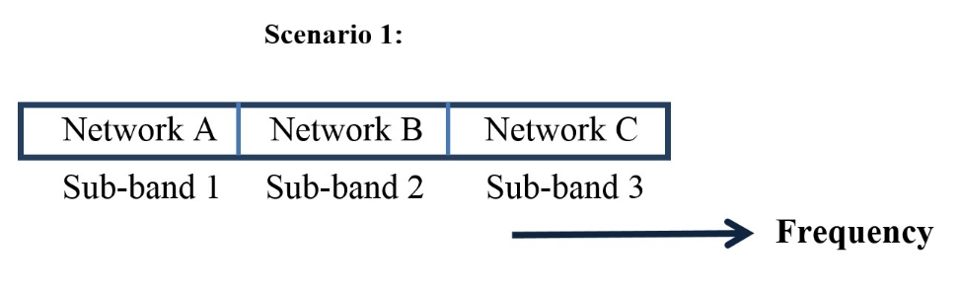
In Case 1 (isolated coverage), no mutual interference exists. As shown in Table 5, such isolated coverage may be operated without any constraints for out-of-band emission and compatibility with the adjacent sub-bands. For example (as shown in Figure 6-1), sub-band 1 is operated by RAT X whereas sub-band 2 employs RAT Y without any need for a guard band. It should be noted that other adjacent sub-bands are left unused in case of each isolated coverage.
Figure 6-1
Operation Scenario 1 for Case of Isolated Coverage
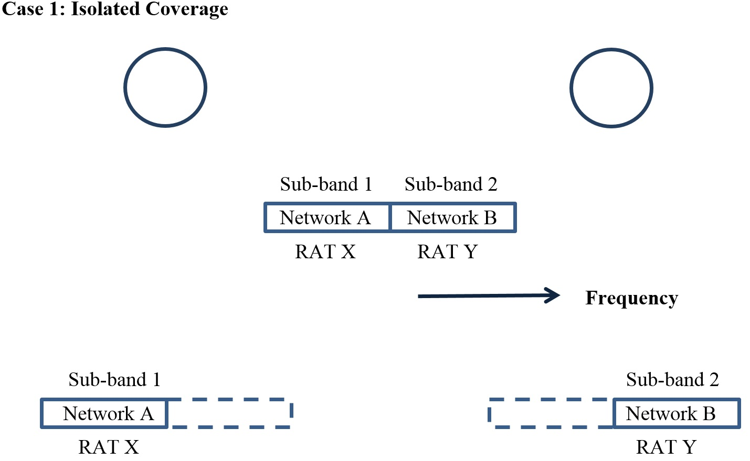
As shown in Table 5, Case 3 (overlapping coverage), some constraints for out-of-band emission and compatibility with the adjacent sub-band are imposed for operation of local coverage. In Case 2 (adjacent coverage), similar constraints may be also needed around the edge in contact as well. For example, as shown in Figure 6-2, some guard band may be needed if the adjacent sub-bands are operated by two different RATs or in the event that a) unsynchronized TDD systems or b) a mix of TDD and FDD systems are present.. On the other hand, it may be possible to remove such a guard band if the adjacent sub-bands are operated by the same RAT.
For these cases, further study will be needed as follows.
– Appropriate criteria will be needed to operate each sub-band by multiple RATs for local coverage.
– Coordination should be managed between adjacent sub-bands operated by different networks.
Case 2: Adjacent Coverage or Case 3: Overlapping Coverage
Figure 6-2
Operation Scenario 1 for adjacent or overlapping coverage
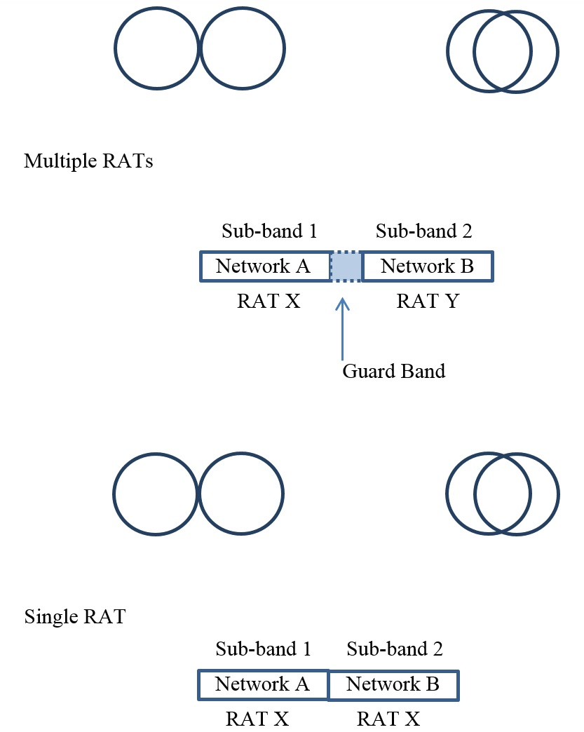
(2) Operation Scenario 2: Shared use of an entire frequency band by multiple networks in a license-exempt band
The entire band of a subject license-exempt frequency is used by multiple networks for shared operation as shown in Figure 7. The investigation should assume not only shared operation by a single RAT but also shared operation allowing multiple RATs.
Figure 7
Shared band
Scenario 2
Networks A, B, C
Frequency
In Case 1, the entire frequency band may be operated by a single network for each instance of isolated local coverage without any other constraints. Operation is feasible for a pair of isolated coverage by either a single RAT or multiple RATs as mutual interference can be disregarded between isolated local coverage. Figure 8-1 illustrates operation of multiple RAT’s in isolated coverage.
It should be noted that the entire frequency band is operated by a number of BWA carriers on a shared basis under certain sharing control mechanisms.
Figure 8-1
Operation Scenario 2 for Isolated Local Coverage
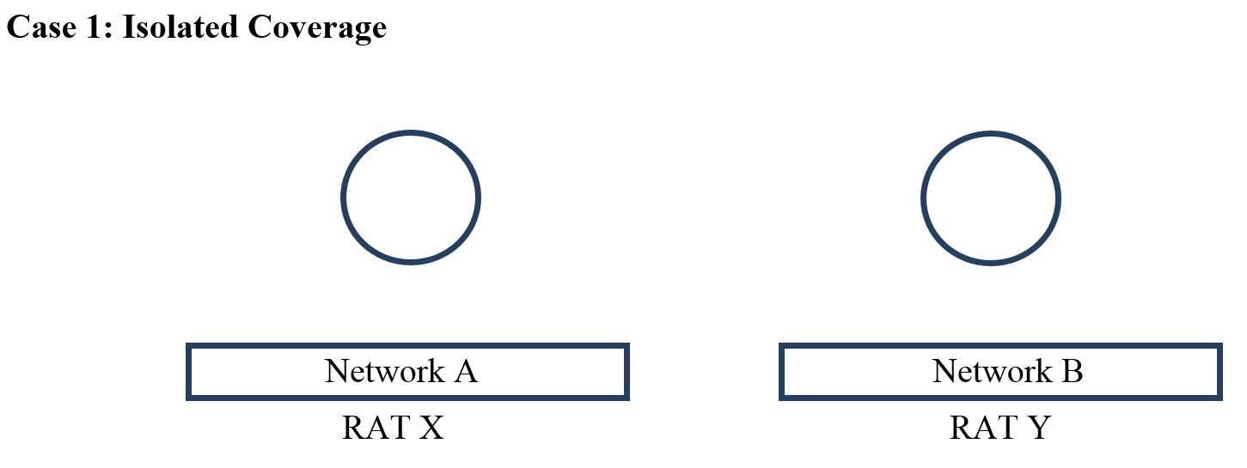
For Case 3 (overlapping coverage), the frequency band is shared by multiple networks. As shown in Table 5, a sharing control mechanism between the networks would facilitate sharing. This may also apply to Case 2 (adjacent coverage) around the contact edge of coverage. Multiple networks may employ the same RAT in some cases or may operate multiple RATs in other cases. Figure 8-2 illustrates operation in adjacent or overlapping coverage. A sharing control mechanism would facilitate sharing not only for the case of a single RAT but also among multiple RATs.
For these cases of shared operation by networks of multiple RATs for adjacent coverage or overlapping coverage in Cases 2 and 3, further study will be needed:
– Mechanisms of frequency selection and interference avoidance not only within a single RAT but also among multiple RATs.
– Carrier sensing prior to start of transmission.
Case 2: Adjacent Coverage or Case 3: Overlapping Coverage
Figure 8-2
Operation Scenario 2 for Adjacent and Overlapping Coverage

Networks A, B
RATs X, Y
Networks A, B
RAT X
In the case of shared operation of multiple networks using a single RAT (Figure 8-3), sharing control is relatively easy as coherent signal detection may be applicable. The complexity may be higher for sharing control for operation of multiple networks using multiple RATs with heterogeneous characteristics as signal detection may have to rely on power sensing. It is assumed that when multiple license- exempt RATs share spectrum, common sharing protocols such as listen before talk would be employed, thus limiting complexity.
(3) Operation Scenario 3: Shared use of an entire frequency band by multiple networks in a licensed band
Operation of a licensed band for shared use is generally similar to the shared operation of license-exempt band in Scenario 2 so methodologies to support operation of Scenario 2 may be applicable to Scenario 3 as well. It should be noted that the number of operating networks in a licensed band (Scenario 3) is limited whereas the number of networks sharing the license-exempt band (Scenario 2) is uncertain. Moreover, the detailed technical parameters and location of radio stations are generally known for the networks operated in a licensed band. This is why it is important that common sharing protocols are employed in the case of license exempt spectrum sharing. A more detailed investigation and coordination may be needed in the case of licensed band operation where common sharing protocols are less likely.

4.3 Operational requirements
The modelling and analysis in the previous sub-section shows that operational requirements of local coverage vary significantly depending on conditions of the operational scenarios and deployment cases. The following table summarizes the operational requirements of local coverage in various conditions.
Table 5
Operational Requirements of Local Coverage in Various Conditions
[Editor’s note: the formatting of the table should be reviewed.]
 | Scenario 1 | Scenario 3 | Scenario 2
 | Licensed frequency band |  | License-exempt frequency band
 | Dedicated Sub-bands | Shared band
Case 1  Isolated local coverage  (No interference between coverage) | [No constraints] for out-of-band emissions and compatibility with the adjacent sub-band | [Full use of the entire frequency band by any single RAT without sharing constraints with other networks]
Case 2  Adjacent local coverage  (Interference around coverage boundary) | [Constraints] for out-of-band emissions and compatibility with the adjacent sub-band | Shared use of the frequency band by multiple networks (Sharing control mechanism is needed for not only a single RAT but also multiple RATs.)
Case 3  Overlapping local coverage  (Interference in the overlapping area) | [Constraints] for out-of-band emissions and compatibility with the adjacent sub-band | Shared use of the frequency band by multiple networks (Sharing control mechanism is needed for not only a single RAT but also multiple RATs.)
Note: Each case in Scenario 1 is deployed for a single network.
As summarized in the table, the analysis of operational scenarios shows some possibilities for relaxing [constraints] for operation of local coverage in certain deployment cases. Operational requirements for various cases including and possible [relaxation of constraints] may be summarized as follows.
[Editor’s note: the notion of removing guard bands is subject to national/international regulations.]
[Editor’s note: the figures below should be reviewed, taking into account “constraints” should be “[constraints]”.]
(1) Operation Scenario 1: Licensed & Dedicated sub-bands
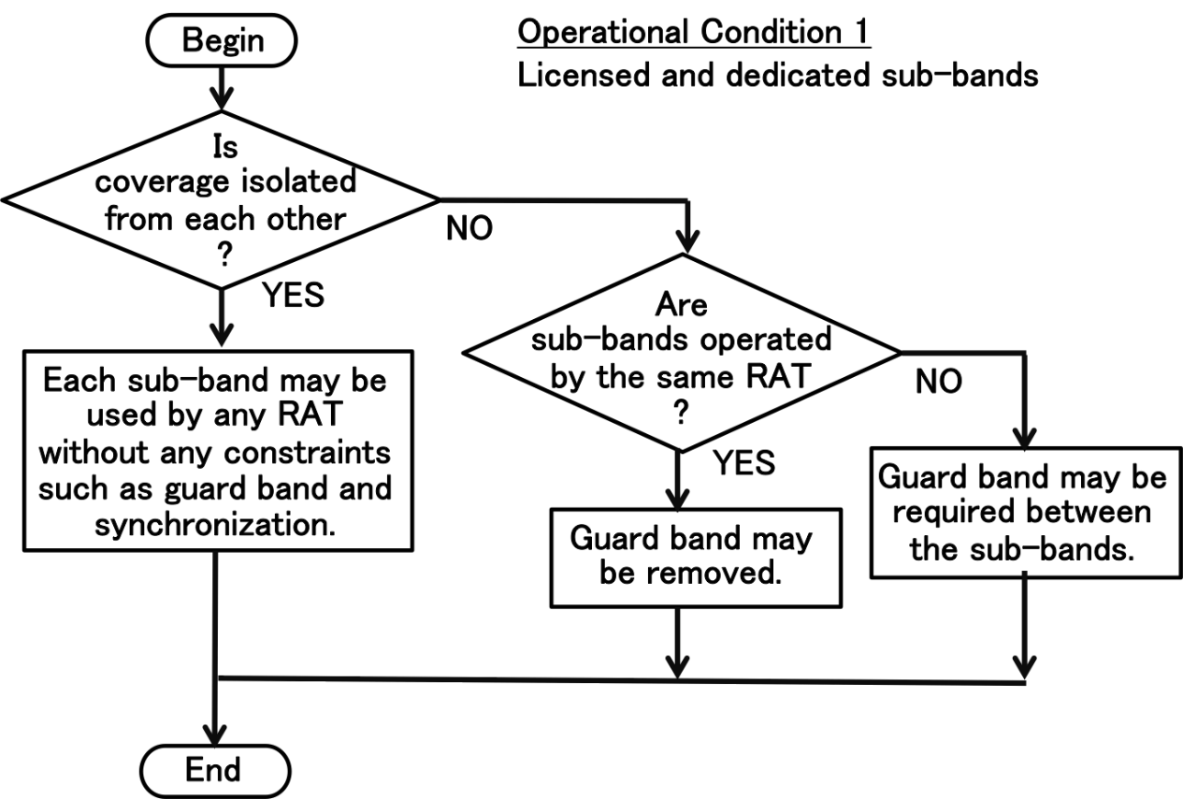
(2) Operation Scenarios 2 and 3: Shared band
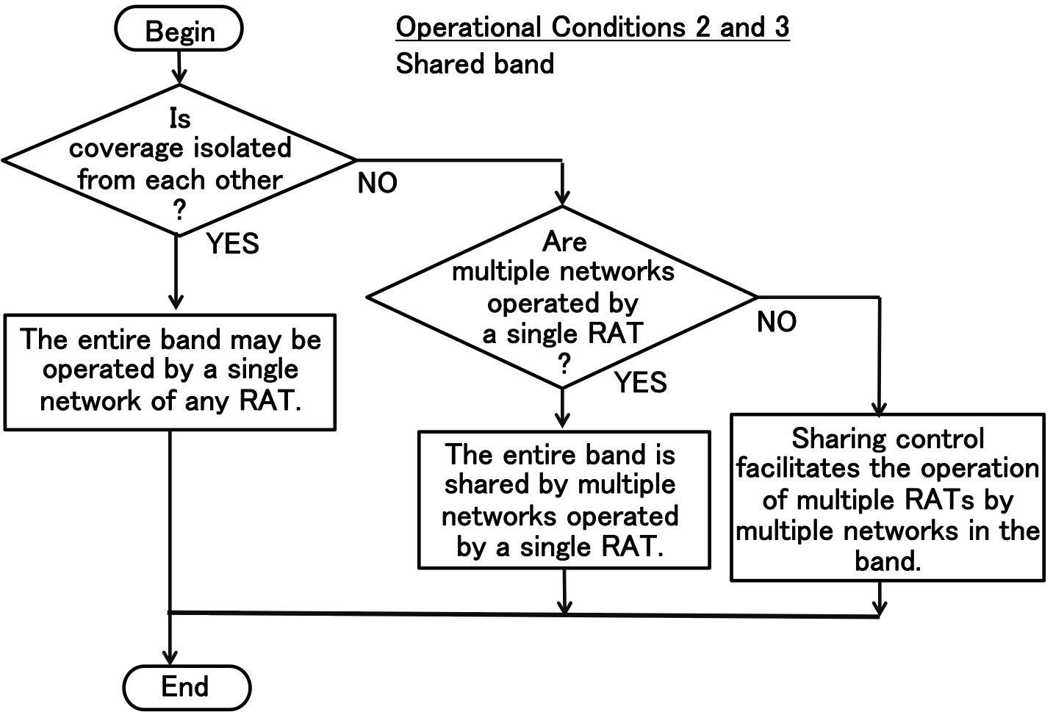

5 Technical and Functional Features for Radio Stations

5.1 Functional features for network operation and management of local coverage
[Editor’s note: This section needs careful review as much of this is spectrum management and may have regulatory implications.]
Operational requirements for local coverage are dependent on various operational scenarios and deployment cases of local coverage as discussed in section 4. Operational requirements should be developed for typical operational scenarios of local coverage with appropriate management schemes in such a way as to take maximum advantage of operational efficiency and flexibility. In accordance with the three operational scenarios, operational requirements have been investigated with focus on relaxation of conventional operational constraints under certain conditions based on technical properties of local coverage. As summarized in section 4.3, there exist some possibility for [relaxing operational constraints/flexible operations] particularly when local coverage areas are isolated from each other.
Possible advantages of such efficient and flexible operation include multi-RAT operation, reduction of guard band, elimination of constraints for network synchronization and flexibility in frame structure for uplink and downlink partitioning in the case of TDD operation.
The following technical capabilities could provide the advantage of flexibility:
1) Detection of isolated local coverage for which [operational constraints] may be relaxed
2) Decision to identify [relaxed operational constraints] (i.e., what can be relaxed and to what extent?)
These capabilities may be provided by making use of basic technical functions of network management and control summarized in section 5.2. These basic functions are applicable for efficient and flexible local coverage operation.
Management scheme for the capabilities (1) and (2) are as follows:
Licensed frequency band
– In the case of local coverage in licensed frequency bands, inter-system operation network coordination between operators could be possible for the functions (1) and (2) as the detailed technical information of radio stations are generally available, such as system parameters and location of radio stations.
– Such coordination may be carried out initially by a manual process as a pre-operation planning. Automatic process may be realized to some extent and may be necessary for management of more than a few channels.
– For dynamic and automatic coordination process, advanced methodologies are needed for monitoring and control such as carrier signal sensing and frequency channel selection control. To this end, application of cognitive radio technologies is highly expected [5]. Adaptive beam forming of base station is another promising technology for interference mitigation among adjacent local coverage so as to create isolated coverage.
License-exempt equipment
– In the case of local coverage by license-exempt equipment, the function (1) may be implicitly provided by existing sharing control mechanisms by carrier sensing. Additional management mechanisms may facilitate inter-system coordination for these two functions.
– Dynamic and semi-automatic mechanism could facilitate the determination of whether the local coverage is isolated, for example, by signal sensing.
[Editor’s note: further description of “semi-automatic mechanism” should be provided.]
– [In the case of isolated local coverage, the frequency band can be used by a single network without any sharing constraints with other networks. The function (2) is not necessarily required as the existing sharing control mechanism may function efficiently. If needed, the sharing control may be further optimized only for intra-network sharing.]
– In the case of adjacent or overlapping local coverage, the existing sharing control mechanism may be applied without explicit implementation of the functions (1) and (2).
With regard to network management functions, it should first be noted that operation of local coverage should make full use of the basic control and management functions originally implemented for each RAN. Basic functions for both base stations and mobile terminals are summarized in section 5.2.1 for such network control and management functions. In the case of multi-RAT operation, each RAN may be operated by its own network control and management functions.
Various monitoring and sensing functions are applicable as well as the basic control and management functions. It is generally assumed that monitoring functions are implemented for both base station and mobile terminals. Control and management functions are basically implemented in each base station. In this case, mobile terminals operate under the control of the base station. In the case of distributed control, some control functions may also be implemented at each mobile terminal. Dynamic channel assignment is generally assumed rather than pre-assigned channels. Frequency channel selection and assignment [is essential for] shared use of a frequency band. In general, multiple RANs for shared operation may use multiple RATs as well as a single RAT.
The basic functions already available are shown in section 5.2.1. Additional technical capabilities which can facilitate local coverage are shown in section 5.2.2.

5.2 Functions and technical features for radio station
[Essential] functions to support those additional capabilities (1) and (2) in section 5.1 include the following technical functions and features of radio stations.
– Monitoring of radio spectrum and radio resource usage for base station and mobile terminals
– Sensing and detection of nearby radio stations of other RANs
– Monitoring of radio channel quality
– [Control of frequency channel selection and assignment] [Editor’s note: this bullet is “essential function”?]
The first two functions may support the capability (1). The other two functions are useful for the capability (2).
Radio stations for local coverage may also utilize the following functions for operation management and control.
– Collection of monitoring data
– Access admission control of mobile terminals by base station
– Transmit power adjustment
– Priority control for radio resource assignment.
It is assumed that these functional features may be categorized into network management functions and radio resource management functions. Some of the operational guidelines may be used as optional. These functions are generally different between licensed band operation and license-exempt band operation. The following sub-sections provide description of desirable technical and functional features for radio stations for local coverage operation.

5.2.1 Network management functions
For local coverage operation, it is assumed to apply basic network operation and management functions existing in RAN systems. Each RAN is operated under given operational conditions according to the operational guideline for local coverage. For this network management, existing operation management and control functions are applicable without additional requirements and modifications.
Basic monitoring and control functions are based on the following features for managed operation in licensed bands. It is assumed that these functions are implemented within a single Radio Access Network. For operation in license-exempt bands, these functions are optional.
– Monitoring of operational status for base stations and mobile stations.
– Identification and management of mobile stations under control of each base station.
– Monitoring and management of traffic loading of base station and mobile station.
– Monitoring and management of transmission performance of base station and mobile station.
– Access admission control for mobile station by base station to maintain sufficient throughput per user.
– High-level authentication process of mobile station by base station.
Network management and control may include functional elements as follows for some operations in licensed band:
– Initiation of operation of mobile station in accordance with the control by base station.
– Forced termination of mobile station operation by the control of base station.
– Monitoring of operational conditions of mobile station by base station.

5.2.2 Radio resource management functions
For efficient and flexible operation of local coverage, various radio resource management functions are required. It is first assumed that management and control functions originally implemented for RAN systems should be fully utilized for radio resource management.
There exist two categories for radio resource management functions for local coverage operation. Section 5.2.2.1 provides technical capabilities (1) and (2) in section 5.1 for local coverage operation. Section 5.2.2.2 deals with radio resource management for operation of each RAN under certain operational conditions.

5.2.2.1 Decision functions for local coverage
As described in section 5.1, basic technical functions of radio resource management are applicable for the technical capabilities (1) and (2). It should be noted that requirements are different between licensed band and license-exempt band as explained in section 5.1. For licensed band operation, pre-operational coordination is available, for which basic management and control functions are applicable. For automatic control, advanced mechanisms such as cognitive radio may be effective. For license-exempt band operation, existing management and control functions may implicitly provide necessary capabilities without additional requirements. For explicit control, additional functions may improve management performance.
Management and control for efficient and flexible operation of local coverage may be based on the radio resource management functions as follows.
Functions which may support the capability (1)
– Monitoring of radio spectrum usage at base station and mobile stations.
– Radio signal sensing for nearby base and mobile stations (for detection of co-channel interference and usage of adjacent channels) [3], [4], [5], [6].
Functions which may support the capability (2)
– Monitoring of radio resource usage and quality of base station and mobile stations.
– Control of frequency channel selection and assignment by base station.

5.2.2.2 Management and control functions for operation of each RAN
[Once operational requirements are determined for local coverage, each RAN is operated by operation management and control functions currently available for radio resource management without additional requirements and modifications.] The following functions may be applied in addition to the four functions in section 5.2.2.1.
– Collection of monitoring data from mobile stations for control functions of base station.
– Transmit power control for base station.
– Transmit power control for mobile station by base station.
– Priority control of radio resource assignment for delay-sensitive traffic.
– Access admission control for mobile stations to maintain minimum acceptable throughput performance (e.g. Rejection of a new connection of mobile station of extremely low throughput around the edge of area coverage).
– Disconnection of a mobile station of extremely low throughput around the edge of area coverage to encourage reconnection to another base station providing better transmission quality and performance. However, this would not be appropriate for most instances of license-exempt local coverage where there is no other base station to connect to.
– Integrated implementation of radio resource management functions through capabilities of cognitive radio technologies, in conjunction with utilization of methods such as spectrum access databases and sensor devices [5].
These functions are originally intended for optimized operation of a single broadband mobile network. These functions may also be applicable across multiple broadband mobile networks.

6 Conclusion
This Report presented a new concept of local coverage for efficient and flexible operation of BWA systems [typically in frequency bands higher than conventional macro cell frequencies].
To analyse these concept in detail, the term of local coverage was defined and technical properties and use cases were presented. Each of the three studied operational scenarios were modelled and analysed in detail to investigate the possibility of developing operational flexibilities. Some possibilities including potential operational requirements have been suggested under certain operational conditions of local coverage to facilitate more efficient and flexible operation of BWA systems operated in local coverage areas.
These guidelines are generally applicable irrespective of RATs. More elaborated approaches will be possible when [new spectral technologies/new spectrum management techniques] are made available [such as Cognitive Radio].
[Editor’s note: further clarification of the term “new spectral technologies” should be provided.]
Operation of local coverage areas may be less [constrained] when local coverage areas are free from mutual interaction from each other.
[Editor’s note: other cases, including adjacent and overlapping cases, should be addressed here.]

References
[1] Vikram Chandrasekhar, et al.: “Femtocell Networks: A Survey”, IEEE Communications Magazine, pp. 59-67, September 2008.
[2] Jeffrey G. Andrews, et al.: “Femtocells, Past, Present, and Future”, IEEE J. on Selected Areas in Communications, Vol. 30, No. 3, pp. 497-508, April 2012.
[3] Tevfik Yucek and Huseyin Arslan: “A survey of spectrum sensing algorithms for cognitive radio applications”, IEEE Communications Surveys & Tutorials, Vol. 11, No. 1, pp. 116-130, First Quarter 2009.
[4] Amir Ghasemi and Elvino S. Sousa: “Spectrum sensing in cognitive radio networks: Requirements, Challenges and Design Trade-offs”, IEEE Communications Magazine, pp. 32-39, April 2008.
[5] Kanshiro Kashiki et al.: “Analytical study for performance evaluation of signal detection scheme to allow the coexistence of additional and existing radio communication systems”, IEICE Transactions on Communications, Vol. E97-B, No. 2, pp. 295-304, February 2014.
[6] Bodhisatwa Sadhu et al.: “Building an On-Chip Spectrum Sensor for Cognitive Radios”, IEEE Communications Magazine, Vol. 52, No. 4, pp. 92-100, April 2014.
[7] IEEE 802.11k-2008, IEEE Standard for Information Technology – Telecommunications and Information exchange between systems – Local and metropolitan area networks – Specific requirements Part 11: Wireless LAN Medium Access Control (MAC) and Physical Layer (PHY) Specifications, Amendment 1: Radio Resource Measurement of Wireless LANs.

Broadband wireless access system refers to the systems operating in the land mobile service between 30 MHz and 6 GHz in Recommendation ITU-R M.1801-2.
For example, some administrations have allowed licensed operations and license-exempt or lightly licensed networks to be deployed in the same spectrum. These operational scenarios are not discussed in this document.

