Bureau de la normalisation
des télécommunications
Genève, le 22 octobre 2014

Réf.: | Corrigendum 1 à la  Lettre collective TSB 2/SG5RG-ARB
Tél.: | +41 22 730 6301
Fax:  E-mail: | +41 22 730 5853  tsbsg5@itu.int | – Aux Administrations des Etats Membres de l'Union;  – Aux Membres du Secteur UIT-T;  – Aux Associés de l'UIT-T participant aux travaux de la Commission d'études 5;  – Aux établissements universitaires participant aux travaux de l'UIT-T;  – Au Bureau régional de l'UIT pour la région des Etats arabes
Objet: | Deuxième réunion du Groupe régional de la Commission d'études 5 de l'UIT-T  pour la région des Etats arabes (SG5RG-ARB), Koweït (Koweït), 25 novembre 2014, de 15 h 30 à 17 heures
Madame, Monsieur,
Veuillez noter que la deuxième réunion du Groupe régional de la Commission d'études 5 de l'UIT-T pour la région des Etats arabes (SG5RG-ARB) se tiendra à l'hôtel Crowne Plaza Kuwait et non à l'hôtel The Regency Kuwait, comme indiqué précédemment dans la Lettre collective TSB 2/SG5RG-ARB du 26 septembre 2014.
Cette modification s'applique également aux manifestations de l'UIT qui devaient avoir lieu au même endroit, à savoir le Forum régional économique et financier des télécommunications/TIC de l'UIT-D pour les Etats arabes et le Forum régional UIT sur la normalisation pour la région des Etats arabes ainsi que les réunions du Groupe régional de la Commission d'études 2 de l'UIT-T pour la région des Etats arabes (SG2RG-ARB) et du Groupe régional de la Commission d'études 3 de l'UIT-T pour la région des Etats arabes (SG3RG-ARB).
Par conséquent, il convient de remplacer l'"ANNEXE C" par l'annexe ci-jointe.
Les dates de la réunion restent inchangées.
Nous vous prions de bien vouloir nous excuser pour ce désagrément.
Veuillez agréer, Madame, Monsieur, l'assurance de ma considération distinguée.
Malcolm Johnson
Directeur du Bureau de la
normalisation des télécommunications
Annexe: 1
ANNEX C
(to TSB Collective letter 2/SG3RG-ARB)
Practical information for participants
- Venue
Crowne Plaza Hotel
Airport Road, P. O. Box 18544
103, Farwaniya 81006 Kuwait
Email: hotel@crowneplaza.com.kw
Telephone: +965 1848111/24742000
Fax: +965 2473 2020
Website: kuwait.crowneplaza.com

2. About Kuwait City
Kuwait City is the capital and largest city of Kuwait. It has a population of 2.38 million in the metropolitan area. Located at the heart of the country on the shore of the Persian Gulf, and containing Kuwait's parliament, most governmental offices, the headquarters of most Kuwaiti corporations and banks, it is the political, cultural and economic center of Kuwait. Kuwait City is considered a Beta - Global city.
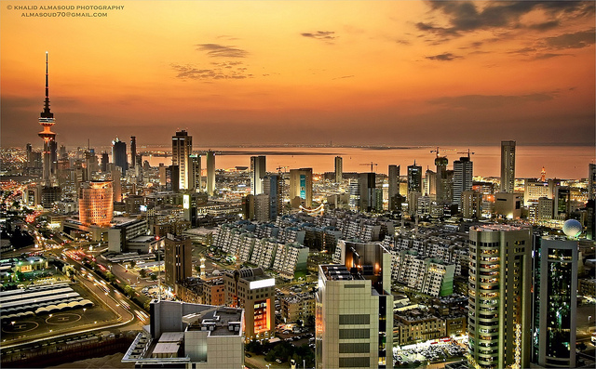
Kuwait City’s trade and transportation needs are served by Kuwait International Airport, Mina Al-Shuwaik (Shuwaik Port) and Mina Al Ahmadi (Ahmadi Port) 50 kilometres (31 miles) to the south, on the Persian Gulf coast. Kuwait City is ranked as one among the 25 largest GDP cities in the world along with New York, Tokyo, Moscow, Mumbai and other financial hubs including Singapore and Dubai.
3. Weather
Kuwait City has a hot desert climate and is one of the hottest cities in summers on earth. Its winters are warm with very little rainfall. Sand storms are quite frequent in mid-year.
The weather in November is moderate and approximate temperatures will vary between 20º-25ºC. Rain frequency does increase around November.
4. Hotel Accommodation
Crowne Plaza Hotel (also meeting venue for the events)
Crowne Plaza Kuwait is an award winning, five-star deluxe international brand that offers a unique experience through its newly refurbished rooms, new meeting facilities, new sense of arrival, large parking facility and its 10,000 m² leisure facility.
The Crowne Plaza has undergone a major transformation in order to continue to lead the way in offering its guests unparalleled facilities and services.
All of the bedrooms and suites have been totally refurnished to provide supreme comfort for its guests.
Twelve brand new meeting rooms have been added to the remarkable range of state-of-the-art meeting facilities.
With adding a Convention Center of 3750 m² in the new extension, Crowne Plaza is all set to be the best place for business as well as leisure.
The new Viaggio Italian Restaurant brings the total number of international restaurants within the hotel to eight.
The new and exclusive 3500 m² Spa Aquatonic features an exotic 650 m² Aquatonic pool, the first of its kind in Kuwait.
Website: kuwait.crowneplaza.com
Address: Airport Road, P. O. Box 18544
103, Farwaniya 81006 Kuwait
Email: hotel@crowneplaza.com.kw
Telephone: +965 1848111/24742000
Fax: +965 2473 2020

Local Contact Person in charge of the bookings:
Ms. Etidal Bakri
Tel: +965 96961416
Fax: +965 25759809
Email: Etidal.bakri@ing.com

ROOM TYPE | ROOM RATE
Single Room | Single room 60 KD + 15% service + Shuttle service from/to the airport
Double Room | Double room 70 + KD+15% service breakfast included + Shuttle service from/to the airport

Check In Time: 14:00 hours
Check Out Time: 12:00 noon
Credit Cards Accepted: Visa Card, Master Card, JCB International, American Express, and Diners Club

Recommended hotels location map:

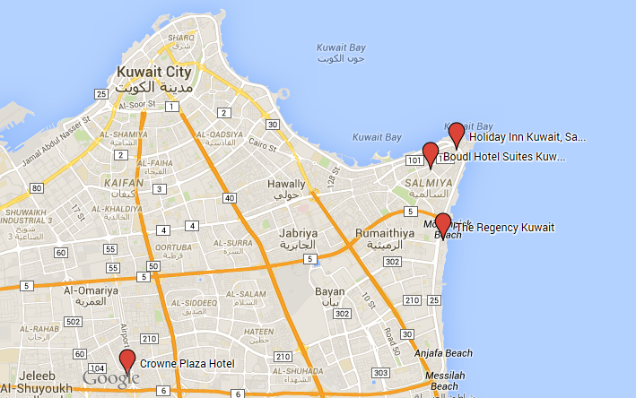

Other Recommended Hotels
Hotel | Rate per night | Address hotel | Booking address | Remarks
Crowne Plaza  5 stars | Single room 60 KD + 15% service + Shuttle service from/to the airport | Al-farwaniya | Tel: +965 96961416  Fax: +965 25759809  Email: Etidal.bakri@ing.com | Venue of the forum and it is recommended
 | Double room 70 + KD+15% service breakfast included + Shuttle service from/to the airport
Regency Kuwait  5 Stars | Single room 70 KD + 15% service + Shuttle service from/to the airport | Al Bida'a, Al Tawoon Street, Salmiya | Tel: +965 2576666  Fax: +965 25766999  Email: info@theregencykuwait.com | Away from the venue 20 minutes
 | Double room 80 KD + 15% service + breakfast included + Shuttle service from/to the airport
Boudl  3 Stars | Delux room 32 KD + 15% service + breakfast included + Shuttle service from/to the airport | Salmiya – Amro ibn Alaas st. | Tel: +965 97349340  Fax: +965 25757886 | Away from the venue 25 minutes
 | Suite (room & lounge) 38 KD + 15% service + breakfast included + Shuttle service from/to the airport
Holiday Inn  5 Stars | Single room 30 KD + 15% service + breakfast included + Shuttle service from/to the airport & venue | 140 Hamad Al Mubarak Street, Gulf road, Salmiya | Tel: +965 96961416  Fax: +965 25759809  Email: Etidal.bakri@ing.com | Away from the venue 30 minutes
 | Double room 45 KD + 15% service + breakfast included + Shuttle service from/to the airport & venue

5. Visa Information
A valid passport & visa are required to enter The State of Kuwait except for nationalities from the following countries that will be issued entry permits upon arrival at the airport in the state of Kuwait:
United states of America, New Zealand, Australia, Canada, Germany, France, Luxembourg, Belgium, Netherlands, Japan, Norway, Sweden, Austria, Switzerland, Greece, Ireland, Portugal, Denmark, Vatican, Monaco, Spain, Finland, Tolkhstein, SanMarino, Andorra, Iceland, Hong Kong, Malaysia, Singapore, South Korea, China.

Each participant is requested to consult the Kuwaiti Embassy in his/her country of origin to obtain the visa.
Please note that the invitation letter will be circulated to all Kuwaiti Embassies abroad, in order to facilitate the procedures for obtaining a valid visa, furthermore, you can contact the hotel or the tour company you chose to apply for the visa at the following official website:
http://www.e.gov.kw/MOI.en/Pages/ServiceContent/V2693StateVisit.aspx

Should you have any queries regarding obtaining a valid visa or need further assistance please feel free to contact:

Mr. Ali Alsalem
Public Relations Dept.
Tel: + 965 969 665 04
Fax: +965 249 274 85
E-mail: al.salem@hotmail.com

Very Important Note:
To facilitate the procedures for obtaining a visa, you should send a copy of your passport [data page and validity of the passport page (special visas countries)] and send it at the above mentioned fax and E-mail.

Official Working hours:
Working days: Sunday - Thursday (From 8.00 am to 2.00 pm)
Weekends: Friday & Saturday (holidays)
6. Transportation from Airport to Hotel
In order to secure reception at the airport and transportation to hotels, participants are requested to fill the hotel reservation form (Form 2) and send it to the hotels, which they chose for accommodation.

The Ministry of Communications will provide transportation only from the hotels to the forum's venue and vice versa.

Tariff for Kuwait airport taxi services ranges between KD 4 for areas near the airport and KD 20 for border areas.

Regarding mobile taxis the fare will be according to the odometer.
Taxi fares in Kuwait city ranges between 2.5 - 3.5 KD.

There are two companies in Kuwait that run public buses: Kuwait Public Transport Company (KPTC) and City Bus, operating around 50 routes.

City Buses are slightly more expensive with prices around 150 - 250 fils for most trips. Travel on KPTC Buses range from as little as 50 - 150 fils.
7. Time zone
UTC/GMT + 0300 hours
8. Currency
The national currency of Kuwait is the “Kuwaiti Dinar (KD, KWD)”.
Banking hours are from 8.30am to 3.00pm, from Sunday to Thursday. Some branches open from 4pm to 6pm.

The exchange rate in Kuwait is pegged to the dollar, other currencies rate can be consulted at http://www.bbkonline.com/Pages/CurrencyConvertor.aspx or http://www.xe.com/ .

As of September 2014:
1 Euro = 0.383 KWD (approx.).
1 US$ = 0.282 KWD (approx.).

9. Electricity (voltage used)
AC power voltage in Kuwait is 240V/50 Hz. Find below used outlets (UK plug):
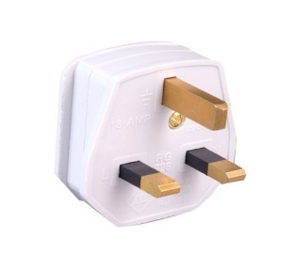

10. General Information
Government: | Constitutional Monarchy
Emir: | Sabah al-Sabah
Crown Prince: | Nawaf al-Sabah
Prime Minister: | Jabber Al-Hamad al-Sabah
Area: | 17’820 sq.km.
Population: | 4,044,500 (approx.)
Capital: | Kuwait City
Language: | Arabic
______________

