Plenipotentiary Conference (PP-14)
Busan, 20 October – 7 November 2014
PLENARY MEETING | Document 7-E
 | 22 October 2013
 | Original: English
Note by the Secretary-General
CANDIDACY FOR THE POST OF DEPUTY SECRETARY-GENERAL

Further to the information contained in Document 3, I have pleasure in transmitting to the conference, in annex, the candidacy of:
Mr Malcolm JOHNSON (United Kingdom of Great Britain and Northern Ireland)
for the post of Deputy Secretary-General of the International Telecommunication Union.

Dr. Hamadoun I. TOURE
Secretary-General

Annex: 1

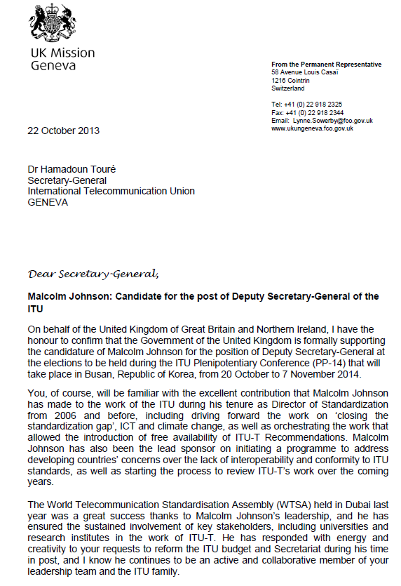

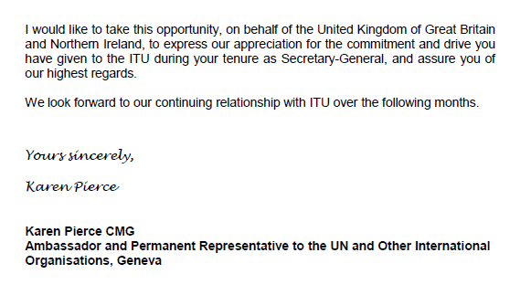

Malcolm Johnson
Candidate for Deputy Secretary-General, ITU Elections 2014
“An ITU for all: building consensus, co-operation and capacity”
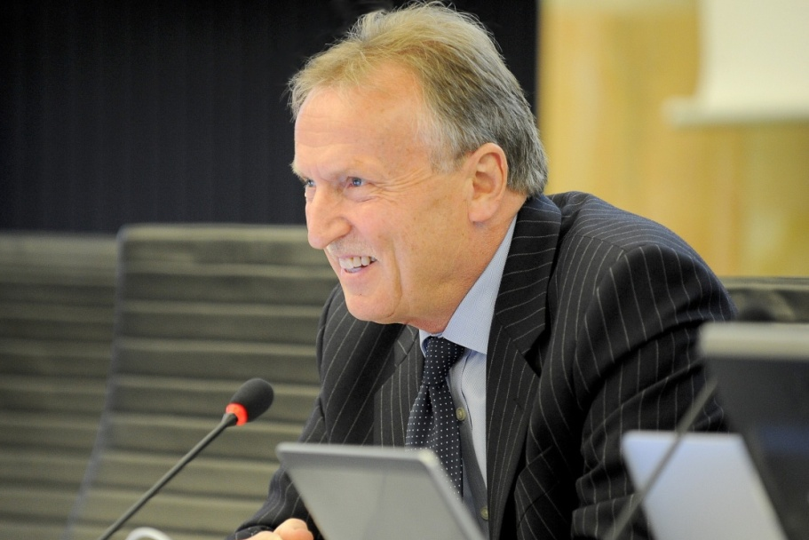
EXPERIENCE AND ACHIEVEMENTS
From 2007 to present: Director of the Telecommunication Standardization Bureau
From 1991 until 2006 was Head or Deputy Head of UK Delegations to all ITU conferences, assemblies and advisory groups of the three Sectors
Chaired the Reform Group on standardization prior to PP‐02
Established the Commonwealth ITU Group (2002)
Four years’ experience in the European Commission – responsible for the projects and legislation supporting the development of the GSM and DECT technical standards
Represented the European Commission in CEPT and in ETSI
Initiated the process for regional preparations for ITU conferences, established and chaired first interregional group to prepare for an ITU conference (WRC-95)
Developed the CEPT preparatory process for ITU conferences with European Common Proposals and co‐ordination procedures and promoted the model in other regions
AS DIRECTOR OF TSB
Reversed the decline in membership of ITU-T, since 2007 41 new, mainly developing, countries have participated in ITU-T work.
Maintained budget levels since 2006, whilst increasing output by 60 per cent and trebling sector activities.
Study group leadership teams now come from 35 countries, 25 of which are developing countries.

Introduction of a new academia membership category has seen 42 universities join ITU-T since 2011.
Increased co-operation with major standards bodies and forums.
Increased access to ITU‐T Recommendations. Removing the fee has lead to over 2 million copies a year now being downloaded, compared with sales of 5000 a year previously.
Increased use of remote participation – more than 600 meetings in 2012, over 500 of which were fully virtual.
Initiated substantial restructuring of the TSB to increase efficiencies and focussing resources on achieving expanded WTSA mandates.
Implemented a paperless policy in TSB saving approximately half a million A4 pages a year.
Introduced substantial programmes on accessibility, climate change and conformity and interoperability.
Created the ITU Kaleidoscope academic conference, the Global Standards Symposium, and the Chief Technology Officers Group and introduced Technology Watch Reports.
Organised and led the highly successful World Telecommunication Standardization Assemblies in 2008 and 2012, both of which significantly increased the ITU-T mandate.
Lead a number of cross-sectoral initiatives such as the ITU ethics policy.
BACKGROUND
NATIONALITY: British
BORN: Trallwng, Wales, 19 June 1947
STATUS: Married, with one daughter
LANGUAGES: English (mother tongue), French and some Spanish
EDUCATION: Master of Science Degree, Bachelor of Science degree (1st class honours), University of Wales; Chartered Engineer; Member of Institution of Engineering and Technology
EMPLOYMENT
2007 – present: Director TSB
2003 – 2006: UK Office of Communications (Ofcom), International Co‐ordinator with lead responsibility for UK in ITU and CEPT
1992 – 2003: Director in UK’s Radiocommunications Agency
1987 – 1992: European Commission, Telecommunication Regulations Division
PREVIOUSLY: Represented UK in many other international organizations including IMO, Inmarsat and the European Space Agency

