RWANDA CONTRIBUTION TO CWG-INTERNATIONAL INTERNET RELATED PUBLIC POLICY ISSUES.

(Ref: CL-13/168 of 22 November 2013)

- Introduction

Since 2000, the Government of Rwanda (GoR) embarked on a 20 year journey through her Vision 2020 aiming at transforming Rwanda into a middle-income country from her agrarian economy to an information-rich, knowledge-based economy by 2020. The GoR strongly believes that Information and Communication Technologies (ICTs) can enable Rwanda leap-frog the key stages of industrialization. As such, GoR has integrated ICTs, through the National Information and Communication Infrastructure (NICI) process, as a key driver for socio-economic development to fast track Rwanda’s economic transformation, and consistently strives to align the country’s development agenda to global trends in order to be competitive.

Based on the circular letter stated above, hereafter are the Rwanda actions undertaken and to be undertaken related to the annex 1 of ITU Council 2009 resolution 1305.

- Rwanda actions related to international Internet public issues

  - International Internet Connectivity

    - Rwanda Internet Exchange Point

A Rwanda Internet Exchange Point (RINEX) was put in place by local network operators and ISPs. Another important point is that a Virtual Landing Point (VLP) is being built to help local ISPs and Network operators acquire submarine capacity that can be redistributed in their respective networks. Currently, all ISPs are connected to RINEX.
RINEX which is currently managed by Rwanda ICT association (RICTA), a neutral body, enables domestic traffic to remain local, and improvement of efficiency of international bandwidth utilization. It also helps to develop local contents and web hosting, attracts International content providers to locate their servers in Rwanda and promotes Internet broadband access and cost affordability.

    - Connectivity to submarine cables

Rwanda is currently connected to three international submarine fibre optic cable systems for Internet connection such as the East Africa Submarine Cable System (EASSY), The East African Marine Systems (TEAMS) and SEACOM through local telecommunication companies and ISPs.
This connectivity drastically increased the gateway capacity up to 5Gbps.

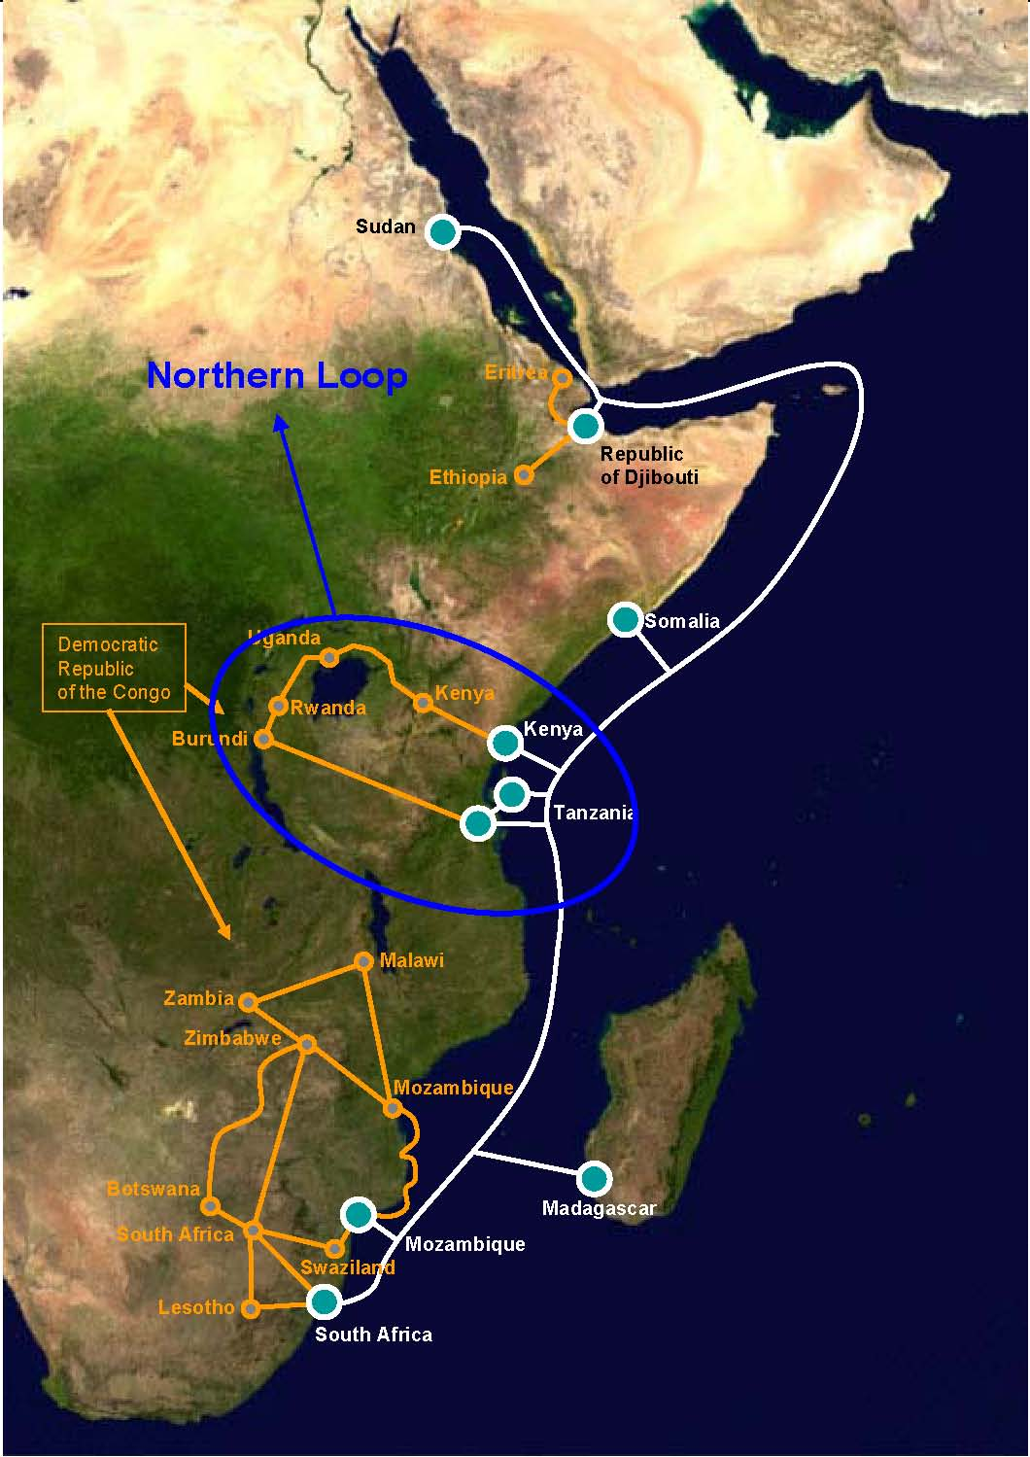
The Rwanda connectivity to three different cables and gateways through Mombasa and Dar es Salam routes increased the reliability and availability of the Internet in Rwanda. The international Internet bandwidth price decreased compared to the satellite Internet connectivity up to twenty times (from USD 2500/Mbps to USD 125/Mbps).
Source: (Lishan Adam, n.d.)
Figure 1: The undersea fibre optic links to the countries of East Africa.

  - Internet and the management of Internet resources, including domain names and addresses

    - ICANN , AFRINIC and AfIGF fora

Rwanda actively participates in different meetings of ICANN and AFRINIC related to Internet resources management. Rwanda is represented in the Government Advisory Council (GAC) and Africa Government Working Group (AfGWG) responsible for handling the Internet governance and Internet resources management issues.

Rwanda as host of East African Communication Organization (EACO) is committed to integrated solutions related to international Internet issues and governance. It is in that framework that Rwanda hosted the fourth East African Internet Governance Forum (EA-IGF) that recommended developing harmonised guidelines on Internet policies for East African countries.

    - National Internet Governance Forum (N-IGF)

Rwanda has national Internet Governance forum (N-IGF) which meets once a year and composed of Internet community, Government representatives, ICT Regulator and ISPs. The forum is governed by non-profit organization (RICTA) in partnership with the Rwanda Private Sector Federation - ICT chamber (PSF-ICT).

The ISOC-Rwanda chapter also plays a vital role in organization of National Internet governance forum. The Rwanda IGF is an open forum where all Rwandans are to engage in active discussions about how ICT can improve their livelihood. The forum is facilitated by multiple media such as audio visual broadcasting, Telephones, Short massages (SMS), and social media. Rwanda National IGF provides a countrywide collaborative discussion about ICT. The discussions are held mainly in national language (Kinyarwanda).

    - Country code top level domain management

The GoR has re-delegated the management of ccTLD to RICTA and is managed locally after its repatriation. This has facilitated the acceleration of development of e-applications in various socio- economic activities.

    - Regional initiatives

Based on dot africa registry policy on reserved names, Rwanda in partnership with other EACO countries will develop the reserve name list (RNL) for reserving Government names. The RNL provides for the following four categories:
- Geographical Names: names recognizing geographic areas and features that are of substantial significance to governmental authorities, for examples regions/states, cities, provincial capitals, major towns among others.
- Religious, Cultural and Linguistic Names: identifiers such as languages, tribes, peoples, religious groups and places of cultural or historic significances.
- Economic and Public Interest Names: Names of substantial economic or public interest significance and uniquely linked to governmental authorities.
- Offensive Names: Names that would inherently have the effect of advocating prejudice or hatred on the basis of race, ethnicity, ,political association, gender, sexuality, religion, conscience, or culture; or have the effect of inciting violence or causing of harm to any person or class of persons.

  - The security, safety, continuity, sustainability, and robustness of the Internet

    - Internet security in Rwanda

In 2010, Rwanda enacted the law governing electronic messages, electronic signatures and electronic transactions.

In a bid to implement the above stated law, Rwanda has implemented the National Public Key Infrastructure (PKI) project in two phases. The implementation of the root CA infrastructure was concluded in December 2013. The second phase on the implementation of the Rwanda certification system that will issue the digital certificates to the end users is on-going.

Rwanda is currently implementing a National Computer Security and Incident Response Team (CSIRT) project. The CSIRT is required to manage and respond to any cyber threats targeting Rwanda’s ICT infrastructure.

Rwanda is in the process of reviewing the legislation regarding ICT governance in general and cyber security in particular.

  - Combating Cybercrime

In 2012, Rwanda enacted an organic law instituting the penal code, in which specific provisions deal with computer related crimes.

Rwanda Development Board (RDB) regularly carries out the national cyber security awareness. The campaign aims at educating citizens on basic cyber security requirements to raise knowledge regarding confidentiality, integrity, availability of systems, data, and related threats.

The GoR supports regular trainings to equip different institutions with skills to detect and investigate cyber-crimes, understand cyber terrorism, principles of evidence collection for cyber-crime, electronic money transfer technology, and basic IT tools in analyzing cyber crime evidence.

  - Issues pertaining to the use of the Internet
Rwanda has clear policy and strategies for the development and usage of Internet services. As of September 2013, the number of Internet subscriptions is 1,674,053 which represent the Internet penetration rate of 15.8%. This shows an increase of 26.4% as compared to the second quarter of year 2013. This increase is mainly due to the widespread of use and adoption of Internet services, availability of content and applications accessible and affordable by low income population. There is an increasing use of online services and popular social media networks especially by young generation.
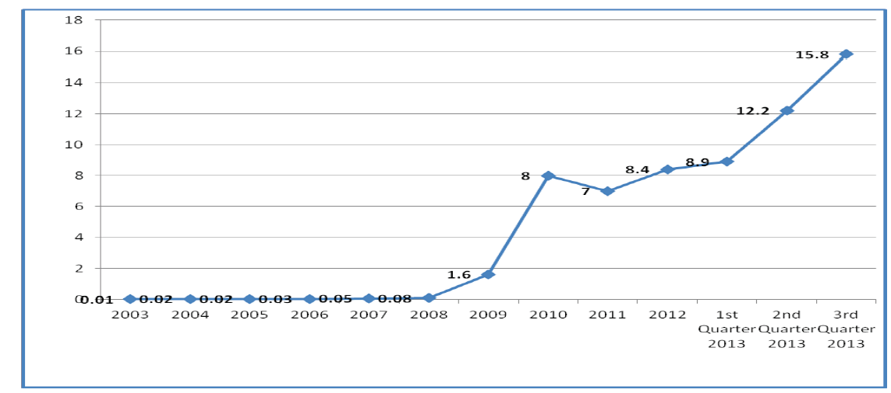
Source: RURA Report Q3,2013
Figure 2: Rwanda Internet penetration as of September 2013

  - Availability, affordability, reliability, and quality of service

The following actions were initiated in the line of ensuring the provision of quality service:

    - Development of appropriate standards and guidelines for the setup of networks, operations and provision of Internet services to end users.
    - Acquisition of Quality of Service (QoS) Monitoring Tools to measure the Quality of Service (QoS) of Broadband Internet provided by ISPs.
    - Spectrum Monitoring System: A system was put in place to monitor and inspect the use of radio-communication frequencies for efficient use of scarce resources.

  - Contributing to capacity building for Internet governance

The capacity building is the cornerstone in the building of the information knowledge based society and the GoR recognised that in its vision 2020. It is in that framework that in every phase of NICI plan the capacity building is an important component and ICT has been introduced as a tool and discipline in all programs from primary to higher education.

The current NICI III plan (2011 - 2015) focus on content and application development and it is in that framework that new institutions such as Knowledge Laboratory (K-Lab) and Africa Digital Multimedia Academy (ADMA) have been created to target specific applications to meet the market needs.

  - Developmental aspects of the Internet
Since 2000 GoR has established institutions and mechanisms to create an enabling environment for ICT development, deployed critical world-class infrastructure and is continuously developing a skilled human resource base in its quest to become a knowledge-based society.
The existence of a conducing legal and regulatory framework, availability of good infrastructure and a growing and innovative human resource base are the enablers of ICT development in Rwanda. The established liberalized environment catalyses and secures private sector initiative in the service development and delivery.
Rwanda adopted consultative approach in addressing Internet governance issues to ensure that all stakeholders’ opinions are taken into consideration.
  - Respect for privacy and the protection of personal information and data
The constitution of Rwanda has provisions that are relevant to the privacy of persons. The current legislation has provisions that protect and ensure the privacy of personal information and data.
  - Protecting children and young people from abuse and exploitation
In 2007, Rwanda took a step towards its long-term goal when it became the first country in the East African Community and the third on the African Continent to join “One Laptop per Child” program. This international initiative aims to introduce computers to the pupils of developing countries in an effort to bridge the global digital divide. With this achievement, Rwanda is now on track to achieving the 2015 MDGs and Vision 2020.
The Government of Rwanda established the National Commission for Children (NCC). The establishment of that Commission represents a major fulfilment of the commitment made to ensure protection of Children.

In 2012, Rwanda enacted the Law relating to the Rights and the Protection of the Child.
The penal code has specific provisions that deal with offences regarding abuse and exploitation of children.

Rwanda ICT regulator took initiative to ensure that all subscribers of mobile cellular services be registered. The SIM cards registration exercise intends to address several security and social issues including abuse and exploitation of children.

