Plenipotentiary Conference (PP-14)
Busan, 20 October – 7 November 2014
PLENARY MEETING | Document 25-E
 | 4 February 2014
 | Original: English
Note by the Secretary-General
CANDIDACY FOR THE POST OF MEMBER OF
THE RADIO REGULATIONS BOARD
Further to the information published in Document 3, I have pleasure in transmitting to the Conference, in annex, the candidacy of:
Mr Momcilo SIMIC (Republic of Serbia)
for the post of member of the Radio Regulations Board.

Dr Hamadoun I. TOURÉ
Secretary-General

Annex: 1

ANNEX
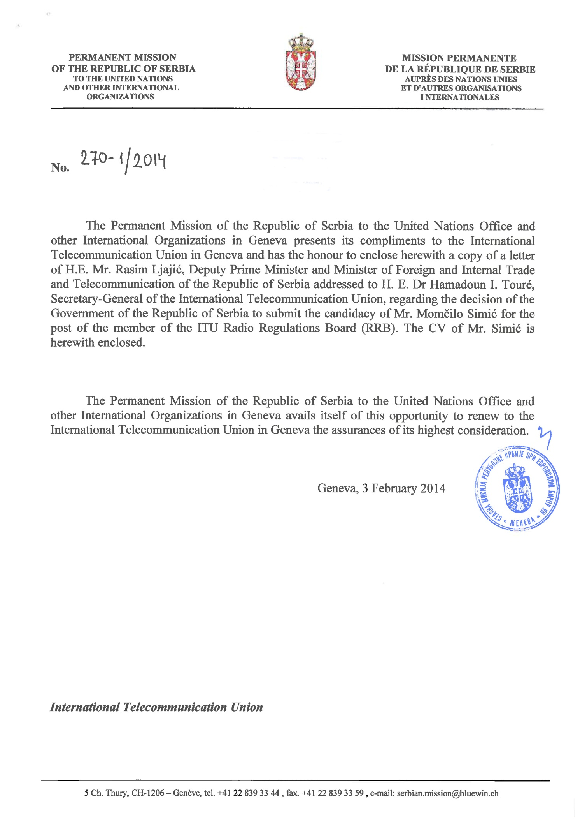

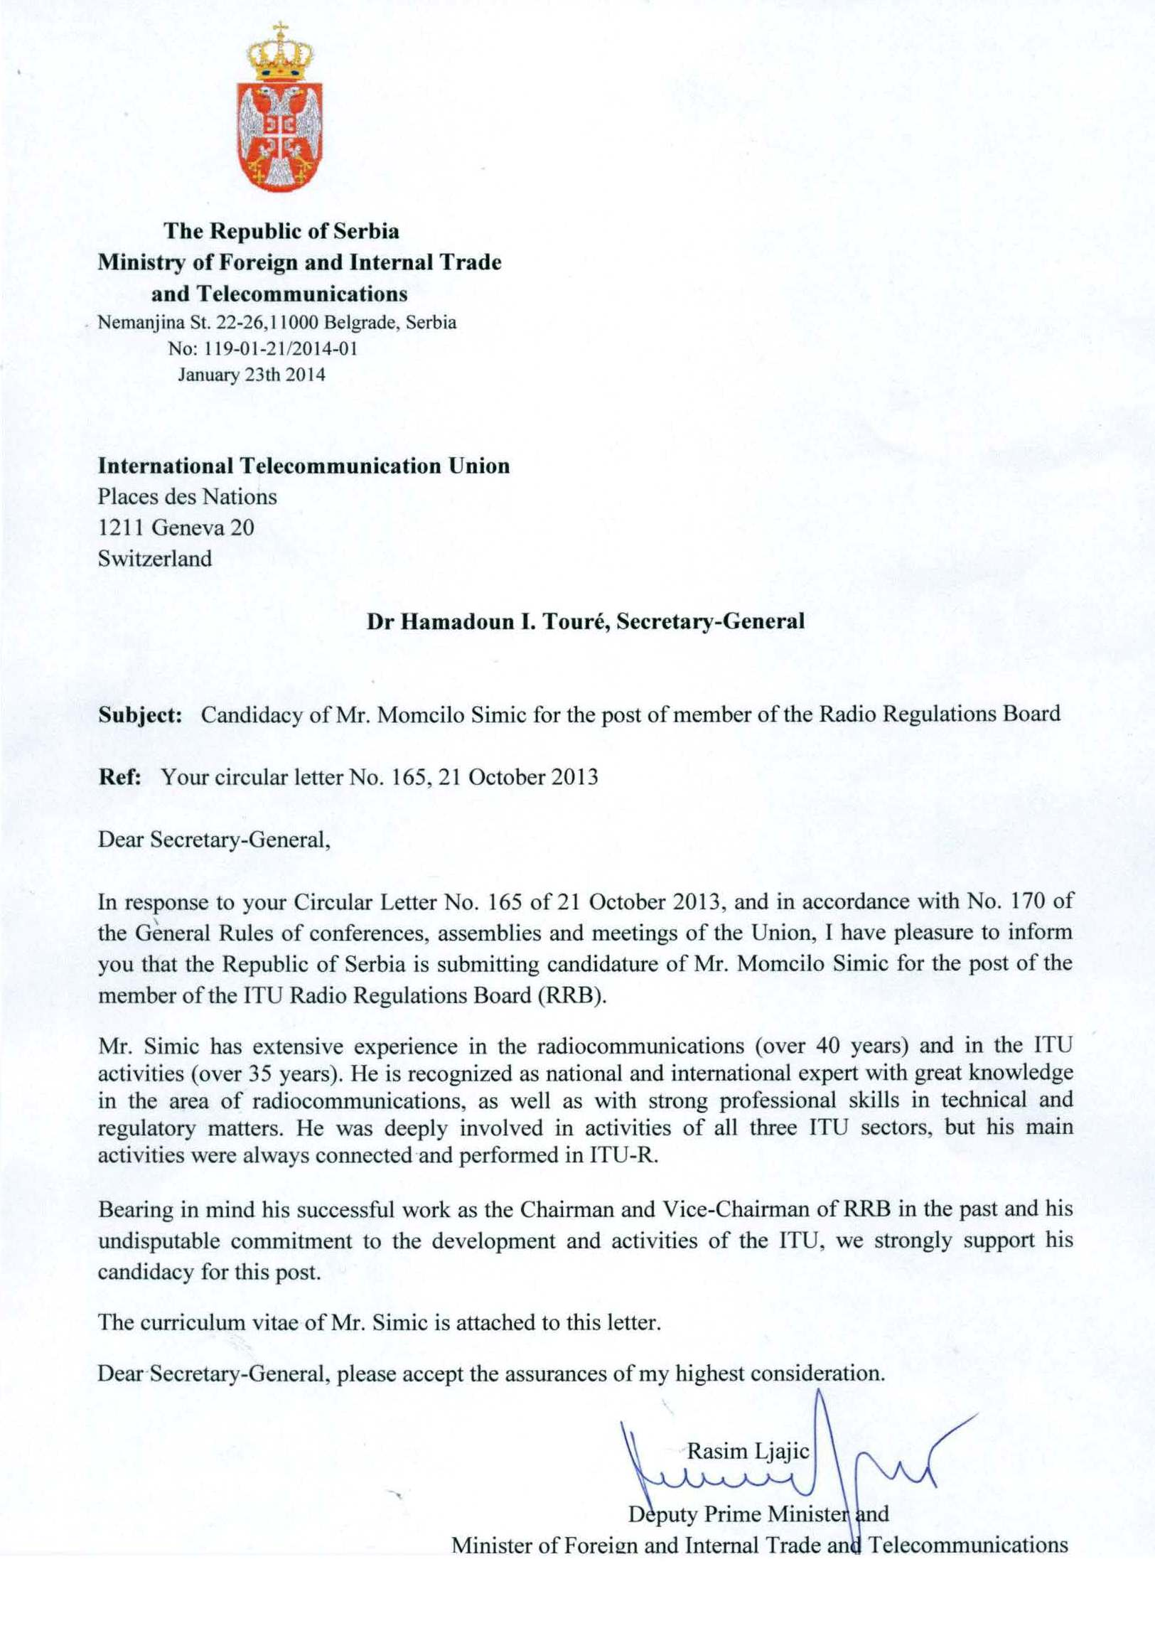

MOMCILO SIMIC
CANDIDATE FROM SERBIA-REGION C- FOR THE POST OF MEMBER OF THE RADIO REGULATIONS BOARD
CURRICULUM VITAE
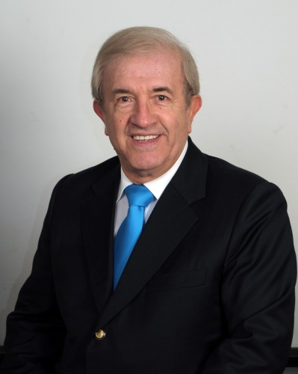
GENERAL INFORMATION
Date of birth: 21 October 1944
Nationality: Serbian
Family status: Married, two grown sons, three grand-children
Languages: Serbian (mother tongue), English (fluent), French (basic knowledge, obtained at language courses)
Honor: Decorated with the Order of Labor with Silver Wreath
EDUCATION
- Master Degree, Faculty of Electrical Engineering, Electronics and Telecommunications, Belgrade University;
- Specialized courses on frequency management and the use of radio frequency spectrum and geostationary satellite orbit, as well as on computer skills;
PROFESSIONAL EXPERIENCE
- 2011 – present Adviser for International Relations, JP ETV;
- 2009 – 2011 Independent International Consultant for Radiocommunications;
- 2007 – 2008 Deputy Minister for International Relations, Ministry of Telecommunications and Information Society;
- 2005 – 2007 Deputy Minister for Telecommunications, Ministry of Capital Investments;
- 1992 – 2005 Department Director, RTV of Serbia (RTS);
- 1990 – 1992 Assistant Director, Development and Frequency Planning, RTS;
- 1987 – 1990 Assistant Director, Research and Development, RTV Belgrade (RTB);
- 1982 – 1987 Director, MF Transmitters, RTB;
- 1976 – 1982 Chief Engineer, Development/Frequency Planning, RTB;
- 1973 – 1976 Senior Engineer, Development/Frequency Planning, RTB;
- 1969 – 1973 Engineer, MF Transmitters, RTB.

INTERNATIONAL ACTIVITIES
International Telecommunication Union (ITU)
Momcilo Simic has been participating in the ITU activities over 35 years, mainly in ITU-R (CCIR) and partly in ITU-D. At the Plenipotentiary Conference (Marrakech, 2002), he was elected for the post of Member of the Radio Regulations Board (RRB) of ITU, serving as Chairman (2004) and Vice-Chairman (2003) of the Board.
Momcilo Simic was awarded the ITU silver medal, in appreciation of all his very good work and positive contribution to the activities of the ITU during his RRB term.
He has participated in many high level ITU conferences, including:
- Three Plenipotentiary Conferences (PP-02, PP-06 – Deputy Head of Delegation, PP-10);
- Nine World Radiocommunication Conferences (WARC-84, WARC-87, WARC-92 – Coordinator for Europe and Africa "Satellite Sound Broadcasting, 1.5 GHz", WRC-95, WRC-97, WRC-2000, WRC-03, WRC-07 – Head of Delegation, WRC-12 – Deputy Head of Delegation);
- Two Regional Radiocommunication Conferences (RRC-04 – in the capacity of Chairman of the RRB, RRC-06);
- World Telecommunication Development Conference (WTDC-02 – Vice-Chairman of Committee 4);
- World Telecommunication Standardization Assembly (WTSA-08 – Head of Delegation);
- Five Council meetings (2002, 2007, 2010, 2012, 2013);
- Two CCIR Plenary Assemblies (1986 and 1990).
Momcilo Simic chaired many expert groups and participated in many SGs, TGs, and WPs in the ITU-R Sector.
Other international organizations and activities
Momcilo Simic participated in many CEPT high-level conferences/meetings, mainly as Head or Deputy Head of Delegation.
From 1974, Momcilo Simic was very active in the European Broadcasting Union (EBU), participating in many expert groups.
As a frequency management expert, Momcilo Simic was involved in the resolving of certain international problems and received the special letter of thanks from EBU, as well as from the countries concerned.
He is the Chairman of the European Committee of the “Tesla Wardencliffe Project – USA” and Member of the Executive Board of the “Tesla Memorial Society – USA”
In 1985, Momcilo Simic received the special JRT award for International technical cooperation and assistance to the LDC (Africa), as Project Leader and Expert Team Leader.
ACTIVITIES AT THE NATIONAL LEVEL
Momcilo Simic began his professional activities in 1969. He was a member or chairman of many expert groups, commissions, and committees within various national organizations, associations and institutions, including:

Federal Commission for the Broadcasting Law – Member
Federal Commission for the Telecommunication Law – Member
RTS Expert Group for the Broadcasting Law – Chairman
SZS (Federal Institute for Standardization) – Chairman – Commission for Transmitting Equipment.
JNK (Yugoslav National CCIR Committee) – Chairman – SG-10.
JRT (Yugoslav Radio-Television) – Chairman of many expert groups and member of the highest JRT bodies
TELFOR – Member of the Scientific Committee
PUBLICATIONS
Momcilo Simic is the author/co-author of numerous scientific and technical publications, which have been published in the relevant proceedings. He has also presented some publications at international events.
SUMMARY
Momcilo Simic has vast experience in frequency management, spectrum engineering, radio regulation (international and national level), and in the applications of new techniques and technologies. He has been invited by many countries to assist in implementation of new techniques/technologies, especially in strategy/approach of transition from analogue to digital broadcasting. He has had very successful presentations in neighbouring countries.
He is the recipient of many special prizes for his contributions, technical solutions/applications, including:
- ITU silver medal, in appreciation of his contribution, as Board member, to the activities of the ITU (Geneva, 2006);
- Special tribute of EBU for his contribution to the development, specification, implementation and promotion of the RDS (Geneva, 1992);
- Annual Prize of Radio Belgrade for “Technical solution for improvement of loudness area of Radio Belgrade Programs” (Belgrade, 1981);
- Annual Prize of Radio Belgrade for “Advancement of the Transmitting Techniques for Sound Broadcasting” (Belgrade, 1988);
- Annual Prize of RTV of Serbia for “Scientific work in the telecommunications” (shared with Academicians, Prof. Dr. J. Surutka and Prof. Dr. A. Djordjevic, Belgrade, 1998).
His professional and cooperative approach is greatly appreciated by all colleagues in the ITU, EBU, CEPT, HFCC and other organizations at global, regional and national levels.
___________________

