电信标准化局

2011年7月27日，日内瓦

文号：  电话：  传真： | 电信标准化局第204号通函补遗1  +41 22 730 6301  +41 22 730 5853 | - 致国际电联各成员国主管部门；  - 致ITU-T部门成员；  - 致ITU-T部门准成员；  - 致ITU-T学术成员；
电子  邮件： | cristina.bueti@itu.int | 抄送：  - ITU-T第5研究组正副主席；  - 电信发展局主任；  - 无线电通信局主任

事由： | 有关通过绿色信息通信技术（ICT）标准推进气候议程的专题研讨会，2011年9月19日，大韩民国首尔

尊敬的先生/女士，
随信在附件1中附有主办方提供的、将于2011年9月19日在韩国首尔召开的“通过绿色信息通信技术（ICT）标准推进气候议程”专题研讨会的其他宾馆信息。

顺致敬意！

电信标准化局主任
马尔科姆•琼森
附件：1 件
附件 1
（电信标准化局第204号通函）
Please find below information on additional accommodation for delegates attending the SG5 meeting in Seoul, Korea. The map indicates each hotel’s proximity to the meeting venue together with a chart including the corresponding hotel rates.

HOTEL | CATEG. |  | ROOM | RATE | NOTES
(1) Uljiro Coop Residence  32 Uljiro 6ga Jung-gu Seoul  Tel: +82. 2-2269-8411  Fax: +82. 2-2269-4209  Check-In: 2:00 PM  Check-Out: 12:00 PM  (Reservation only as a fax)  http://residences.co-op.co.kr/accommodations_17_4.htm  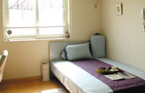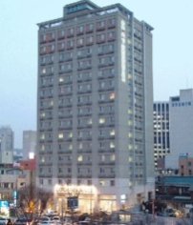 | Standard |  | Twin  Double | KRW 90,000 (≒USD 85) | Included Taxes  buffet breakfast  : KRW 6,600 (≒USD 6)
 | Distance from  Lotte Hotel (Venue) |  |  | 2 km, 10 min by taxi
 | Deadline of Reservation |  |  | 19th of August
 | Cancelation Policy |  |  | Notice to the hotel of any cancellations 2 days before on the date of arrival or be charged for one night.
(2) Western Coop Residence  77-2Uljiro 5ga Jung-gu Seoul  Tel: +82. 2-2269-8411  Fax: +82. 2-2269-4209  Check-In: 2:00 PM  Check-Out: 12:00 PM  (Reservation only as a fax)  http://residences.co-op.co.kr/accommodations_23_4.htm  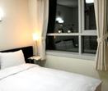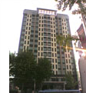 | Standard | Twin  Double |  | KRW 90,000 (≒USD 85) | Included Taxes  buffet breakfast  : KRW 6,600  (≒USD 6)
 | Distance from  Lotte Hotel (Venue) |  |  | 2.5 km, 10 min by taxi
 | Deadline of Reservation |  |  | 19th of August
 | Cancelation Policy |  |  | Notice to the hotel of any cancellations 2 days before on the date of arrival or be charged for one night.
(3) Hyundae Residence  22-5 Chungmooro 5ga Jung-gu Seoul  Tel: +82. 2-3406-8000  Fax: +82. 2-3406-8003  Check-In: 2:00 PM  Check-Out: 12:00 PM  reservation@hyundairs.com  http://hyundairs.com/rooms.htm  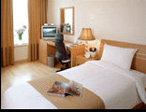 | Standard |  | Weekly  Double  Twin | KRW 100,000  KRW 103,000 | Included Taxes  buffet breakfast  : KRW 8,800 (≒USD 8)
 |  |  | Weekend  Double  Twin | KRW 135,000  KRW 138,000
 | Distance from  Lotte Hotel (Venue) |  |  | 2.5 km, 10 min by taxi
 | Deadline of Reservation |  |  | 19th of August
 | Cancelation Policy |  |  | 50% penalty fee from 28th of August  75% penalty fee from 5th of September  100% penalty fee from 12nd of September
(4) The SOHO Residence  90, Pirun-dong, Jongno-gu, Seoul  Tel: +82. 2-722-1999  Fax: +82. 2-722-3920  Check-In: 2:00 PM  Check-Out: 12:00 PM  hotelmoa@naver.com  http://www.thesoho.co.kr/  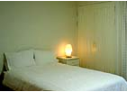 | Standard | Single |  | KRW 150,000 (≒USD 136) | None
 | Distance from  Lotte Hotel (Venue) |  |  | 3 km, 15 min by taxi
 | Deadline of Reservation |  |  | 19th of August
 | Cancelation Policy |  |  | 100% penalty fee from 7days prior to check in date.
(5) Tea Guest House  15-6 Gye-dong Jongno-gu Seoul  Tel: +82. 2-3675-9877  Check-In: 3:00 PM  Check-Out: 11:00 PM  tea@teaguesthouse.com  http://www.teaguesthouse.com/index.php  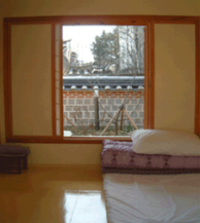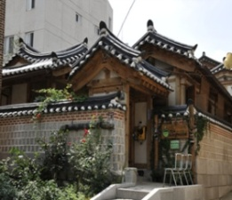 | Standard | Double |  | KRW 90,000  (≒USD 88) | buffet breakfast  : complimentary
 | Distance from  Lotte Hotel (Venue) |  |  | 2.5 km, 10 min by taxi
 | Deadline of Reservation |  |  | Booking is first-come-first-served due to a limit of the number of available rooms of accommodations.
 | Cancelation Policy |  |  | 100% penalty fee from 7days prior to check in date.
(6) Eugene Guest House  5-43 Hyewha-dong Jongno-gu Seoul  Tel: +82. 2-741-3338  Fax: +82. 70-4149-3308  Check-In: 15:00 PM  Check-Out: 11:00 AM  Yykim65@hotmail.com  http://www.eugenehouse.co.kr/index_en.php  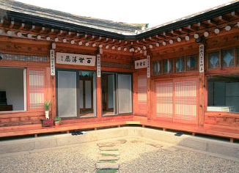 | Standard | Single |  | KRW 115,000 (≒USD 110) | buffet breakfast  : complimentary
 |  | Twin or Double |  | KRW 190,000 (≒USD 170)
 | Distance from  Lotte Hotel (Venue) |  |  | 5 km, 20 min by taxi
 | Deadline of Reservation |  |  | Booking is first-come-first-served due to a limit of the number of available rooms of accommodations.
 | Cancelation Policy |  |  | - NO-SHOW : Customers have to pay 100% of the whole payment.  - On the starting day : Customers have to pay 100% of the whole payment.  - 7 days before : Customers have to pay  70% of the whole payment.  - 12 days before : Customers have to pay  60% of the whole payment.  - 25 days before : Customers have to pay  50% of the whole payment.
(7) Sophia Guest House  59-5 Myeongdong 1ga Jung-gu Seoul  Tel: +82. 2-720-5467  Fax: +82. 2-6280-5469  Check-In: 15:00 PM  Check-Out: 12:00 PM  Sophia-house@hanmail.net  http://www.sophiagh.com/index.php  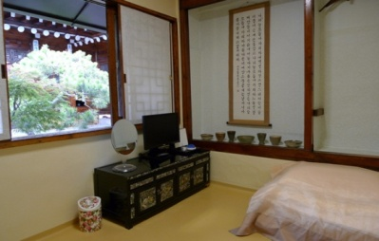 | Standard | Double |  | KRW 60,000 (≒USD 58) | buffet breakfast  : complimentary
 | Distance from  Lotte Hotel (Venue) |  |  | 2.5 km, 10 min by taxi
 | Deadline of Reservation |  |  | Booking is first-come-first-served due to a limit of the number of available rooms of accommodations.
 | Cancelation Policy |  |  | 50% penalty fee from 5 days prior to check in date.  100% penalty fee from 3days prior to check in date.

