Radiocommunication Study Groups
Source: Document 5A/TEMP/267(Rev.1)  Subject: Question ITU-R 205-5/5 | Annex 12 to  Document 5A/636-E
 | 10 November 2014
 | English only
Annex 12 to Working Party 5A Chairman’s Report
Working document toward a preliminary
new report ITU-R M.[ITS usage]
Intelligent transport systems usage Report in ITU Member States
(Question ITU-R 205-5/5)

TABLE OF CONTENTS

1 Introduction
2 Background
3 Related documents
4 List of acronyms and abbreviations
5 Overview of ITS radiocommunication and vehicular radar
5.1 ITS radiocommunication
5.1.1 Terms and definitions
5.1.2 Technical characteristics
5.2 Vehicular radar
5.2.1 Terms and definitions
5.2.2 Technical characteristics
6 Traditional ITS radiocommunication
6.1 Overview
6.1.1 Technical characteristics
6.1.2 Frequency usage
6.1.3 Standardization
6.1.4 Applications
6.2 Europe
6.2.1 Technical characteristics
6.2.2 Frequency usage
6.2.3 Standardization
6.2.4 Applications
6.3 North America
6.3.1 Technical characteristics
6.3.2 Frequency usage
6.3.3 Standardization
6.3.4 Applications
6.4 Asia-Pacific
6.4.1 Technical characteristics
6.4.2 Frequency usage
6.4.3 Standardization
6.4.4 Applications
7 Advanced ITS radiocommunication
7.1 Overview
6.1.1 Technical characteristics
6.1.2 Frequency usage
6.1.3 Standardization
6.1.4 Applications
7.2 Europe
6.2.1 Technical characteristics
6.2.2 Frequency usage
6.2.3 Standardization
6.2.4 Applications
7.3 North America
6.3.1 Technical characteristics
6.3.2 Frequency usage
6.3.3 Standardization
6.3.4 Applications
7.4 Asia-Pacific
6.4.1 Technical characteristics
6.4.2 Frequency usage
6.4.3 Standardization
6.4.4 Applications

8 Millimeter-wave vehicular radar
8.1 Overview
7.1.1 Technical characteristics
7.1.2 Frequency usage
7.1.3 Standardization
7.1.4 Applications
8.2 Europe
7.2.1 Technical characteristics
7.2.2 Frequency usage
7.2.3 Standardization
7.2.4 Applications
8.3 North America
7.3.1 Technical characteristics
7.3.2 Frequency usage
7.3.3 Standardization
7.3.4 Applications
8.4 Asia-Pacific
7.4.1 Technical characteristics
7.4.2 Frequency usage
7.4.3 Standardization
7.4.4 Applications
9 Conclusions

[Editor’s note: All the texts may be addressed in future contributions to this document.]

1 Introduction
This report addresses the usages of ITS radiocommunication applications, such as vehicle to infrastructure, vehicle to vehicle, vehicle to pedestrian communications for road safety applications and vehicular radars for collision avoidance in ITU Member states.

2 Background
Asia-Pacific Telecommunity (APT) already published an APT Report on “The usage of intelligent transport systems in APT Countries” Revision 1 (APT/AWG/REP-18 (Rev.1)) which APT contributed to WP 5A in May 2013 (Document 5A/223).

3 Related documents
ITU-R Recommendations:
ITU-R M.1890 Intelligent transport systems – Guidelines and objectives
ITU-R M.1452 Millimetre wave radiocommunication systems for Intelligent Transport Systems applications
ITU-R M.1453 Intelligent Transport Systems – dedicated short-range communications at 5.8 GHz
ITU-R M.2057 Systems characteristics of automotive radars operating in the frequency band 76-81 GHz for intelligent transport systems applications
ITU-R Report:
ITU-R M.2228 Advanced intelligent transport systems (ITS) radiocommunication
ITU-R Handbook: Land Mobile (including Wireless Access) - Volume 4:
Intelligent Transport Systems
Other related documents:
APT/AWG/REP-18 (Rev.1) The usage of intelligent transport systems in APT Countries

4 List of acronyms and abbreviations
APT Asia-Pacific Telecommunity
ARIB Association of Radio Industries and Businesses
ATIS Alliance for Telecommunications Industry Solutions
AWG APT Wireless Group
CEN European Committee for Standardization
CEPT European Conference of Postal and Telecommunications Administrations
ECC Electronic Communications Committee
ETSI European Telecommunications Standards Institute
FCC Federal Communications Commission
IEEE Institute of Electrical and Electronics Engineers
ISO International Organization for Standardization
ITS Intelligent Transport Systems
RLAN Radio Local Area Network
TIA Telecommunications Industry Association
TTA Telecommunication Technology Association
WLAN Wireless Local Area Network

5 Overview of ITS radiocommunication and vehicular radar
Since several decades ago, traffic congestion has been increasing all over the world as a result of increased motorization, urbanization, population growth, and changes in population density. Congestion reduces efficiency of transportation infrastructure and increases travel time,
air pollution, and fuel consumption. Interest in Intelligent Transport Systems (ITS) comes from the problems caused by traffic congestion and a synergy of new information technology for simulation, real-time control, and communications networks. Namely, ITS is systems to support transportation of goods and humans with information and communication technologies in order to efficiently and safely use the transport infrastructure and transport means (cars, trains, planes, ships)^{[1]}.
Figure 1
Communication technologies and services for ITS^{[2]}
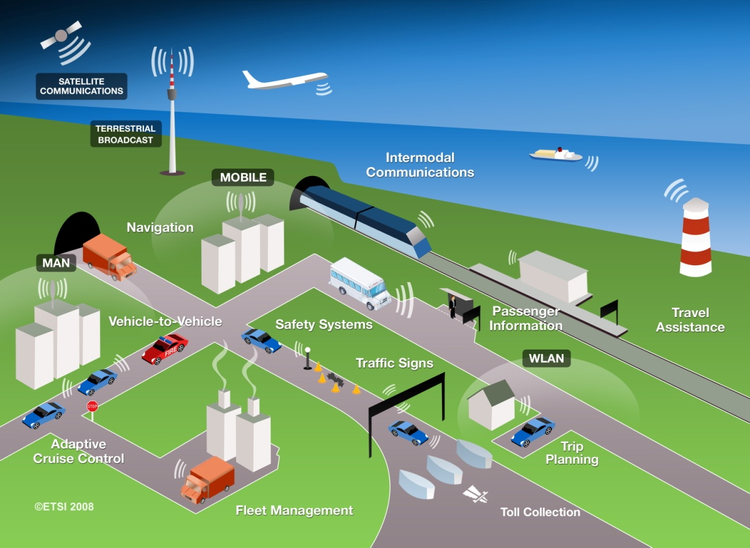

ITS has been standardized and studied in various standards development organizations. As an international level, ITU-R ISO TC 204, and IEEE are working on developing the standards and recommendations.

In Asia-Pacific, AWG is working as a regional level as well as ARIB, TTA and other standard organizations in each countries and regions. In Europe, ETSI TC ITS and CEN TC278 are working as a regional level.
This Report identifies current and planned usage of ITS technologies, frequency bands, status of services deployment in ITU member states.
Based on the major deployed ITS systems in the world were classified as electronic toll collection, vehicular radar, and vehicle information & communication. In this report, we described service overview, established standards, frequency plan, and implication in each ITS system.

5.1 ITS radiocommunication
Electronic toll collection allows for the manual in-lane toll collection process to be automated in such a way that drivers do not have to stop and pay cash at a toll booth. ETC systems improve traffic flow at toll plazas, and the level of pollution by reducing fuel consumption. In addition, allowing traffic to pass through the gate without stopping can increase road capacity by three or four times and relieve traffic congestion at the tollgate. It is also expected that ETC systems will reduce the operating costs of toll roads by replacing manual toll collection.
Since 1994, Vehicle Information and Communication System (VICS) has been using in Japan for delivering traffic and travel information to road vehicle drivers.
Nowadays, to extend beyond the existing ITS applications and to achieve traffic safety and reduce the environmental impact by the transportation sector, vehicle-to-vehicle (V2V), vehicle-to-infrastructure (V2I), infrastructure-to-vehicle (I2V) communications are studied. According to this progress, ITU-R WP 5A has developed report on advanced ITS radiocommunication^{[3]}. In the report, traditional ITS and advanced ITS are classified by its technical characteristics as shown in table 1. Wireless Access in Vehicular Environments (WAVE) and Continuous Access for Land Mobiles (CALM) technologies could be inclusive in advanced ITS category.

5.1.1 Terms and definitions
[Editor’s note: Text to be added]

5.1.2 Technical characteristics
Table 1
Technical characteristic of Traditional ITS and Advanced ITS
Items | Traditional ITS (DSRC) | Advanced ITS (WAVE, CALM, etc.)
Vehicular networking | V2I | V2I, V2V, V2N
Radio performance | Radio coverage: Max. 100 m  Data rate: ~ 4 Mbps  Packet size: ~100 bytes | Radio coverage: Max. 1 000 m  Data rate: Max. 27 Mbps  Packet size: Max. 2 kbytes  Latency: within 100 msec

5.2 Vehicular radar
Vehicular radar facilitates various functions which increase the driver’s safety and convenience.

Exact measurement of distance and relative speed of objects in front, beside, or behind the car allows the realization of systems which improve the driver’s ability to perceive objects during bad optical visibility or objects hidden in the blind spot during parking or changing lanes. Radar technology has proved its ability for automotive applications for several years. Vehicular radar systems are of two categories according to the applications and frequency band
− Automatic Cruise Control 'long-range radar' (usually operating at 76 GHz band).
This enables a vehicle to maintain a cruising distance from a vehicle in front.
− Anti-collision 'short-range radar' (usually operating at 24 GHz and 79 GHz bands).
This is being developed as part of a system to warn the driver of a pending collision, enabling avoiding action to be taken. In the event where collision is inevitable, the vehicle may prepare itself (for example by applying brakes, pre-tensioning seat belts) to minimize injury to passengers and others.
Figure 2
Vehicular radar^{[4]}
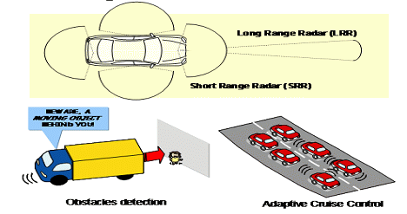

5.2.1 Terms and definitions
[Editor’s note: Text to be added]

5.2.2 Technical characteristics
[Editor’s note: Text to be added]

6 Traditional ITS radiocommunication
[Editor’s note: Text to be added]

7 Advanced ITS radiocommunication
[Editor’s note: Text to be added]

8 Millimeter-wave vehicular radar
[Editor’s note: Text to be added]

9 Conclusions
[Editor’s note: Text to be added]
References
[1] ETSI EN 302 665 V1.1.0, “Intelligent Transport Systems (ITS); Communications Architecture”
[2] http://www.etsi.org/website/Technologies/IntelligentTransportSystems.aspx
[3] ITU-R Report M.2228, “Advanced Intelligent Transport Systems (ITS) radiocommunication”

