Plenipotentiary Conference (PP-14)
Busan, 20 October – 7 November 2014
PLENARY MEETING | Document 16-E
 | 3 December 2013
 | Original: French
Note by the Secretary-General
candidacy for the post of director of the
telecommunication development bureau (BDT)
Further to the information contained in Document 3, I have pleasure in transmitting to the
conference, in annex, the candidacy of:
Mr Brahima SANOU (Burkina Faso)
for the post of Director of the Telecommunication Development Bureau (BDT) of the International
Telecommunication Union.

Dr Hamadoun I. TOURÉ
Secretary-General

Annex: 1

Burkina Faso
Ouagadougou, 21 November 2013
To: Dr Hamadoun I. Touré, ITU Secretary-General
From: The Prime Minister of Burkina Faso
Reference: 2013 26 13/PM/DIR-CAB
Subject: Candidacy of Mr Brahima SANOU, candidate from Burkina Faso for election to the post of Director of the Telecommunication Development Bureau (BDT) of the International Telecommunication Union (ITU) for the period 2015-2018
Dear Sir,
I have the honour and the pleasure to renew to you my compliments on your personal commitment and very significant contribution to the international influence of our Union.
Burkina Faso, which believes in ITU's ideals, reaffirms its readiness to pursue and strengthen, over the coming years, its efforts in terms of an increasingly active contribution to the life of our shared organization.
It is for this reason, and further to your Circular Letter 165 of 21 October 2013, that I hereby inform you, on behalf of the President of Faso and of the Government and people of Burkina Faso, of our decision to put forward the candidacy of Mr Brahima SANOU for election to the post of Director of the Telecommunication Development Bureau (BDT) of the International Telecommunication Union.
Under the leadership of Mr Brahima SANOU, the Telecommunication Development Bureau has, since 2011, brought very noteworthy improvements to bear in its achievement of the Development Sector’s objectives, in particular where services to the membership are concerned. Mr Sanou has laid emphasis on effective implementation of the Hyderabad Action Plan (2010), using the tools of good governance, resource mobilization and partnership, innovation and project execution. His undertakings have included strengthening of the regional presence, and he has launched three initiatives, relating to the use of mobile telecommunications as a platform for development, emergency telecommunications and sustainable development, and capacity building.
The rich variety of Mr Brahima SANOU’s experience, accumulated at both the national and international levels, and particularly within ITU, constitutes, for us, the guarantee of his ability to stand once again, during the period 2015-2018, at the helm of our Union’s Telecommunication Development Bureau.
I would ask that you inform the Member States of our Union that Mr Brahima SANOU has our full confidence and unreserved support in pursuing the accomplishment of his mission at the head of BDT over the forthcoming 2015-2018 programme cycle.
Yours faithfully,
(signed)
Beyon Luc Adolphe TIAO
Grand Officer of the National Order

Enclosure: CV of Mr Brahima SANOU
[Official stamp of the Prime Minister of Burkina Faso]

BRAHIMA SANOU
Candidate of Burkina Faso for the post of
Director of Telecommunication Development Bureau (BDT)

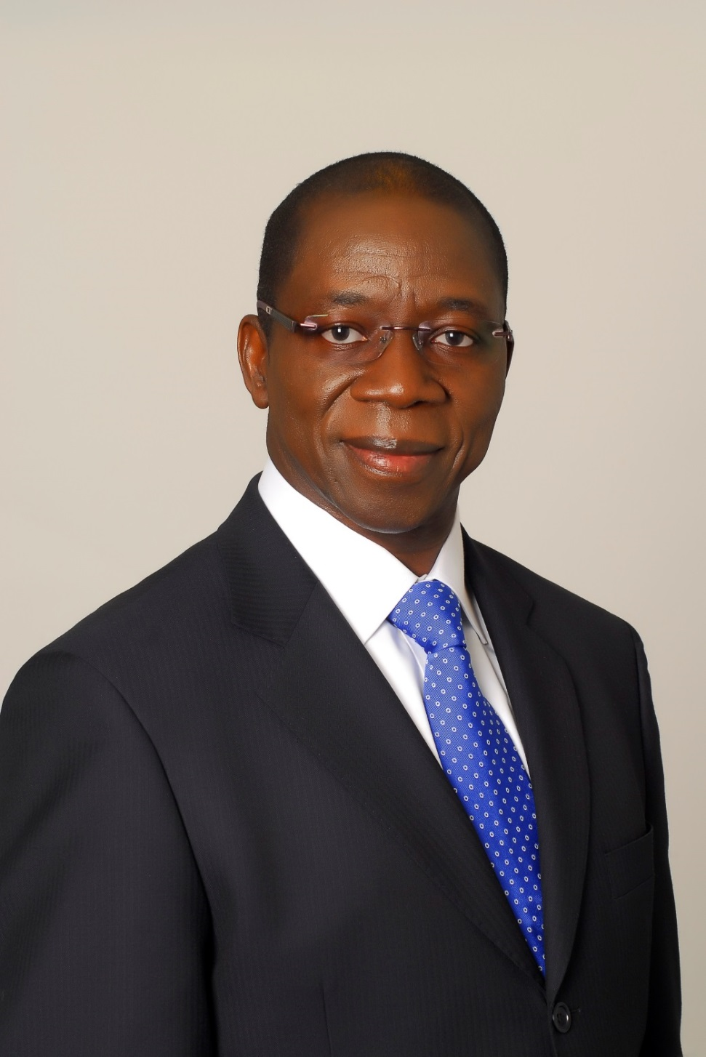

MY BELIEF AND MY COMMITMENT

In a rapidly expanding global information society, our responsibility is to foster the development of broadband access, particularly in developing countries, making it a powerful vehicle for sustainable development while at the same time giving a human face to telecommunications/ICT through new applications such as e-health, e-education, e-commerce and e-government.
In order for this to happen, there has to be close cooperation between governments and the private sector. There is need to promote public-private partnerships and to strengthen cooperation and collaboration among all stakeholders in the telecommunication/ICT ecosystem.
I am committed to serving you and advancing the cause of development, each day better than the day before.

THE CANDIDATE’S STRENGTHS

A telecommunication engineer, Mr Brahima SANOU also holds a postgraduate diploma from the Centre for Financial, Economic and Banking Studies of Paris. His training and his experience spanning 35 years in the telecommunication/ICT sector have afforded him the proficiency and broad-mindedness needed to grasp the issues involved in sustainable development and the Millennium Development Goals from the standpoint of the emerging global information society and the revolution in information and communication technologies in terms of their technical, economic and financial aspects.

PROFESSIONAL EXPERIENCE

Since January 2011: Director of the Telecommunication Development Bureau (BDT)
Elected Director of the Telecommunication Development Bureau (BDT) by the Plenipotentiary Conference (Guadalajara, 2010), Mr Sanou immediately set about tackling the priorities identified by Member States, guided by the key components of the vision which had underpinned his election, namely good governance, resource mobilization and partnerships, innovation and project execution.

To enhance transparency vis-à-vis the Member States, one of the first steps taken by Mr Brahima SANOU was to implement the principles of results-based management, thereby making it possible to monitor the evolution and use of resources and gauge the degree to which any given objective or regional initiative has been implemented. Performance indicators are used to measure, at regular intervals, the level of implementation achieved and results obtained. In a further mark of transparency, BDT now publishes a quarterly report on the implementation of the Action Plan adopted by the World Telecommunication Development Conference held in Hyderabad in 2010 (WTDC-10).

Mr Brahima SANOU has always favoured a listening and sharing approach. His steadfastly participative style has included frequent brainstorming sessions, open to ITU-D membership and BDT staff, as well as ongoing multifaceted relations with all players from the telecommunication/ICT community.

He has successfully instilled a new sense of purpose into the ITU-D Study Groups. Strengthening of the resources needed for content development forms part of the sharing vision to which he is committed. His objective has been to transform the study groups into an ideal and universally beneficial platform for the exchange and sharing of knowledge, aware as he is that sustainable development is unattainable without capacity building.

In the interest of partnership building, Mr Sanou has systematically sought to galvanize relations with the private sector and other players in the telecommunication/ICT ecosystem. He successfully organized the “Connect the World” series of summits (Connect Arab States in 2012, Connect Americas in 2012, and Connect Asia-Pacific in 2013), while ensuring that the preparatory process was done in close cooperation and in partnership with regional telecommunication organizations.

Throughout the period of his first mandate, Mr Brahima SANOU has displayed the vision and commitment needed to make BDT the operational arm of ITU, delivering ICT solutions for sustainable development and achievement of the Millennium Development Goals.

In this regard, he has recently launched three major initiatives within the framework of an overarching vision of sustainable development. The first initiative, m-Powering Development, seeks to give a human face to ICTs by harnessing mobile technology for the delivery of basic services such as health, education, commerce and finance. The second initiative, Smart Sustainable Development Model, seeks to link the use of ICTs for socio-economic development and for disaster preparedness and response in the immediate aftermath of disasters striking.. The aim of the third initiative, ITU Academy, seeks to provide a platform for the sharing of training and professional development programmes.

In the course of his term of office, Mr Brahima Sanou has also been at pains to step up the level of interaction between BDT and the ITU-D membership through numerous wide-ranging visits and meetings that have enabled him to enhance his knowledge and understanding of the unique requirements of each region and each country, over and above the common challenges facing the international community, thereby ensuring that BDT, as a key player in the telecommunication/ICT ecosystem, is always in a position to respond appropriately to the ever-growing and multifaceted demand for telecommunication/ICT development and capacity building.

In managing the BDT, he has undertaken a restructuring based on an evaluation of the existing structures and processes through broad consultation of staff, with the emphasis on innovation, improvement of the products and services provided to the ITU-D membership, and on strengthening of the regional presence. This restructuring has led to harmonization and standardized structure and staffing of the regional presence.

In pursuing his objectives, he has taken due account of the need to improve BDT’s internal procedures and working methods, empowering regional and area offices to implement the ITU-D operational plan, strengthen cooperation with regional telecommunication organizations and enhance their information dissemination function.

As Director of BDT, Mr SANOU will continue to focus on innovation, partnerships and resource mobilization, knowledge-sharing and project execution to ensure that tomorrow’s responses to the challenges of the technological revolution will, in the interests of sustainable development, build on and surpass those of yesterday and today.

2000 to 2010: Head of the Regional Office for Africa and Liaison Officer to the African Union and the United Nations Economic Commission for Africa
Throughout these years of work in the field, Mr Sanou focused his efforts on finding innovative solutions to the problems posed by development disparities in a region marked by the highest concentration of LDCs. In so doing, he practiced a listening approach and engaged in direct interaction with relevant administrations and other stakeholders. One of his key objectives was strengthening cooperation with the African Union, regional and subregional telecommunication, finance and development organizations, and agencies of the United Nations common system.

1997 to 2000: Coordinator, African regional project on telecommunication reform and General Agreement on Trade in Services (GATS)
During this period, Mr Brahima Sanou worked to support Africa’s telecommunication and information technology administrations in adapting to the changing international telecommunication paradigm and the emergence of a new regulatory framework (liberalization, competition, harmonization of regulations and market access within the WTO framework).

1981 to 1997: Employee in the postal and telecommunication services of Burkina Faso
Mr Sanou held a number of senior posts concerned with development of his country’s telecommunication sector.

INTERNATIONAL EXPERIENCE

In the course of a career marked by a rich variety of international experience, Mr Brahima SANOU has served as:
– Councillor and Head of Burkina Faso’s delegation to sessions of the ITU Administrative Council (now the Council) (1989 to 1996);
– Vice-Chairman of the Telecommunication Development Advisory Board (now the Telecommunication Development Advisory Group (TDAG)), responsible for least developed countries (1994 to 1996);
– Vice-Governor, then Governor, representing a group of 15 African countries on the Board of Governors of INTELSAT (1990 to 1992);
– Representative of ITU at numerous high-level meetings in Africa, including summits of Heads of State and Government of the African Union.
Mr Brahima Sanou’s international experience has taken on a new dimension and unique character in his capacity of Director of ITU’s Telecommunication Development Bureau.

QUALIFICATIONS

Engineering degree from the Ecole Nationale Supérieure des Télécommunications (ENST), Paris.
Postgraduate diploma from the Centre for Financial, Economic and Banking Studies (CEFEB), Paris.

LANGUAGES: French, English, Arabic (basic knowledge, following courses)
FAMILY STATUS: Married, with three children
HONOURS: Officer of the National Order of Burkina Faso
E-MAIL: brahima@bsanou.name
_________________________

