Plenipotentiary Conference (PP-14)  Busan, 20 October – 7 November 2014 | 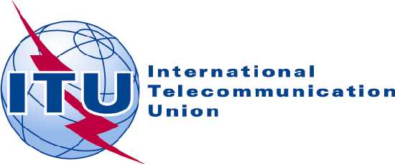
PLENARY MEETING | Document 14-E
 | 18 November 2013
 | Original: English
Note by the Secretary-General
CANDIDACY FOR THE POST OF DEPUTY SECRETARY-GENERAL

Further to the information contained in Document 3, I have pleasure in transmitting to the conference, in annex, the candidacy of:
Mr Shola TAYLOR (Nigeria)
for the post of Deputy Secretary-General of the International Telecommunication Union.

Dr Hamadoun I. TOURE
Secretary-General

Annex: 1

ANNEX
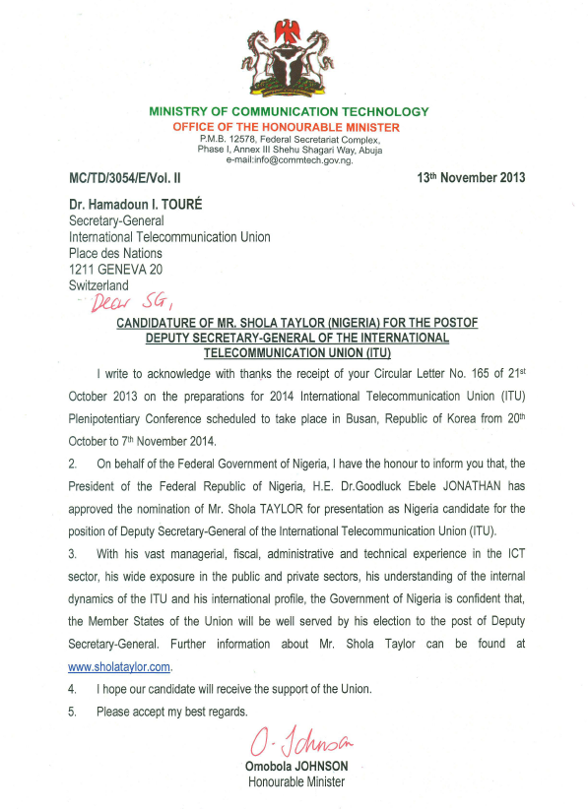

Shola TAYLOR
Nigerian Candidate for the post of Deputy Secretary-General of
the International Telecommunication Union (ITU)
Contact: sholataylor2014@gmail.com Website: www.sholataylor.com

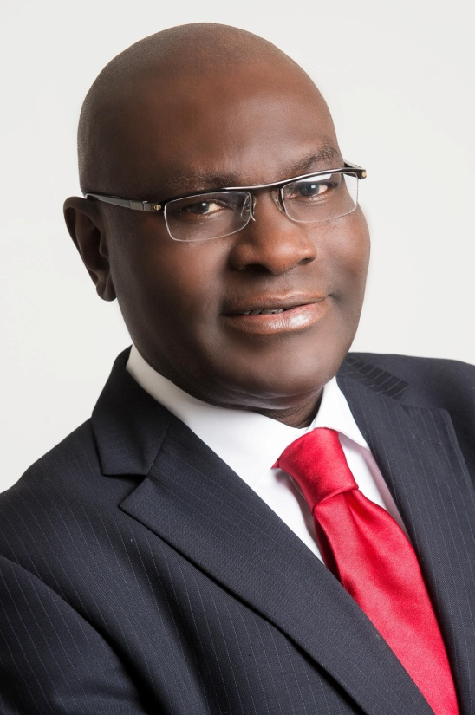

As the global community continues to enjoy an increasing array of Information and Communication Technology (ICT) services and applications, many challenges remain in this dynamically changing industry. These include, inter alia, lack of universal broadband access, gender balance, ICT affordability, cybersecurity including child online protection, privacy protection and emergency communications.

The ITU management team to be elected in 2014 should consist of professionals with global exposure and vision who will elaborate the best strategies for successful implementation of the ITU 2016-2019 strategic and financial plans that will tackle these challenges. These actions will need to take into account and complement the post-2015 global development agenda. In this regard the ITU management will need to ensure that ICTs are seen as an engine of economic growth and a major contributor to sustainable development. The new management will also need to ensure the fulfilment of the Purpose of the Union as stated in the Union’s Constitution and Convention. To this end, the ITU management must continue all efforts to connect the world and to bring the benefits of ICTs to all the world’s people, wherever they live and whatever their circumstances.

Taking into consideration these important aspects of the ITU’s mandate, the government of the Federal Republic of Nigeria is pleased to present Shola TAYLOR as its candidate for the strategic position of Deputy Secretary-General. His Vision, Mission objectives and Profile are all presented in this CV.

CV of Shola TAYLOR
Vision

Affordable and high quality connectivity for all citizens of the world

Mission
- Strengthen the consultation process and strategic partnership between ITU Member States, Sector Members and other ICT stakeholders to promote common and shared understanding;
- Assist in the continued development of ICTs, especially broadband technologies, and their applications for the benefit of all mankind;
- Enhance collaboration amongst the three ITU Sectors and the General Secretariat to provide better value for the Union and its membership;
- Assist the Secretary-General in the implementation of the Union’s financial and strategic plans;
- Assist the Secretary-General in applying innovative mechanisms to mobilize additional resources and continue to manage the ITU resources more transparently, efficiently and effectively;
- Promote internal reforms within the ITU to achieve greater efficiency through results-based management;
- Maintain an attractive working environment for ITU staff members.
Brief Profile
- Over 30 years of global experience in ICT with government and private sector;
- A very rich inside knowledge of the ITU, having been a previous senior member of ITU staff at Director level for 7 years (1987-1994);
- Direct experience with other UN organisations;
- Practical working experience with international organisations including INTELSAT Washington DC, Inmarsat UK and ITU Geneva;
- Commissioner/Board Member of the Nigerian Communications Commission;
- Adviser to ICT Ministers of Nigeria, Rwanda and South Africa;
- Regional Director for Africa, Inmarsat UK;
- Commissioner at the NEPAD e-Africa Commission;
(NEPAD = The New Partnership for Africa’s Development)
- Coordinator of the African Telecom Think Tank, a world-wide association of African professionals active in the ICT sector;
- Recipient of several Awards, including the ITU Silver Medal for outstanding contribution in support of the activities of the ITU and the Radio Regulations Board;
- Over 25 years of active participation in ITU activities as described below.

ITU-related Experience
The post of Deputy Secretary-General is of strategic importance to the ITU management, especially in assisting the Secretary-General, in cooperation with other elected officials to ensure the successful implementation of ITU strategic and financial plans and other assignments. With his vast managerial, fiscal, administrative and technical experience in the ICT sector, Shola TAYLOR is uniquely qualified to hold the position of Deputy Secretary-General of the ITU. His ITU-related experience includes the following:
- Project Director, Technical Cooperation Department (now BDT), ITU, 1987-1994;
- Elected twice by the ITU Plenipotentiary Conference as a Member of the Radio Regulations Board (RRB) each time for a mandate of 4 years, in Marrakech, Morocco in 2002 and Antalya, Turkey in 2006 respectively
  - Elected Vice Chairman of the Board (RRB) in 2004 and
  - Chairman of the Board (RRB) in 2005;
- ITU Expert on ICT Policy, Regulations, Infrastructure development and Spectrum Management;
- Adviser to the Ministry of Communication Technology, Nigeria, on ITU Council and other related matters;
- Member of Nigerian delegation to several ITU Conferences, Seminars and Meetings including ITU Council, ITU Plenipotentiary Conferences, ITU World Radiocommunication Conferences, ITU World Telecommunication Standardization Assembly (WTSA), ITU World Telecommunication Development Conferences (WTDC), ITU World Conference on
International Telecommunications (WCIT), World Summit on the Information Society (WSIS), Study Groups of the Radiocommunication Bureau, Development Sector and Standardization Sector;
- Elected Chairman of Committee 5B of the World Radiocommunication Conference, Geneva 2012 (WRC-2012) which dealt with some of the most critical issues of the Conference.

Professional Positions in reverse chronological order
Shola TAYLOR has held senior positions in the ICT industry globally, as follows:

1999 to date: CEO, Kemilinks International
In this position, he is responsible for managing this global consultancy firm. He also leads several project teams of experts to undertake various medium to large consultancy projects for a number of national, regional and international clients. Projects undertaken include:
- Preparation of a draft telecommunication policy for Nigeria;
- Evaluation of the ICT regulatory regimes in the Economic Community of West African States (ECOWAS) Member countries for Vodacom South Africa;
- Preparation of NEPAD ICT African Infrastructure Plan for the African Union Commission;
- Restructuring of the Special Fund for Telecoms for ECOWAS Bank in collaboration with the CMTL of Togo; (CMTL = Centre Régional de Maintenance des Télécommunications de Lomé)
- Providing advice to Eskom South Africa on the Second National Operator licensing process;
- Licensing of the third national telecommunication operator in Rwanda;
- Undertook several missions as ITU Expert on spectrum management, analogue to digital transition, ICT infrastructure requirements, preparation of training modules and the establishment of frequency coordination mechanisms for cross-border coordination;
- Review of short-term plan of the NEPAD ICT Infrastructure Programme for the African Development Bank;
- Participation in the restructuring of Commonwealth Telecommunications Organisation to attract private sector membership from the ICT industry;
- Preparation of tender documents for the Nigerian Communications Commission for the selection of GSM operators for Nigeria;
- Preparation of a comprehensive plan for the Presidential Advisory Committee on the transition from analogue to digital terrestrial broadcasting in Nigeria;
- Preparation of tender documents and evaluation of bids for the selection of licensees for Radio & TV Broadcasting Networks in Nigeria;
- Preparation of an optimal interconnection regime for MTN Nigeria;
- Preparation of a viable tariff regime for Airtel Nigeria;
- Viability Assessment/Business Case Study for the Nigerian Communication Satellite System;
- Preparation of Communications Bill for Uganda;
- Provision of Advice to Sierra Leone and Nigeria on ICT Convergence [Economic Commission for Africa (ECA) project];
- Audit of spectrum utilisation in the 900 and 1800 MHz bands in Uganda;
- Technical Coordinator for the Nigerian Government and the African Telecommunication Union on all relevant issues for Africa in preparation for WRC-07 and WRC-12.

During this period, he also held a number of advisory positions at various times as follows:
- Adviser to respective Ministers of Communications for Nigeria, Rwanda and South Africa;
- Coordinator of the African Telecom Think Tank, a world-wide association of African professionals active in the ICT sector;
- Commissioner, NEPAD E-Africa Commission, South Africa, a body set up by African Leaders to promote the development of information and communication technology (ICT) in Africa;
- Member of the Board/Commissioner, Nigerian Communications Commission.

1994-1999: Regional Director for Africa, Inmarsat, UK
In this position, he was responsible for promoting and developing the Inmarsat business in Africa and provided technical, business and market development, spectrum and other regulatory support to Inmarsat. He successfully engaged with Ministers and Chief Executives of African Telecom Regulatory agencies and Telecom Operators in adopting policy and regulatory frameworks designed to accelerate the development of their communications infrastructure.

1993-1994: Coordinator, Space Technology for developing countries, ITU, Geneva
He conceived and spearheaded the ITU SPACECOM project, within the ITU Technical Cooperation Department (now “BDT”) which has now become the framework for the promotion of satellite communications technology in developing countries. He also succeeded in obtaining substantial private sector financial support for its implementation.

1987-1993: Project Director, Technical Cooperation Department (now BDT) ITU Geneva
He directed and managed a team of several international experts, consultants and over 600 national experts from 50 African countries which undertook the most comprehensive feasibility study (to date) for short, medium and long term telecommunications and broadcasting requirements for Africa. During this study, he conceived the establishment of the Regional African Telecommunication Database (RATDA) which formed the basis for the widely accepted ICT indicators which are now regularly published by the ITU. He also served as a Member of the ITU Appointments and Promotions Board and represented the ITU at many international events.

1985-1987: Technical Staff Member (Spectrum Planning), Intelsat Washington DC, USA
As a member of the Intersystem Coordination Department, he was mainly responsible for preparing various technical documentation required for ITU registration of Intelsat satellites. These included Advance Publication Information and the Request for Coordination in preparation for filing of those systems. He also carried out some interference analyses to aid the Intelsat team responsible for coordination of planned Intelsat satellites with other satellite systems.

1981-1985: Senior Engineer, Nigerian Telecommunications (NITEL) Ltd, Nigeria
He provided technical inputs to the preparation of specifications for transmission systems - both terrestrial and satellite. He was a member of various teams that evaluated technical bids for satellite communication earth stations, microwave transmission and switching systems. He was appointed by the Nigerian Minister of Communications as Secretary of the task force that reviewed the domestic satellite systems in Nigeria with a view to enhancing the systems for more efficient use. He prepared the system design for the first business satellite systems used in Nigeria. He also represented Nigeria at many regional and international telecommunications meetings and conferences.

1979-1980: Development Engineer, Ultra Communications Ltd, UK (now Ultra Electronics)
He served as a Member of the engineering team responsible for the design and development of VHF transmitters for Sonobuoys used by the British defence industry. He proposed a number of design improvements, some of which were adopted to achieve optimum performance. He also carried out several tests to ensure that equipment that was to be deployed performed according to specifications.

Main Educational Qualifications
- MSc Telecommunications Systems, University of Essex, UK 1981
- BSc Electrical and Electronic Engineering, University of East London, UK 1979

Personal Details
Date of birth: 22 January 1956
Marital Status: Married with 3 children
Languages: English, French, Yoruba
Other interests: Reading, Music, Youth Empowerment/Mentoring

