Telecommunication Standardization  Bureau | 

Geneva, 13 July 2011

Ref:  Tel:  Fax: | TSB Circular 204  +41 22 730 6301  +41 22 730 5853 | - To Administrations of Member States of the Union;  - To ITU-T Sector Members;  - To ITU-T Associates;  - To ITU-T Academia;
E-mail: | cristina.bueti@itu.int | Copy:  - To the Chairman and Vice-Chairmen of ITU-T Study Group 5;  - To the Director of the Telecommunication Development Bureau;  - To the Director of the Radiocommunication Bureau

Subject: | Symposium on Progressing the Climate Agenda through Green ICT Standards, Seoul, Korea – 19 September 2011

Dear Sir/Madam,
1 I would like to inform you that a symposium on “Progressing the Climate Agenda through Green ICT Standards” will take place on 19 September 2011 from 1330 to 1800 hours at the International Conference Hall in Korea Press Center, Seoul, Korea. The symposium will be held back to back with ITU-T Study Group 5 (Environment and climate change) which is to meet in Seoul, Republic of Korea, from 20 to 28 September 2011 inclusive (see TSB Collective letter 8/5).
2 Discussions will be held in English only.
3 Participation is open to ITU Member States, Sector Members, Associates and Academia and to any individual from a country which is a member of ITU who wishes to contribute to the work. This includes individuals who are also members of international, regional and national organizations. The symposium is free of charge.
4 A draft programme of the symposium is set out in Annex 1 hereto.
5 Practical information on the meeting provided by the host organization is given in Annex 2.
6 Information relating to the symposium will be available on the ITU-T website at the following address http://www.itu.int/ITU-T/worksem/climatechange/201109/index.html.
7 To enable TSB to make the necessary arrangements concerning the organization of the symposium, I should be grateful if you would register via the on-line form at http://www.itu.int/cgi-bin/htsh/edrs/ITU-T/workshop/edrs.registration.form?_eventid=3000286 , as soon as possible, but not later than 10 September 2011. Please note that pre-registration of participants to the symposium is carried out exclusively online.

8 ITU-T will provide a limited number of partial fellowships to one participant per eligible country within the Asia-Pacific region only and within the available budget. The participant must be duly authorized by the respective ITU Administrations from Least Developed Countries and from developing countries with per-capita income under US$ 2,000. While the provision of fellowship is limited to only one participant per country, the number of delegates from a country is not limited provided the expenses of additional delegates are borne by the country. Participants requiring a fellowship are requested to complete the Fellowship Request Form in Annex 4 and return it to the ITU by e-mail: bdtfellowships@itu.int or by fax to +41 22 730 5778 by 19 August 2011 at the latest.
9 We would like to remind you that citizens of some countries are required to obtain a visa in order to enter and spend any time in the Republic of Korea. The visa must be requested at least four (4) weeks before the date of beginning of the meeting and obtained from the office (embassy or consulate) representing the Republic of Korea in your country or, if there is no such office in your country, from the one that is closest to the country of departure.
Participants who need an invitation letter and/or a visa supporting letter for entering the Republic of Korea are advised to get in touch with the contact person in the Republic of Korea:

Ms. Hye Young (Grace) Hwang
Tel: +82 2 338 1082
Fax: +82 2 338 1083
E-mail: sg5_visa@kcc.go.kr
10 For your convenience, a hotel reservation form is enclosed as Annex 3.
Yours faithfully,
Malcolm Johnson
Director of the Telecommunication
Standardization Bureau
Annexes: 4
ANNEX 1
(to TSB Circular 204)
Draft programme for the Symposium on progressing the Climate Agenda
through Green ICT Standards
(Seoul, 19 September 2011)

Monday, 19 September 2011
13:30 - 13:45 | Opening Session  Moderator: Dr. Hye Joo Yoon, KCC  - Dr. Yong-Sup Shin, Standing Committee Commissioner, KCC (Republic of Korea)  - Ms. Judit Katona Kiss, Counsellor, Study Group 5 (on behalf of Malcolm Johnson, Director, Telecommunication and Standardization Bureau, ITU)  - Mr. Ahmed Zeddam, ITU-T SG5 Chairman
13:45 -14:00 | Keynote Speaker: Ms. Cristina Bueti, Programme Coordinator, ITU activities on ICTs, the Environment and Climate Change
14:00 - 15:30 | Session I : Roadmap: “ICTs and Environmental Sustainability”  This session will provide an overview of ongoing activities and efforts to reduce GHG emissions and energy consumption through the use of ICTs and will shed light on national and regional policies and best practices on how ICTs can help to address climate change.
15:30 - 16:00 | Coffee Break
16:00 - 17:30 | Session II : Can the ICT Sector Save the Planet and Humanity?  It is estimated that the ICT sector produces directly some 2-2.5 per cent of total emissions of greenhouse gases, and this share will increase as ICTs make a larger contribution to the global economy. What ICT manufactures and service providers have done so far to reduce their own carbon footprint and energy consumption?
17:30 - 18:00 | Questions & Answers, Review and Wrap-up  This session will provide an opportunity for participants and speakers to share their views which will be summarized in the outcome of the symposium.  The outcome of the symposium will be a set of recommendations and actions which will be submitted for consideration to the upcoming UNFCCC conference of parties-17 which will be held in Durban, South Africa in December 2011 as well as to the next TSAG (ITU Telecommunication Standardization Advisory Group which will be held in Geneva in January 2012.

ANNEX 2
(to TSB Circular 204)
Practical Information
(Republic of Korea, 19-28 September 2011)

INFORMATION ABOUT THE MEETING AND SYMPOSIUM

- Venue

ITU-T SG5 Meeting
The ITU-T SG5 will be held from 20th of September to 28th of September 2011 at ‘Sapphire Ballroom’(3F) and meeting rooms on the 36th floor of Lotte Hotel, Seoul, Korea.
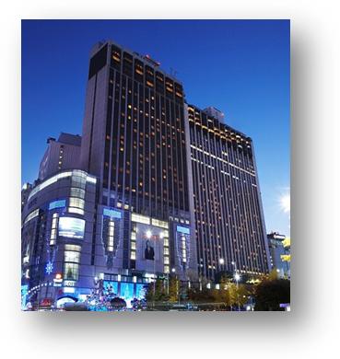
Address | 1, Sogong-Dong, Jung-Gu, Seoul, Korea 100-721
Facilities | Club Floor, Fitness Club, Business Center, Duty Free Shop
Telephone | +82-2-771-1000
Fax | +82-2-752-3758
Website | www.lottehotelseoul.com

Symposium on “Progressing the climate agenda through green ICT standards”
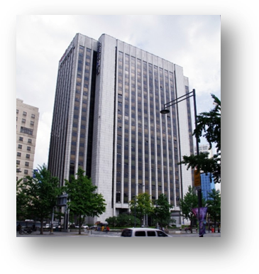
The Symposium will be held on 19th of September 2011 at ‘International Conference Hall’(20F) in Korea Press Center, Seoul, Korea.
Address | 33, Taepyeongro, Jung-Gu, Seoul, Korea 100-721
Facilities | VIP Room, Press Room
Telephone | +82-2-2001-7114
Fax | +82-2-2001-7770
Website | www.kpf.or.kr

How to get from Lotte Hotel to Press Center
It takes 10 minutes by walk and 5 minutes by taxi as below map.
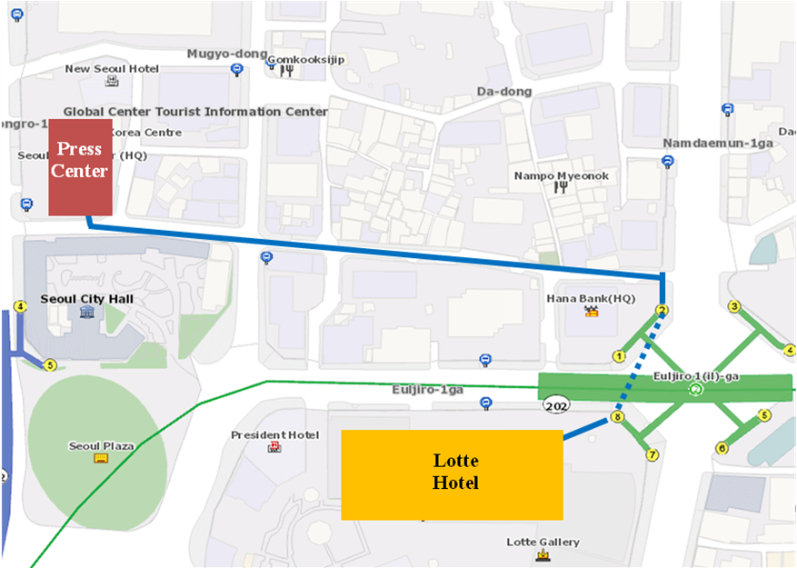

- National Coordinator

Dr. Sam Young CHUNG
Tel: +82 2 710 6595
Fax: +82 2 710 6639
E-mail: sychung@kcc.go.kr

Ms. Hye Young (Grace) Hwang
Tel: +82 2 338 1082
Fax: +82 2 338 1083
E-mail: sg5_general@kcc.go.kr

- Accommodation and hotel reservations
The Korea Administration has obtained special rates in different downtown hotels. Next page shows a map indicating each hotel’s proximity to the meeting venue together with a chart including the corresponding hotel rates.
Delegates are kindly requested to fill out the corresponding reservation form, send it directly to the hotel, copy to Ms. Grace at: sg5_general@kcc.go.kr or fax. +82 2 338 1083.
It is important to make your reservation as soon as possible. All reservations must include a credit card number. You shall receive a confirmation message once your reservation has been accepted by the hotel. In case of failure to attend the meeting, all reservations must be cancelled well in advance.
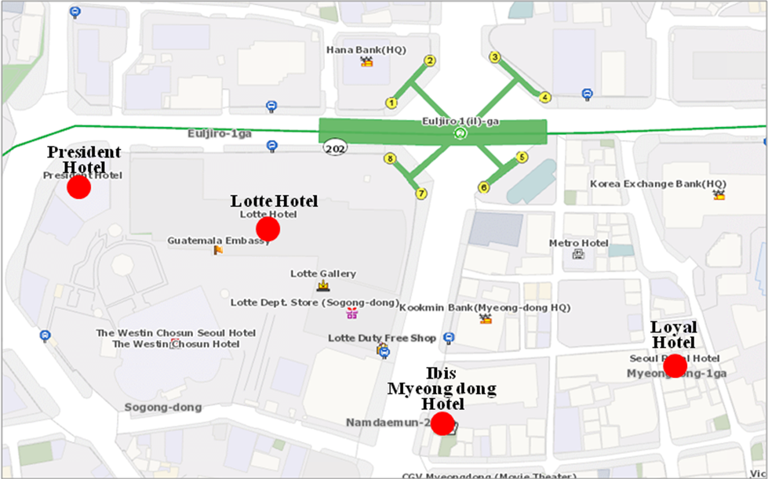

HOTEL | CATEG. | ROOM | RATE | NOTES
(1) Lotte Hotel (Venue)  1 Sogong-dong Jung-gu Seoul  Tel: +82. 2-759-7311~6  Fax: +82. 2-773-4910  Check-In: 2:00 PM  Check-Out: 12:00 PM  reservation@hotellotte.co.kr www.lottehotelseoul.com/index.asp | Standard  (Basis on Single Occupancy) | Superior  Deluxe | KRW 254,100 (≒USD 234)  KRW 278,300 (≒USD 257) | Included Taxes  buffet breakfast  : KRW 30,250 (≒USD 29)  Double occupancy charge will be added KRW 24,200 (≒USD 25)
 | Deadline of Reservation |  | 1st of August
 | Cancelation Policy |  | Inform to the hotel of any cancellations by 6:00 pm on the date of arrival or be charged for one night.
(2) Ibis-Myeongdong Hotel  59-5 Myeongdong 1ga Jung-gu Seoul  Tel: +82. 2-6361-8888  Fax: +82. 2-6361-8050  Check-In: 2:00 PM  Check-Out: 12:00 PM  ibismres@ambatel.com  ibis.ambatel.com/FrontSite/ibis/myeongdong/Default.aspx | Standard | Double  Twin | KRW 172,480 (≒USD 159)  KRW 188,650 (≒USD 174) | Included Taxes  buffet breakfast  : KRW 16,500 (≒USD 15)
 | Deadline of Reservation |  | 29th of August
 | Cancelation Policy |  | 50% penalty fee from 14days prior to check in date.  100% penalty fee from 7days prior to check in date.
(3) Hotel President  188-3 Euljiro 1ga Jung-gu Seoul  Tel: +82. 2-753-3131  Fax: +82. 2-752-7417  Check-In: 2:00 PM  Check-Out: 12:00 PM  marketing@hotelpresident.co.kr  www.hotelpresident.co.kr/english | Standard | Twin or Double | KRW 165,000 (≒USD 152) | Included Taxes  buffet breakfast  : KRW 22,000 (≒USD 20)
 | Deadline of Reservation |  | 19th of August
 | Cancelation Policy |  | 100% penalty fee from 7days prior to check in date.
(4) Royal Hotel  6 Myeongdong 1ga Jung-gu Seoul  Tel: +82. 2-2129-5754~7  Fax: +82. 2-2129-5880  Check-In: 2:00 PM  Check-Out: 12:00 PM  reser@royal.co.kr  www.royal.co.kr | Standard | Double  Twin | KRW 187,000 (≒USD 173)  KRW 203,500 (≒USD 188) | Included Taxes  buffet breakfast  : KRW 15,400 (≒USD 14)
 | Deadline of Reservation |  | 19th of August
 | Cancelation Policy |  | 50% penalty fee from 28th of August  75% penalty fee from 5th of September  100% penalty fee from 12nd of September

Participants are requested to reserve a hotel on a first-come-first-served basis through E-mail or Fax. Please note that there is a limit of the number of available rooms of Hotels. Therefore, if the reservations are full, it will be shifted to nearby Hotel and the reservation counter of the hotel will inform the corresponding participants about the situation

- Flights and transportation

Incheon International Airport handles all international air traffic and is 60 minutes away from the Seoul. Delegates have several transfer options from the airport to their hotel in the city of Seoul:
ITU-T SG5 and Symposium on “Progressing the climate agenda through green ICT standards” Information desk: Korea Secretariat will open the Information desk for participants’ convenience at arrivals (see below map). It will be opened from 18th of September to 19th of September at 7:00AM to 7:00PM. (Operating hours can be changed to depend on the participant's schedule) If you need to help to go to Seoul, drop by the information desk and get information.
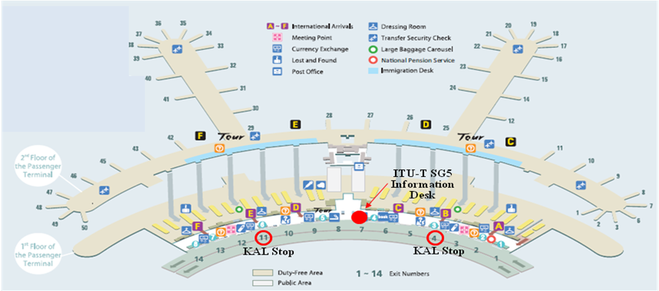
Car services and private taxis: taxi is recommended if you arrive late at night and buses are no longer operating or if you have heavy baggage or there are many members in your party. If you go to Myeong-dong (near the main venue) by a deluxe taxi late at night, you need to pay about 100,000 won. The fare varies depending on distance (meters).
Airport Bus: Airport buses run from Incheon Int'l Airport to various parts of Seoul. You can buy a ticket for your destination at the ticket desk on the arrival floor (1st floor). You can get information on bus routes and bus stops at the Airport Information Desk. Also Korea Secretariat will be operating the ITU-T SG5 and Symposium Information desk for participants’ convenience. If you would like to go from Incheon International Airport to the Lotte Hotel (main venue) you can use a KAL limousine bus.
Airport Railroad Express and Seoul Metro: Incheon International Airport Station of AREX is located on the first underground level of the Transportation Center at Incheon International Airport. You can get to Seoul and Lotte Hotel (main venue) using Airport Railroad Express and Seoul Metro.
How to get from Incheon Int’l Airport to Lotte Hotel :
- Get on the Airport Railroad Express on 1st floor of Incheon International Airport
- Transfer to line number 2 (green line) at the Hongik University station
- Get off the train at the Uljiro1(il)-ga station
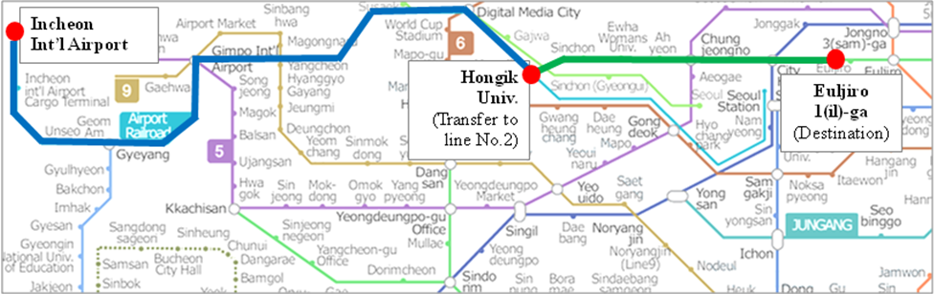
If you want to further information, please visit below website :
Airport Railroad Express : http://www.airport.kr/iiacms/pageWork.iia?_scode=C1203020000&fake=1308136787130
Seoul Metro :
http://www.seoulmetro.co.kr/eng/

Information for KAL limousine bus from Incheon Int’l Airport to the Lotte Hotel
- Course Time : About 1 hour and 20 min / Adult(15,000won), Child(10,000won)
- Boarding : KAL Stop - 4B or 11A
- Ticket Office : ITU-T SG 5 and Symposium Information desk at Incheon International Airport
(Ticket for the Bus departure from the entrance of the Hotel is sold at Front desk of Main building and New Wing)
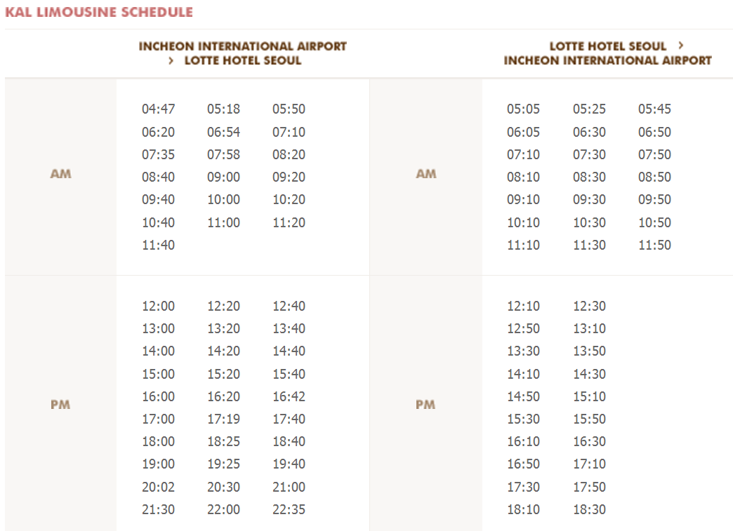
For further information, please visit the following web page: http://english.visitkorea.or.kr/enu/GK/GK_EN_2_2_2_3.jsp

- GENERAL INFORMATION

Introduction

The Korean Peninsula is located in North-East Asia and roughly 1,030 km (612 miles) long and 175 km (105 miles) wide at its narrowest point. Korea's total land area is 100,140 sq km, and it has a population of 48.7 million people (2009). Korea is a culturally diverse and economically advanced country full of dynamism. Building upon incredible post-war economic growth, Korea is the 12th largest economy in the world, and is becoming a powerful focal point of the Asian economic block. With a history tracing back more than 5,000 years, Korea is also rightly proud of its dazzling culture. It possesses 8 UNESCO cultural heritage sites, which compares favourably with any other nation in the world.

- The City of Seoul
Seoul is the capital and largest city of the Republic of Korea (South Korea). With a population of over 10 million, it is one of the world's largest cities and is by far the most densely populated city among OECD nations. The Seoul National Capital Area, which includes the Incheon metropolis and most of Gyeonggi province, has 24.5 million inhabitants, and is the world's second largest metropolitan area. Almost half of South Korea's population lives in the Seoul National Capital Area, and nearly a quarter in Seoul itself, making it the country's foremost economic, political, and cultural center

- Visa
Most delegates do not require a visa to enter Korea. You can check all visa requirements at http://www.mofat.go.kr/english/visa/apply/index.jsp. However, for more certainty we recommend you consult your embassy or consulate.
Those who require a visa to enter Korea should contact Ms. Ellva or Grace at sg5_visa@kcc.go.kr in order to request a personalized letter of invitation addressed to the petitioner via e-mail. This letter shall then be delivered to the petitioning country’s Korea Embassy in order to get the visa.

- Language
Korean is the official language (English, Japanese and Chinese are also spoken).

- Power
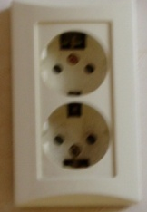
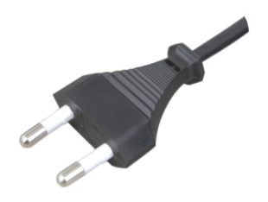
Supply voltage is 220V, 50Hz~60Hz. Participants are requested to bring the A-type adapter which is two parallel pronged and requested to bring the electric transformer, if necessary, for your equipments

Electrical Outlet

- Climate
The month of September is autumn that is well and truly in Seoul. In the mid September, Korea will be hot but less humid than August. Temperature is between 17 °C ~ 25°C.

- Currency
The unit of Korean currency is Korean Won (KRW). Also the most widely accepted credit cards are American Express, VISA and Master card.
Examples of exchange rates as of 10 June, 2011 is US$1= 1083.00 KRW
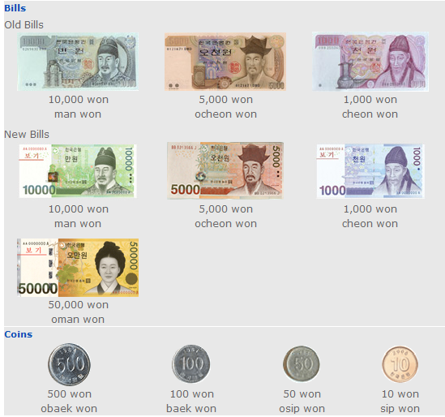

- Tax Refund
At the airport, passengers can get a 10% refund of the amount paid for Value Added Tax (VAT), if they have bought national products for amounts over $ 30 (per purchase slip) at the shops and within 3 months of departure from Korea adhered to the “Global Refund” system.
For further information, please visit: http://english.visitkorea.or.kr/enu/SH/SH_EN_7_1_4.jsp
- Business hours
Banks, post offices, and public offices generally open from 09:30 to 16:00 on weekdays but are closed on Saturdays and Sundays. Most of the shops are open from 10:00 to 22:00 through the entire week. However, some shops in Itaewon and Dongdaemon Shopping Mall are opened all night.
- Customary Tip
It is not customary tip in Korea. However, a 10% service charge and 10% taxes is added to your bill at all tourist hotels and some larger restaurants.

- Useful Information
For further information on the city of Seoul, please visit the following web page: http://english.seoul.go.kr

- Attire
Formal attire is recommended for officials attending the Meeting of Study Group 5 and the Symposium, on “Progressing the climate agenda through green ICT Standards” throughout the event.

- Invitation to the Welcome Dinner

The Communications Secretary of the Republic of Korea are pleased to invite the officials attending the meeting to the Welcome Dinner to be celebrated on Tuesday 20 September 2011 at 6.30 pm at the Sapphire Ballroom of the venue.

Suggested attire: Formal

ANNEX 3
(to TSB Circular 204)
ITU-T Study Group 5 meeting and Symposium
Seoul, Republic of Korea, 19-28 September 2011
*****

HOTEL RESERVATION

Please type or print clearly. Retain a copy for your records. Please send this form to the Hotel and one copy to Grace, e-mail address: sg5_general@kcc.go.kr Tel: (+82 2) 338-1082, Fax: (+82 2) 338-1083

Last Name: |  |  |  |  |  |  |  | First Name:
Organization-Company:
Address: |  |  |  |  |  |  |  |  |  |  |  | Country
Tel.: |  |  |  | Fax: |  |  |  |  |  | E-mail:
Hotel Information |  |  |  |  | Please choose type of room |  |  |  |  |  |  |  | Remarks
Hotel Name |  |  | Number |  | Room Type |  |  |  |  | Breakfast |  |  | Remarks
 |  |  |  |  | Double |  |  |  |  | Included |  |  | e.g. Smoking or  Non-Smoking
 |  |  |  |  | Twin |  |  |  |  | Excluded |  |  | e.g. Smoking or  Non-Smoking
Shared with:
Arrival date and time:
Airline and flight No.:
Departure date and time:
I authorize the use of the following credit card to guarantee my hotel reservation:
Type of Card: |  | Number:
Name on Card : |  | Expiration Date:

ANNEX 4
(to TSB Circular 204)

 |  | Symposium on Progressing the Climate Agenda Through Green ICT Standards  Seoul, Republic of Korea, 19 September 2011 |  |  |  |  |  | 
Please return to: |  |  | ITU/BDT  Geneva (Switzerland) |  | E-mail : bdtfellowships@itu.int  Tel: +41 22 730 5487  Fax: +41 22 730 5778
 | Request for a partial fellowship to be submitted before 19 August 2011
 |  |  |  | Participation of women is encouraged
Country: _____________________________________________________________________________________________________
Name of the Administration or Organization: ______________________________________________________________________

Mr. / Ms. _______________________________________(family name) ______________________________________(given name)

Title: ____________________________________________________________________________________________________

Address: ____________________________________________________________________________________________________
______________________________________________________________________________________________________________

Tel.: ____________________________ Fax: ____________________________ E-Mail:_________________________________

PASSPORT INFORMATION :
Date of birth: _______________________________________________________________________________________________

Nationality: __________________________________________ Passport number: ________________________________________

Date of issue: ___________________ In (place) : _____________________________Valid until (date): _______________________

CONDITIONS (Please select your preference in “condition” 2 below)
- One partial fellowship per eligible country.
- ITU will cover either one of the following:
□ Economy class air ticket (duty station / Seoul / duty station).
□ Daily subsistence allowance intended to cover accommodation, meals & misc. expenses.
- It is imperative that fellows be present from the first day to the end of the meeting.
Signature of fellowship candidate: |  |  |  |  |  | Date:
TO VALIDATE FELLOWSHIP REQUEST, NAME, TITLE AND SIGNATURE OF CERTIFYING OFFICIAL DESIGNATING PARTICIPANT MUST BE COMPLETED BELOW WITH OFFICIAL STAMP.

Signature |  |  |  |  |  | Date

