Bureau de la normalisation  des télécommunications | 
Genève, le 10 août 2009

Réf.:  Tél.:  Fax:  E-mail: | Addendum 1 à la  Circulaire TSB 50  NGN-GSI/TK  +41 22 730 5126  +41 22 730 5853  tsbngngsi@itu.int | - Aux administrations des Etats Membres de l'Union  Copie:  - Aux Membres du Secteur UIT-T  - Aux Associés de l'UIT-T  - Aux Président et Vice-Présidents de toutes les Commissions d'études de l'UIT-T  - Au Directeur du Bureau de développement des télécommunications  - Au Directeur du Bureau des radiocommunications

Objet: | Réunion NGN-GSI  2-12 septembre 2009  Mar del Plata, Argentine

Madame, Monsieur,
1 J'ai l'honneur de vous informer que la prochaine réunion NGN-GSI se tiendra du 2 au 12 septembre 2009 à Mar del Plata (Argentine) à:
HÔTEL HERMITAGE
Av. Colón et Boulevard Marítimo P. P. Ramos 2657 - Mar del Plata.
2 Vous trouverez dans l'Annexe 1 de plus amples informations sur les hôtels et des précisions concernant la situation, en Argentine, de la grippe A(H1N1) chez l'homme, ainsi qu'un plan actualisé de Mar del Plata indiquant l'emplacement du lieu de la réunion et des hôtels.
Veuillez agréer, Madame, Monsieur, l'assurance de ma haute considération.
Malcolm Johnson
Directeur du Bureau de la
normalisation des télécommunications
Annexe: 1

ANNEX 1
(to Addendum 1 to TSB Circular 50)

Additional practical information
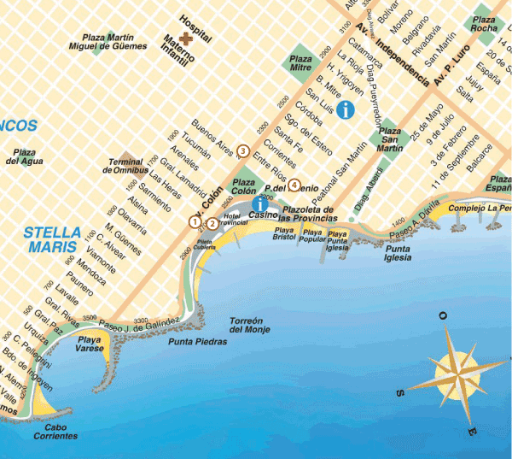

Hotel |  | Category |  | Type of room |  | Rate |  | Remarks
(1) Hotel Hermitage  Av. Colón 1643 and Blvard. Marítimo. P.P. Ramos 2657  Mar del Plata - Argentina  Tel: (54) (0223) 451-9081/86  Fax: (54) (0223) 451-7235  Check-in: 1400 hours  Check-out: 1100 hours  www.hermitagehotel.com.ar  reservas@hermitagehotel.com.ar |  | * * * * * |  | Double or standard single  (with view over the city) |  | USD 150 |  | Includes VAT and buffet breakfast
(2) Apart Hotel Avenida del Mar  Las Heras 2128  Mar del Plata – Argentina  Tel: 54 0223 451-2125  Check-in: 1400 hours  Check-out: 1100 hours  reservas@apart-avenidadelmar.com.ar | * * * * |  | 1 room  (2 persons)  2 rooms  (2 or 3 persons)  3 rooms  ( 4 or 5 persons) |  | USD 74  USD 104  USD 144 |  | Includes VAT and buffet breakfast
(3) Hotel Dos Reyes  Av. Colón 2129  Mar del Plata – Argentina  Tel : 54 0223 491-0383/0037  Check-in: 1400 hours  Check-out: 1100 hours  www.dosreyes.com.ar  info@dosreyes.com.ar | * * * * |  | Single  Double |  | USD 75  USD 85 |  | Includes VAT and buffet breakfast
(4) Argentino Hotel  Belgrano 2225  Mar del Plata – Argentina  Tel/fax : 54 0223 493-0091/2/4  Check-in: 1400 hours  Check-out: 1100 hours  www.argentinohotelmdp.com.ar  info@argentinohotelmdp.com.ar | * * * |  | Single  Double |  | USD 40  USD 55 |  | Includes VAT and buffet breakfast

COMMUNICATION ON HUMAN INFLUENZA A(H1N1)
On the basis of bulletins issued by the Ministry of National Health of the Argentine Republic, the following information is provided to delegates attending the ITU-T KALEIDOSCOPE and NGN-GSI events to be held in Mar del Plata concerning the measures and recommendations being adopted to prevent the spread of human influenza A(H1N1).
Through an intense national campaign, the Ministry of Health has taken the necessary measures to minimize the risks of contagion of the virus, and most cases have been successfully and quickly cured, through simple and safe treatment.
Any additional information that delegates might require can be obtained on the webpage of the Ministry of National Health at: www.msal.gov.ar/.
Recommendations regarding the new human influenza A(H1N1)
What is influenza A(H1N1)?
It is a very contagious acute respiratory infection of viral origin.
How is it transmitted?
• From person to person.
• Through drops of saliva which travel through the air when a person coughs, sneezes or spits.
• It is not transmitted through the consumption of pork or pork derivatives.
What are the symptoms?
• Temperature over 39ºC.
• Cough.
• Sore throat.
• Blocked nose.
• Headache.
• Muscular pains.
How can it be prevented?
• When coughing or sneezing, use a disposal tissue.
• When coughing without a tissue, cover your mouth with your forearm (never with your hands).
• Wash your hands often with soap and water.
• Avoid treating yourself.
• Use of a mask is recommended only if you show symptoms.

______________

