INTERNATIONAL TELECOMMUNICATION UNION |  |  |  | Focus Group On IPTV
TELECOMMUNICATION  STANDARDIZATION SECTOR  STUDY PERIOD 2005-2008 |  |  | FG IPTV-DOC-0177
 |  |  | English only
WG(s): 4 |  | 6th FG IPTV meeting:  Tokyo, Japan, 15-19 October 2007
OUTPUT DOCUMENT
Source: | Editor
Title: | Living List: IPTV multicast frameworks
This document contains living list issues focusing to multicasting as following the agreement taken at the July 2006, October 2006, January 2007, May 2007 and July 2007 meeting based on Terms of References and contributions (input documents)
The following living list structure is intended to progress the work on WG4 related deliverables.
A. List of Items
- Title of item
B. Description of each item
- Title
- Description of the problem and possible solutions
- List of documents addressing the issue
- Intermediate agreements
No. | Title of Living Lists
1 | Functional requirement for IPTV service quality measurement in IPTV multicast network
2 | Multicast interfacing for IPTV service between IP multicast and application layer multicast
3 | Proposed multicast models for IPTV services
4 | RADIUS extensions in IPTV (C-705)
5 | Multicast VLAN Aggregation in IPTV Network (C-706)

Living List #1 of WG4

Area: Service Quality Measurement issues
Title: Functional requirement for IPTV service quality measurement in IPTV multicast network
Related Document: FGIPTV-C-0399
Background:

When we provide IPTV service for residential customer, or when we provide the company internal broadcasting services of the enterprise and advertisement services, we need the function to measure the service quality of IPTV and manage it, in order to provide high quality IPTV service or to provide QoS guaranteed IPTV service. Even though it will be able to consider from the multi branch side which embody IPTV service quality measurement and a control facility, we can consider the server-client measurement model which is the most feasible.

If we use the Statistics based on the information of the measurement data which it receives from the client as the measurement feedback information, we can accomplish the broadcasting service quality measurement and service quality management also. The quality measurement information which is made from the client is transmitted to multicast streaming server itself (or the other quality measurement server), and it can be applied as the real time quality measurement data.
Study Issues:

For the IPTV service quality measurement, we can consider the signal requirement in the server-client model described in following diagram.
The functional block diagram of control signal for IPTV service quality measurement

- Server requirements
  - The server needs to send the signal information to clients, which is necessary to measure broadcasting quality, in each media’s data frame header.
- Clients requirements
  - The clients need to make the service quality measurement data based on the information of each media’s broadcasting service quality measurement data transmitted from the source.
  - And, the clients need the control function to transmit such quality measurement data to IPTV service quality management daemon.

It is necessary to define the quality measurement data field information for IPTV service like following table.

IPTV service quality measurement field definition
Multicast group IP
Multicast Port
Multicast Channel number to be watched
Client IP
Client MAC
Media play start time
IPTV service quality measurement time
Media play Start sequence number
Measurement sequence number
Video Width
Video Height
Video Codec type
Bitrate
FPS
I-Frame number per unit hour
P-Frame number per unit hour
B-Frame number per unit hour
Total I-Frame number
Total P-Frame number
Total B-Frame number
Frame number from server per unit hour
Frame number to receiver per unit hour
Frame Loss number per unit hour
Total Frame number from server
Total Frame number to receiver
Total Frame Loss number
Frame Loss rate per unit hour
Total Frame Loss rate

In above scenario, we can provide the following IPTV service quality measurement data.

- Multicast Group information
  - The multicast groups IP, port information are delivered from streaming server to clients in the live broadcasting connection time. That information is used for checking whether multicast group information is correct or not.
- Client information
  - If the clients start to receive the live broadcasting data, IPTV service management server can get the information of the each client’s IP, MAC addresses. That information is used for checking the client’s status.
- Video information
  - When receiving live broadcasting, the clients get the video information like video size and codec type which is received from the streaming server. That information is used for video quality measurement data.
- Video Frame information
  - With checking the timestamp and sequence number of the media data header, we can get the exact time information about frame reception and remaking.
  - The Sequence number is consecutive one, so the unusual increase can be regarded as the case of IPTV service frame loss, so it can be used for service quality measurement factor.
  - From the decoding procedure of media data, we can get the I, P, B frame information which can be used as service quality measurement information.
- Bitrate & FPS
  - The Bitrate and FPS information can be also used for IPTV service quality measurement factor
- Bitrate(bit/sec) = data size / time
- FPS(frame/sec) = Frame number / time

And finally, these IPTV service quality measurement data will be transmitted to service quality management daemon in fixed time period. In this case, we need to define transmission protocol and specific transmission method in each IPTV service network.

Living List #2 of WG4

Area: Multicast issues
Title: Multicast interfacing for IPTV service between IP multicast and application layer multicast
Related Document: FGIPTV-C-0420
Background:

From the efficient point of view, for the media delivery system, multicast can play a key role in the service network. Since if the system adopts unicast instead of multicast, a source should send the target data n times for n receivers. This activity makes the service network burdensome. However, by duplication of the data, IP multicast router can achieve high performance. This ordinary kind of multicast is called as IP multicast or native multicast.
For IPTV, multicast can be also the best solution to transport media service. However, unfortunately, there exists another reserved problem when we adopt IP multicast in IPTV system. That is, IP multicast can be implemented over multicast-enable routers only. Nevertheless, most of routers do not have the capability supporting multicast. Therefore many routers should be replaced with multicast-enabled ones but, because still ISPs have not shown being willing to pay for that, practically multicast have difficulty to be widely spread.
Alternatively we can replace IP multicast with overlay multicast (also called as application level multicast). In an overlay or end-system multicast approach participating peers organize themselves into an overlay topology for data delivery. Each edge in this topology corresponds to a unicast path between two end-systems or peers in the underlying network. All multicast-related functionality is implemented at the peers instead of at routers. (The difference between native multicast and overlay multicast is shown on Figure 1.)

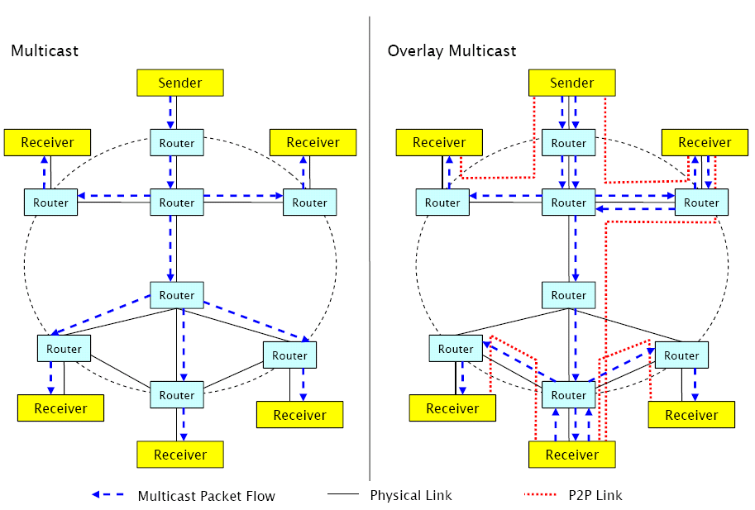
Figure 1. Native Multicast VS. Overlay Multicast

However there still remains a difficulty that should be noticed. Owing to the lack of standardization, each application layer multicast has its own API and addressing scheme which prohibits already existing multicast-aware application from using the application layer multicast _{[1]}. Also, how brides overlay multicast with IP multicast should be considered. There should be a possible standard that makes seamless implementation. In QoS, there exists one possible multicast interface, Middleware Multicast, which can adequately solve the previous two problems.

Study Issues:
  - IP Multicast and Application Layer Multicast
We propose a solution called Multicast Middleware, which uses Application Layer Multicast for transporting multicast traffic. However it also offers a standard multicast interface for the applications. The Multicast Middleware is also aware of limitations regarding connectivity on the network layer.

  - Concept
The IP Multicast interface for the applications is usually offered by the operating system. The operating system on the other side communicates with a multicast-enabled router in the local network using IGMP for signaling. Sending IP multicast traffic is not different from sending IP unicast traffic. The only difference is the reserved source/address range, which denotes different multicast groups (groups of multicast traffic receivers). On the network layer, multicast traffic is handled differently. For example, in Ethernet the IP packets with a multicast group as a destination address get an Ethernet multicast address assigned. To provide an IP Multicast interface for the whole system (including services integrated in the operating system’s kernel), we propose to use a virtual Ethernet device (also known as TAP device – a software analogy of a wiretap). The TAP interface is a special kind of network interface, which is seen by the operating system as a normal Ethernet device. However instead of forwarding the Ethernet frames to a hardware device, the TAP interface forwards the received Ethernet frames to a user-space process. On the other side, the TAP interface forwards all Ethernet frames received from the user-space process as incoming frames to the operating system’s kernel. TAP support exists for all major operating systems.

Using a TAP interface, Multicast Middleware makes processing of multicast traffic transparent to all applications. This includes the multicast functionality integrated in the operating system’s kernel. This approach does also not require any modification of application code. Multicast traffic originating from an end-user host can be routed through the TAP device. This device forwards the packets (encapsulated in Ethernet frames) to a user-space process (which we call the Multicast Middleware) for processing. The Multicast Middleware acts as a multicast router by implementing IGMP and transporting the multicast data.

IP Multicast enabled applications must subscribe to different multicast groups to receive video broadcast announcements and audio/video streams. The multicast group subscription is usually a system call, which instructs the operating system’s kernel to send IGMP membership report messages to the IP Multicast router. In our case, the IGMP membership reports are sent via the TAP interface to the Multicast Middleware. The Multicast Middleware interprets the IGMP membership reports and notifies the neighbor peers about the changes in the multicast routing table. This information (depending on the multicast routing protocol used in the overlay network) is propagated to other peers. The flow of the multicast subscription as described before can bee seen in a figure 2.
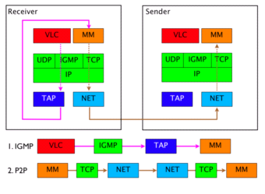
Figure 2. Receiver initiated Multicast Group join _{[2]}

In the network, video broadcast announcements and audio/ video streams are handled in the same way: they are delivered as multicast data packets. Sending multicast traffic does not differ from sending unicast traffic. The only difference is the destination address, which is in the case of the multicast traffic the address of an IP Multicast group and not of a host. After a data packet has been sent by the application, it is forwarded by the operating system’s kernel to the appropriate multicast-enabled network device (in our case the TAP device). The Multicast Middleware process receives the outgoing multicast traffic via the TAP device. The received multicast traffic is then encapsulated into Application Layer Multicast messages. The IP Multicast destination address of the packets is translated into Application Layer Multicast addresses to which the messages are sent.

After receiving an encapsulated IP Multicast packet by Application Layer Multicast, the Multicast Middleware encapsulates the IP Multicast packet into an Ethernet frame. The Multicast Middleware then sends the Ethernet frame via the TAP interface to the operating system’s kernel for processing. The operating system’s kernel delivers the data to the video application. The delivery of multicast traffic from the sender through the Multicast Middleware to the receiver is presented in figure 3.

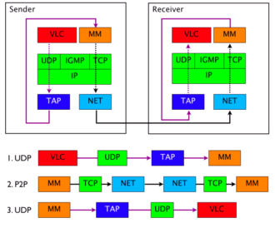
Figure 3. Sender controlled Broadcasting of UDP Multicast Traffic _{[2]}

  - Video Broadcasting
Using the proposed solution, we can provide a video streaming service for a very large group of Internet users without the need for large investments in infrastructure. Certain requirements for sender and clients must be fulfilled. The sender of a video stream must have a Multicast Middleware installed on a computer, which is connected to the Internet. The Internet connection should support at least the bandwidth for sending the stream once. Any application
supporting streaming using IP Multicast can be used (for example VLC or VLS). Each client, which wants to receive a video stream must install the Multicast Middleware on his computer and must have an Internet access. Any video application with IP Multicast support (like VLC) can be used for receiving the video stream.
The session announcement protocol (SAP) can be used to announce running or scheduled video broadcasts over IP Multicast. The SAP announcements include session description protocol SDP stream descriptions encapsulated in UDP packets and are sent to a predefined IP Multicast group (for example IPv4 global scope session announcements are sent to 224.2.127.254) and port (9875). Since the Multicast Middleware enables IP Multicast on the end-host, SAP can be used for announcing video broadcast transmissions.
  - Multicast Middleware for IPTV media service
IPTV media service will also deliver variety of video based streaming services. Therefore here still exists equivalent necessity to adopt application level multicast with IP multicast properly; Multicast Middleware in IPTV delivery network will play a key role in those solutions.

Living List #3 of WG4

Area: Multicast issues
Title: Proposed multicast models for IPTV services
Related Document: FGIPTV-C-0530

Background:
In the last IPTV FG meeting, a new working document on IPTV multicast frameworks has been introduced to cover multicast issues for IPTV services. But because the current working document is at its initial stage, it still does not cover multicast models for IPTV services enough. Therefore it is required to have well-defined multicast models for IPTV service.
Study Issues:

P2P-based model
Figure 2 shows the concept of P2P-based data delivery mechanism.
In this scheme, each end-node can be both a media producer as well as a media consumer. The way of communications is as follows; each node discovers its peers and then connects them; each node can exchange media between themselves.
Because P2P model does not want to have ISP’s censorship, this model usually does not involve node of ISP’s. Although the size of group is not logically bounded, it may not be adequate to distribute contemporary media. To improve data receiving, each node tries to finds more peers as possible.

Figure 2 – Data distribution scheme with P2P

Living List #4 of WG4
(Editor’s Note : The meeting is agreed that this issue is very important in IPTV multicast management but the following text is not enough to be contained in the WD of “IPTV Multicast Frameworks”. Therefore, more detailed contributions are invited on this topic.)

Area: IPTV Multicast Management Issues
Title: RADIUS extensions in IPTV
Related Document: FGIPTV-C-0705
Background:
Due to the commercial operation of multicast service, the billing mode of multicast service becomes more and more important. With flexible billing modes, for example the billing based upon operating time, traffic and mixed factors, users have more options when choosing billing mode, and carriers can achieve more profit. But currently there is not a protocol designed particularly for multicast billing in IPTV service.
We can develop our existing RADIUS protocol to enable it to work together with server to process multicast billing. After start using a channel, the user dispatches request for billing. And when the user leaves the channel, he will deliver billing terminated packet including multicast address of the channel, and the multicast traffic and time in which user watches the channel to server. Then according to the duration and traffic, the server will settle user billing flexibly as per pre-set billing policy.
Study Issues:
According to the analysis above, RADIUS extensions are proposed to be used for user billing in IPTV. The extended attributes are:
- multicast group address
- multicast traffic
- multicast time
Living List #5 of WG4
(Editor’s Note : The meeting is agreed that this issue is very important in IPTV multicast management but the following text is not enough to be contained in the WD of “IPTV Multicast Frameworks”. Therefore, more detailed contributions are invited on this topic.)

Area: IPTV Multicast Management Issues
Title: Multicast VLAN Aggregation in IPTV Network
Related Document: FGIPTV-C-0706
Background:
Multicast VLAN aggregation is implemented on IPTV access equipment, requiring IGMP PROXY to run IGMP host function in multicast VLAN and to run IGMP router function in user access VLAN.
Study Issues:
In IPTV application, multicast duplication should be as near as possible to the multicast users. But the accessed users at multicast access points are usually in different VLANs. Different users can apply to join the same multicast channel in their own VLAN. If the access equipment only runs IGMP PROXY or IGMP SNOOPING, user VLAN will be transparent to uplink network nodes, which will get heavier burden with the user number increases. When multicast user joins one channel, IGMP PROXY running in access equipment implements IGMP host side function in specified multicast aggregation VLAN. At the same time, multicast traffic coming from specified multicast aggregation VLAN is forwarded to different user VLANs. In this way, the uplink equipment of access point can only “see” the multicast aggregation VLAN ; the multicast duplication points are moved down and nearer to the user. As figure1 shows:
Figure 1

Requirements for multicast VLAN aggregation on IPTV multicast access equipment are as following:
- Implement IGMP host function in specified multicast VLAN on access equipment; implement IGMP router function in user VLANs.
- Choose multicast aggregation VLAN based on the “group” the user joins in.
- Distribute multicast traffic coming from multicast aggregation VLAN to user VLANs.

_________________

