INTERNATIONAL TELECOMMUNICATION UNION |  |  |  | Focus Group On IPTV
TELECOMMUNICATION  STANDARDIZATION SECTOR  STUDY PERIOD 2005-2008 |  |  | FG IPTV-DOC-0176
 |  |  | English only
WG(s): 4 |  | 6th FG IPTV meeting:  Tokyo, Japan, 15-19 October 2007
OUTPUT DOCUMENT
Source: | Acting Editor
Title: | Living List: IPTV network control aspects
This document contains living list issues following the agreement taken at the July 2006, October 2006, January 2007, May 2007, and July 2007 meeting based on Terms of References and contributions (input documents)
The following living list structure is intended to progress the work on WG4 related deliverables.
A. List of Items
- Title of item
B. Description of each item
- Title
- Description of the problem and possible solutions
- List of documents addressing the issue
- Intermediate agreements

No. | Title of Living Lists
1 | Harmonization control and signalling aspects between telecommunication and broadcast (C
2 | Network requirements including the IP tuner behaviour for interactive control
3 | Interactive control for other platform’s interactive services
4 | RTP/UDP/MPEG2 TS as a means of transmission for IPTV Streams
5 | Requirements for IPTV Network Node
6 | Requirements of Identification on IPTV
7 | Requirements of IPTV access network

8 | Performance statistics for Content Distribution
9 | A method for channel zapping support in IPTV scenarios
10 | Reorganization of WG1 requirements related to IPTV network
11 | CDN based network aspects of mechanisms for Content distribution
12 | Proposal of Restructuring of WD of IPTV Network Control Aspects
13 | Proposal for Resource Control Function of Access Network for IPTV Services
14 | Reorganizing the Functional Requirements of IPTV Multicast Availability and Security
15 | Enhancements of section 12 Overlay Networking in “ FG IPTV-DOC-0068”
16 | DNG Network Attachment
17 | ITF Network Attachment
18 | IPTV Device Attachment and Initialization process for Core IPTV and NGN IPTV Achitectures
19 | Overlay Networking

Living List #1 of WG4

Area: Control and signaling mechanisms issues
Issues: Harmonization control and signalling aspects between telecommunication and broadcast
Related Document: FGIPTV-ID-83
Background:
By considering the difference of traffic characteristics between telecommunication and broadcast traffic, harmonization in control and signalling between two parties could be studied.
Especially, in most cases of broadcasting service, multicast mechanism is supposed to be employed. Signalling mechanism of multicast technology is very different from that of existing communication services on the Internet or telecommunication networks. For example, existing communication services on the Internet mostly assume end-to-end negotiation of call connection establishment, and single signalling protocol is used for it. However, in the multicast’s case, different signalling protocols are used for core network and access network.
Study Issues:
Study for harmonization between telecommunication and broadcasting
- Analysis of traffic characteristics and its control mechanism
- Multicasting mechanism in both areas and requirements for harmonization

Living List #2 of WG4

Area: Content distribution issues
Title: Network requirements including the IP tuner behaviour for interactive control
Related Document: FGIPTV-ID-28
Background:
The receiver of the STB can discover and select appropriate services in Transport Stream. In different with the terrestrial, satellite and cable operation, and IP interactive service system needs the IP-specific network parameter not only to distinguish and join diverse multicast group but also recognize the state of IGMP join for the receiving MPEG2 TS or changing to another connection. And for the reliable delivery of the A/V channel and data contents, it is essential to establish interactive control requirements of bandwidth, reliability, and congestion control in network view. Total bandwidth of interactive data service in IPTV to support seamless data transmission is indispensable. In addition to this, it is required to define the “IP tuner” for the concept of IGMP Multicast group join in MPEG 2 TS. The activity of the IGMP Multicast group join means the tuning of some available MPEG 2 TS.
Study Issues:
IPTV Network requirements need study in interactive control aspects and followings are proposed example of requirements.
- IP-specific network parameter (IP address and port) could be inserted into the channel loop descriptor for the multicast group connection in IPTV.
- Interactive IPTV service network could recognize prerequisite bandwidth of each channel and application to ensure total necessary bandwidth of interactive service including A/V channel streaming contents.
- Interactive IPTV service network is recommended to use of priority regeneration of interactive service stream to allocate enough bandwidth about requested service for the quick reflection of user's service order.
- Interactive service transport protocol could support reliable data transmission in IP interconnection.
- Interactive service network is recommended to use of QoS (Quality of Service) and FEC (Forward Error Correction) for low packet loss and low delay with packet correction.
- Interactive data service network is recommended to monitor packet loss to ensure the error rate is within acceptable limit.
- Interactive service network could provide internet-friendly congestion control for adaptation of IPTV service.
- Interactive service system could control the lifetime of application when its lifetime is over or changed according to the user’s request.
- The mapping between the classical broadcast network and IP based network is necessary.
- TUNE_LOCKED – Multicast group join succeeded: TS can be received.
- TUNE_UNLOCKED – Multicast group disconnected: TS cannot be received.
- TUNED – Multicast group leave and join: TS connection changed from one to another.
Living List #3 of WG4

Area: Content distribution issues
Title: Interactive control for other platform’s interactive services
Related Document: FGIPTV-ID-28
Background:
The interactive service of IPTV can be combined with other platform’s services such as terrestrial (or cable, satellite) A/V channel and interactive data service. Sometimes it is necessary to re-transmit other platform’s interactive data services for the transparent service without contents processing. The integrated interactive service system may provide customer with easy interface about several platform’s services and allow service provider to make flexible, cost-effective, and efficient system by defining schema which is presented regardless of real time broadcasting and additional valued data service, composing the schema with an integrated method.
Study Issues:
Requirements on IPTV interactive control system need study and followings are proposed example of requirements.
- IPTV interactive control system recommended be able to combine or re-transmit other platform’s interactive services.
- As an example of a combined interactive data service, following figure show transmission method for the combination of A/V channel and application as well as re-transmission method for the A/V channel and application.
Figure 1 Transmission method example for the combination of A/V channel and Application

Figure 2 Re-transmission method example for the A/V channel and Application
Living List #4 of WG4

Area: Content distribution issues
Title: RTP/UDP/MPEG2 TS as a means of transmission for IPTV Streams
Related Document: FGIPTV-ID-87
Background:
A video stream may be transmitted over an IP network in a number of ways, of which the three most popular are:
- MPEG-2 Transport Stream encapsulated in IP/UDP only.
- MPEG-2 Transport Stream encapsulated in IP/UDP and RTP as documented in “Digital Video Broadcasting (DVB); Transport of MPEG-2 TS Based DVB Services over IP Based Networks” (ETSI TS 102 034) which uses IETF RFC 2250 and 3550.
- Elemental streams encapsulated in UDP and RTP as documented in IETF RFC 3550, 3984 etc.
Study Issues:
Means of transmission for IPTV Streams need study and followings are proposed method.
In item 1) and 2) above an MPEG-2 transport stream is used which combines sound, video and other data into a series of 188 byte packets, whilst in item 3) each of these separate forms of data are carried in separate streams over IP. An MPEG-2 transport stream, for this document, can simply be seen as a stream of 188 byte packets.

Figure 1 IP/RTP/UDP encapsulation of MPEG2-TS

In item 1), these 188 byte packets are encapsulated into UDP datagrams by simply dividing the transport stream across a number of UDP datagrams. In each datagram there can be up to 7 packets because of the size of a typical Ethernet or Ethernet like MTU (maximum transport unit).

Figure 2 RTP Header.

In item 2), an additional RTP header is added, as shown in Figure .3.2
In item 3), the elemental streams use RTP for encapsulation to; however, because synchronization is needed between the streams the addition of RTCP is required.
Living List #5 of WG4

Area: Content distribution issues
Title: Requirements for IPTV Network Node
Related Document: FGIPTV-ID-59
Background:
In order to enable the IPTV system and achieve the interoperability, many aspects should be standardized, especially for IPTV media delivery system. Careful study is required on IPTV media delivery system and on the standard work on this domain to produce correlative standard documents.
Study Issues:
Study on functional requirements of IPTV network node to support IPTV Streams is required.
- Requirements on IPTV network node in “Content Storage” aspects: File Operation, Stripe Storage and Share Storage etc.
- Requirements on IPTV network node in “Content Delivery” aspects: TV (Unicast/ Multicast), VOD (Push/Pull), TSTV (Time Shifted TV) and PVR (Push/Pull)
- Requirements on IPTV network node in “Streaming Media Service Function” aspects: VOD, TV, TSTV, PVR, Code Format and Bandwidth Control
- Requirements on IPTV network node in “Content/Schedule Control” aspects: Content Publish, Content Delete and Load Balance

Living List #6 of WG4

Area: Identification issues
Title: Requirements of Identification on IPTV
Related Document: FGIPTV-ID-93
Background:
IPTV subscriber’s identification is to solve the problem of calling and addressing other subscriber. In IPTV framework for client and server mode is not the only mode, other direct subscriber to subscriber applications will be provided by IPTV framework such as VoIP, video conference, instant message, Blog and etc. For such applications calling and addressing between subscribers is needed, which means giving the subscriber identification is required. In addition, unified identification is needed for end user and for providers helpful to implement simplified authentication through authenticating the user once, which makes IPTV easier for subscriber using and for the IPTV system.
Study Issues:
Study on requirements of identification for IPTV network and service is required.
- Taking consideration of protecting user’s privacy, requirements for user identification mapping is needed; including equipment-oriented mapping, communication-oriented mapping, billing-oriented mapping, SP/CP oriented mapping and etc.
- Considering the interoperability between IPTV and other service network such as NGN and 3G, requirements for using SIP URL format as the IPTV unified subscriber’s identification is needed; E.164@Domain
- Identification of the Source or Distributor for IPTV services by using IPv4/IPv6 address, URL name, E.164 number, etc.

Living List #7 of WG4

Area: Home, Access and Core network issues
Title: Requirements of IPTV access network
Related Document: FGIPTV-ID-49
Background:
Although the definition of IPTV architecture is still ongoing, it is clear that IPTV services and related applications would have requirements on the IP access network, including the bandwidth, service classification, QoS, multicast and security, etc. So the study and standardization on IP access network in IPTV is very important and necessary.
Study Issues:
Study on requirements of identification for IPTV network and service is required.
- Requirements on IPTV access network; Service transmission mode and Access Network structure
- Requirements on subscriber management and access control; IGMP proxy/snooping, User access control and Cross-VLAN multicast
- Requirements on subscriber authentication and identification; VLAN stacking support, DHCP option 82 and PPPoE intermediate Relay.

Living List #8 of WG4

Area: Content distribution issues
Title: Performance statistics for Content Distribution
Related Document: FGIPTV-C-0268
Background:
One of the most important aspects of content distribution network is its effectiveness, i.e. how it performs better than centralized system and how different content distribution networks perform against one another. To help measure effectiveness of content distribution, a set of quantified indicators is needed.

Study Issues:
A content distribution network is effective when it
  - enables system to serve more users with limited network bandwidth and computing resource
  - makes system more responsive to user’s requests

Following statistics are proven to be very useful in measuring effectiveness of content distribution network,
    - Number of requests for contents
This number indicates the amount of load. The greater the number, the higher the demand is.
    - Number of requests satisfied by pushed contents
Pushed contents are those contents that became locally present as result of push operation. The greater proportion this number accounts for among total number of requests, the more effective the content push is.
    - Number of requests satisfied by pulled contents
Pulled contents are those contents that became locally present as result of pull operation. The greater proportion this number accounts for among total number of requests, the more effective the content pull is.
    - Number of requests satisfied by pulling remote contents
Remote contents are not locally present and become locally present as result of the pulling operation triggered by the request. These are the requests that triggered pulling operation. The smaller proportion this number accounts for among total number of requests, the more effective the content push is.
    - Number of requests satisfied by locally present contents
Locally present contents include pushed contents and pulled contents. The greater proportion this number accounts for, the more effective the combination of push and pull is.
Note: Value of 5) is sum of 2) and 3)
    - Number of requests for remote contents
The smaller proportion this number accounts for among total number of requests, the more effective the content push is.
    - Number of unsatisfied requests for remote contents
When system is overloaded request can not be satisfied regardless of whether the content is locally present or remote. Since content distribution is one of the contributors to system load, the smaller proportion this number accounts for among total number of requests, the less intrusive the overall content distribution is.
Note: Value of 6) should be sum of 4) and 7)
    - Number of unsatisfied requests for locally present contents
When system is overloaded request can not be satisfied regardless of whether the content is locally present or remote. Since content distribution is one of the contributors to system load, the smaller proportion this number accounts for among total number of requests, the less intrusive the overall content distribution is.
Note: Value of 1) should be sum of 4), 5), 7) and 8).
    - Number of push sessions
The ratio between 2) number of requests satisfied by pushed contents and this number indicates the effectiveness of content push. The greater the ratio, the more requests a push session satisfies therefore more effective.
    - Number of pull sessions
One request for remote content may trigger multiple pull sessions. The ratio between 3) number of requests satisfied by pulled contents and this number indicates the effectiveness of content pull. The greater the ratio, the more requests a pull session satisfies, therefore more effective.
    - Number of pushed bytes
This indicates the total push traffic generated by the content distribution network.
    - Number of pulled bytes
This indicates the total pull traffic generated by the content distribution network.
    - Number of served bytes
This number indicates the number of bytes actually consumed by users – the effective bytes. Sum of 10) and 11) indicates the number of bytes made available to users. The ratio between the effective bytes and the available bytes indicates effectiveness of content push and pull. The greater the ratio is, the more effective the content push and pull are.

________________
Living List #9 of WG4

Area: Network QoS issues
Title: A method for channel zapping support in IPTV scenarios
Related Document: FGIPTV-C-0320
Background:
In Figure 1, we give a simple prototype for IPTV LTV service. Before the terminal can get the media flow for a different channel, it may need interact with the media server using specific signaling (such as HTTP, RTSP, even SIP if IMS is used as session control layer) to get the addresses of the source of the media flow and the destination multicast addresses (MAs) of the media flow if LTV service is provided in IP multicast techniques. If the content is protected by some service protection mechanisms, then the encryption materials may also need transfer in the signaling interaction procedure.
Figure 1. A simple prototype for IPTV usage

After the terminal gets the needed parameters (e.g. MAs of channels, encryption material to decode the content, etc), it may need to initiate multicast activation procedures that are different in specific access networks in order to join the multicast group. In xDSL scenarios, the terminal may need to initiate an IGMP join request to BRAS; in MBMS network, in addition to the IGMP join request, a MBMS context activation procedure may need to be executed in order to establish a path for multicast transferring; In these procedures, authentication may need to be applied to the multicast join/leave request. After all these procedures, the terminal may then get the media flow it requests.
From the scenarios described above, it can be seen that delays will be introduced in different steps, such as the delay from signaling interaction, the media transferring delay from transport layer, the authenticating delay in access network or media server, so that the overall delay experienced by the user is the sum of:
- the delay from signaling interaction
- the media transfer delay from transport layer
- the authentication delay in the access network or media server
When a user changes a channel, these delays will influence his user satisfaction.

Study Issues:
A method is described here to address the factors discussed above.
Figure 2. The principle of proposed method
Figure 2, shows the principle of the proposed method. In the Figure, only the relationship of Terminal and Media server is considered.
There are two media flows between terminal and Media Server. One is for transferring the media flow of the current channel that the user watching, and the other is for transferring the media flow for supporting channel zapping (the Channel Zapping Flow is abbreviated to CZF below), which may include one or more media streams for different channels. These two media flows can be set up using a normal service request in the first user request procedure or by other possible means. After that, these two media flow are all sent from the media server to the terminal in multicast mode.
If a user doesn’t make a channel change, the CZF can be dropped silently after being received by the terminal. However, when the user does make a channel change, the normal service request procedure will be applied; there will have a delay due to the signaling interaction and the transmission for the media flow of target channel being sent from the media server to terminal. During this period, the CZF continues to be sent to the terminal, and this media flow is then used to render the screen before the normal media flow for the target channel can be received and decoded by terminal.
The described CZF can be sent out from the media server in multicast mode regardless of whether the user requests it or not. The media server that provides the CZF may be different from the one/ones that provide the normal media flows of channels. In multicast mode, the bandwidth of the core transport network can be saved. To reduce the load on the access network or save user bandwidth on the access line, the bit-rate of CZF should be controlled in a reasonable range.

Living List #10 of WG4

Area: General issues
Title: Reorganization of WG1 requirements related to IPTV network
Related Document: FGIPTV-C-0342
Background:
The current WG 1 working document “IPTV Service Requirements” contains very detailed requirements for network and control aspects. WG 1 should focus on high-level requirements, and such detailed requirements should be transferred to WG 4 for discussion by the experts on network control
Study Issues:
Following detailed requirements should be discussed and be transferred to WG 4.

Requirements | Comments
IPTV_NET_028: IPTV network can support a service selection mechanism with RTSP, IGMP [DVB]. | Solutions are proposed, so review by WG 4 is needed
IPTV_NET_039: The IPTV Architecture shall provide a mechanism for the ITF to synchronize between different content streams. [IIF.ARCH.OPERATOR.28] | Relation to network is unclear, so review by WG4 is needed
IPTV_NET_060: There are some different data transmission ways: unicast, multicast and broadcast. In current IPTV architecture, each transmission has a corresponding network model. For unicast, the corresponding network model is C-S model. For multicast/broadcast, corresponding network model is a multicast/broadcast tree. | Unclear, so review by WG4 is needed
IPTV_NET_062: Should not preclude service continuity over different network | Unclear, so review by WG4 is needed
IPTV_NET_063: The design, deployment and operation of IPTV services across several yet distinct operators' domains must rely upon the activation of fully interoperable link layer, network layer, transport layer protocols for seamless service continuity purposes. | Too detailed
IPTV_NET_065: The IPTV Architecture should specify the use of existing standards and/or protocols to assign IP-addresses and subnet masks to an attaching user’s device -- e.g., DHCP. [IIF.ARCH.OPERATOR.15]The IPTV system shall support existing naming, addressing and numbering schemes (including multicast). | A solution is proposed as an example, so review by WG 4 is needed
IPTV_NET_066: Provide NAT traversal | A solution is proposed , so review by WG 4 is needed
IPTV_NET_069: The Multicast Feature of IPTV Bearer Network should construct the multicast service distribution tree in the backbone network  IPTV_NET_070: The Multicast Feature of IPTV Bearer Network should be adaptive to the changes of backbone network unicast routing  IPTV_NET_071: Stream session control protocol should support cross server session  IPTV_NET_072: Stream session control protocol should support representation of position in frame  IPTV_NET_073: Stream session control protocol should support carrying authentication/authorization token  IPTV_NET_074: Stream session control protocol should support carrying message signature | Too detailed
IPTV_NET_075: IPTV receiver should select at least one version amongst several versions of the IPTV content following its own decision as well as condition. | Relation to network is unclear, so review by WG4 is needed
IPTV_NET_076: Provide multicast address requirements of IPTV Network | Unclear, so review by WG4 is needed
IPTV_NET_077: One multicast group address representing a IPTV channel  IPTV_NET_078: The multicast address of IPTV stream should interconnect some broadcasting service sources across multiple multicast bearer domains  IPTV_NET_079: The multicast address of IPTV stream coming from other domains should be optionally changed before entering local domain  IPTV_NET_080: The multicast address of IPTV stream should arrange the inquiry and registration on the PORTAL of carrier-provided Multicast Address and Service Control Platform  IPTV_NET_081: Check the situation of this multicast address from multicast address policy controller | Too detailed
IPTV_NET_083: The IPI-4a Interface, if supported, shall comply with the appropriate standard DSL specifications. [IIF.ARCH.HOME.10]  IPTV_NET_084: The IPI-4b Interface, if supported, shall comply with the appropriate IEEE 802.3 standard specifications. [IIF.ARCH.HOME.11]  IPTV_NET_085: The IPI-4c Interface, if supported, shall support the transport of digital information, in packet format, over RF carriers over coax. [IIF.ARCH.HOME.12]  IPTV_NET_086: The RF carrier(s) utilized to carry the digital information over the IPI-4c Interface shall not interfere with the standard CATV RF plan within the residence. To clarify further, the new RF carrier(s) used for the IPTV service shall either operate below the CATV-defined RF spectrum or above it. [IIF.ARCH.HOME.13]  IPTV_NET_087: The IPTV Architecture shall specify one or more fixed wireless instantiations of the IPI-4d interface. [IIF.ARCH.HOME.14]  IPTV_NET_088: The IPTV Architecture shall support at least one IPI-4 interface with sufficient bandwidth and QoS to support the IPTV service. [IIF.ARCH.HOME.15] | Review from access network viewpoint is needed
IPTV_NET_104: If IP transmission over power lines is supported in the Home Network, the IPTV Architecture shall support one or more instantiations of the IPI-1a interface. [IIF.ARCH.HOME.42]  IPTV_NET_105: If Ethernet over point-to-point CAT5 copper interface is supported in the home network, the IPI-1b Interface shall comply with standard IEEE 802.3 10/100/1000BaseT specifications. Multiple instances (multiple lines) could exist between the DNGF and the different devices implementing the ITFs. [IIF.ARCH.HOME.43]  IPTV_NET_106: If Ethernet over copper telephony wiring is supported in the home network, the IPI-1c Interface shall comply with standard HomePNA over copper specifications, per ITU-T G.9954. IIF.ARCH.HOME.44  IPTV_NET_107: If coaxial HNS networking is supported in the home network, the IPI-1d interface shall comply with coaxial transport specifications listed below: [IIF.ARCH.HOME.45]  I) The first is based on HomePNA 3.0, per ITU-T G.9954.  II) The second is based on a recommendation offered by the Multimedia over Coax Alliance (MoCA), which is a consortium of companies and not a formal standards organization. More information can be found at < http://www.mocalliance.org >.  III) The third is based on TVnet technology offered by Coaxsys, which argues for a simple solution that does not require software to operate.  NOTE - There are at least three competing technologies for the transport of digital data over coax.  IPTV_NET_108: If wireless HNS interface is supported in the home network, the IPI-1e Interface shall comply with standard WiFi specifications, per 802.11 a/g/n. [IIF.ARCH.HOME.46]  The IPTV Architecture shall support the ability for the ITF to support channel change functionality. [IIF.ARCH.HOME.54]  IPTV_NET_109: The IPTV Architecture shall support the ability for the DNGF to support channel change functions between the ITF and service provider. [IIF.ARCH.HOME.55]  IPTV_NET_110: The IPTV Architecture shall support the ability to provision the DNG and ITF remotely. [IIF.ARCH.HOME.56]  IPTV_NET_111: The IPTV Architecture shall support the ability to collect status information from the DNG and ITF remotely. [IIF.ARCH.HOME.57]  IPTV_NET_112: The IPTV Architecture shall provide mechanisms for transport of time of day to the Home Network. [IIF.ARCH.HOME.58]  IPTV_NET_113: The IPTV Architecture shall identify circumstances under which a frequency distribution protocol may be required to support aspects of IPTV services. [IIF.ARCH.HOME.59]  IPTV_NET_114: Where the Home Network transports multiple latency sensitive traffic types (e.g., the IPTV service and frequency distribution protocols, or time distribution protocols), these protocols and the Home Network infrastructure should be configured such that they do not impact the latency requirements of each service. [IIF.ARCH.HOME.60]  IPTV_NET_115: The IPTV Architecture should support the ability for the DNGF to perform the bandwidth management of all HNS networks attached to the DNG. [IIF.ARCH.HOME.30]  IPTV_NET_116: The IPTV Architecture shall support the ability for the DNGF to be the arbitrator for local traffic traversing from one HNS network to another HNS network, attached to the DNG. [IIF.ARCH.HOME.31]  IPTV_NET_117: The IPTV Architecture should support the ability for the DNGF to perform call admission functions to protect the home network from excessive and harmful traffic on any HNS, between two HNSs attached to the DNG, and between any HNS and any DN. [IIF.ARCH.HOME.32]  IPTV_NET_118: The IPTV Architecture should support the ability for the DNGF to perform policing functions on incoming traffic and drop offending traffic to protect the home network. [IIF.ARCH.HOME.33]  IPTV_NET_119: The IPTV Architecture shall support the ability for the DNGF to enforce proper queuing, scheduling, and prioritization mechanisms to guarantee the processing of higher priority flows and to meet SLA on traffic from the end-user network to the delivery network. [IIF.ARCH.HOME.34]  IPTV_NET_120: The IPTV Architecture shall support the ability for the DNGF to route IP traffic based on provision-able/manageable mechanisms to guarantee QoS for different service classes. [IIF.ARCH.HOME.35]  IPTV_NET_121: The IPTV Architecture shall support the ability for the DNGF to support IP filtering functions to prevent selected local multicast traffic on the HNS from appearing on the DN. [IIF.ARCH.HOME.36]  IPTV_NET_122: The IPTV Architecture shall support the ability for the DNGF to map downstream traffic to corresponding local flows to provide QoS for the different services. This includes L3 to L2 mapping, based on the local HNS. [IIF.ARCH.HOME.37]  IPTV_NET_123: The IPTV Architecture shall support the ability for the DNGF to map upstream traffic generated by the end-devices to corresponding outgoing flows to provide QoS for the different services. This includes L2 to L3 mapping. [IIF.ARCH.HOME.38]  IPTV_NET_124: The IPTV Architecture shall support the ability to provision the DNGF with QoS rules that govern traffic mapping (upstream or downstream) for the different services. [IIF.ARCH.HOME.39]  IPTV_NET_125: The IPTV Architecture shall support the ability of the DNGF to classify traffic based on factors such as: [IIF.ARCH.HOME.40] | Too detailed

Living List #11 of WG4

Area: Contents Delivery Network issues
Title: CDN based network aspects of mechanisms for Content distribution
Related Document: FGIPTV-C-0359
Background:

Some requirements on CDN based media delivery aspects are listed in Working Document: IPTV Network Control Aspects. This proposal provides some network aspects of mechanisms for CDN based media delivery.
Study Issues:

The CDN based IPTV media delivery mechanism should include:
1. One or more media delivery manager(s), which are used to take the responsibility for the global load balance, and to offer the interface with external system;
2. Some media delivery agents, which are used to take the responsibility for the local load balance;
3. Stream media systems, which are used to offer streaming, as well as realize content storage.

Among media delivery system, media delivery manager shall support serving control function, content control function and operation maintenance function.

The media delivery agent shall be attached with every stream media nodes. It shall support serving control function, content control function and operation maintenance function for the corresponding node.

The stream media system shall support streaming function, content storage function, content distribution/delivery function and operation maintenance function.

The functionalities are described as following:
Service control function and content control function:
Service control function and content control function are located in media delivery manager(s) and/or media delivery agent(s). They are used in realizing content issuance, content deleting/aging, and load balanced function. They are also used to carry out automatic task arrangement and load balance to users’ requests between several distributed stream media nodes. Additionally, they allocate users’ requests to proper edge node according to the certain policies. The policies include distributing according to network scope, node healthy degree, dependent relationship between nodes, service priority and so on.

Content storage function:
Content storage function is located in stream media system. It is used to carry out file operation and file storage; it stores media content by the way of storage based on file or after-stream-handling file. It also stores the content of high heating degree on edge node, and adjusts the content distribution dynamically according to content heating and SP/CP resource state.

Stream service function:
Stream service function is located in stream media system. It is used to carry out the broadcast, VOD, TSTV, RTV and bandwidth control; it pushes the broadcast TV to edge node by the way of real time stream.

Content distribution function:
Content distribution function, is located in media delivery manager, media delivery agent and/or stream media system. It is used to carry out content distribution.

Operation maintenance function:
Operation maintenance function is located in media delivery manager and media delivery agents and/or stream media system. It is used to carry out operation maintenance.

Living List #12 of WG4

Area: General issues
Title: Proposal of Restructuring of WD of IPTV Network Control Aspects
Related Document: FGIPTV-C-0533
Background:
During the last meeting of FG-IPTV WG4, there were lots of contributions on IPTV network control aspects. Even if Working Document of IPTV Network Control Aspects had been developed based on there contributions, the current WD does not look well organised.
Also, the IPTV Architecture, developed at the previous FG-IPTV meeting in January 2007, provides quite stable figures. Therefore the WG4 deliverables need to be aligned to relevant part of IPTV Architecture. In this contribution, we propose to restructure the current WD of IPTV Network Control Aspects.
Study Issues:
Restructuring of the current WD of IPTV Network Control Aspect according to the detail functional components, specified in Architecture document of WG1 is proposed. Currently, the following functional components could be used for restructuring of WG4 document on IPTV Network Control Aspects.

<Figure: Architecture Framework for IPTV>

- Service Components Aspects
  - IPTV Control
  - User Profile
  - Delivery and Broadcast

- Network Components Aspects
    - Network Control Functions
  - Authentication and IP Allocation
  - Resource Control
    - Network Transport Functions
  - Access Network Functions
  - Edge Functions
  - Core Transport Functions

- OSS/BSS Component Aspects
  - Customer Relationship Management
  - Provisioning
  - Assurance
  - Billing

- Customer Component Aspects
  - IPTV Device
  - Customer Transport
_________________

Living List #13 of WG4

Area: QoS of Access line issues
Title: Proposal for Resource Control Function of Access Network for IPTV Services
Related Document: FGIPTV-C-0581

Background:
ITU-T Rec.Y.2111 describes the definition of “QoS resource control scenarios”. It is preferable that ITU-T Rec.Y.2111 specification is applied for NGN network of IPTV services. However, these scenarios do not supply a sufficient quality service. Because the access lines of NGN between each CPE and central office have various types of physical line and various types of topology, and the available bandwidth of the access line differs from. So it is proposed that some parameters should be added to the parameters of Rw reference point (between RACF and Transport Functions) of “QoS resource control scenarios” for IPTV services.

Study Issues:

Resource Control Function of Access Network for IPTV Services
ITU-T Rec.Y.2111 describes the definition of ‘QoS resource control scenarios’ between CPE, SCF (Service Control Functions), RACF and Transport functions in case of using NGN based control. And also ITU-T Rec.Y.2111 defines information components at the reference points. If these scenarios and information components were applied to IPTV services as it is, it doesn’t supply a sufficient quality service. Because of the available bandwidth between CPE and central office occupied by IPTV service, each case by ‘a type of access line*’ or ‘a type of topology’ is different. So, ‘information components’ considering effect of a IPTV service quality is necessary.
* Access line : The line between CPE and Access Node
The below is an example of ‘a type of access line’ and ‘a type of topology’.
Example 1 type of access line (e.g. xDSL)
For example, if xDSL is used for the access line, the available bandwidth differs by the distance
from CPE to central office.
Example 2 a type of topology (e.g. PON, FTTN(Optical + xDSL or Ethernet))
For example, if share topology such as PON or FTTN (Optical + xDSL or Ethernet) is
used, the available bandwidth differs by the figure of connected user simultaneously or
occupied bandwidth by each user.
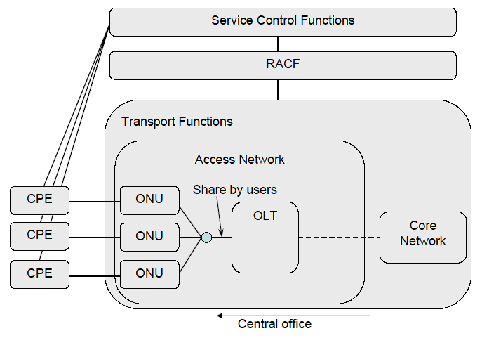
Example of share topology (PON)

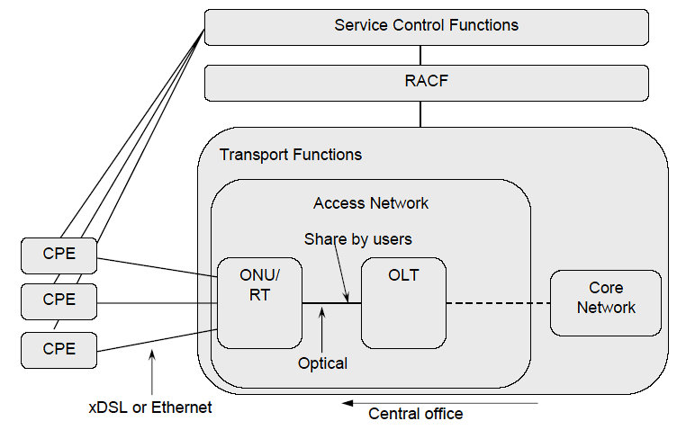
Example of share topology (Optical + xDSL or Ethernet)

The information components which might be able to change the value by conditions of each user should be managed. In addition, in case of “share topology”, it’s necessary to manage the bandwidth not only of each user or session, but also all users or sessions which share the same physical line as a group.
The information components of the reference point named Rw is defined in ITU-T Rec. Y.2111. Rw is the reference point between PE-FE of Transport Functions and PE-FE of RACF.
The following parameters should be added to the components of Rw reference point.
The information components including below are for future study.
- type of access line (e.g xDSL, FTTN etc.)
- maximum bandwidth which can be occupied
Living List #14 of WG4

Area: General issues
Title: Reorganizing the Functional Requirements of IPTV Multicast Availability and Security
Related Document: FGIPTV-C-0498

Background:
In the last meeting in Mountain View, WG4 agreed to create new output document on IPTV multicast frameworks. As a result, WG4 has two separate working documents, the original WD(IPTV network control aspects) and the new WD(IPTV multicast frameworks). “IPTV network control aspects” is an umbrella WD such that “IPTV multicast frameworks” needs to deal with more specific functional requirements on multicast issues in order to minimize duplication between two WDs. We proposed the requirements of IPTV multicast availability and security in the last meeting, and they were both included in the chapter 7 of the original WD and the chapter 6 of the new WD. In this text, we modified and reorganized the functional requirements according to the scope of each WD and separate the details into two WDs accordingly.

Study Issues:

Reorganizing: Availability of IPTV Multicast

IPTV Network Control Aspects
- IPTV service shall be restored without service intervention in the event of IPTV content delivery infrastructure failures.
- IPTV architecture shall provide redundancy and failover mechanisms in order to avoid a single point of failure affects the whole IPTV service.
- IPTV architecture shall be robust against denial of service attacks throughout the infrastructure.
- IPTV architecture shall provide a mechanism to guarantee quality of experience factors such as channel zapping time, loss, delay, and jitter, etc.
- IPTV service shall be managed and monitored for each service group in order to perceive service outages.
- IPTV architecture shall provide a mechanism to avoid service intervention in the event of maintenance period.

Reorganizing: Security of IPTV Multicast

IPTV Network Control Aspects
- IPTV architecture shall provide an admission control mechanism to regulate undesirable events.
- IPTV architecture shall be robust against denial of service attacks targeting the IPTV service components.
- IPTV architecture shall be robust against denial of service attacks initiated by the IPTV service components.
- IPTV architecture shall provide a mechanism for service user authentication and authorization any time.
- IPTV architecture shall provide a mechanism to protect contents from being illegally peculated.

Living List #15 of WG4

Area: General issues
Title: Enhancements of section 12 Overlay Networking in “ FG IPTV-DOC-0068”
Related Document: FGIPTV-C-0596

Background:
Over the past several years, we have seen the emergence of numerous types of so-called “overlay” networks in the internet. There are many diverse examples of such overlay networks including the contents-delivery-caching networks, peer-to-peer file sharing networks, and various testbed networks.
Because of the internet growing role as basic infrastructure and increasingly central role in the communications industry, these overlays take an important focus to solve the on-going debate on regulatory issues and business restrictions in internet space. And overlay networks are relevant to the tussle over what services are provided by ISPs as opposed to other third party service providers or by customer-managed layers. From these senses, the spawning of overlay networks over internet transport for IPTV services affects to IPTV service deployment and service provider’s structure.
To cope with these challenges and barriers of legacy internet for IPTV deployment, overlay networks for IPTV will provide various possible answers to

Study Issues:

Overlay Networking

1. Overlay Networking Functions for IPTV Service
Overlay network is virtual communications structure that is logically laid over a physical network. Nodes in the overlay can be thought of as being connected by virtual or logical link, each of which corresponds to a path, perhaps through many physical links, in the underlying network. So, overlay network is a set of servers deployed across the internet to provide some sort of infrastructure to one (or ideally several applications.
In some way overlay network takes responsibility for forwarding and handling of application data in ways that are different form or in competition with what is part of the basic internet. And overlay networks are operated in organized and coherent way by third parties to provide IPTV services.
An overlay network is consisted of virtual network topologies on top of the physical network, which directly interfaces to users. With the rapid advancement of internet and computing technology, much more aggregate information and computing resources are available from clients or peers than from a limited number of centralized servers. The figure 1 shows the general architecture for overlay service and networking.
Figure 1. Overlay Service and Networking Architecture for IPTV

Overlay networks provide IPTV service providers and users with the following advantages and opportunities to better utilize the increasingly growing internet information and resources.
- In overlay network, a routing function can provide a flexible route that is intrinsically tunes to the specific needs of the application, rather than relying on the generic route chosen by BGP. This effect is particularly important because the generic route rarely optimized for application performance.
- Overlay network allows both networking developers and application users to design and implement their own communication environment and protocols on top of the internet, such as data routing and file sharing management. These functional features will be efficiently applied to IPTV service deployment through overlay networking.
- Data routing in IPTV overlay network will be very flexible, quickly detecting and avoiding network congestions by adaptively selecting paths based on different metrics, such as probed latency.
- The high connectivity of increasingly more end nodes to join IPTV overlay network enables effective sharing of a huge amount of information and resources available in the internet.
- Overlay networking offers one-to-one transmission and one-to-many overlay multicast function in legacy internet environments with QoS and resource management to provide IPTV service requirements through overlay networking control functions.
To provide these flexibilities and intelligent features to IPTV customers, the proposed overlay service networking for IPTV is necessary to consider the following issues.
- For each new host that joins the network, a new connection is created that connects it to a IPTV overlay networking control point, and the topology is then updated with new channel and routing tables are re-computed. For more dynamic running on IPTV service networking, intelligent features will be necessary to select tunnel(s) for each end system that has to be connected to the other IPTV service networking control point.
- The configuration of the particular (or virtual) mesh, among allowed hosts, that connects all hosts in order to satisfy the best approach in IPTV customer.
- QoS-capable IPTV is also necessary feature to provide tailored diverse IPTV services, which could be differentiated in terms of performance and QoS, accounting, security and privacy.
- Application-aware overlay networking for IPTV services will be another important feature to provide to reflect IPTV service specific capabilities. Its active and intelligent service networking will provide flexible capability to adopt user’s requirements for IPTV services efficiently.

2. Overlay Control Functions for IPTV Service
Functions for overlay service are offered in IPTV Control. IPTV Control is constituted Session Agent whose role is data transmission and Session Manager to control and manage sessions. Figure 2 shows functional components to provide overlay IPTV service capability

Figure 2. Functional Architecture of Overlay Network for IPTV Service

In order to provide session management functions in overlay networks for IPTV service, Session Manager is introduced to perform session control and management for IPTV service in overlay network. Major functions of Session Manager will provide the following functionalities to perform overlay networking capabilities over legacy internet.
Figure 3. Requirement of Session Manager

● Configuration Management
It offers functions confirming and managing IPTV customers participated in IPTV overlay service.
● Resource and QoS Control
It controls rate, QoS and delay IPTV customers using overlay service.
It requests resource and QoS information of network to IPTV customers to resource control.
● Performance Management
It manages delay and bandwidth of overlay service.
Performance is managed and controlled through report message of Session Agents.
● Overlay Node Fault Management
It senses problem occurrence of link and fault of Session Agents.

In order to perform overlay session management in large size networks, session management functionality will have two-tier hierarchy, Session Manager and Session Agent.
Session Agent constructs relayed multicast delivery path and forwards data along the constructed path from IPTV server or other Session Agent to IPTV customers or Session Agent. Session Agent will consist of control channel and data transport channel. The main function of former is to establish relayed data delivery path and that of latter to setup data channel along the path constructed by control channel and relay data through the channel. Session Agent will have the following functional requirements which are divided into three parts of management, maintenance and packet processing.
- Management Functions:
- QoS management
- Security management
- Maintenance Functions.
- Performance monitoring
- Diagnostics and Troubleshooting
- Packet processing Functions
- Classification
- Queuing and Scheduling
- Routing
- Support downstream QoS
- Encapsulation and session support

And each Session Agent delivers report message to Session Manager. Report message will include the following information:
- Information of agent being added newly
- Access Session Agent's routing status information
- Overlay tree topology (e.g., overlay multicast)
- Data transmission Information
- Session Agent error information

3. Multicast Function in IPTV Overlay Network
In internet, reliable multicast transport has not been resolved well, including scalability, flow control, congestion control and etc. Until the related reliable multicast transport mechanism settles down, group communications requiring reliable data transfer are actually clinging to replicate unicast method based on servers. Although IP multicast has not deployed globally, a lot of local networks have already been equipped with IP multicast transport. For example, Ethernet-based LANs and private networks such as corporate and campus networks substantially provide the multicast transport capability within their local subnet or administrative domains.
Recognizing these observations, there is a crucial need to develop an alternative multicast delivery scheme in overlay network. It makes good use of existing unicast, multicast and/or multicast tunnelling schemes. In addition, overlay multicast is designed as several separate forms to support any kinds of group service type well. Overlay multicast is expected to provide a substantial solution for group applications for IPTV service, and will be possible to provide application-aware multicast and QoS-aware multicast.

Figure 4. Hierarchical Structure for Overlay IPTV Multicast

In order to provide scalability in networking capacity and to support dynamic service capability multiple-tiers hierarchical structure will be introduced in IPTV overlay networks as shown in Figure 4. IPTV streaming server transmits data to one agent according to the overlay routing tree, and the agent re-transmits data to sub-agent again if necessary.

4. Security and Privacy Functions for IPTV Overlay Network
Security and Privacy for overlay network change the routing and caching behaviour of communications and content on the internet. In that sense overlay networking will enhance some aspects of IPTV customer security and privacy, with provision for secret communications or anonymity for IPTV customer.
Decentralized overlay network models also confront with various vulnerabilities and risks that impede from being widely deployed in mission critical business systems and applications. There are three important security challenges for the overlay network service model: Confidentiality and integrity, authenticity, and availability. These three important security challenges can be classified with some properties for architectures and algorithms for building secure and scaleable information dissemination services on wide area overlay networks. It will be necessary to provide overlay network security and privacy to support the following properties.

Living List #16 of WG4

Area: Home Network issues
Title: DNG Network Attachment
Related Document: FGIPTV-C-0527

Background:
There are at least two types of devices in the consumer domain that need to attach to the network to establish IP layer connectivity, over which management, control, and user plane data can flow. The two devices are the Delivery Network Gateway (DNG) and the IPTV Terminal Function (ITF) device. This document addresses the DNG attachment to the network.

Study Issues:

Delivery Network Gateway (DNG)

Setup and Initial Configuration (pre-configuration)
In some network deployments the DNG and ITF devices are preconfigured with all or part of the network attachment information. For example, a DNG or an ITF device could use the procedure described below to get its own IP address, and then proceed directly to communicate with a remote configuration server based on some hard-coded addressing information, or based on some plug-in methods, such as smart card.
In lack of such pre-configuration information, the device needs to follow the procedures listed in this document.

DNG Network Attachment
The term ‘Network Attachment’ refers to the activities associated with the DNG establishing Layer-3 connectivity to an IP-network. Once the network attachment activities have been completed, the DNG will be capable of transmitting and receiving IP packets, and establishing a management session with a remote configuration server. Subsequently the remote configuration server, such as an auto-configuration server (ACS) defined in TR-69, can be used to provision the DNG with access-network specific parameters.

DHCP
The most prevalent automatic method currently used to attach to the network is the DHCP protocol. Using this protocol, the DNG acquires its WAN IP address, and can also learn the address of the remote configuration server.
The figure below shows the sequence of events that take place when the DNG is powered up or initialized.
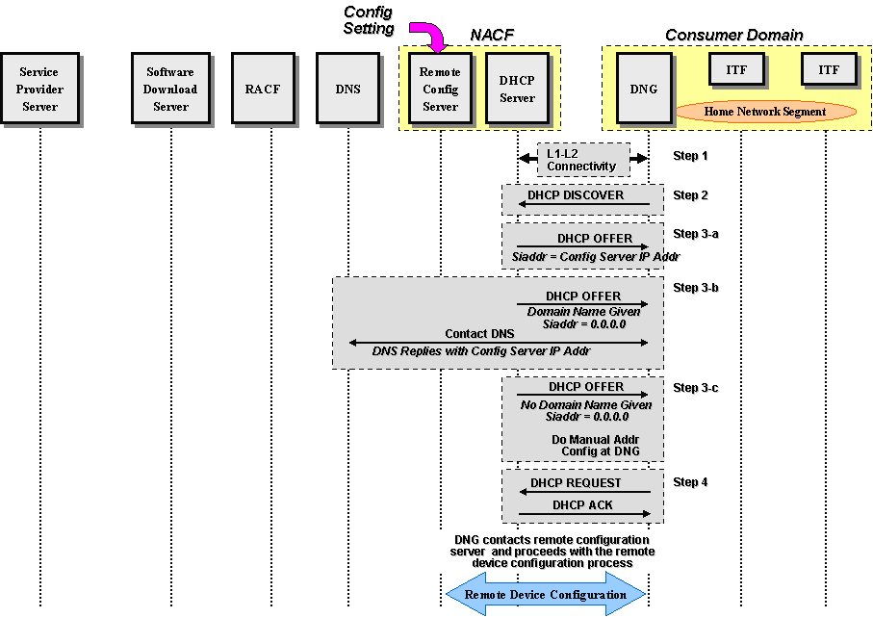
Figure 1 : DNG Network Attachment

Specifically, the following procedure takes place:
- The DNG establishes L1 and L2 connectivity with the network. The specific steps depend on the type of the access network (DSL, PON, Wireless) and are beyond the scope of this document.
  - The DNG issues a DHCP DISCOVER message toward the network that must include all the mandatory DHCP options, per RFC 2131. If the DNG device supports the Container option (pending the IETF final approval), it must request that option in option 55 (parameter request list).
- The network provider DHCP server replies to the DNG with a DHCP OFFER message that must include all the DHCP mandatory options, per RFC 2131. The DHCP server must provide the following information to the DNG:
  - DNG WAN IP address
  - DNG network mask
  - DNS IP address
  - If configured, the container option to convey specific information to the ITF.
  - If configured, the remote configuration server addressing information (see possibilities below).
There are three possibilities at this point, reflected in the content of the DHCP OFFER message:
  - If the DHCP server is provisioned with the remote configuration server IP address, then it must include it in the siaddr field of the OFFER message. This is shown as step 3-a in the figure above.
  - If the DHCP server is provisioned with the remote configuration server domain name but not its IP address, then it must set siaddr = 0.0.0.0 and provide the remote configuration server domain name to the DNG. The DNG must interact with the DNS to resolve the remote configuration server IP address. This is shown as step 3-b in the figure above,
  - If the DHCP server is not provisioned with the remote server addressing information (IP address or domain name) and therefore does not provide the remote configuration server IP address or its domain name, then the DNG needs to be configured manually by the end user. This is shown as step 3-c in the figure above.
4) The DHCP protocol sequence completes with the standard DHCP REQUEST and DHCP ACK messages.
After acquiring the IP address of the remote configuration server, the DNG interacts with the remote configuration server to acquire needed configuration parameters.

Living List #17 of WG4

Area: Home Network issues
Title: ITF Network Attachment
Related Document: FGIPTV-C-0528

Background:
This contribution discusses the ITF Network Attachment which occurs right after the DNG Network attachment is completed
There are two cases for ITF device attachment to the network. The first is a case where the ITF device is behind the DNG’s NAT and the second is a case where the ITF resides on a mobile device and is attaching to the network without passing through the DNG. The second case is out of the scope of this document.

Study Issues:

ITF Device

Setup and Initial Configuration
The activities associated with ‘ITF Setup and Configuration’ are those related to acquiring and configuring a physical ITF device. Functions performed during this step are prerequisites for other stages in the process.
For an ITF to properly function in different environments, its setup and configuration should provide means for specifying the following:
- The identity and authentication credentials to be established for the ITF. Identity credentials are data elements maintained on the ITF that are used to identity the device and/or its associated subscriber(s) to a service provider.
- Service provider(s) identities and any additional information for establishing a service account with one or more service providers.
- Other device and service options.

Note that while the mechanisms for implementing the ‘ITF Setup and Configuration’ procedure are outside the scope of IIF, the specific types and formats used to contain the required information are in scope.

Network Attachment
The term ‘Network Attachment’ refers to the activities associated with the ITF establishing Layer-3 connectivity to an IP-network and potentially obtaining additional network configuration data.
During the network attachment phase the following information may be obtained or otherwise established by the ITF:
- IPv4 address, network mask, default route
- DNS, local network domain name, SIP proxies, others…
Once network attachment activities have been completed, the ITF will be capable of transmitting and receiving IP packets and establishing a management session with a remote configuration server. Among existing mechanisms for implementing the Network Attachment function and relevant to the IIF are:
- the Dynamic Host Configuration Protocol (DHCP)
- NGN NACF
The profiles and the details for each of the mechanisms as applicable for various IPTV use cases are described in the following sections.

DHCP
There are two cases to consider. The first case is when the DNG supports DHCP server capability and thus acts as the network DHCP server for the ITFs on the home network. The second case is when the DNG passes DHCP messages through as a DHCP relay agent.
Note that while the second case can still be found in today’s deployments, home networks are moving towards self-contained IP domains, with the network DHCP server located in the DNG.

Local DHCP Server on the DNG
In this case it is assumed that the DNG has already attached to the network and acquired its L3 networking information. The following sequence takes place when an ITF device is powered up or initialized:
- The ITF device establishes L1 and L2 connectivity with the DNG across the home network, which could be over a copper network, a coaxial network, fiber/plastic network, or wireless network.
  - The ITF device issues a DHCP DISCOVER message toward the DNG that must include all the mandatory DHCP options, per RFC 2131. The ITF device must include option 60 to allow it to identify itself to the DNG. If the ITF device supports the option(s) associated with the Container option (pending the IETF final approval), it must request those option(s) in option 55 (parameter request list).
- The DNG, as a DHCP server, replies to the ITF device with a DHCP OFFER message that must include all the DHCP mandatory options, per RFC 2131. The DNG must provide the following information to the ITF device:
  - ITF device local IP address
  - ITF device local network mask
  - DNS IP address
  - The remote configuration server IP address (same as the one assigned to the DNG).
  - Default gateway IP address
  - If configured, the option(s) associated with the container option to convey specific information to the ITF such as a remote configuration server (different than the one assigned to the DNG) to be used by the ITF.
- The ITF device continues the DHCP message exchange with the standard DHCP REQUEST message
- The DNG completes the DHCP message exchange with the standard DHCP ACK message
The flow is shown below:
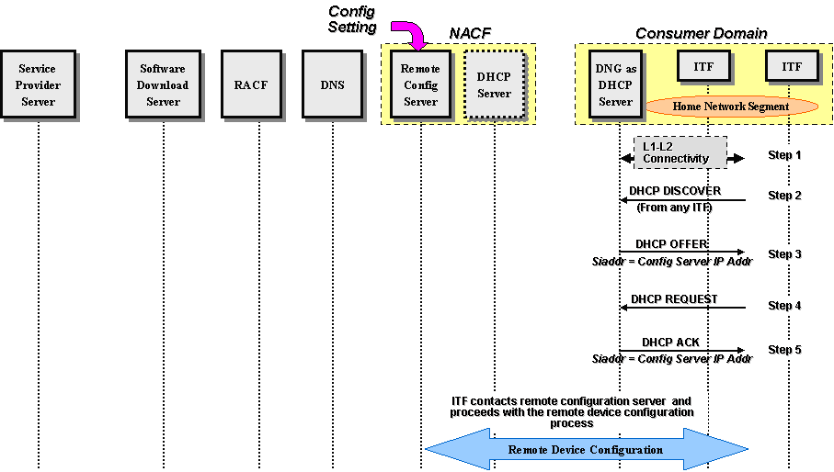
Figure 2: ITF Device Network Attachment with a Local DHCP Server in the DNG
After acquiring the IP address of the remote configuration server, the ITF device interacts with the remote configuration server to acquire needed configuration parameters.

Remote DHCP Server across the network
In this case the DNG passes all DHCP messages transparently to the network. The Figure 3: ITF Device Network Attachment with a Remote DHCP Server shows the sequence of events that take place when the ITF device is powered up or initialized.
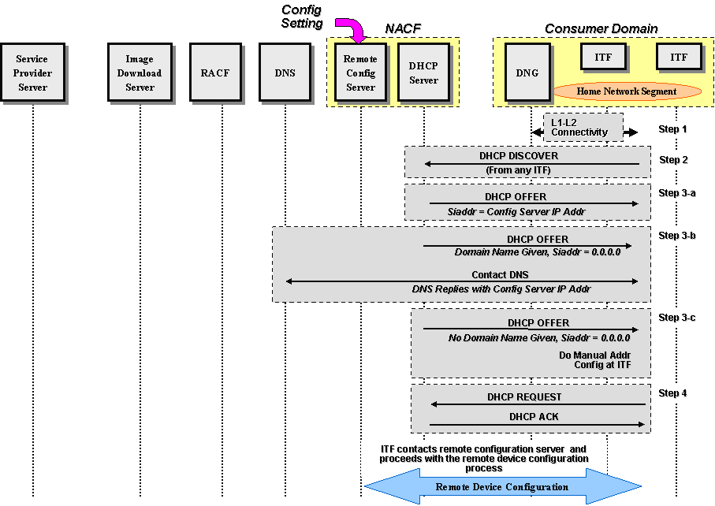
Figure 3: ITF Device Network Attachment with a Remote DHCP Server
Specifically, the following takes place:
- The ITF device establishes L1 and L2 connectivity with the DNG across the home network, which could be a copper network, a coaxial network, fiber/plastic network, or wireless network (not shown in the figure above).
- The ITF device issues a DHCP DISCOVER message toward the DNG that must include all the mandatory DHCP options, per RFC 2131. The ITF device must also include option 60 to allow it to identify itself to the network. The DNG passes this DISCOVER message to the WAN network transparently.
- The network provider DHCP server replies to the ITF device with a DHCP OFFER message that must include all the DHCP mandatory options, per RFC 2131. The DHCP server must provide the following information to the ITF device:
  - ITF device IP address
  - ITF device network mask
  - DNS IP address
  - If available, the remote configuration server IP address
  - Default gateway IP address
The DNG must pass the DHCP OFFER message to the ITF transparently.
There are three possibilities at this point reflected in the content of the DHCP OFFER message:
  - If the DHCP server is provisioned with the remote configuration server IP address, then it must include it in the siaddr field of the OFFER message. This is shown as step 3-a in the figure above.
  - If the DHCP server is provisioned with the remote configuration server domain name but not its IP address, then it must set siaddr = 0.0.0.0 and provide the remote configuration server domain name to the ITF. The ITF device must interact with the DNS to resolve the remote configuration server IP address. This is shown as step 3-b in the figure above.
  - If the DHCP server is not provisioned with the remote server addressing information (IP address or domain name) and therefore does not provide the remote configuration server IP address or its domain name, then the ITF device needs to be configured manually by the end user. This is shown as step 3-c in the figure above.
- The DHCP protocol sequence completes with the standard DHCP REQUEST and DHCP ACK messages.
After acquiring the IP address of the remote configuration server, the ITF device interacts with the remote configuration server to acquire needed configuration parameters.
Living List #18 of WG4

Area: Network Control issues
Title: IPTV Device Attachment and Initialization process for Core IPTV and NGN IPTV Achitectures
Related Document: FGIPTV-C-0529

Background:
This contribution describes the attachment and initialization process of the IPTV device in an IPTV environment that prepares it to receive IPTV services. In addition, this contribution discusses the means for control and service access (e.g. broadcast) to support IPTV.

Study Issues:
The IPTV device attachment and initialization process (see Fig 1) can be broken down into the following steps:
- Setup & Configuration
- Network Attachment
- Service Provider Discovery
- Services discovery and Service attachment

It’s assumed that the DNG and the ITF have initialized and attached to the network Details can be found in Ref [WG5 outpout document]. The ITF proceeds with the following steps:

Service Provider Discovery
Service Provider discovery is the process by which an ITF becomes aware of the available IPTV Service Providers, learns the location of their Service Discovery (SD) Servers and the means for attaching to each SD server. As a result, by contacting the discovered SD Server(s), an ITF can perform the subsequent Services Discovery and Service Attachment procedures.
The Service Provider Discovery process is defined as a set of alternative procedures/cases defined below, which can be extended further.

Manual
The ITF may be preconfigured with the necessary information that allows its first contact with the Service Provider (SP), such as a list of SD Servers URLs or a well-known multicast stream address registered with IANA that will convey a list of the SD Servers hostnames.
DHCP
This alternative requires the DHCP Container Option and will be described after an official RFC is assigned.
Editor’s Note: DHCP Container Option is still awaiting for IETF approval.

Services Discovery and Service Attachment
Services Discovery is the process by which an ITF receives the necessary signaling information which prepares it to learn about and access the available IPTV Services. The ITF interacts with one or more Service Provider Servers (discovered earlier) in order to acquire information about specific services.
The Services Discovery function includes both the ‘services discovery authorization’ means and the ‘services description’. Having been authorized by a Service Provider SD Server, the consumer needs to be able to navigate through the variety of service offerings and then attach to a specific service. The ITU Metadata Working Group (WG 6) is responsible for the definition of the metadata and the supporting schemas.

Multicast-based “Push Mode”
The following steps are executed during this phase:
- Using the SP contact information received during the Service Discovery step, the ITF sends an IGMPv3 Membership report to join the ‘System-wide’ stream generated from a Service Provider server. This stream contains the following information:
- Host name of the Registration server. This Registration server can be the same as the one streaming the ‘System-wide’ flow.
- STUN server host name and keepalive frequency (s) for NAT traversal. Alternatively, other mechanism (e.g. UPnP) may be used for NAT traversal.
- Software Download Directory. This directory lists the source IPA and multicast destination address of various streams that carry images.
- Based on certain rules (e.g. ITF hardware ID) defined by the SP, the ITF joins the appropriate multicast address specified in the Software Download Directory to download its image.
Download software authentication mechanism is not discussed in this document and should be addressed in WG 3.
- The ITF sends a Binding Request to the STUN server for each UDP-based application on which the ITF expects to receive unsolicited unicast traffic from the Service Provider server.
- The ITF publishes to the SP server all the NATed IPaddresses and ports to be used by that server for unsolicited unicast traffic destined to the ITF.
- Based on information unique to ITF and the location of the ITF (which can be accessed from Billing system or other server), the SP provides the ITF with information containing other servers’ URL or IP addresses, the source IPA and multicast destination IPA for the subsequent flows required by the ITF before it can access IPTV services. Note that the subsequent multicast flows are region-specific and may consist of the following:
  - Flow A: Emergency Alert Service (EAS) and Update messages regarding the other multicast signaling streams. Because of the type of data that are conveyed on this flow, the ITF never leaves it.
  - Flow B: EPG data and other information
  - Flow C: Service/System Information data.

Note 1: The SP can define as many flows as deemed necessary .
Note 2: Any addressable CA (Conditional Access) information is unicast to the ITF.
After having registered with the SP successfully, the ITF joins flows A, B and C in any order. Once the ITF joins flow A, it never leaves it unless it is rebooted. It needs to continuously join this stream in order to receive any EAS message, monitor any update information concerning the other flows (i.e. System-wide, flows B, and C).

When an update is received on flow A, the ITF joins the flow which the update refers to in order to apply the appropriate changes.

The ITF uses information (from flows B and C) received from the SP server that allows the consumer to navigate through the variety of service offerings and select specific content. In the context of a linear / broadcast TV service this involves the discovery of available content, and the use of some sort of content selection mechanism.

The ITF uses the EPG data received from flow B in order to display the program guide that allows the consumer to navigate and select content based on channel, title and other descriptive information.

The ITF uses the Service/System Information data received from flow C in order to find out where to access any stream that the user selects. In order to support IPTV, new or existing Service/System Information data need to be updated to provide the data necessary for an ITF/navigation device to discover and access digital/analog services offered by the Service Provider.
A summary of the IPTV device Initialization and Attachment flow is represented below.

Fig. 1 IPTV Device Initialization and Attachment flow
Living List #19 of WG4

Area: Network Control issues
Title: Draft of “13 Overlay Networking” in FG IPTV-DOC-0091
Related Document: FGIPTV-C-0815

Background:
Overlay networking provides the ability to customize a network without the overhead of deploying physical links. Overlay network is virtual communications structure that is logically laid over a physical network. Nodes in overlay network can be thought of as being connected by virtual or logical link, each of which corresponds to a path, perhaps through many physical links, in the underlying network.
Overlay network can be constructed in order to permit routing messages to destinations not specified by an IP address. And overlay network has also been proposed as a way to improve Internet routing, such as through quality of service guarantees to achieve higher-quality streaming media. And also overlay networking capability can be used to enhance IPTV services features like overlay multicast at application service level.

Study Issues:

Overlay Networking

13.1 Definition of Overlay Network
An overlay network is virtual communications structure that is logically laid over a physical network. An overlay node, networking functional element in overlay network, can be thought of as being connected by virtual or logical link, each of which corresponds to a path.
In some way overlay network takes responsibility for forwarding and handling of application data in ways that are different form or in competition with what is part of the basic internet. And overlay networks are operated in organized and coherent way by third parties to provide IPTV services.
As a result, an overlay network is consisted of virtual network topologies on top of the physical network, which directly interfaces to users. With the rapid advancement of internet and computing technology, much more aggregate information and computing resources are available from clients or peers than from a limited number of centralized servers.
The figure 1 shows the general architecture for overlay service and networking.
Figure 1. Overlay Service and Network for IPTV

13.2 Benefits of Overlay Network for IPTV Services
The most immediate benefit of using an overlay network instead of modifying Internet protocols or routers is that the overlay provides a quick and easy deployment path that lacks many of the technical and political hurdles of a router-level deployment.
Another benefit of overlay network is that they avoid burdening the underlying network with features better performed at higher layers and bug in the overlay network is much less likely to crash the underlying IP routing infrastructure.
Additionally few flexibilities and intelligent features to IPTV customers of the overlay network the following issues will be another benefits in IPTV overlay network.

- The configuration of the particular (or virtual) mesh, among allowed hosts, that connects all hosts in order to satisfy the best approach in IPTV customer.
- QoS-capable IPTV is also necessary feature to provide tailored diverse IPTV services, which could be differentiated in terms of performance and QoS, accounting, security and privacy.
- Application-aware IPTV overlay networking is requested to reflect IPTV service specific features.
- Provision of active and intelligent service networking features for adaptive service requirements of IPTV.
- Multi-homed contents delivery will be provided over overlay network to meet efficient content delivery with high quality service requirements for IPTV services.
- Overlay network combines overlay failure masking with explicitly engineered access link redundancy to ensure that clients are not easily disconnected from the network. Overlay network also seeks out multiple servers when they are available in order to reduce the impact of server access link failures.

13.3 Overlay Control Function for IPTV Service
Functions for overlay service are offered in IPTV Control. IPTV Control is constituted Session Agent whose role is data transmission and Session Manager to control and manage sessions. Figure 2 shows functional components to provide overlay IPTV service capability.

Figure 2. Functional Architecture of Overlay Network for IPTV Service

In order to provide session management functions in overlay networks for IPTV service, Session Manager is introduced to perform session control and management for IPTV service in overlay network. Major functions of Session Manager will provide the following functionalities to perform overlay networking capabilities over legacy internet.
Figure 3. Requirement of Session Manager

● Configuration Management
It offers functions confirming and managing IPTV customers participated in IPTV overlay service.
● Resource and QoS Control
It controls rate, QoS and delay IPTV customers using overlay service.
It requests resource and QoS information of network to IPTV customers to resource control.
● Performance Management
It manages delay and bandwidth of overlay service.
Performance is managed and controlled through report message of Session Agents.
● Overlay Node Fault Management
It senses problem occurrence of link and fault of Session Agents.

Session Agent constructs relayed multicast delivery path and forwards data along the constructed path from IPTV server or other Session Agent to IPTV customers or Session Agent. Session Agent will consist of control channel and data transport channel. The main function of former is to establish relayed data delivery path and that of latter to setup data channel along the path constructed by control channel and relay data through the channel. Session Agent will have the following functional requirements which are divided into three parts of management, maintenance and packet processing.
- Management Functions:
- QoS management
- Security management
- Maintenance Functions.
- Performance monitoring
- Diagnostics and Troubleshooting
- Packet processing Functions
- Classification
- Queuing and Scheduling
- Routing
- Support downstream QoS
- Encapsulation and session support

And each Session Agent delivers report message to Session Manager. Report message will include the following information:
- Information of agent being added newly
- Access Session Agent's routing status information
- Overlay tree topology (e.g., overlay multicast)
- Data transmission Information
- Session Agent error information

13.4 Multicast Function in IPTV Overlay Network
The overlay IPTV multicast can use diverse mechanisms for constructing different multicast trees depending on IPTV application parameters or application classes. The overlay IPTV multicast supports efficient routing and resource usage by overlay multicast control.
In order to provide scalability in multicast function, multiple-tiers hierarchical structure for overlay multicast will be introduced in IPTV overlay networks.

13.5 Security and Privacy Functions for IPTV Overlay Network
Security and Privacy for overlay network change the routing and caching behaviour of communications and content on the internet. In that sense overlay networking will enhance some aspects of IPTV customer security and privacy, with provision for secret communications or anonymity for IPTV customer.
Decentralized overlay network models also confront with various vulnerabilities and risks that impede from being widely deployed in mission critical business systems and applications. There are three important security challenges for the overlay network service model: Confidentiality and integrity, authenticity, and availability. These three important security challenges can be classified with some properties for architectures and algorithms for building secure and scaleable information dissemination services on wide area overlay networks. It will be necessary to provide overlay network security and privacy to support the following properties.

_______________

