Radiocommunication Advisory Group  Geneva, 13-15 February 2008 | 
 | Document RAG08-1/4-E
 | 7 February 2008
 | English only
Coordinator of the RAG Correspondence Group
on Electronic Document Handling (EDH)
PROGRESS REPORT on edh correspondence activities

1 Introduction
The Radiocommunication Assembly formed the Electronic Document Handling (EDH) correspondence group reporting to the RAG as announced in Administrative Circular CA/130.
There has been little activity within the EDH correspondence group, which, again, may be taken as an indication that things are progressing well with respect to the use of electronic facilities in ITU-R. Some suggestions that have been made were pursued with the IS Department and BR. The correspondence to-date is available in the Archive of the rag-edh@itu.int e-mail reflector.

2 ITU-R website
After the previous testing period that ended in December 2006, all pages related to general ITU-R information and ITU-R conferences (except for the RRCs) have been migrated to the six languages and are displayed using the XML format.
A new website has been launched for the Union in 2007. All the ITU-R pages have been migrated to the new template with the exception of the space and terrestrial services sites, which will be done soon.
To avoid the changes in URLs, an ITU-R “GO System” has been put into production. This system gives this kind of URL: www.itu.int/ITU-R/go/XXX where “XXX” is the link of the page, i.e. “rag” for RAG, “rsg5” for ITU-R Study Group 5, “wrc-07” for WRC-07, etc. Furthermore, the root page of this system www.itu.int/ITU-R/go gives all the redirections available. The languages can also be recognized by adding (/en, /fr, /es, /ar, /zh, /ru) at the end, otherwise the English is displayed as default.
So, for example, the Chinese RAG page URL will be www.itu.int/ITU-R/go/rag/zh. By using this system, we should avoid broken links as the URLs are redirected to the real ones and are not dependent on the system used. The next step will be to display in the URL link bar this go URL to simplify the copy/paste.
The ITU-R homepage, www.itu.int/ITU-R, has also been redrawn to incorporate dynamic elements like next meetings, newsflashes and latest publications, recommendations and circulars.

3 Registration of delegates
The online web-based Event Delegate Registration System (EDRS) was successfully used for the main ITU-R single-event meetings (CPM, RAG, RA and WRC) in 2007. The enhancement of EDRS to facilitate the meetings of the study groups and their affiliated groups is foreseen to take place in 2008, depending upon the completion of further developments by the ITU IS Department.

4 Terminology database
At its last meeting, the RAG advised the Director of the BR to participate actively in the activities called upon by Resolution 154 (Antalya, 2006) for the merging of all terminology databases, noting that the functionalities of the ITU-R database should not be lost in the final consolidated ITU new system.
In 2007, the ITU Intersectoral Project Team on Terminology (BR, TSB, BDT, GS) decided, as a first step of this merging, an automatic replication mechanism in order to import and export data from Termite 6L (Ingress DBMS – http://www.itu.int/terminology/index.html) to ITU-R/ITU-T Terms and Definitions database (SQL Server – http://www.itu.int/ITU-R/go/terminology-database) (data exchanged weekly, see figure below). The work of the project team is ongoing and the functionalities of the ITU-T part will be reviewed.
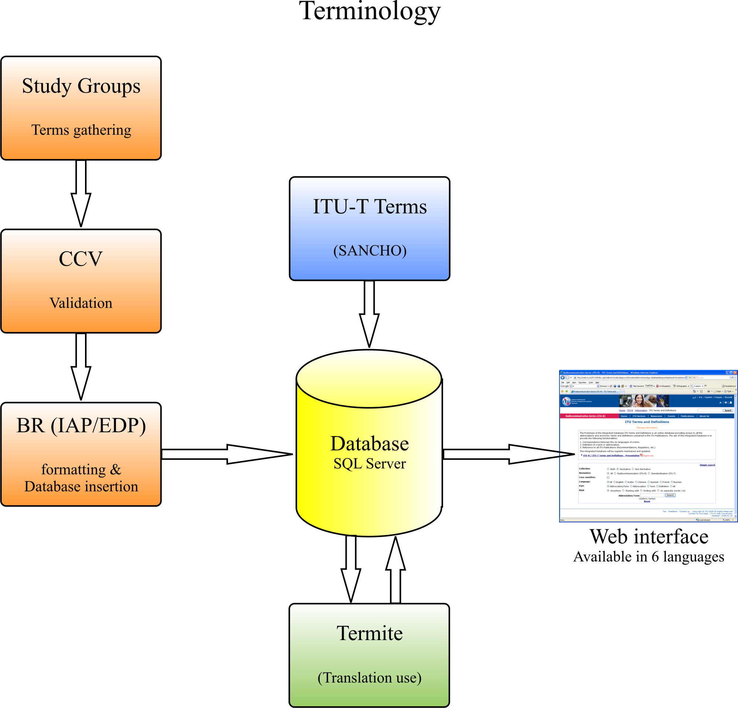

It is worth noting that RA-07 adopted the replacement of several V-Series Recommendations (ITU-R V.573 (list of all existing radiocommunication terms) and ITU-R V.607) by the terminology database.

5 Electronic working methods
For those participating in, or organizing ITU meetings, there are a number of tools that can be used to improve or substitute face-to-face meetings, or to facilitate remote participation in meetings (e.g. for developing countries). In addition to the use of TIES, these tools include:
• Internet Broadcast System (IBS). Many ITU meetings are now broadcast over the web, either with or without restrictions on access, and many have sound and or video archives available for consultation. For instance, the archives for the September 2007 workshop on multimedia in NGN are available online at: http://www.itu.int/ibs/ITU-T/200709multimedia/index.html.
• E-learning. ITU conducts many different courses each year through e-learning, organized both by the HQ in Geneva and the regional offices (see: http://www.itu.int/ITU-D/hrd/elearning/index.asp).
• Correspondence activities. The ITU Jive facility is falling into disuse and will eventually be replaced by Sharepoint; other solutions may be implemented in the interim. TIES e-mail reflectors and FTP facilities (ftp://ftp.itu.int/) will continue to be available as usual.
• Remote participation tools. ITU is currently evaluating two popular remote participation or groupware packages, and these are available to meeting organizers (e.g. for organizing meetings of rapporteurs, offering webinars, etc). These include GoToMeeting (see: www.gotomeeting.com) and WebEx (see: www.webex.com).
• Information dissemination tools. ITU offers a number of information dissemination tools to its members, including websites, bulletin boards, email reflectors, forum discussions, newslogs, interactive calendars etc. One recent innovation is the use of a wiki by the Focus Group on Digital Identity Management (see: http://www.ituwiki.com/).

6 Proposal
It is proposed that more groups should try the various approaches available in ITU-R for EDH with the goal of making our work in ITU-R easier and more productive. The experiences and suggestions for further improvements should be sent to the RAG-EDH correspondence group: rag-edh@itu.int.

______________

José Costa (Nortel Networks, Canada), Tel.: +1 613 763-7574, E-mail: costa@nortel.com.

