Radiocommunication Advisory Group  Geneva, 13-15 February 2008 | 
 | Addendum 2 to Document RAG08-1/1-E
 | 14 February 2008
 | English only
Director, Radiocommunication Bureau
REPORT ON ITU-R ACTIVITIES ON CLIMATE CHANGE

Introduction
Radiocommunications are an integral part of information and communication technology and they are playing a significant role in the following aspects of the ICT used in combating the negative effects of climate change:
- climate change monitoring;
- actions against global warming
- mitigating the local effects of climate change.

The following is a report on the Radiocommunication Sector main activities relevant to reducing the effects of climate change with aim to be used for informing the general public on these activities.

1. Radio Technologies and Radiocommunication Systems Used in Monitoring Climate Change
1.1. Radio Technologies Used in Monitoring Climate Change – Technical Background
Radio based applications and radio systems are currently playing a very significant role in monitoring of climate change. They provide the backbone of the Global Observing System (GOS) created by the World Meteorological Organization (WMO). GOS, as shown in Figure 1, is comprised of observation stations located on land, at sea, on aircraft, and on meteorological satellites. GOS is a composite system of complex methods, techniques and facilities for measuring meteorological and environmental parameters. It provides observations of the atmosphere and earth surface (including ocean surface) from all parts of the globe and from outer space. GOS mainly relays on remote sensing equipment placed on satellites, aircrafts, radiosondes, as well as meteorological radars on the Earth and at sea. The system ensures that critical information is available to every country to generate weather analyses, forecasts and warnings on a day-to-day basis. A subset of data gathered by GOS is also used in the Global Climate Observing System (GCOS). GCOS addresses the total climate system including physical, chemical and biological properties, and atmospheric, oceanic, hydrologic, cryospheric and terrestrial processes.
An important aspect and additional complexity of the use of radio-based technologies for climate control and weather forecasting is the fact that there is no free choice of frequency bands used for environmental measurements; the choice of the frequency band is dictated by the physical phenomena to be observed. As shown in Figure 2 it is not possible to use frequency bands from 75 to 100 GHz for measuring the oxygen level in atmosphere.
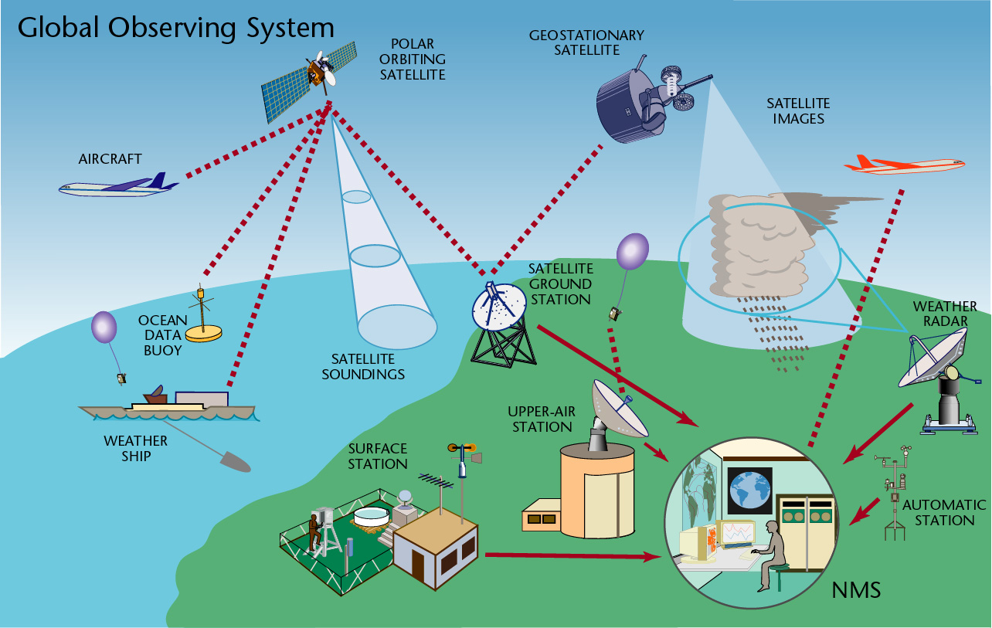
Figure 1 WMO Global Observing System
Source: WMO and ITU-R Handbook “Use of Radio Spectrum for Meteorology”
Note: NMS = National Meteorological Service
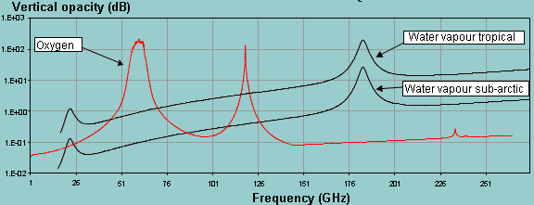
Figure 2. Atmospheric opacity in the frequency range 1-275 GHz
Within the framework of the climate and weather monitoring systems, radiocommunication systems and radio applications are employed for:
- observations of the atmosphere and the Earth surface from all parts of the globe and from outer space, mainly using remote active and passive sensors;
- delivery of measurement results
to international and national monitoring centres;
- the real-time exchange of meteorological observational data, processed products, and related information between national meteorological and hydrological services;
- warning the general public of dangerous events (flooding, hurricanes, typhoons, tornadoes, thunderstorms, the effluent from volcanoes, forest fires, and other natural and man-made disasters)²;
Box 1: XV World Meteorological Congress, 2007 of the World Meteorological Organization in Resolution 3:

Re-affirmed the crucial importance of RF bands for meteorological and related environmental operations and research, and for disaster risk reduction.

Stressed that some RF bands are a unique natural resource for passive sensing that deserve absolute protection.

Urged all Members to do their utmost at national, regional and international levels to ensure the availability and protection of suitable RF bands.

Appealed to ITU and its Administrations to ensure the absolute protection of the passive sensing RF bands, and to give due consideration to the WMO requirements for RF allocations and regulatory provisions.
- damage assessment and planning and monitoring of disaster relief operations (see also section 3).
Meteorological aids, meteorological-satellite and Earth exploration-satellite radiocommunication services play a major role in climate change monitoring and weather forecasting. It is essential that these services have sufficient spectrum and the frequencies allocated to these services remain free of interference (see also Box 1).

1.2 Radiocommunication Sector and Climate Change Monitoring
In this respect the Radiocommunication Sector carries out the following main activities:
- The World Radiocommunication Conferences (WRCs) analyze proposals relevant to the further development and operation of meteorological and Earth observation systems and allocate the necessary spectrum for different applications insuring adequate protection of these systems from harmful interference (see Box 2). WRCs also modify the ITU Radio Regulations;
Box 2: Recognizing that the radio frequency spectrum is a critical resource for remote sensing employed in GOS (see Resolution 673 (WRC-07) “Radiocommunications use for Earth observation applications”) WRC-07:
- considered four Agenda items (with positive results) directly related to remote sensing (including extension of frequency bands for some active sensors);
- approved five new Resolutions concerning new studies relevant to remote sensing which is a vital component in the science of climate change;
- included four items in the draft of WRC-11 Agenda on the use and further development of remote sensing systems.
- The Radiocommunication Assembly (RA) approved Resolutions which instruct the Radiocommunication Study Groups (SG) to carry out studies and develop relevant ITU-R publications (Recommendations, Reports, Handbooks) that facilitate the development and operation of the relevant services and systems (see Box 3).
Box 3: RA-07 approved Resolutions ITU-R 53 and 55 instructing all ITU-R Study Groups to carry out studies on the use of radiocommunication in disaster prediction, detection, response, mitigation and relief. This is to be done collaboratively within and outside ITU to avoid duplication.
- ITU-R Study Groups analyze study results and proposals submitted by ITU Member States, Radiocommunication Sector members, including the World Meteorological Organization, international and national agencies and organizations, involved in climate control, so as to adopt and approve relevant ITU-R publications (see Box 4). The results of studies corresponding to WRC Agenda items are reported to WRCs for consideration. In accordance with WRC-07 decisions, the main areas for studies to be reported to WRC-11 are the following:
  - use of optical links for remote sensing;
  - development of systems for lightning detection;
  - use of high-frequency oceanographic radars for measurement of coastal sea surface conditions (these radars are used for oceanographic, climatological, meteorological and disaster response operations);
  - further development of the meteorological-satellite systems operating near 8 GHz;
  - use of radiocommunications for Earth observation.
Box 4: ITU-R Study Groups are very active in developing ITU-R publications relevant to the radio systems and radio-based meteorological instruments for climate control. ITU-R Study Group 7 “Science Services” developed a special RS (Remote Sensing) series of ITU-R publications related to the use of sensors (passive and active) for environmental activities. SG 7 in conjunction with WMO developed the ITU/WMO Handbook On the Use of Radio Spectrum for Meteorology. This Handbook describes modern meteorological and Earth exploration-satellite systems, tools and methods (see at: http://www.itu.int/publ/R-HDB-45/en).
SG 5 “Terrestrial services” (former SG 8) published Volume 4: Intelligent Transport Systems, of the Handbook on Land Mobile (including wireless) (see: http://www.itu.int/publ/R-HDB-49/en), which describes how to use cars as environment monitoring equipment (e.g., probes to measure air temperature, humidity, precipitation – when a vehicle is near a roadside receiver these data are sent through wireless links and used for weather forecasting and climate control).
- The Radiocommunication Sector experts and BR staff participate in international symposia, seminars, workshops and other events on climate change (e.g. in December 2007 BR specialists participated in the workshop on the Role of Remote Sensing in Disaster Management organized during the Global Forum on Effective Use of Telecommunications / ICT for Disaster Management: Saving Lives). Close collaboration has been established with WMO (especially with the WMO Steering Group on Radio Frequency Coordination (SG-RFC)), the Space Frequency Coordination Group (SFCG), as well as with other international and national agencies and organizations.
Box 4: Studies carried out by the ITU-R SGs provide necessary support for development and proper operation of radiocommunication systems for climate control and weather forecasting such as:
- meteorological and Earth exploration-satellites that track the progress of hurricanes and typhoons, etc.;
- space- and Earth-based meteorological active and passive sensors that track the progress of tornadoes and thunderstorms, the effluent from volcanoes, major forest fires, measuring sea level (see Figure 2), many Earth’s surface parameters (for example: soil moisture, sea surface temperature, snow cover, rainfall, water vapour content, important gases), etc.;
- radio-based meteorological aid systems that collect and process weather data, without which the current and planned accuracy of weather predictions would be seriously compromised; and
- satellite systems that are also used for dissemination of information concerning different natural and man-made disasters.

2. Radiocommunication Systems and Concerted Action against Global Warming
2.1. Radio and Global Warming
The Intergovernmental Panel on Climate Change (IPCC) concludes "most of the observed increase in globally averaged temperatures since the mid-20th century is very likely due to the observed increase in anthropogenic greenhouse gas concentrations" which result in the greenhouse effect. Hundreds of millions of different radiocommunication devices utilized around the World consume significant amounts of electricity that contribute to the production of the greenhouse gases. Reduction of power consumption of radio equipment is one of the main tasks of the Radiocommunication Sector.
2.2 Radiocommunication Sector Concerted Action against Global Warming
- Introduction of new radio technologies such as digital modulation for broadcasting, ultra-wideband (UWB) technology employing extremely low power, smart antennas, etc. is also relevant to energy saving (see Box 5). All the ITU-R Study Groups are concentrating their studies not only on increasing service quality and the efficient use of the radio spectrum, but also on energy saving and reduction of power consumption.
Box 5: Digital broadcasting Plan GE06 reduces transmission power and may reduce the number of powerful transmitters employed for TV and sound broadcasting
The Regional Radiocommunication Conference 2006 (RRC-06), which involved 120 countries, developed a new digital broadcasting Plan GE06 that envisages significant reduction (~7-10 dB) of transmitter power due to the use of digital modulation. Moreover the number of transmitters (there are tens of thousands of transmitters around the World with powers of up to 100-150 kW each) may be reduced due to the possibility of transmitting several TV and sound programs on one channel (instead of one TV program per channel). ITU-R BT and ITU-T H series Recommendations are used as the technical basis for switching from analogue to digital broadcasting.
- In terms of technologies for reducing carbon emission, the use of radiocommunications might be considered as replacing virtually the need for a physical journey. The work of ITU-R Study Groups 4, 5 and 6, on multimedia, is of particular importance, notably in terms of standards for remote wireless collaboration, such as the BO, M, S Series of ITU-R Recommendations on audiovisual and multimedia systems, including video-conferencing, which provides a means for people to collaborate at a distance without needing to travel.
- The Radiocommunication Sector has been working on the spectrum requirements of intelligent transport systems (ITS) since the early-1980s. ITS can assist in reducing carbon emissions through more efficient traffic management, reduction of congestion, etc. ITU-R Study Group 5 “Terrestrial services” (SG 8 before 2008) produced Volume 4: Intelligent Transport Systems, of the ITU-R Handbook on Land Mobile (including wireless) in the Land Mobile Series.
- ITU-R promotes electronic publications (the use of a paperless approach) for submission and publication of characteristics of frequency assignments as well as at different events (World and Regional Radiocommunication Conferences, Radiocommunication Assemblies, seminars, workshops, Study Group meetings, etc.) organized by the Radiocommunication Sector.

3. Radiocommunications in Mitigating the Local Effects of Climate Change
3.1. Technical background
The impact of climate change and associated disasters may dramatically increase in the future especially for some specific areas of the World, such as low-lying coastal areas due to the rise in sea levels. The radiocommunication services are already capable to monitor and detect many negative effects caused by climate change including any change of the sea level. For example the satellite remote sensing systems are permanently measuring the ocean level and provide information concerning any change with precision up to 2 cm. (see Figure 3). One of the governing factors, which influences climate change and violent storms and hurricanes is increasing ocean surface temperature. The global control of the ocean temperature is being carried out by remote sensors from satellites (see Figure 3). Modern tools measure the sea surface temperature with an accuracy of up to 0.2° C. These data are used for weather forecast and prediction of natural disasters.
Figure 3 Mediterranean sea surface temperature map from Envisat’s Advanced Along Track Scanning Radiometer (AATSR) instrument
Source: European Space Agency (http://www.esa.int/)
Disaster mitigation activities actually eliminate or reduce the probability of disaster occurrence, or reduce the effects of unavoidable disasters. Mitigation of negative effect of climate change and the associated natural disasters consists of several phases such as:
Figure 4 Deep-ocean assessment and report of tsunami (DART) system
Source: National Oceanic and Atmospheric Administration – NOAA (http://www.noaa.gov)
- preparedness for possible climate change and associated natural disasters;
- prediction of climate change and prediction of disasters initiated by climate change. The role, which radiocommunication systems play for climate monitoring is described in section 1. An example of a tsunami prediction system, which uses acoustic and satellite links, is shown in Figure 4;
- detection of natural disasters and early warning;
- disaster relief.
Radiocommunication services play a very important role at all these phases. They are especially vital in disaster relief operations because, in many cases, when disaster strikes the “wired” telecommunication infrastructure is significantly or completely destroyed and only radiocommunication services can be employed for disaster relief operation (especially radio amateurs and satellite systems).
At different phases of a disaster the radiocommunication systems are involved in the following activities:
- prediction, detection and tracking of different disasters such as earthquakes, tsunamis, hurricanes, typhoons, forest fires, oil leaks, etc. using systems of the science services (meteorological services and Earth exploration-satellite service);
- providing early warning information, disseminating alert messages and advice to large sections of the public (through systems of almost all the radiocommunication services);
- assessment of damage and providing information for planning relief activities (science services);
- coordination of relief activities by disseminating information from relief planning teams to the concerned populations (mobile services (land, satellite, maritime, etc.), fixed-satellite and broadcasting-satellite services).
3.2 Radiocommunication Sector activities in Mitigating the Local Effects of Climate Change
The main activities of the Radiocommunication Sector in mitigation of negative effects of climate change and the associated disasters are the following:
- WRCs allocate the necessary spectrum, paying special emphasis to the services involved in mitigating the local effects of climate change and the associated natural disasters. Conferences also consider regulatory provisions, which should facilitate the use of spectrum and cross-border circulation of equipment intended for use in emergency and disaster relief situations (see Box 6);
Box 6: WRC-07 approved: Resolution 646 (Rev.WRC-07) (an international treaty) in emergency situations strongly recommends use of the following regionally harmonized bands for public protection and disaster relief:
- Region 1: 380-470 MHz as the frequency range within which the band 380-385/390-395 MHz is a preferred core harmonized band for permanent public protection activities within certain countries of Region 1;
- Region 2: 746-806 MHz, 806-869 MHz, 4 940-4 990 MHz;
- Region 3: 406.1-430 MHz, 440-470 MHz, 806-824/851-869 MHz, 4 940-4 990 MHz and 5 850-5 925 MHz
ITU Regions
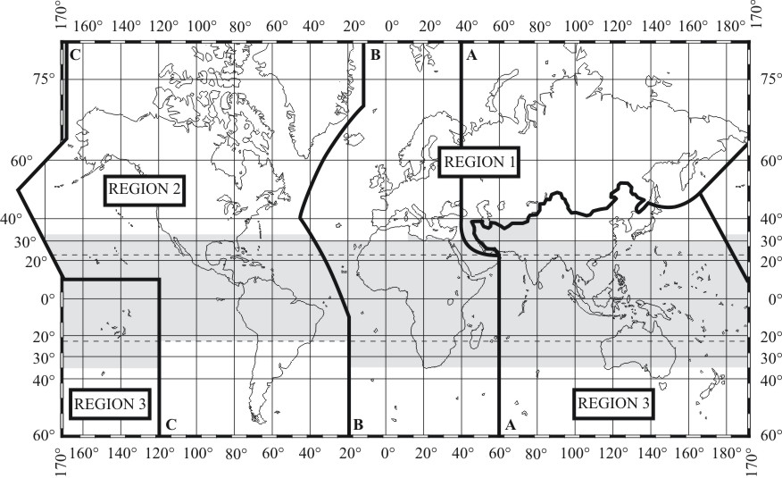.
Resolution 647 (WRC-07) advocated the development of spectrum management guidelines for use of radiocommunications in emergency and disaster relief as well as the identification and maintenance of available frequencies for use in the very early stages of humanitarian assistance intervention in the aftermath of disaster. ITU is developing a database for frequency management in disaster situations. Such a database in conjunction with the modern software defined radio will allow quick delivery of radio equipment, which will operate in accordance with the national regulations.
- Radiocommunication Assemblies request the ITU-R to study aspects of radiocommunications relevant to disaster mitigation and relief operations. RA-07 approved Resolutions ITU-R 53 and 55 that identifies areas that ITU-R Study Groups could address in their studies/activities and develop guidelines related to the management of radiocommunication systems in disaster prediction, detection, mitigation and relief. This is to be done collaboratively within and outside ITU to avoid duplication.
- All ITU-R Study Groups develop and regularly update ITU-R Recommendations, Reports, Handbooks providing the technical basis for development and use of a majority of radiocommunication services (amateur, broadcasting, satellite-broadcasting, Earth exploration-satellite, meteorological and meteorological-satellite, fixed and fixed-satellite, mobile and mobile-satellite, radiodetermination services, etc.) for early warning of the public of impending disasters, for planning and relief operations, and in emergency situations (see Box 7).

Box 7: Maritime mobile Access and Retrieval System (MARS)
This system has been developed by the International Telecommunication Union (see http://www.itu.int/ITU-R/terrestrial/mars/) with the purpose of providing the Maritime Community, in particular those entities that are involved in search and rescue activities, with the most up-to-date data registered in the ITU master Ship station database. Updated weekly and available on a 24-hour per day/7-day per week basis, this system contains characteristics of over 400 000 ship stations as well as the addresses and contact information of Accounting Authorities (AAICs) and Notifying Administrations.
- Much of the work undertaken within the ITU-R Study Group 5 “Terrestrial services” (former SG 8) has been in support of Radio Regulatory texts and procedures addressing distress and safety communications and many relevant provisions, derived from this work, now exist in Articles of the RR.

The Radiocommunication Sector cooperates with other ITU Sectors and contributes to ITU activities related to the use of ICT in combating the negative effects of climate change.

____________

Further details are provided at: http://www.wmo.int/pages/prog/www/OSY/GOS.html.
ITU Radio Regulations No. 1.182: active sensor: A measuring instrument in the earth exploration-satellite service or in the space research service by means of which information is obtained by transmission and reception of radio waves.
ITU Radio Regulations No. 1.183: passive sensor: A measuring instrument in the earth exploration-satellite service or in the space research service by means of which information is obtained by reception of radio waves of natural origin.
“Wired” telecommunication systems are also intensively used for the real-time data exchange and early warning.
ITU-R Recommendations are the de facto international voluntary standards recognized by international organizations, administrations, operators and companies. ITU-R Recommendations incorporated in the Radio Regulations have international treaty status.
SFCG objective is the effective use and management of those radio frequency bands that are allocated by the Radio Regulations to the Space Research, Space Operations, Earth Exploration Satellite, and Meteorological Satellite services.
ITU-Ts Study Group 16 develops the relevant H-Series of ITU-T Recommendations on multimedia.
The use of paperless document preparation and publication method at the last World Radiocommunication Conference 2007 (WRC-07), which was attended by more than 2800 participants, saved several millions of pages.
Wired telecommunication systems are also intensively used at this stage.

