Radiocommunication Advisory Group  Geneva, 24-26 January 2007 | 
 | Document RAG07-1/16-E
 | 19 January 2007
 | English only
Chairman, Working Party 8F
Information about and Statistics of Working Party 8F

1 Background
ITU-R is discussing the structure of Study Groups and other related matters. It may be useful for ITU-R to have accurate information at hand that is germane to these deliberations. This document provides a summary of certain aspects of Working Party 8F that are important to have as the dialog progresses within ITU-R.

2 WP 8F
Working Party 8F held its initial meeting in March 2000 and has held 20 meetings over the period of time from 2000 through 2006, which spans almost 2 study periods. Two further meetings will be held in 2007 to conclude the current study period, one in January (#21) and one in May (#22).
Working Party 8F has enjoyed a remarkable level of participation in its meetings with the Questions and scope of work assigned to WP 8F having significant relevance to ITU-R members and non-members around the world.
3 Relevance
In terms of relevance, WP 8F addresses a wireless user marketplace currently over 2.6 billion mobile users, many utilizing IMT-2000 technologies. IMT-2000 has attained a critical mass of sustainable growth with exponential network turn-on and subscriber uptake globally. This materially and measurably contributes to industry revenues.
As of December 2006, IMT-2000 was being used by over 450 million subscribers around the world with IMT-2000 subscribers doubling from January 2005 to December 2006 : As of January 19, 2007, IMT-2000 is deployed by 263 operators in 109 countries) offering a rich portfolio of voice, high speed data, internet access, video services (both mobile broadcast and one way/two way sharing & conferencing) and other specialized applications with an open and evolving portfolio being developed. Figures 1 through 4 provide some information in this regard.

Various industry analysts estimate in the next several years the number of mobile subscriptions could approach 4 billion users or around 50% of the world’s population. Within this timeframe, IMT-2000 and IMT-Advanced are anticipated to be almost 2 billion of those subscriptions.
Attendance in Working Party 8F encompasses regulatory and policy agencies from around the world, as well as the top tier network operators, infrastructure manufacturers, terminal suppliers, and other key representatives of the “wireless value chain” as shown in the Figure 5. ITU-R, through WP 8F, is a nucleus for the on-going evolution and development of this wireless industry, acting as the catalyst for the future for IMT-Advanced just as has transpired for IMT-2000. These operators, manufacturers and others represent a combined market valuation (capitalization) of an estimated 10 trillion equivalent US dollars. WP 8F is not a passive organization. Its stakeholders contribute inputs and actively participate in WP 8F meetings to pursue their views.
WP 8F enjoys close and on-going working relationships with the major standards development organizations (SDOs), partnership projects and technology development entities around the world, which further enhances the value of the ITU-R. Such relationships prove the point that the ITU-R can balance the role of members with that of experts (some of which are from organizations that are not permitted by their charters to become members of the ITU-R) having acknowledged competency through the utilization of Resolution ITU-R 9-2.
It is ONLY in the ITU-R and specifically in WP 8F that the confluence of the four pillars of the industry come together – the requirements of the users and the market place, the scarce/limited resource of the spectrum, the technology to utilize the spectrum efficiently and effectively and the overarching GLOBAL regulatory view.
4 Statistics
Furthermore, as can be seen from the accumulated statistics of these 20 meetings, there is a consistently high attendance level in WP 8F with an average of 226 delegates, 76 members (29 administrations represented, 47 sector/associate members), and over 100 input documents per meeting (1100 per study period). These levels of interest are not expected to decline and it is envisioned that as the process for specifying IMT-Advanced moves forward additional participation will be evidenced. See Table 1 and Figures 6-7.
Working Party 8F accomplishes this in approximately 17 meeting days per year over a study period which is on par with the number of meeting days of other Working Parties. Thus reducing the number of meetings of WP 8F would only contribute to longer meetings and not shorten the actual days in session. Furthermore, the rapid pace of the mobile industry addressing IMT-2000 and IMT-Advanced and the annual update cycle of the specifications in the external SDOs and Partnership projects requires an ongoing and timely interchange of information following the formal liaisons procedures of the ITU-R and those of the other organizations. Thus a one or two meeting per year mandate imposed on Working Party 8F as the norm would have a negative impact on the assigned responsibilities of WP 8F and reduce the value of ITU-R Working Party 8F to members and to industry.

WP 8F is invited by various administrations, along with supporting companies in those administrations, to hold meetings of WP 8F in their country. WP 8F looks towards a reasonable regional balance in the coordination of these venues, along with Geneva as the home base, in allocating meetings. This balance allows delegates from all regions to benefit from having at least some meetings close to their home countries as travel to Geneva can be lengthy and expensive from many regions of the world. If all meetings were to be convened in Geneva it would put some counties at a disadvantage for participating, or participating with as many delegates as they would like, or even preclude their attendance altogether.
In the current 17-25 January 2007 WP 8F meeting being held in Yaounde, Cameroon, the preliminary meeting statistics indicate that 15 African countries were registered with a total of 57 delegates. Many of these delegates have not previously had the opportunity to attend a WP 8F meeting, or indeed any meeting of the ITU-R. This phenomenon is not restricted to just developing countries and can be seen in other regionally located meetings. Also, it should be noted that hosting a meeting like Working Party 8F with a few hundred participants provides a major positive impact on the local economy. Thus “taking the meetings” to the ITU Regions has multiple benefits.
It should also be noted that scheduling WP 8F meetings in Geneva can be difficult, as it is often not possible to have additional Working Party meetings overlapping with WP 8F due to the size of the meeting.
The table below provides the distribution along with Figure 8.

 | Geneva | Region 1 | Region 2 | Region 3
Number of Meetings | 4 | 6 | 5 | 5
 | 20% | 30% | 25% | 25%
In accordance with the relevant provisions of Resolution 5 (Kyoto, 1994) of the ITU Convention, countries hosting meetings outside Geneva cover any “additional expenditures” incurred by the ITU, i.e. there is no net additional cost to the ITU when meetings are held outside Geneva.
Over the years, Working Party 8F has also developed and pioneered many initiatives in ITU-R, such as utilization of electronic working methods to eliminate paper expenditures, use of computer video projectors in all meetings and drafting sessions to improve work efficiency, use of correspondence groups, etc. This has translated into significant cost reductions (as reported by the WP to the Study Group and in reports issued by the BR).and allows for each meeting to more effectively accomplish its objectives. Many of these working methods have been subsequently adopted by other Working Parties.
5 Summary
Working Party 8F is a highly regarded Working Party with close linkages to a fast moving segment of the wireless industry that has a significant market presence, high capital investments and revenues, and direct ties with the technology development community and relevant regional and national standards bodies.
Working Party 8F contributes significantly to the stature and mission of the ITU, furthering it as a relevant global organization that plays a critical role is regarded as the leader in these global developments in accordance with the 2004-2007 Strategic Plan In short, WP 8F ensures the ITU is a key ”player” in the game.
Working Party 8F is at parity with other Working Parties in ITU-R with regard to meeting days, support costs and other such factors. Furthermore, WP 8F is continuing to pioneer improvements in working methods to reduce expenses to the ITU-R while maintaining its high level of performance.
Working Party 8F continues to be relevant and, with the developments towards IMT-Advanced which are under way, these activities will and should continue through the next study period.
As a global unifying and driving force, the members of the ITU-R and the users of ITU-R Recommendations and Reports have come to expect the ITU-R to have a leadership role in these activities. Significant changes to the structure or responsibilities of Working Party 8F could materially and adversely affect the terrestrial mobile industry as a whole. Moreover, combining Working Party 8F with another Working Party is also not feasible due to the heavy workload facing Working Party 8F participants at every meeting. Therefore, Working Party 8F should remain intact and its current mandate should continue unchanged and even be reinforced.

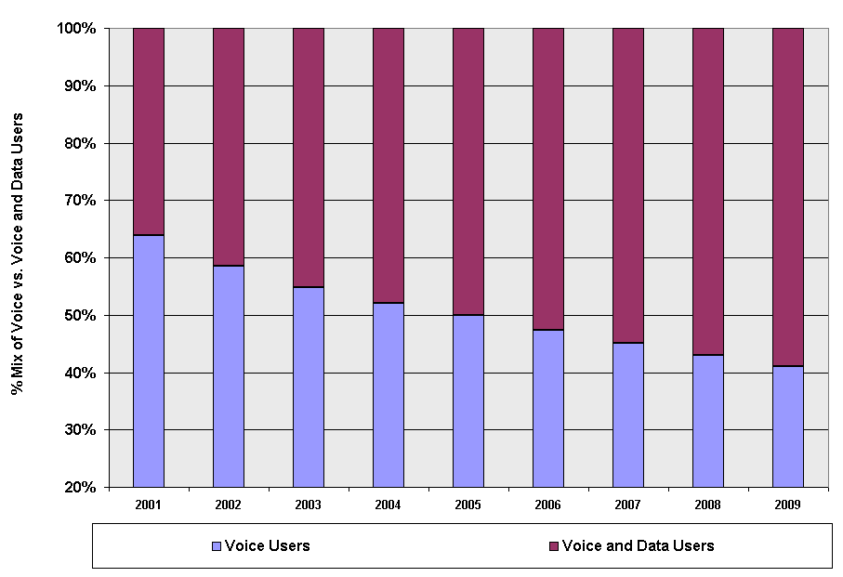
50% of all global wireless customers use data and voice
Source: Yankee Group
Figure 1 - 50% of all global wireless customers use data and voice
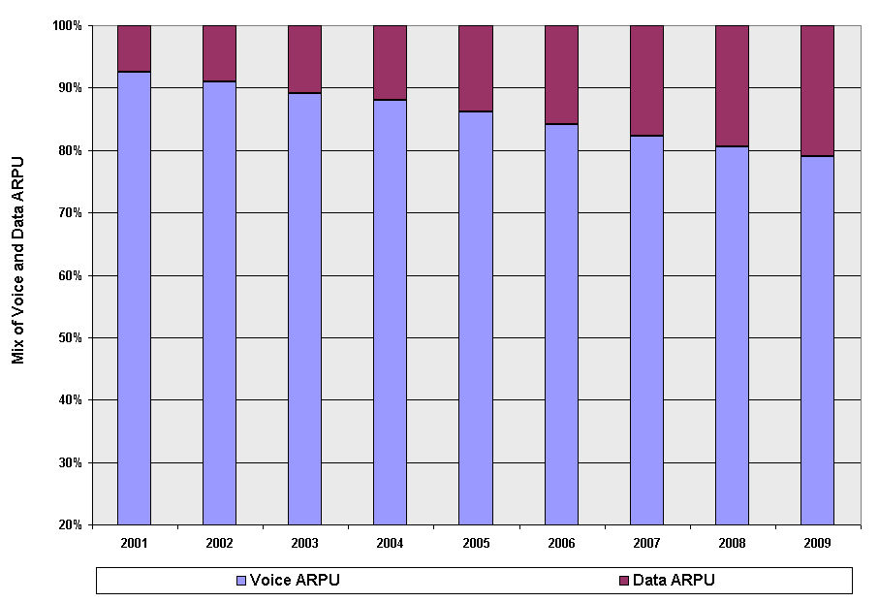
15+% of total global ARPU now comes from data
Roughly double the level of the U.S.
Source: Yankee Group
Figure 2 - 15+% of total global ARPU (average revenue per user)
now comes from data applications

Figure 3 - In 2006, IMT-2000 handset sales in Europe will double to 40%;
By 2009, nearly every handset sold will be IMT-2000

Source: Forrester Research
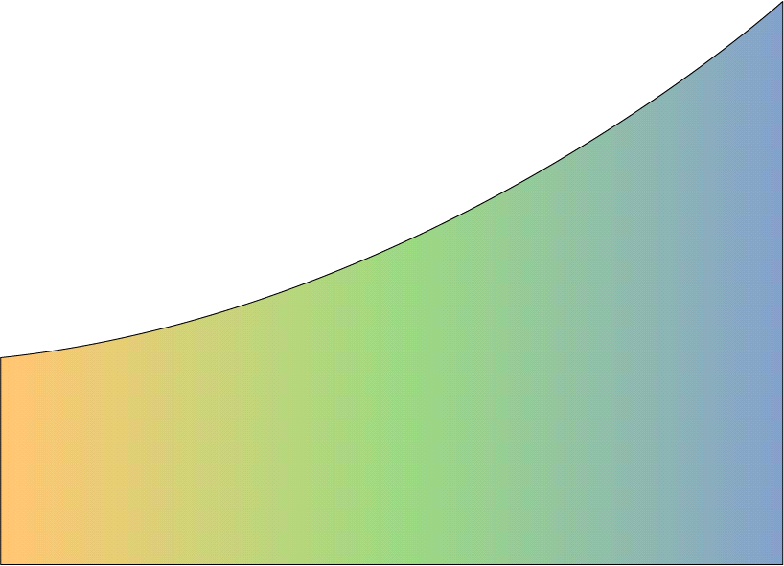
Figure 4 - 3G
expands the variety and utility of all services

Text E
-
Mail
E
-
Mail with Attachments
SMS
Micro
-
Browsing
(Text)
Picture Messaging
Full Web Browsing
MP3 Download
Intranet Access
Optimized
Vertical Applications
Video E
-
Mail
E
-
Mail with
Large Attachments
Micro
-
Browsing
(Color & Graphics)
Audio Messaging
See What I See
Video Telephony
Large File Transfer
2G
3G
2.5G
Interactive Gaming
•
Makes what
is
already
offered
better
•
Expands
customer
product set into completely new
areas
Video Clips
IMT
-
ADVANCED
4G
Table 1
Summary Information for Working Party 8F Meetings 1-20 (2000-2006)

Meeting | Start Date | Days | Venue | Delegates | Member States | Sector & Associates | Inputs
1 | 7-Mar-00 | 5 | Geneva | 158 | 26 | 23 | 30
2 | 21-Aug-00 | 6 | USA | 197 | 27 | 39 | 68
3 | 23-Oct-00 | 6 | Geneva | 244 | 46 | 24 | 109
4 | 21-Feb-01 | 6 | Morocco | 254 | 31 | 43 | 90
5 | 27-Jun-01 | 6 | Sweden | 253 | 34 | 54 | 108
6 | 10-Oct-01 | 6 | Tokyo | 253 | 34 | 54 | 113
7 | 22-Feb-02 | 6 | New Zealand | 206 | 26 | 43 | 133
8 | 5-May-02 | 6 | Canada | 206 | 32 | 49 | 117
9 | 25-Sep-02 | 6 | Geneva | 221 | 31 | 45 | 117
10 | 26-Mar-03 | 7 | Brazil | 184 | 22 | 40 | 98
11 | 8-Oct-03 | 7 | Scotland | 187 | 23 | 57 | 86
12 | 18-Feb-04 | 6 | Korea | 213 | 23 | 57 | 133
13 | 16-Jun-04 | 6 | Germany | 197 | 23 | 57 | 72
14 | 12-Oct-04 | 6 | China | 220 | 25 | 57 | 79
15 | 1-Feb-05 | 6 | Geneva | 216 | 30 | 36 | 77
16 | 8-Jun-05 | 6 | Canada | 227 | 25 | 53 | 167
17 | 12-Oct-05 | 6 | Finland | 242 | 29 | 47 | 112
18 | 25-Jan-06 | 6 | Thailand | 282 | 36 | 51 | 101
19 | 3-May-06 | 6 | France | 261 | 35 | 56 | 101
20 | 23-Aug-06 | 6 | USA | 300 | 31 | 62 | 139
 |  |  | Average | 226 | 29 | 47 | 103

21 | 17-Jan-07 | 7 | Cameroon | 236 | 37 | 58 | 113

Figure 6 - Working Party 8F Statistics by Meeting, for Meetings #1-20 (2000-2006)
0
50
100
150
200
250
300
350
Geneva
USA
Geneva
Morocco
Sweden
Tokyo
New Zealand
Canada
Geneva
Brazil
Scotland
Korea
Germany
China
Geneva
Canada
Finland
Thailand
France
USA
Location
Delegates
Member States
Sector & Associates
Inputs
Figure 7 - WP 8F Annual Average Statistics Over Meetings #1-20 (2000-2006)
0
50
100
150
200
250
300
2000
2001
2002
2003
2004
2005
2006
Delegates
Member States
Sector & Associates
Inputs
Figure 8 - Distribution of WP 8F Meetings #1-20 (2000-2006)
Geneva
4
20%
Region 1
6
30%
Region 2
5
25%
Region 3
5
25%
Geneva
Region 1
Region 2
Region 3

http://www.3gtoday.com
This is the interactive process: create a liaison at a meeting of WP 8F, send to other Working Party or external organization, wait for them to meet and craft a reply liaison, receive reply at next meeting as input document, and so on and so forth. Having a three meeting cycle at roughly a 16 week interval between WP 8F meetings has been proven over the years to interleave well and effectively with the meeting schedules of these other organizations.
See the 2004-2007 Strategic Plan (http://www.itu.int/aboutitu/strategic_plans/04-07/goals.html) which states: A continuing challenge facing the Union in the 2003-2007 time-frame is to remain a pre-eminent intergovernmental organization where Member States, Sector Members and Associates work together to enable the growth and sustained development of telecommunications and information networks, and to facilitate universal access so that people everywhere can participate in, and benefit from, the global information economy and society - thus advancing the "right to communicate".

