 | INTERNATIONAL TELECOMMUNICATION UNION
 | RADIOCOMMUNICATION  ADVISORY GROUP  GENEVA, 31 OCTOBER - 4 NOVEMBER 2005 | Document RAG05-1/19-E
 |  | 31 October 2005
 |  | English only
Chairman, Council Working Group for the Elaboration of the Draft Strategic Plan and the Draft Financial Plan 2008-2011
REQUEST FOR INPUT FROM SECTOR ADVISORY GROUPS AND THE GENERAL SECRETARIAT FOR THE ELABORATION OF THE DRAFT STRATEGIC PLAN 2008-2011

With a view to elaborating the 2008-2011 Strategic Plan of the ITU, the Council Working Group requests each Sector Advisory Group and the General Secretariat to:
- Review the sections in the 2004-2007 Strategic Plan pertinent to their activities (i.e. Parts II and III of the Annex to Resolution 71) in order to determine their continued relevance;
- Following this review, propose a limited number of objectives (approx. 5) and a short mission statement, for input to the 2008-2011 Strategic Plan;
- Illustrate the link between these objectives and the Union’s outputs as defined in the Results Based Budgeting (RBB) Framework (see Annex A), and as set out in the example below:
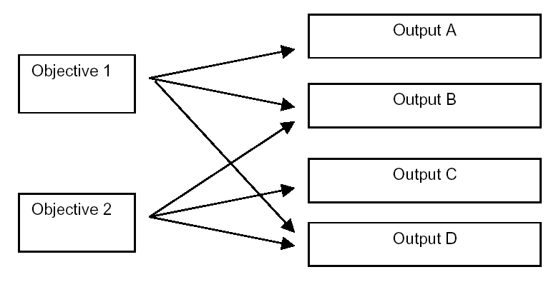

- Identify 4 to 5 outputs that of are of particularly high priority (with the exception of intersectoral outputs).
In addition, the Working Group solicits comments on the relevance of the strategic orientations and goals of the 2004-2007 Strategic Plan (Part I of the Annex to Resolution 71).
The Working Group will next meet in Geneva from 30-31 January 2006, and requests that the above input be made available by 16 January 2006 to be posted on the strategic plan website for discussion at the January meeting.

Annex: 1
ANNEX A
List of current ITU outputs as defined within the
Results Based Budgeting (RBB) framework

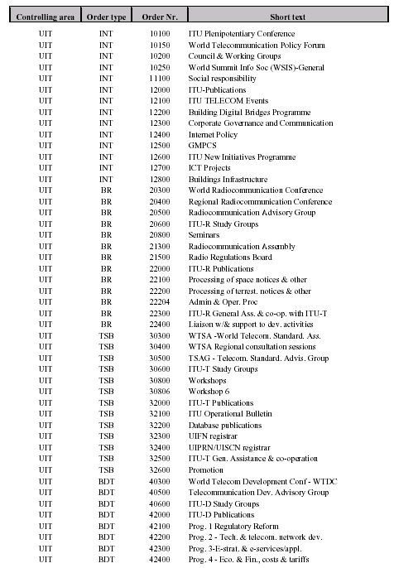

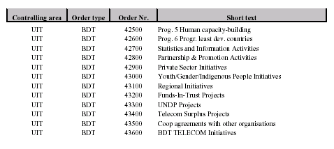

__________________

In Annex 4 of the Draft Budget of The Union for 2006-2007, outputs are defined as Sector or inter-sectoral products or services representing the deliverables of a programme.
See www.itu.int/strategicplan/

