 | INTERNATIONAL TELECOMMUNICATION UNION
 | RADIOCOMMUNICATION  ADVISORY GROUP  GENEVA, 31 OCTOBER – 4 NOVEMBER 2005 | Document RAG05-1/2-E
 |  | 23 September 2005
 |  | Original: English only
Chairman, ITU-D Study Group 2
LIAISON STATEMENT
Spectrum Management System for Developing Countries (SMS4DC)

In the context of:
- Resolution 7 (Rev. WRC-03)
- Resolution ITU-R 11 (RA-03)
- Recommendation ITU-R SM.1604
- Recommendation ITU-R SM.1370-1
ITU-D Study Group 2 wishes to inform the Radiocommunication Advisory Group of the progress in developing a Spectrum Management System for Developing Countries (SMS4DC).
Attached is the progress report and related information (screen shots etc.) which were presented to ITU-D Study Group 2 at its last meeting.
Complete information will be sent to the Radiocommunication Advisory Group for its meeting in 2006, after delivery of the final version of the software for SMS4DC.

Attachment: 1

Attachment (Source: Document 2/281 of 12 August 2005)

PROGRESS REPORT ON THE DEVELOPMENT OF A
SPECTRUM MANAGEMENT SYSTEM FOR DEVELOPING COUNTRIES

Abstract:
This report describes the activities undertaken so far for an ITU Spectrum Management System for Developing Countries (SMS4DC)
One of the tasks given to the Joint Group between ITU-R and ITU-D dealing with Resolution 9 is the responsibility for assisting, monitoring and reporting on the progress of the development of a spectrum management system intended to meet the basic requirements of those least developed countries that are not in a position to acquire a commercially available system.
Some years ago, the ITU-R and the ITU-D had developed, jointly, a Basic Automated Spectrum Management System (BASMS), including a version for the Windows© Operating System (WinBASMS). The system requirements are described in Recommendation ITU-R SM.1048 and the software has been available from the BDT since 1997, free of charge to developing countries. In order to assist administrations to prepare invitations to tender for more complex systems (i.e. commercially available systems), ITU-R has approved Recommendation ITU-R SM.1370-1: “Design Guidelines for an Advanced Automated Spectrum Management System (AASMS)”.
Through operational use, several limitations with the WinBASMS software have been identified; therefore a requirement to provide an enhanced spectrum management system (SMS) was included in Programme 2 of the WTDC-02 (Istanbul) Action Plan. As mentioned above, the responsibility for this aspect of Programme 2 was given to the ITU-R and ITU-D Joint Group dealing with WTDC-02 Resolution 9. Within the framework of that group, a detailed specification for a SMS to meet the objectives of IAP Programme 2 was finalized early in 2005. It combines elements of Recommendation ITU-R SM.1048 with some of the elements from ITU-R SM.1370-1.
Following the completion of the specification, the software has been developed and an action plan for the provisional and final acceptance testing was agreed during August 2005.
The BDT has proposed a short description of the system functionalities and features for presentation during the ITU-D SG 2 meeting in September (Resolution 9 session).
It is noted that ITU-R has been effectively collaborating with ITU-D in the implementation of these activities within the thrust of WTDC-02 Resolution 9 "invites the Director, BR".

Annex 1: Action Plan for final acceptance testing and delivery of the software.
Annex 2: Brief description of SMS4DC
Annex I : Action Plan (rev.1) for development of SMS4DC
Milestone  Activities | March  2005 | April | May | June | July | August | Sept. | October | Nov. | Dec. | Jan.  2006 | Feb.  2006
Design Review Meeting | 14-16
Provisional test for terrestrial segment of SMS4DC  (annexes II & III) ¹ |  |  |  |  |  | 9-11
Performing Beta test for terrestrial segment + design review meeting / provisional test for Space segment Annex 7)² + delivery of user manual & training material in English. |  |  |  |  |  |  |  | 24-28
Trial test of SMS4DC (country case study) in Guinea

Final Acceptance Test for Terrestrial & possibly final test for Space segment)
Delivery of completed, SMS4DC in English + user manual & training material in French.
¹ Provisional test for items listed in Annex II & III.
² Software developers would try to make the space segment ready for provisional acceptance test.
Note: French version of SMS4DC will be ready before WTDC-06 and the other 4 languages if required by the end of 2006.
Annex 2
Brief description of ITU Spectrum Management System for Developing Countries (SMS4DC)

Introduction
The Spectrum Management System for Developing Countries (SMS4DC) has been developed in accordance with technical specifications prepared by ITU-R and ITU-D joint group dealing with WTDC-02 Resolution 9.
SMS4DC is a multi-functional and multi-lingual computer program that covers the following three main functions:
- Administrative Function that include:
  - A relational database management system
  - Recording frequency application, frequency assignment, licensing, coordination data, import data from BRIFIC & WinBASMS, producing electronic notices and spectrum fee,
  - Security features, including Multi level security, which enables system administrator to define users and groups with different access levels.
- Engineering Analysis Function
  - Enhanced analysis tools for frequency assignment and Interference calculation including:
  - Propagation modeles based on ITU-R latest recommendations available at the time of development namely P.1546, P.370, P.530, P.452, P.526 and Extended HATA models for various service types,
  - Calculation of coverage area, Calculation of field strength, Calculation of field strength contour, Microwave link calculations, Availability calculation in microwave link, Calculation of network coverage and Calculation of best server.
- Develop Geographic Map Display Function which include:
Detailed map displays, using IDWM, a 30 arcsec terrain database and operational models which include:
- User friendly interface, Displaying of Digital Terrain Model, Capability of importing standard mapping formats including Globe map and Displaying of geographical maps,
- Online latitude, longitude and altitude presentation, Overlaying of area calculation results, Capability of handling vectors, Scrolling, Zooming in/out functionality, Possibility to change color map,
- Providing of multiple entry of functions including icons on toolbar as well as menu items, Assigning new stations on map and Searching and displaying a station or group of stations on map.

SMS4DC

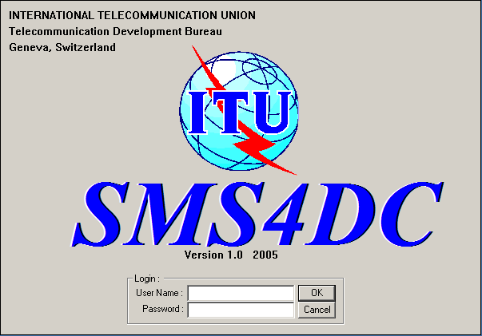

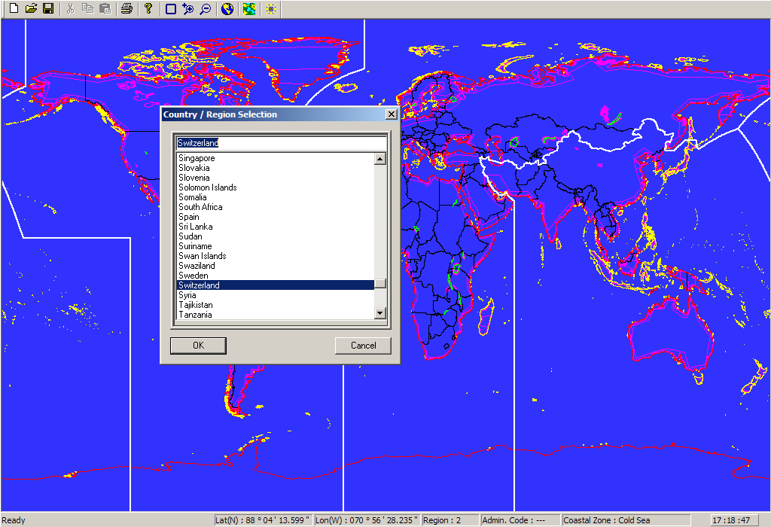

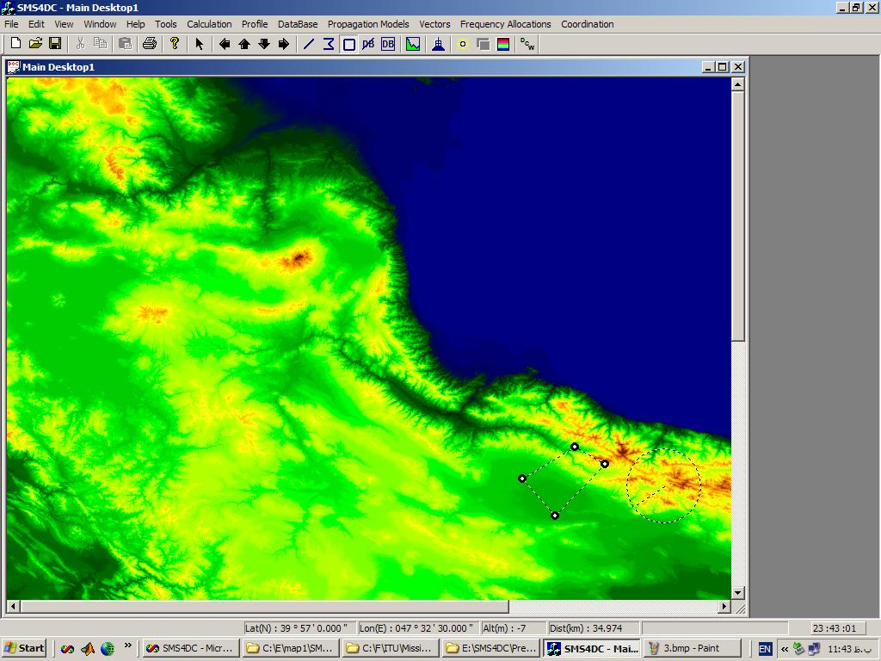
Tools-Licensing

Administrative functions
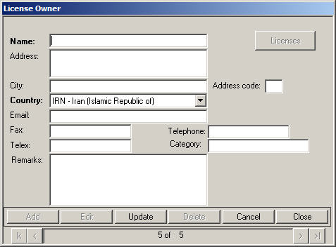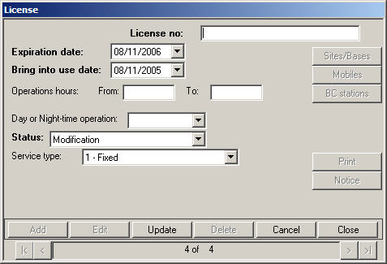
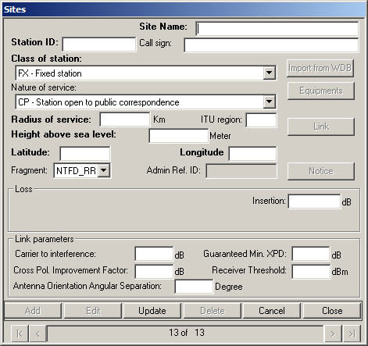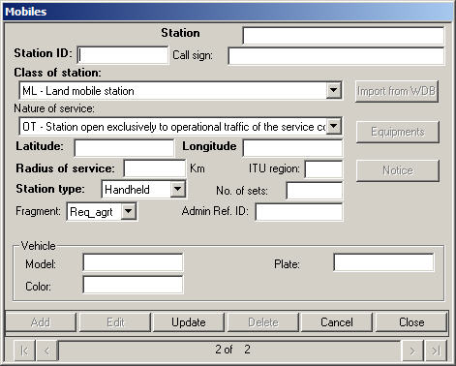
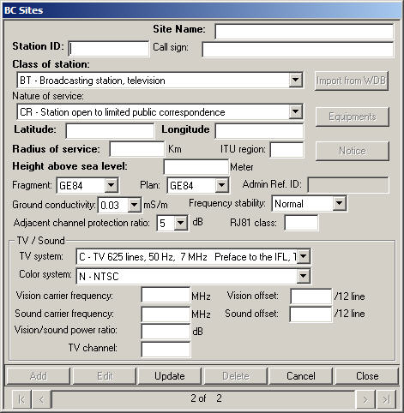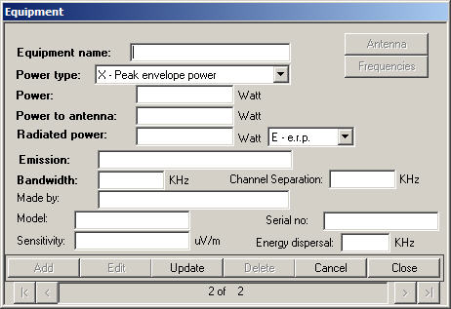

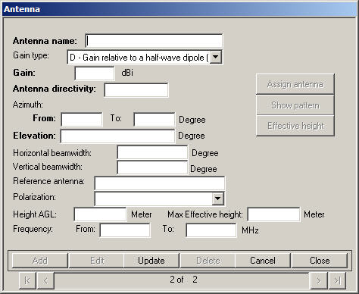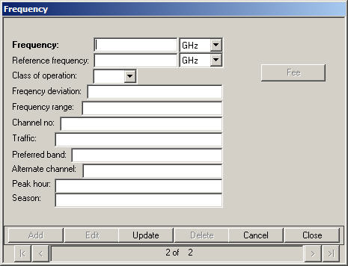

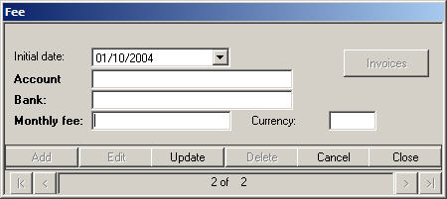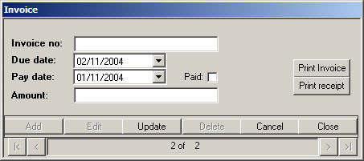

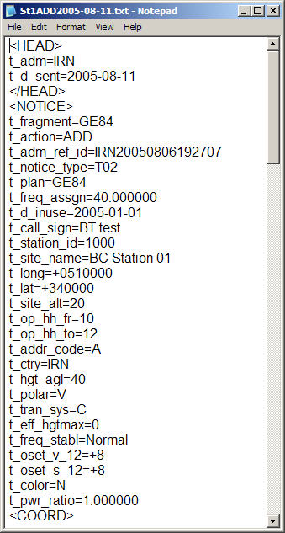
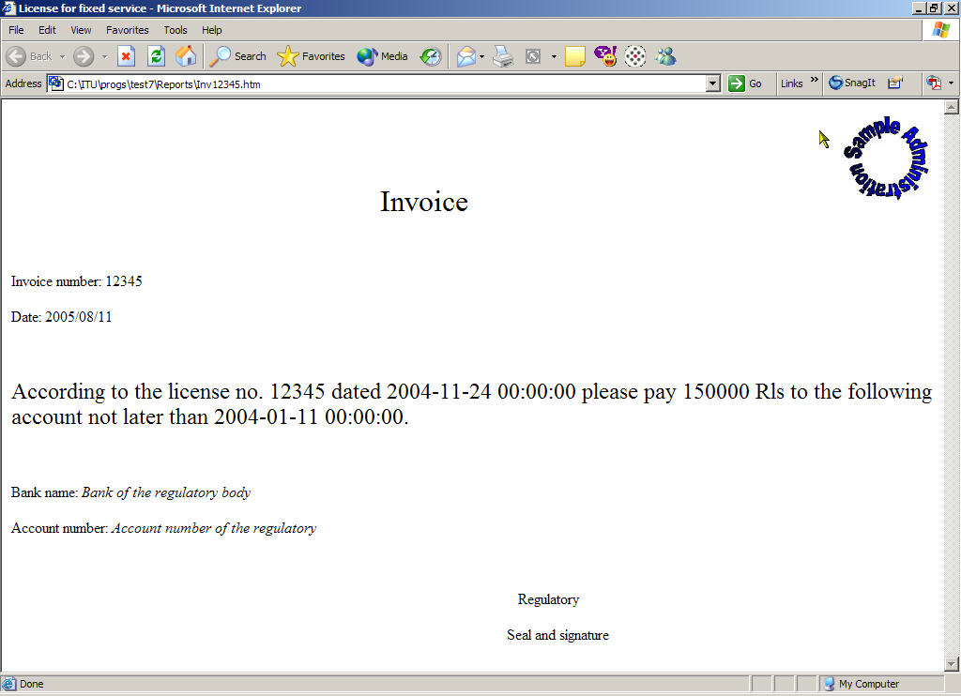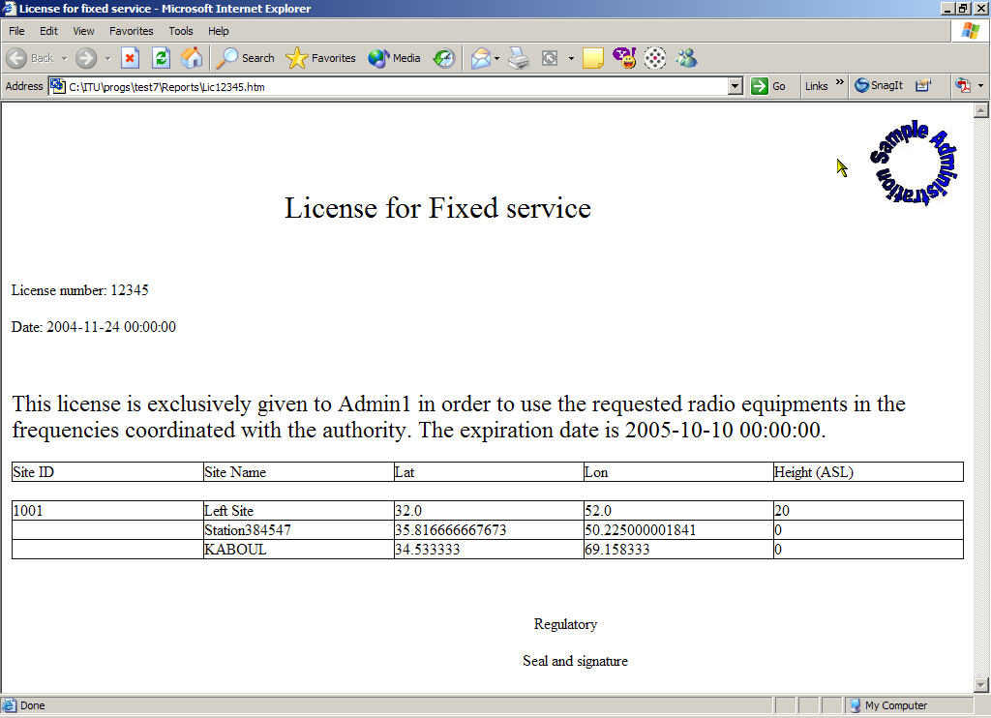

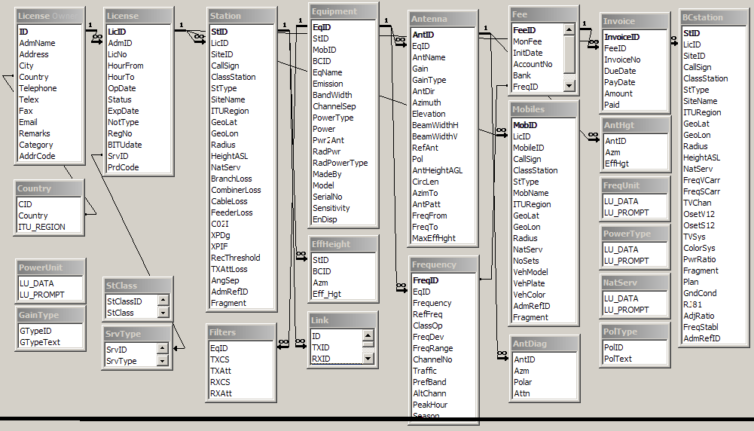
Data structure data flow diagram
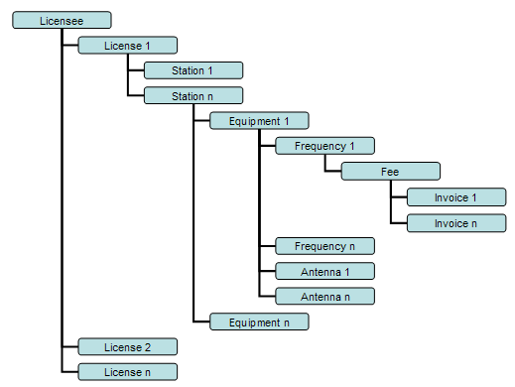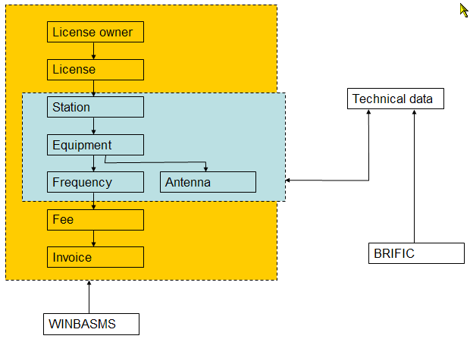

International & National frequency allocations table (chart)
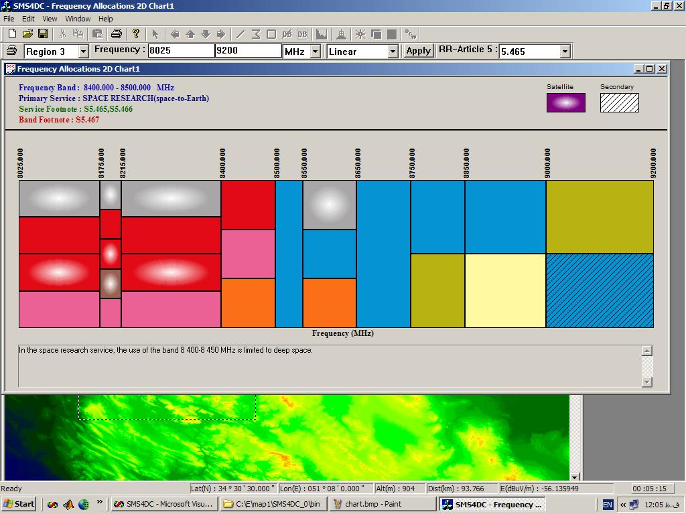

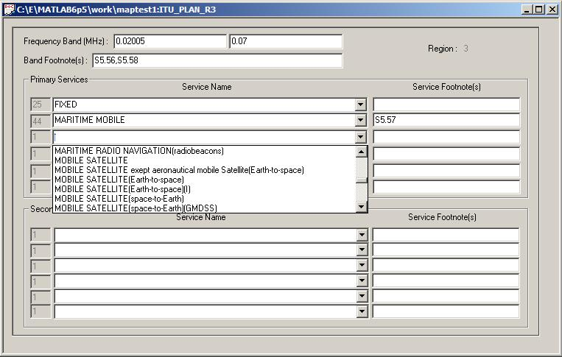
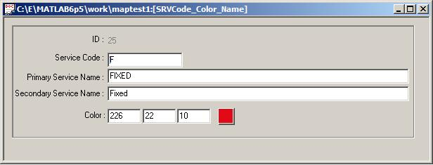

Geographical Information System (GIS) functions
Topographical map of a selected area (Globe30), relevant 3D view and vector overload
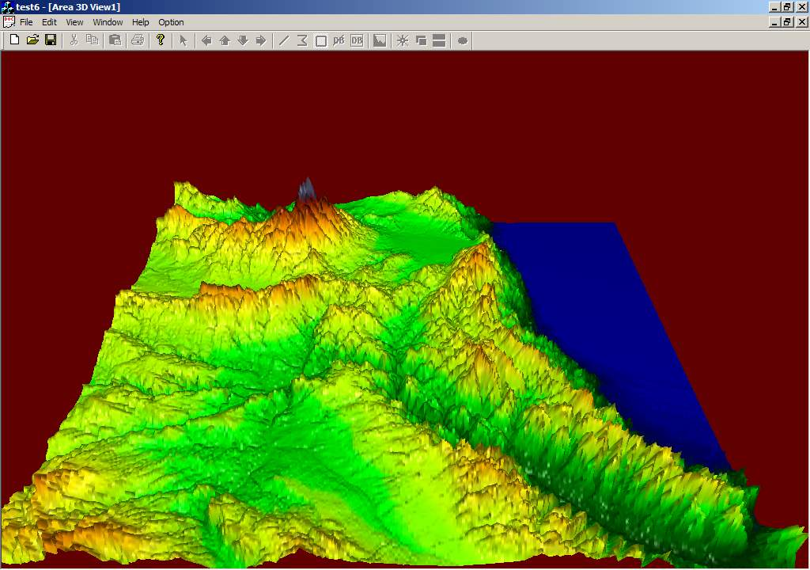
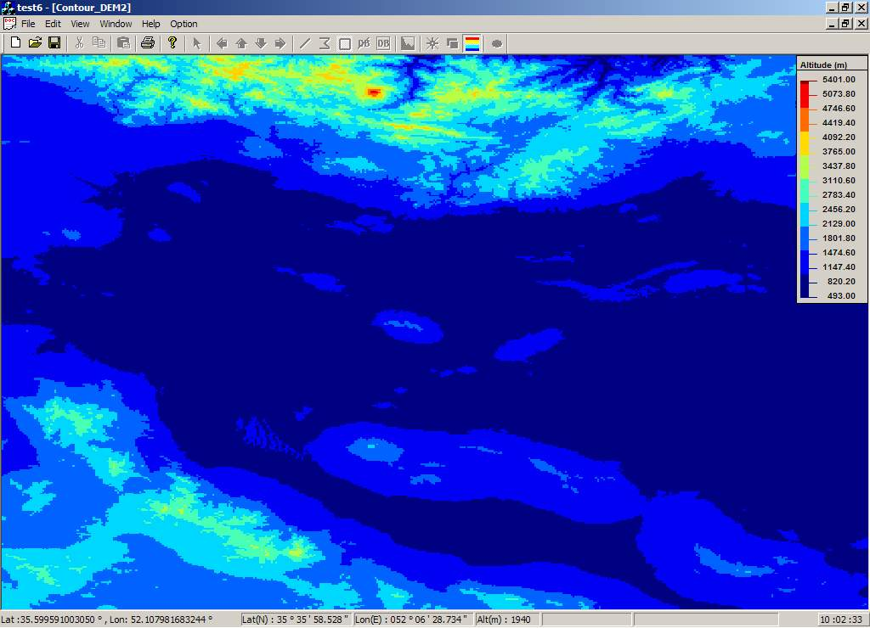
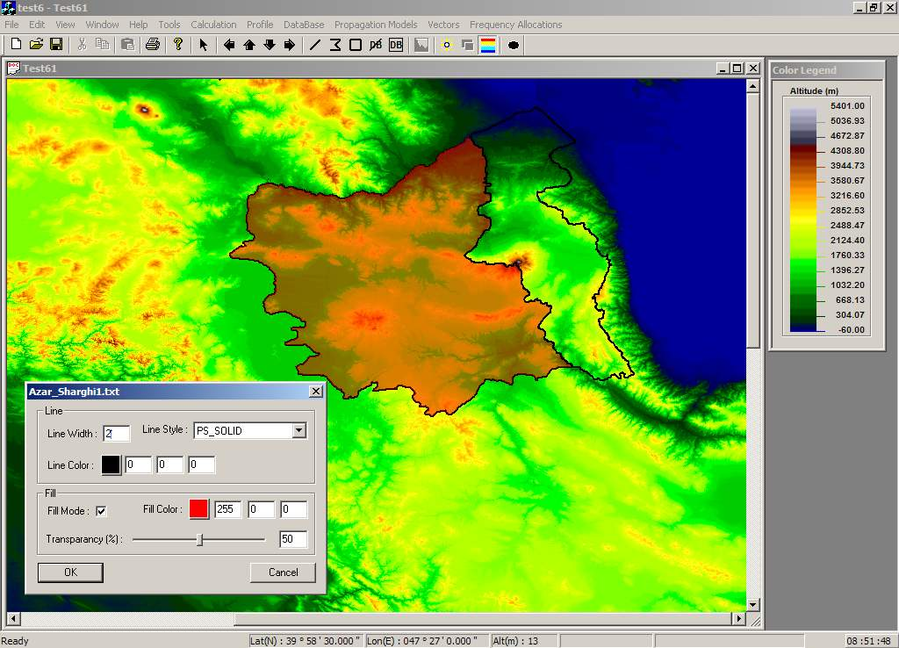

3D view of city map with one-meter resolution

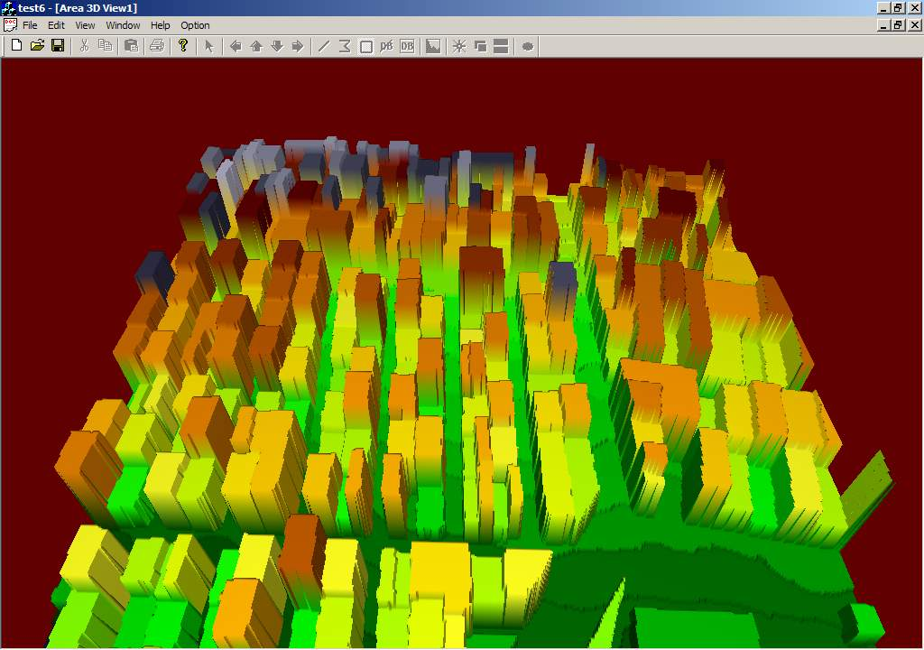
Engineering functions
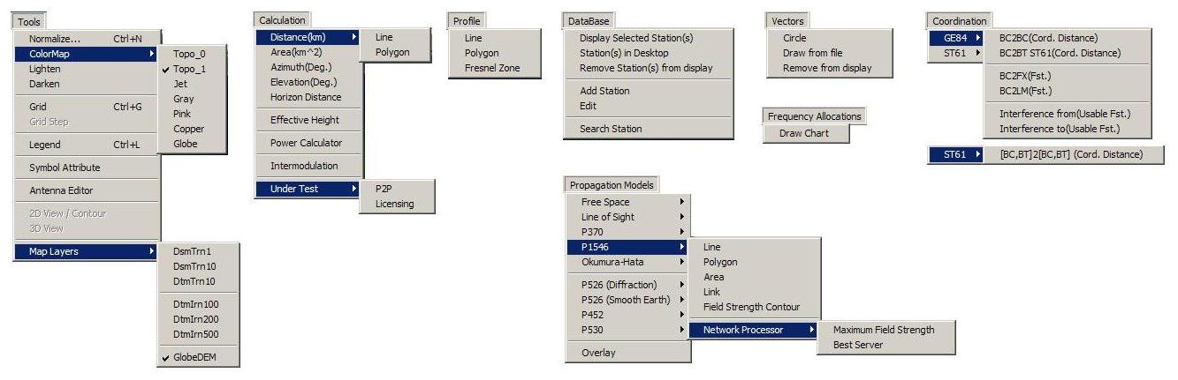

Antenna tools:

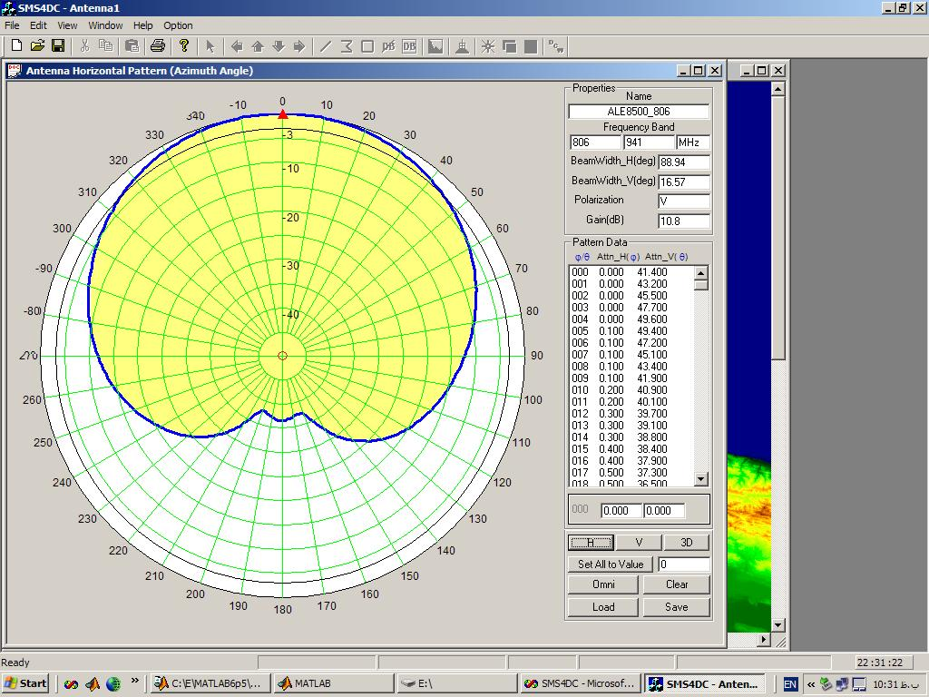
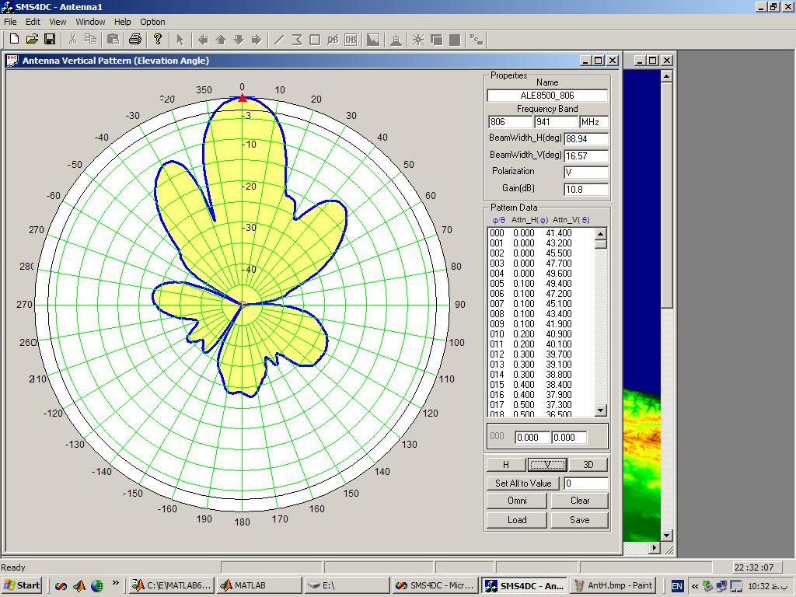
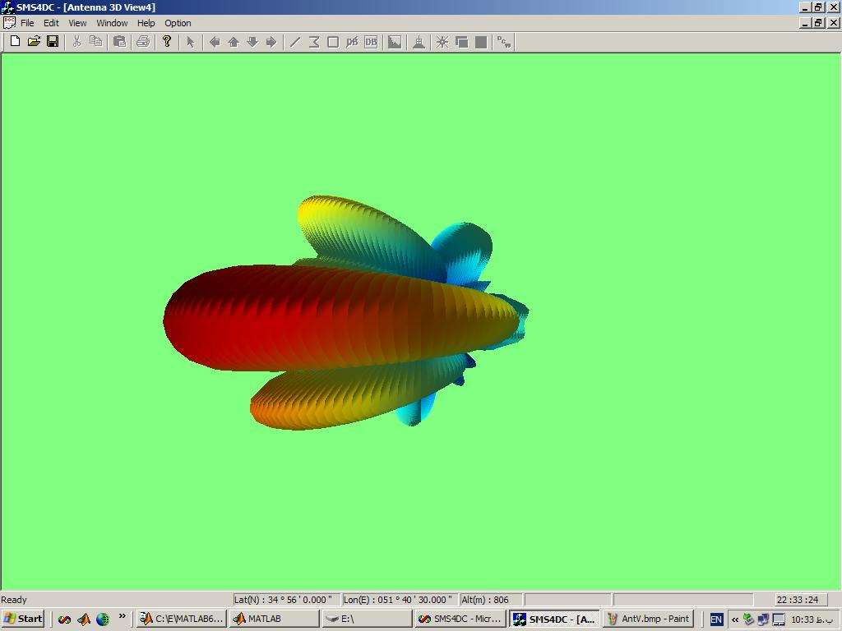

The SMS4DC is able to:
- Import antenna pattern & its characteristic from antenna library;
- Modify the existing antennas in the library for generation of new patterns;
- Completely generate a new antenna pattern

Effective height of antenna calculation
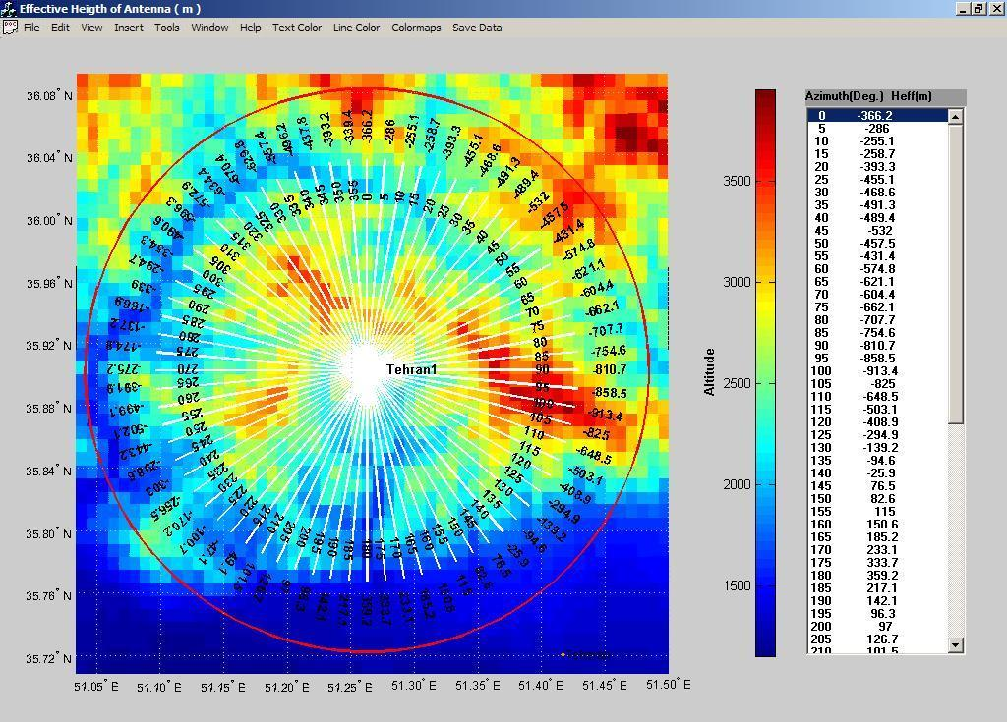

Effective height of an antenna can be calculated based on ITU-R Recommendations P.1546 or P.370. This parameter is needed for Field strength calculations in point to area services (i.e. Broadcasting, land-mobile…).

Propagation model parameter modification prior to calculation
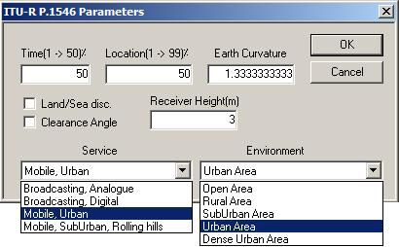
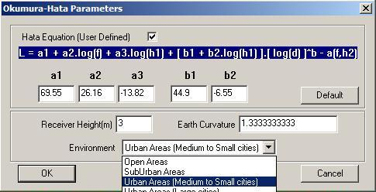

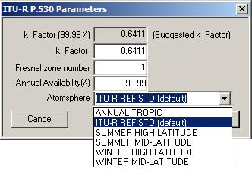

Field Strength along a line
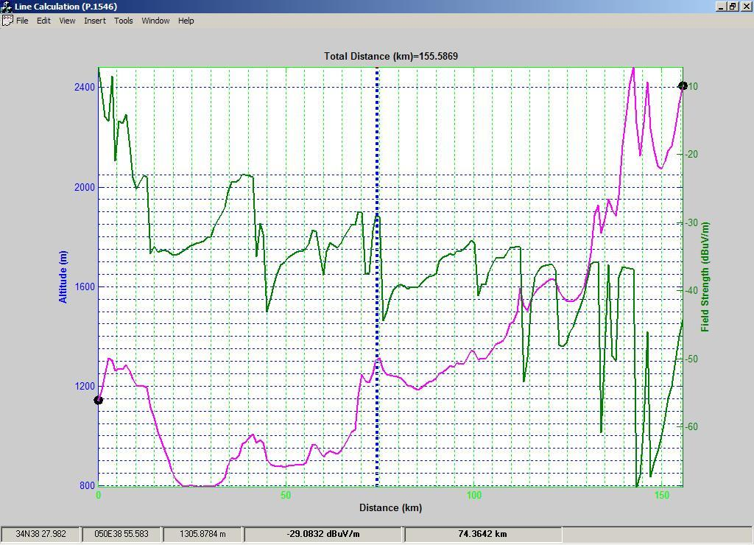

Field strength calculation in an area

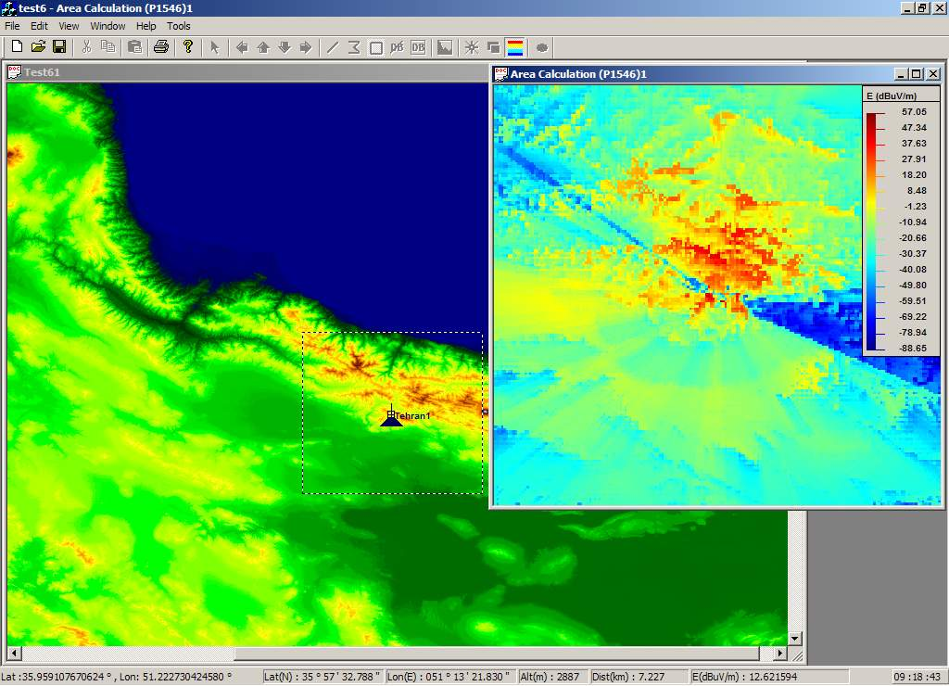
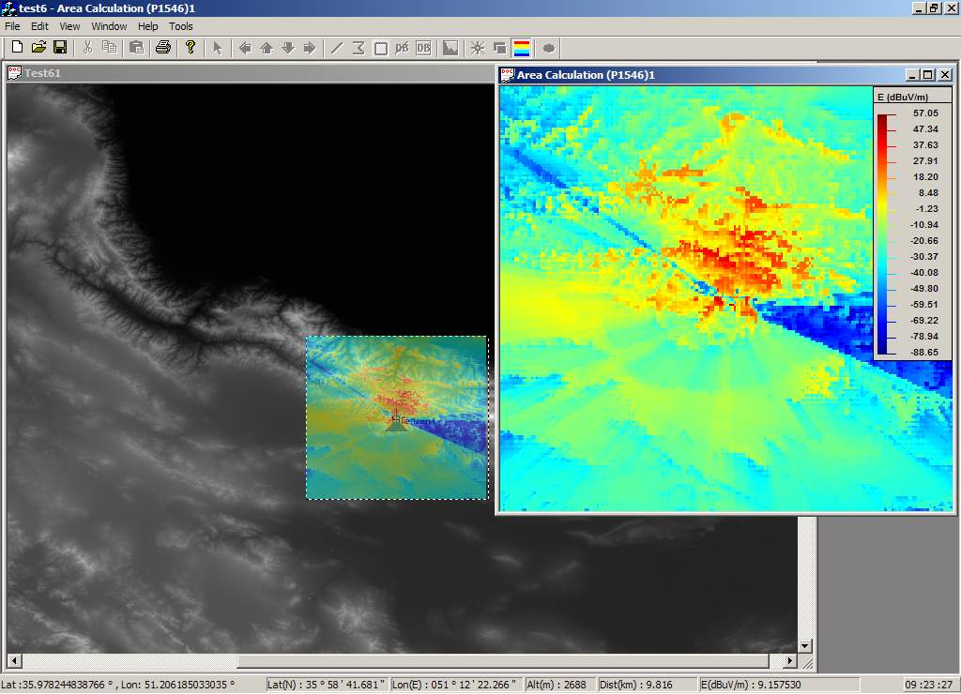

Contour & coverage area calculations
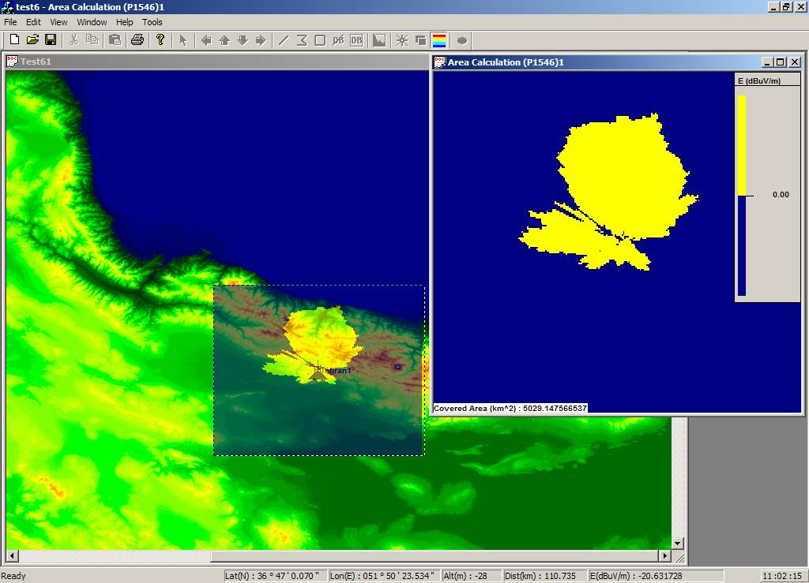
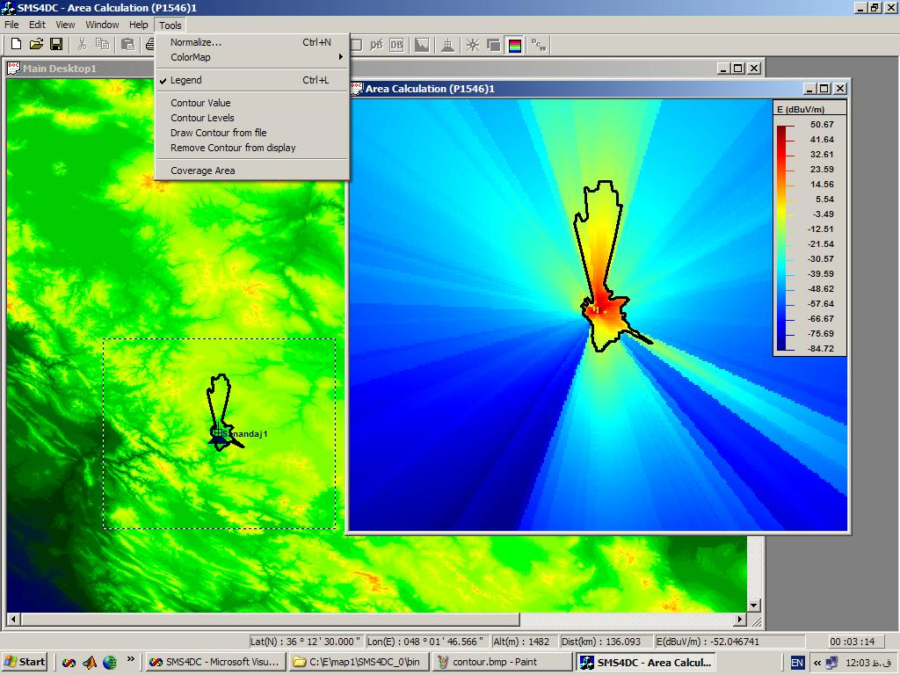

Microwave link calculation
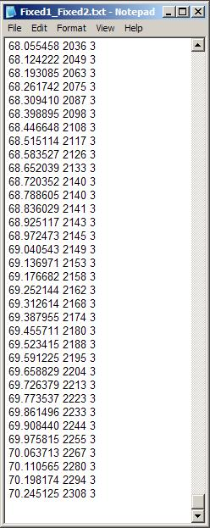
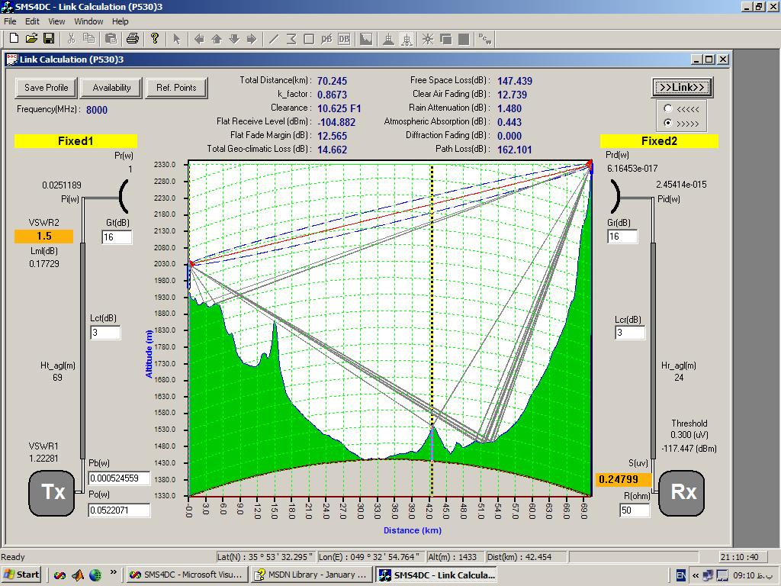

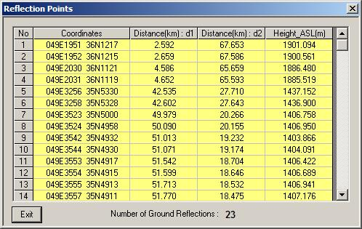
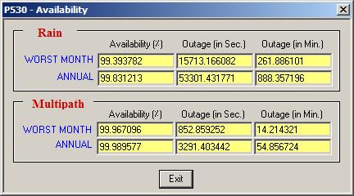

Link-budget and availability (outage) analysis implemented in accordance to the P.530-10 calculation method. Several link parameters have been put on active edit boxes for trial by user to obtain favorite result. The height of antennas can be changed by mouse for visual optimization of microwave link, for example removing of reflection paths and increasing of path-clearance. Reflection points and profile data are exportable in simple text files. Interference analysis options are also available for a microwave link.
Network Analysis (Maximum field strength & best server)
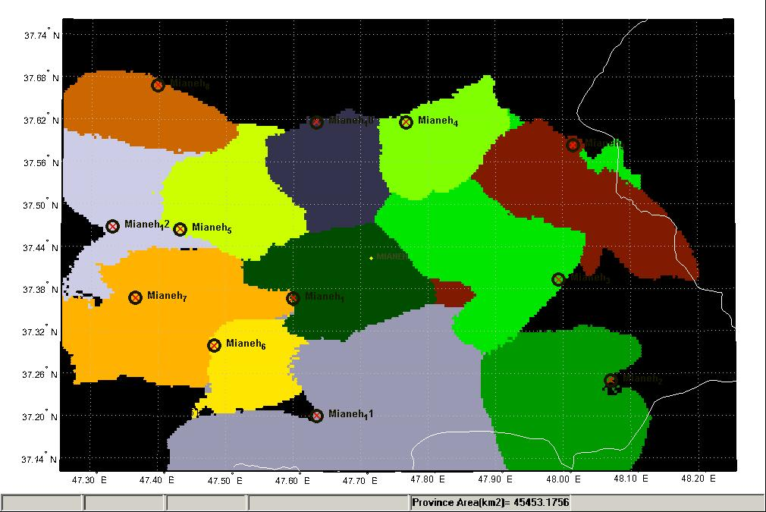
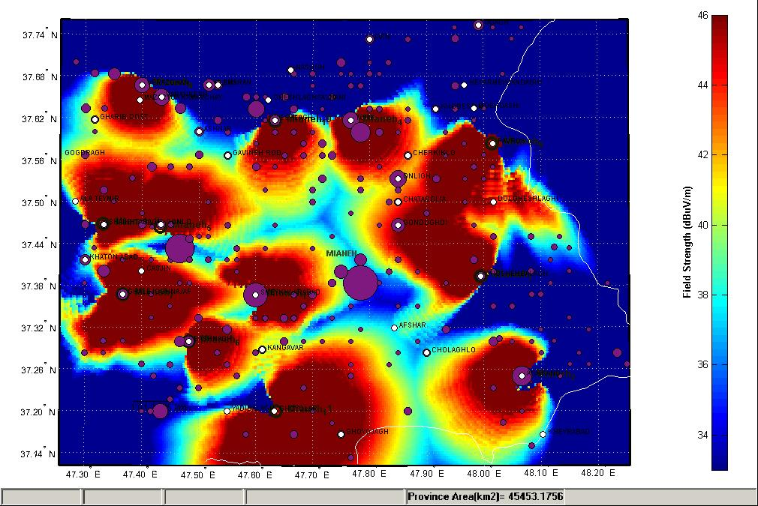

Coverage areas obtained through individual calculation for each station could be combined to figure out overall radio coverage of a multi-station network. Furthermore, by analysis of network radio coverage area, users are able to distinguish the best serving station for each point inside the network service area. Above Figure displays sample analysis result for a WLL (wireless local loop) network built up from 12 BTSs (base station transceivers).
Report of coordination distance in HTML format for a broadcasting station
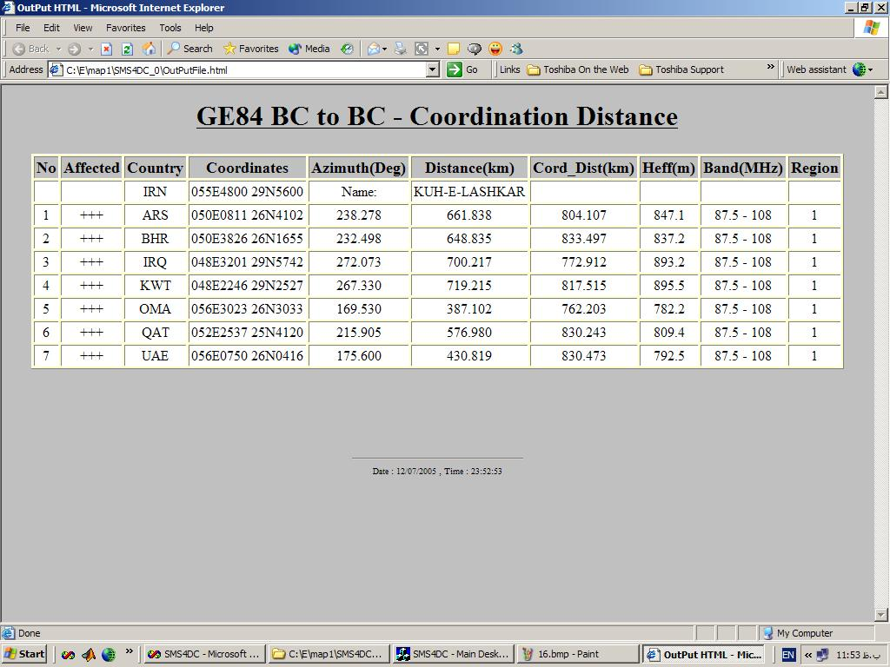
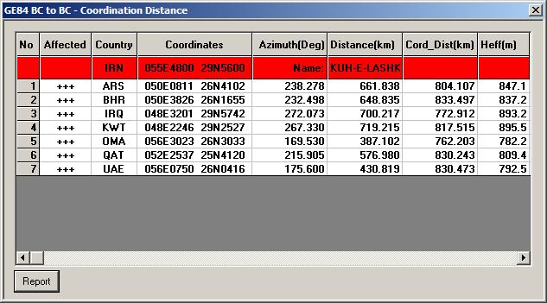

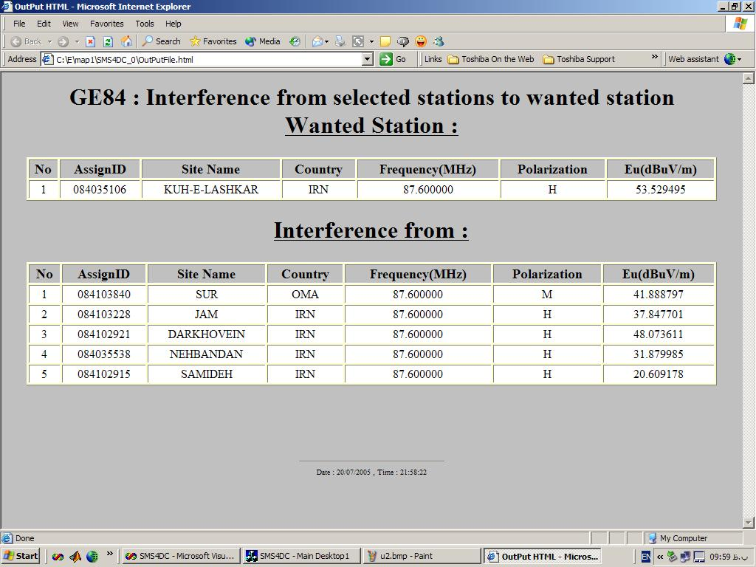
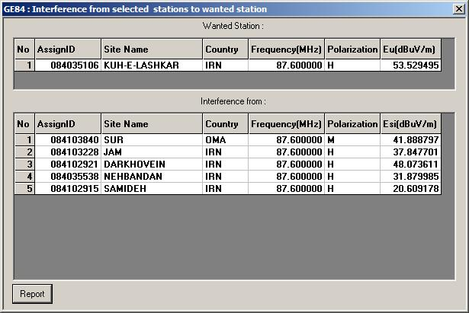

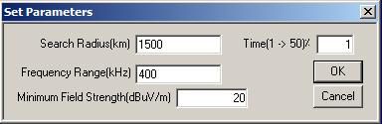

Capability for Inter-modulation calculation

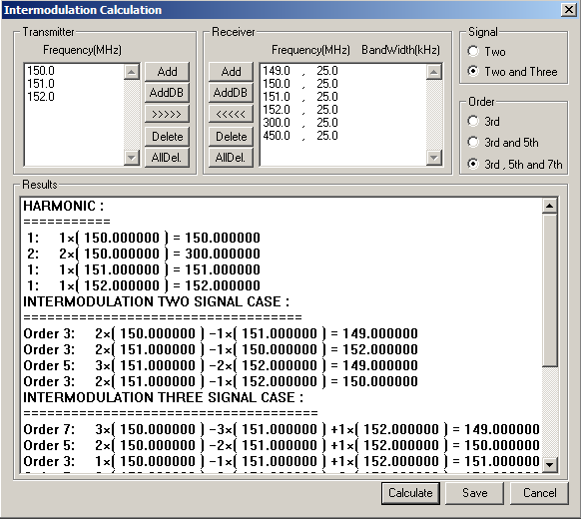
Frequency arrangement
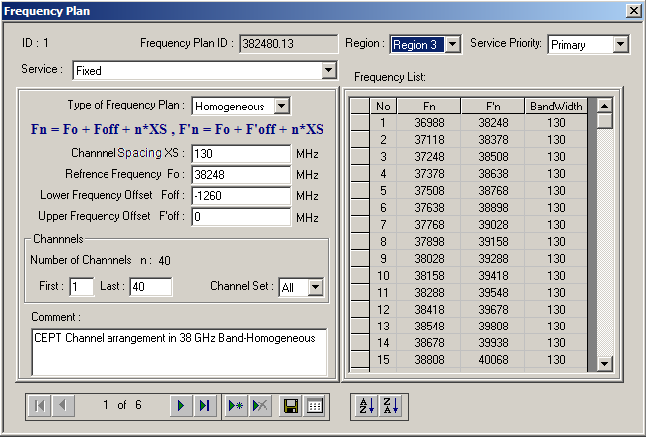

Frequency arrangement module covers three types of arrangements i.e. Homogeneous, Uniform, Non-uniform channel arrangement).
Radio horizon calculator and technical units converter

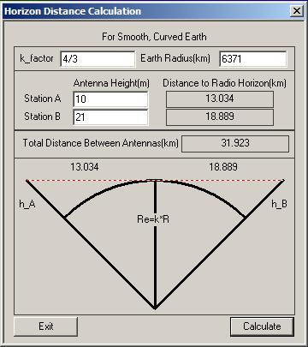

____________________

Programme 2 of the Istanbul Action Plan states: “Taking into account the different needs of the ITU membership, two different levels of automated Spectrum Management Systems (SMS) are identified: 1.1.1 Enhanced basic system designed to operate on: a) a single computer or number of separate standalone PCs; b) a computer network equipped with dynamic management and a higher degree of calculation accuracy based on Digital Terrain Modules (DTM). The number of frequency assignments should not exceed 100 000. The enhanced basic system would require extensive training and qualified professional staff. 1.1.2 Advanced system, only worthwhile when the number of frequency assignments exceeds around 100 000, applying full automation and the very latest procedures and propagation prediction models in a full-scale computer network. Such a system requires substantial initial investment and an impressive operational budget for a large group of highly qualified and experienced specialists to operate it. Advanced SMS systems are offered by number of specialized companies. It is proposed that Enhanced Basic automated SMS be upgraded/developed under this programme, along with technical assistance and appropriate training activities.”

