INTERNATIONAL TELECOMMUNICATION UNION
Radiocommunication Bureau
(Direct Fax N°. +41 22 730 57 85)

Circular Letter  3/LCCE/25 | 29 April 2005
To Administrations of Member States of the ITU, Radiocommunication Sector Members
and ITU-R Associates participating in the work of Working Parties 3J, 3K, 3L and 3M
of Radiocommunication Study Group 3
Subject: Meetings of Working Parties 3J, 3K, 3L and 3M
Working Party 3J: Propagation fundamentals
Working Party 3K: Point-to-area propagation
Working Party 3L: Ionospheric propagation
Working Party 3M: Point-to-point and Earth-space propagation

Introduction
By means of this Circular Letter, we wish to announce that meetings of ITU-R Working Parties 3J, 3K, 3L and 3M will take place in Cleveland, Ohio at the kind invitation of the United States of America, from 28 September to 7 October 2005.

Place of the meetings
The meetings will take place at the:

Hilton Garden Inn Cleveland Downtown hotel
1100 Carnegie Avenue
Cleveland, Ohio, OH 44115

For further information see Annex 1.

Programme of the meetings

Group | Date | Opening
Joint Meeting of Working Parties | 28 September 2005 | 28 September 9:30 hours
Working Party 3J | 28 September – 7 October 2005 | 28 September 14:00 hours
Working Party 3K | 28 September – 7 October 2005 | 28 September 15:45 hours
Working Party 3L | 4 – 7 October 2005 | 4 October 9:30 hours
Working Party 3M | 28 September – 7 October 2005 | 28 September 10:45 hours
Services directly connected with meeting activities, such as delegate registration, document distribution, etc. will be located in the vicinity of the meeting room. Registration of delegates will start at 8:30 hours on the opening day.
Delegates may wish to note that these Working Party meetings immediately follow the conference “ClimDiff 2005”, (sponsored by URSI Commission F), which is to be held at the same venue, from 26 to 27 September 2005. For more information, see http://spectrum.nasa.gov/climdiff/.
A draft agenda for the meetings is contained in Annex 2. The Questions assigned may be found on: http://www.itu.int/ITU-R/publications/download.asp?product=que03&lang=e. The Working Parties will conduct their work in English.

Contributions
Contributions in response to the work of Working Parties 3J, 3K, 3L and 3M are invited. These will be processed according to the provisions laid down in Resolution ITU-R 1-4, posted on http://www.itu.int/ITU-R/study-groups/rsg3/index.asp and distributed to participants on CD-ROM at the opening of the meeting.
One copy of each contribution should be sent to the Director, Radiocommunication Bureau for processing. A copy should also be sent to the Chairman of the relevant Working Party and to the Chairman and Vice-Chairmen of Study Group 3. The pertinent addresses can be found at:
http://www.itu.int/ITU-R/study-groups/index.asp (see Chairmen and Vice-Chairmen)
Participants are encouraged to submit contributions by electronic mail to:
elizabeth.mostyn@itu.int
As decided at the last meeting of the SG 3 Steering Group, the deadline for submitting contributions is Tuesday, 20 September 2005 at 12:00 hours Geneva time. Documents received after the deadline will be forwarded to the next meeting of the concerned Working Party.

Documentation
All contributions will be made available to the delegates on CD-ROM as well as on the ITU-R Study Group 3 Web page at: http://www.itu.int/ITU-R/study-groups/rsg3/index.asp (go to Web page of the related Working Party). Participants are expected to bring with them to the meeting paper copies of all of the input documents of interest to them (if necessary). Delegates also should indicate on the registration form whether they wish to receive paper copies of temporary, administrative and information documents during the meeting.
Participants are encouraged to use electronic working methods and to bring their laptops (equipped with a CD-ROM drive and a WLAN-card) with them to the meeting.

Hotel accommodation and arrival information
Annex 1 contains details on hotel accommodation; delegates are advised to make reservations at the earliest opportunity. Also included in Annex 1 is information concerning arrival in Cleveland, together with a map indicating the conference venue.

Participation
The intended participation of your representative(s) should be advised not later than one month before the opening of the meeting, by means of the annexed form (Annex 4) (to be photocopied as required).

Valery Timofeev
Director, Radiocommunication Bureau
Annexes: 4
Distribution:

– Administrations of Members of the ITU and other members of the Radiocommunication Sector participating in the work of Working Parties 3J, 3K, 3L and 3M of Radiocommunication Study Group 3
– ITU-R Associates participating in the work of Radiocommunication Study Group 3
– Chairman and Vice-Chairmen of Radiocommunication Study Group 3
– Secretary General of the ITU, Director of the Telecommunication Standardization Bureau, Director of the Telecommunication Development Bureau
Annex 1
Information for participants

1 Meeting venue and hotel accommodation
The venue of the meeting is:
Hilton Garden Inn Cleveland Downtown hotel
1100 Carnegie Avenue
Cleveland, OH 44115
Home page:
http://www.clevelandgateway.gardeninn.com/
Tel: +1-216-658-6400
Fax: +1-216-658-6405


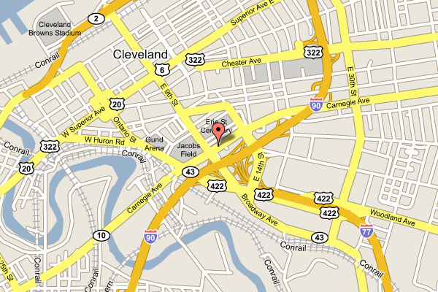

The hotel rooms are reserved for your disposal from 24 September to 7 October 2005, plus 3 days before and 3 days after the meeting on a space available basis at the conference rate.

Room reservation (special hotel rates)
The conference rates for the Study Group 3 Working Parties meeting are USD 99 (single) or USD 109 (double), plus 15.5% tax. Reservations must be made on or before 3 September to take advantage of the conference rate. After that date, reservations at the conference rate cannot be guaranteed.
In order to get the special conference rate, delegates should indicate the following when requesting a room:
Group Code: NGR
Guest accommodation
Guest accommodation includes: one king bed or two queen beds, a large work desk, complimentary high speed internet access, 2 phones with two lines, dataport, voicemail and private line, a refrigerator, a microwave, a coffee maker, an iron and full size ironing board and a 27" T.V. A coin-operated laundry is available on the premises.

2 Transportation
Shuttle bus service is recommended between Hopkins International Airport (CLE) and the Hilton Garden Inn and is available from either the Red Sparrow company at a cost of approximately USD 25 (Tel. 216-695-7550), or the Royal Fleet at approximately USD 15 (Tel. 216-631-5598). Alternatively, rental cars are available from a variety of car rental companies in the immediate vicinity of the airport. It is best to make reservations for car rentals in advance. From the Rental Car Center (shuttle bus from airport), the recommended and most direct route to the hotel is I-71. Parking at the hotel for this event is complimentary. A map and driving directions are included below.

Direction by car:


1100 Carnegie Avenue
Cleveland, OH 44115
(216) 658-6400
(216) 658-6405 - FAX
www.clevelandgateway.gardeninn.com

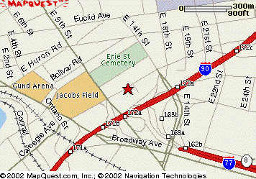
Easily accessible off of I-77, exit E. 9th, then right on Carnegie. Hotel will be on your right.
*Off I-71, exit E. 9th, then right on Carnegie. Hotel will be on your right.
Off I-90 from west, exit E. 9th, then right on Carnegie. Hotel will be on your right.
Off I-90 from east, exit Prospect & turn right, left on E. 18th, then right on Carnegie. Hotel will be on your left.

Should directions be necessary from a specific area to the Hilton Garden Inn, please call the front desk for assistance at (216) 658-6400.
Hotel shuttle service is available from 7 a.m. to 7 p.m. for destinations within the downtown area of Cleveland.

3 Electricity and socket design
The standard power supply in the United States is 110 volts - 60 Hz.
Standard North American 3 pin socket:



4 Contact point
For any further information you may require or if you need a personal invitation letter or official document from the US Administration for your visa application, please contact:

Mr. Glenn S. Feldhake  National Aeronautics and Space Administration  NASA Glenn Research Center  21000 Brookpark Road  Mail Stop 501-1  Cleveland, OH 44135  United States | Tel: 1-216-433-5668  Fax: 1-216-977-7444  E-mail: Glenn.S.Feldhake@nasa.gov

5 Invitation
A copy of the invitation letter from the United States of America is reproduced in Annex 3.

6 Visas
Delegates are urged to apply, as soon as possible, for U.S. visas, if needed, to facilitate entrance to the United States. If a special invitation is required, please contact the meeting coordinator, Mr. Glenn S. Feldhake (see Section 4 above).

Annex 2
Draft agenda for the meeting of Working Party 3J
(Cleveland, 28 September – 7 October 2005)
(opening at 14:00 hours on 28 September 2005)

1 Opening remarks
2 Approval of the agenda
3 Questions assigned to the Working Party (Doc. 3/1 available on: http://www.itu.int/md/meetingdoc.asp?type=sitems&lang=e&parent=R03-SG03-C-0001)
4 Issues concerning future WRCs
5 Studies requested by the first session of the Regional Radiocommunication Conference (RRC-04) – Resolution COM4/4
6 Organization of the work during the meeting
6.1 Allocation of texts and documents
6.2 Liaison statements
7 Reports by Subgroup Chairmen and discussion of documents
7.1 3J-1 Effects of the clear atmosphere (C. Gibbins)
7.2 3J-2 Effects of clouds and precipitation (M. Pontes)
7.3 3J-3 Noise and ground-wave propagation (D. Cole)
7.4 3J-4 Global mapping and statistical aspects (L. Castanet)
7.5 3J-5 Vegetation and obstacle diffraction (A. Nyuli)
8 Handbook on Radiometeorology
9 Approval of output documents
10 Any other business
G. Brussaard
Chairman, Working Party 3J

Documentation relevant to the meeting of Working Party 3J

Question ITU-R 201-2/3 | Question ITU-R 209/3
Question ITU-R 202-1/3 | Question ITU-R 214-1/3

Chairman's Report, Chairman, WP 3J, Doc. 3J/78 (24 December 2004) at: http://www.itu.int/md/meetingdoc.asp?type=sitems&lang=e&parent=R03-WP3J-C-0078
Contributions to agenda items, received in accordance with Resolution ITU-R 1-4.
Draft agenda for the meeting of Working Party 3K
(Cleveland, 28 September – 7 October 2005)
(opening at 15:45 hours on 28 September 2005)

1 Opening remarks
2 Approval of the agenda
3 Questions assigned to the Working Party (Doc. 3/1 available on: http://www.itu.int/md/meetingdoc.asp?type=sitems&lang=e&parent=R03-SG03-C-0001)
4 Examination of WP 3K Chairman's Report (Doc. 3K/66 at: http://www.itu.int/md/meetingdoc.asp?type=sitems&lang=e&parent=R03-WP3K-C-0066)
5 Issues concerning future RRC and WRCs
6 Studies requested by the first session of the Regional Radiocommunication Conference
(RRC-04) – Resolution COM4/4
7 Organization of the work during the meeting
7.1 Allocation of texts and documents
7.2 Liaison statements
8 Work programme
8.1 Propagation aspects concerning terrestrial path specific prediction methods in the frequency range 30 MHz – 3 GHz (3K-1, A. Paul)
8.2 Propagation aspects concerning terrestrial path general prediction methods in the frequency range 30 MHz – 3 GHz (3K-2, P. McKenna)
8.3 Propagation aspects concerning short-path personal communications and wireless LANS in the frequency range 300 MHz – 100 GHz (3K-3, H. Suzuki)
8.4 Propagation aspects concerning terrestrial wireless access systems (3K-4, T. Tjelta)
8.5 Handbooks
9 Approval of output documents
10 Future work programme
11 Any other business

R. GROSSKOPF
Chairman, Working Party 3K

Documentation relevant to the meeting of Working Party 3K
Question ITU-R 203-3/3
Question ITU-R 211-3/3
Chairman's Report, Chairman, WP 3K, Doc. 3K/66 (6 December 2004) at: http://www.itu.int/md/meetingdoc.asp?type=sitems&lang=e&parent=R03-WP3K-C-0066
Contributions to agenda items, received in accordance with Resolution ITU-R 1-4.
Draft agenda for the meeting of Working Party 3L
(Cleveland, 4 – 7 October 2005)
(opening at 9:30 hours on 4 October 2005)

1 Opening remarks
2 Approval of the agenda
3 Questions assigned to the Working Party (Doc. 3/1 available on: http://www.itu.int/md/meetingdoc.asp?type=sitems&lang=e&parent=R03-SG03-C-0001)
4 Issues concerning future WRCs
5 Work Programme of the meeting
5.1 Reports by the Chairmen of Rapporteur Groups
5.1.1 Correspondence group on HF digital communications (D. Cole)
5.1.2 Correspondence group on PLT (A. Paul)
5.1.3 Propagation above about 2 MHz (3L-RG1, L. Barclay)
5.1.4 Propagation below about 2 MHz (3L-RG2, J. Wang)
5.1.5 Trans-ionospheric propagation (3L-RG3, R. Leitinger)
5.1.6 Measurements and data banks (3L-RG4, N. Wakai)
5.2 Presentation and discussion of documents
5.3 Organization of drafting groups and allocation of documents
5.4 Liaison with other groups (including response to liaison statements)
6 Approval of output documents
7 Future work
8 Any other business

J. WANG
Chairman, Working Party 3L

Documentation relevant to the meeting of Working Party 3L

Question ITU-R 212-1/3 | Question ITU-R 225-4/3
Question ITU-R 213-1/3 | Question ITU-R 226-2/3
Question ITU-R 218-2/3 | Question ITU-R 227-1/3
Question ITU-R 221/3 | Question ITU-R 229/3
Question ITU-R 222-1/3 | Question ITU-R 230/3

Chairman's Report, Chairman, WP 3L, Doc. 3L/41 (28 January 2005) at: http://www.itu.int/md/meetingdoc.asp?type=sitems&lang=e&parent=R03-WP3L-C-0041
Contributions to agenda items, received in accordance with Resolution ITU-R 1-4.
Draft agenda for the meeting of Working Party 3M
(Cleveland, 28 September – 07 October 2005)
(opening at 10:45 hours on 28 September 2005)

1 Opening remarks
2 Approval of the agenda
3 Questions assigned to the Working Party (Doc. 3/1 available on: http://www.itu.int/md/meetingdoc.asp?type=sitems&lang=e&parent=R03-SG03-C-0001)
4 Working Party Chairman’s Report (Doc. 3M/94 at: http://www.itu.int/md/meetingdoc.asp?type=sitems&lang=e&parent=R03-WP3M-C-0094)
5 Requirements for WRC-07
6 Organization of the work during the meeting
7 Work programme of the meeting
7.1 Propagation aspects of terrestrial point-to-point communication (3M1 – T. Tjelta)
7.2 Propagation aspects of Earth-space communication (FSS, BSS and MSS) (3M2 – F. Haidara)
7.3 Propagation aspects of interference and coordination (3M3 – G. Feldhake)
7.4 Data banks (3M4 – B. Arbesser-Rastburg)
8 Liaison with other groups (including response to liaison statements)
9 Handbooks
10 Future work programme
11 Any other business
C.D. WILSON
Chairman, Working Party 3M

Documentation relevant to the meeting of Working Party 3M

Question ITU-R 204-3/3 | Question ITU-R 208-3/3
Question ITU-R 205-1/3 | Question ITU-R 226-2/3
Question ITU-R 206-3/3 | Question ITU-R 228/3
Question ITU-R 207-3/3

Chairman's Report, Chairman, WP 3M, Doc. 3M/94 (27 January 2005) at: http://www.itu.int/md/meetingdoc.asp?type=sitems&lang=e&parent=R03-WP3M-C-0094
Contributions to agenda items, received in accordance with Resolution ITU-R 1-4.
Annex 3
Copy of the invitation letter
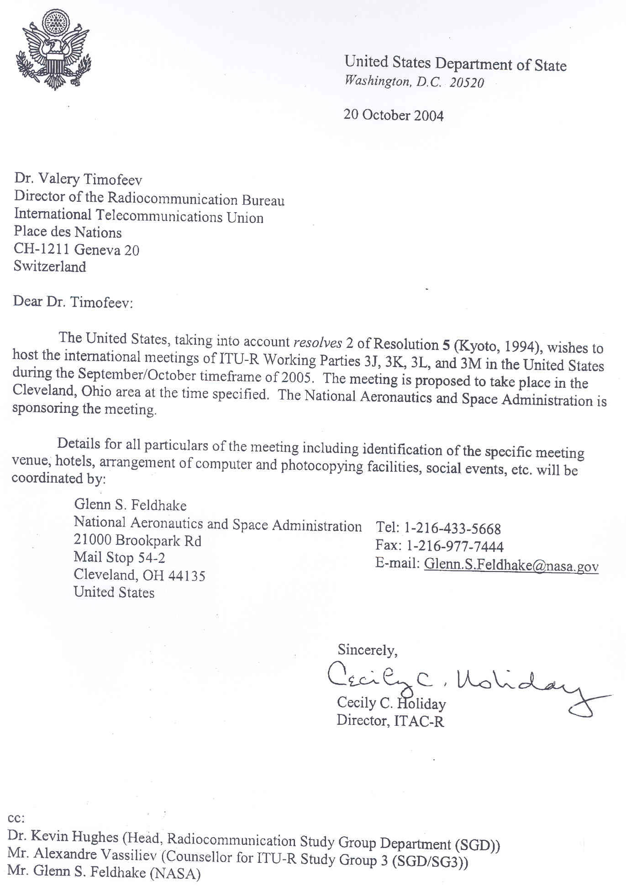
Annex 4
Registration Form
ITU-R Working Parties 3J, 3K, 3L and 3M Meetings
Cleveland, USA, 28 September – 7 October 2005
Radiocommunication Bureau |  | I wish to participate in

WP 3J  28 Sept. – 7 Oct. | WP 3K  28 Sept. – 7 Oct. | WP 3M  28 Sept. – 7 Oct. | WP 3L  4-7 Oct.

Mr. Mrs. Ms. Miss: |  | …………………………………………………………. |  |  |  |  |  |  |  | …………………………………………………………………...
 |  |  |  | (family name) |  |  |  |  |  | (first name)
Accompanied by family member(s): |  |  |  | …………………………………………… |  |  |  |  |  | …………………………………………………………………...
 |  |  |  | (family name) |  |  |  |  |  | (first name)
1. REPRESENTATION
Name of Member State: |  |  |  | …………………………………………………………………………………………………………………….
❒ Head of Delegation |  |  |  |  | ❒ Deputy |  |  |  |  |  |  |  | ❒ Delegate
(to be completed by representatives of Member States only)
Name of Sector Member: |  |  |  | …………………………………………………………………………………………………………………….
r | Recognized Operating Agencies |  |  |  |  |  |  | r |  |  | Regional Telecommunication Organizations
r | Scientific or Industrial Organizations |  |  |  |  |  |  | r |  |  | Intergovernmental Organizations operating Satellite Systems
r | UN, Specialized Agencies and the IAEA |  |  |  |  |  |  | r |  |  | Other Entities dealing with Telecommunication matters
r | Regional and other International Organizations |  |  |  |  |  |  | r |  |  | Associates
2. OFFICIAL ADDRESS
Name of the Company: |  |  | …………………………………………………………………………………………………………………………
Street Address: |  |  | …………………………………………………………………………………………………………………………
City/State/Code/Country: |  |  | …………………………………………………………………………………………………………………………
Business tel.: |  |  | …………………………………………… |  |  |  |  |  | Fax: |  |  | ……………………………………………
E-mail: |  |  | …………………………………………… |  |  |  |  |  | In case of emergency: |  |  | ……………………………………………
3. DOCUMENTS
I wish to receive paper copies during the meeting: |  |  |  |  |  | r | Yes |  |  |  |  |  | r | No

Date : |  | ……………………………………………………………………… |  |  |  | Signature: | …………………………………………………………...
 | For BR Secretariat use only
 | Approved (if applicable) |  | Personal Section |  | Meeting Section |  |  | Pigeonhole
 | To be returned duly completed to the Radiocommunication Bureau |  |  | Place des Nations  CH-1211 Geneva 20  Switzerland |  |  |  |  | Telephone: +41 22 730 5802  Telefax: +41 22 730 6600  Email: linda.kocher@itu.int

