INTERNATIONAL TELECOMMUNICATION UNION
Radiocommunication Bureau
(Direct Fax N°. +41 22 730 57 85)

Circular Letter  1/LCCE/75 | 20 January 2006
To Administrations of Members of the ITU and other members of the
Radiocommunication Sector participating in the work
of Radiocommunication Study Group 1
Subject: Meeting of the WP 1C Rapporteur Group - Report on “Technical Specifications Receiver for Spectrum Monitoring”
Introduction
By means of this Circular Letter, we wish to announce that a meeting of ITU-R WP 1C will take place at premises of Thales in Colombes (Paris, France) from 15-18 May 2006. The opening session will take place on Monday, 15th May, at 09:30 hours and registration of delegates will start at 08:30 on the opening day.
Programme of the meeting
Following the decision of Study Group 1 at its meeting in October 2005, the Rapporteur Group should prepare the Report on “Technical Specifications Receiver for Spectrum Monitoring”. The programme for the meeting together with logistical details may be found in Annex 1.
The Rapporteur Group will conduct its work in English.
Participation
The intended participation of your representative(s) should be advised not later than one month before the opening of the meeting, by means of the annexed form (Annex 2) (to be photocopied as required).
Valery Timofeev
Director, Radiocommunication Bureau
Annexes: 2
Distribution:

– Administrations of Members of the ITU and other members of the Radiocommunication Sector of Radiocommunication Study Group 1
– ITU-R Associates participating in the work of Radiocommunication Study Group 1
– Chairman and Vice-Chairmen of Radiocommunication Study Group 1
– Secretary General of the ITU, Director of the Telecommunication Standardization Bureau, Director of the Telecommunication Development Bureau
Annex 1
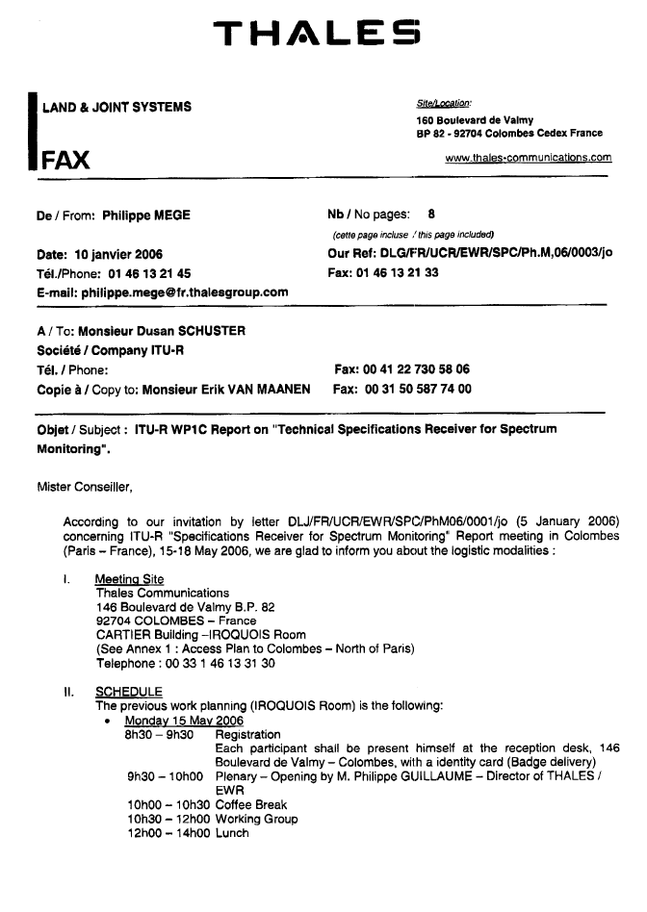

Annex 2
Registration Form
ITU-R Working Party 1C Rapporteur Group
Paris, France, 15 - 18 May 2006
Radiocommunication Bureau |  | I wish to participate in

Working Party 1C Rapporteur Group
✓

Mr. Mrs. Ms. Miss: |  |  |  | …………………………………………………………. |  |  |  |  |  |  |  |  |  |  |  | …………………………………………………………………...
 |  |  |  |  |  |  | (family name) |  |  |  |  |  |  |  |  | (first name)
Accompanied by family member(s): |  |  |  |  |  |  | …………………………………………… |  |  |  |  |  |  |  |  | …………………………………………………………………...
 |  |  |  |  |  |  | (family name) |  |  |  |  |  |  |  |  | (first name)
1. REPRESENTATION
Name of Member State: |  |  |  |  |  |  | …………………………………………………………………………………………………………………….
❒ Head of Delegation |  |  |  |  |  |  |  | ❒ Deputy |  |  |  |  |  |  |  |  |  |  |  |  | ❒ Delegate
(to be completed by representatives of Member States only)
Name of Sector Member: |  |  |  |  |  |  | …………………………………………………………………………………………………………………….
r |  |  | Recognized Operating Agencies |  |  |  |  |  |  |  |  |  | r |  |  |  | Regional Telecommunication Organizations
r |  |  | Scientific or Industrial Organizations |  |  |  |  |  |  |  |  |  | r |  |  |  | Intergovernmental Organizations operating Satellite Systems
r |  |  | UN, Specialized Agencies and the IAEA |  |  |  |  |  |  |  |  |  | r |  |  |  | Other Entities dealing with Telecommunication matters
r |  |  | Regional and other International Organizations |  |  |  |  |  |  |  |  |  | r |  |  |  | Associates
2. OFFICIAL ADDRESS
Name of the Company: |  |  |  |  | …………………………………………………………………………………………………………………………
Street Address: |  |  |  |  | …………………………………………………………………………………………………………………………
City/State/Code/Country: |  |  |  |  | …………………………………………………………………………………………………………………………
Business tel.: |  |  |  |  | …………………………………………… |  |  |  |  |  |  |  |  |  | Fax: |  |  |  |  | ……………………………………………
E-mail: |  |  |  |  | …………………………………………… |  |  |  |  |  |  |  |  |  | In case of emergency: |  |  |  |  | ……………………………………………
3. DOCUMENTS
I wish to receive paper copies during the meeting: |  |  |  |  |  |  |  |  | r |  |  | Yes |  |  |  |  |  |  |  |  | r |  | No
Date : |  | ……………………………………………………………………… |  |  |  |  |  |  |  |  |  |  |  | Signature: |  |  |  | …………………………………………………………...
 | For BR Secretariat use only
 | Approved (if applicable) |  |  |  |  | Personal Section |  |  |  |  | Meeting Section |  |  |  |  |  |  |  | Pigeonhole
 | To be returned duly completed to the Radiocommunication Bureau |  |  |  |  |  |  |  |  | Place des Nations  CH-1211 Geneva 20  Switzerland |  |  |  |  |  |  |  |  |  |  |  | Telephone: +41 22 730 5802  Telefax: +41 22 730 6600  Email: linda.kocher@itu.int

