INTERNATIONAL TELECOMMUNICATION UNION
Radiocommunication Bureau
(Direct Fax N°. +41 22 730 57 85)

Circular Letter  1/LCCE/67* | 17 November 2004
To Administrations of Member States of the ITU and
Radiocommunication Sector Members participating in
the work of Radiocommunication Study Group 1

Subject: Second meeting of SG 1 Rapporteur Group to revise the Handbook on Computer-Aided techniques for Spectrum Management

The Study Group 1, at its last meeting in November 6-7, 2003 decided to create a Rapporteur Group to revise the Handbook on Computer–Aided techniques for Spectrum Management, edition 1999. The Group will work according to the Terms of reference as contained in the SG 1 Decision [Doc. 1/17].
Date and place
The second meeting of the Rapporteur Group will be held from 31 January to 4 February 2005, following the kind invitation of LS telcom AG, Germany. The meeting will take place at the premises of LS telcom, Im Gewerbegebiet 31-35, D-77839 LICHTENAU, Germany.
A copy of the invitation letter together with the practical information concerning the venue of this meeting, including hotel accommodation may be found in Annex 1.
Reservation for accommodation has to be made by the reservation form (Annex 2), which should be sent, whenever possible, before 7 January directly to the Hotel and the meeting co-ordinator for information.
Delegates may wish to note that LS telcom cannot be held responsible for hotel bookings.
The meeting will commence at 9:30 hours on 31 January 2005. The registration of delegates will start at 08.30 hours.
For more information, please contact meeting co-ordinator:
Dr. Ing. Manfred LEBHERZ, LS telcom AG
Tel.: + 49 7227-95 35-600
Fax: + 49 7227-95 35-605
E-mail: mlebherz@LStelcom.com

Work programme and submission of contributions
The programme of the meeting is contained in the invitation letter (Annex 1).
Contributions are invited in accordance with the Terms of Reference as indicated in the Decision [1/17]. These will be posted on the ITU web. Contributions with indication of the contact person should also be sent to the Chairman of SG 1 and to the Chairman of the Rapporteur Group. It is recommended to widely use the email reflector that was established for the purpose of the Group in view to assist all potential participants and contributors to communicate.

http://www.itu.int/ITU-R/study-groups/reflectors-ftp/mail-ftp.asp?link=rsg1&lang=e&couns=rsg1

Participants are encouraged to submit contributions by electronic mail to:

dusan.schuster@itu.int

Documents may be found in the ITU Website:

http://web/md/meetingdoc.asp?lang=e&type=sfolders&parent=R03-1.HNB.CAT-C

Working language
The meeting will be conducted in English.
Participation
The intended participation of your representative(s) should be advised not later than one month before the opening of the meeting, by means of the annexed form (Annex 3).

Valery Timofeev
Director, Radiocommunication Bureau
Annexes: 3
Distribution:
– Administrations of Members States and Radiocommunication Sector Members participating in the work of Radiocommunication Study Group 1
– ITU-R Associates participating in the work of Radiocommunication Study Group 1
– Chairman and Vice-Chairmen of Radiocommunication Study Group 1
– Secretary General of the ITU, Director of the Telecommunication Standardization Bureau, Director of the Telecommunication Development Bureau
ANNEX 1
A copy of the Letter from LS Telcom

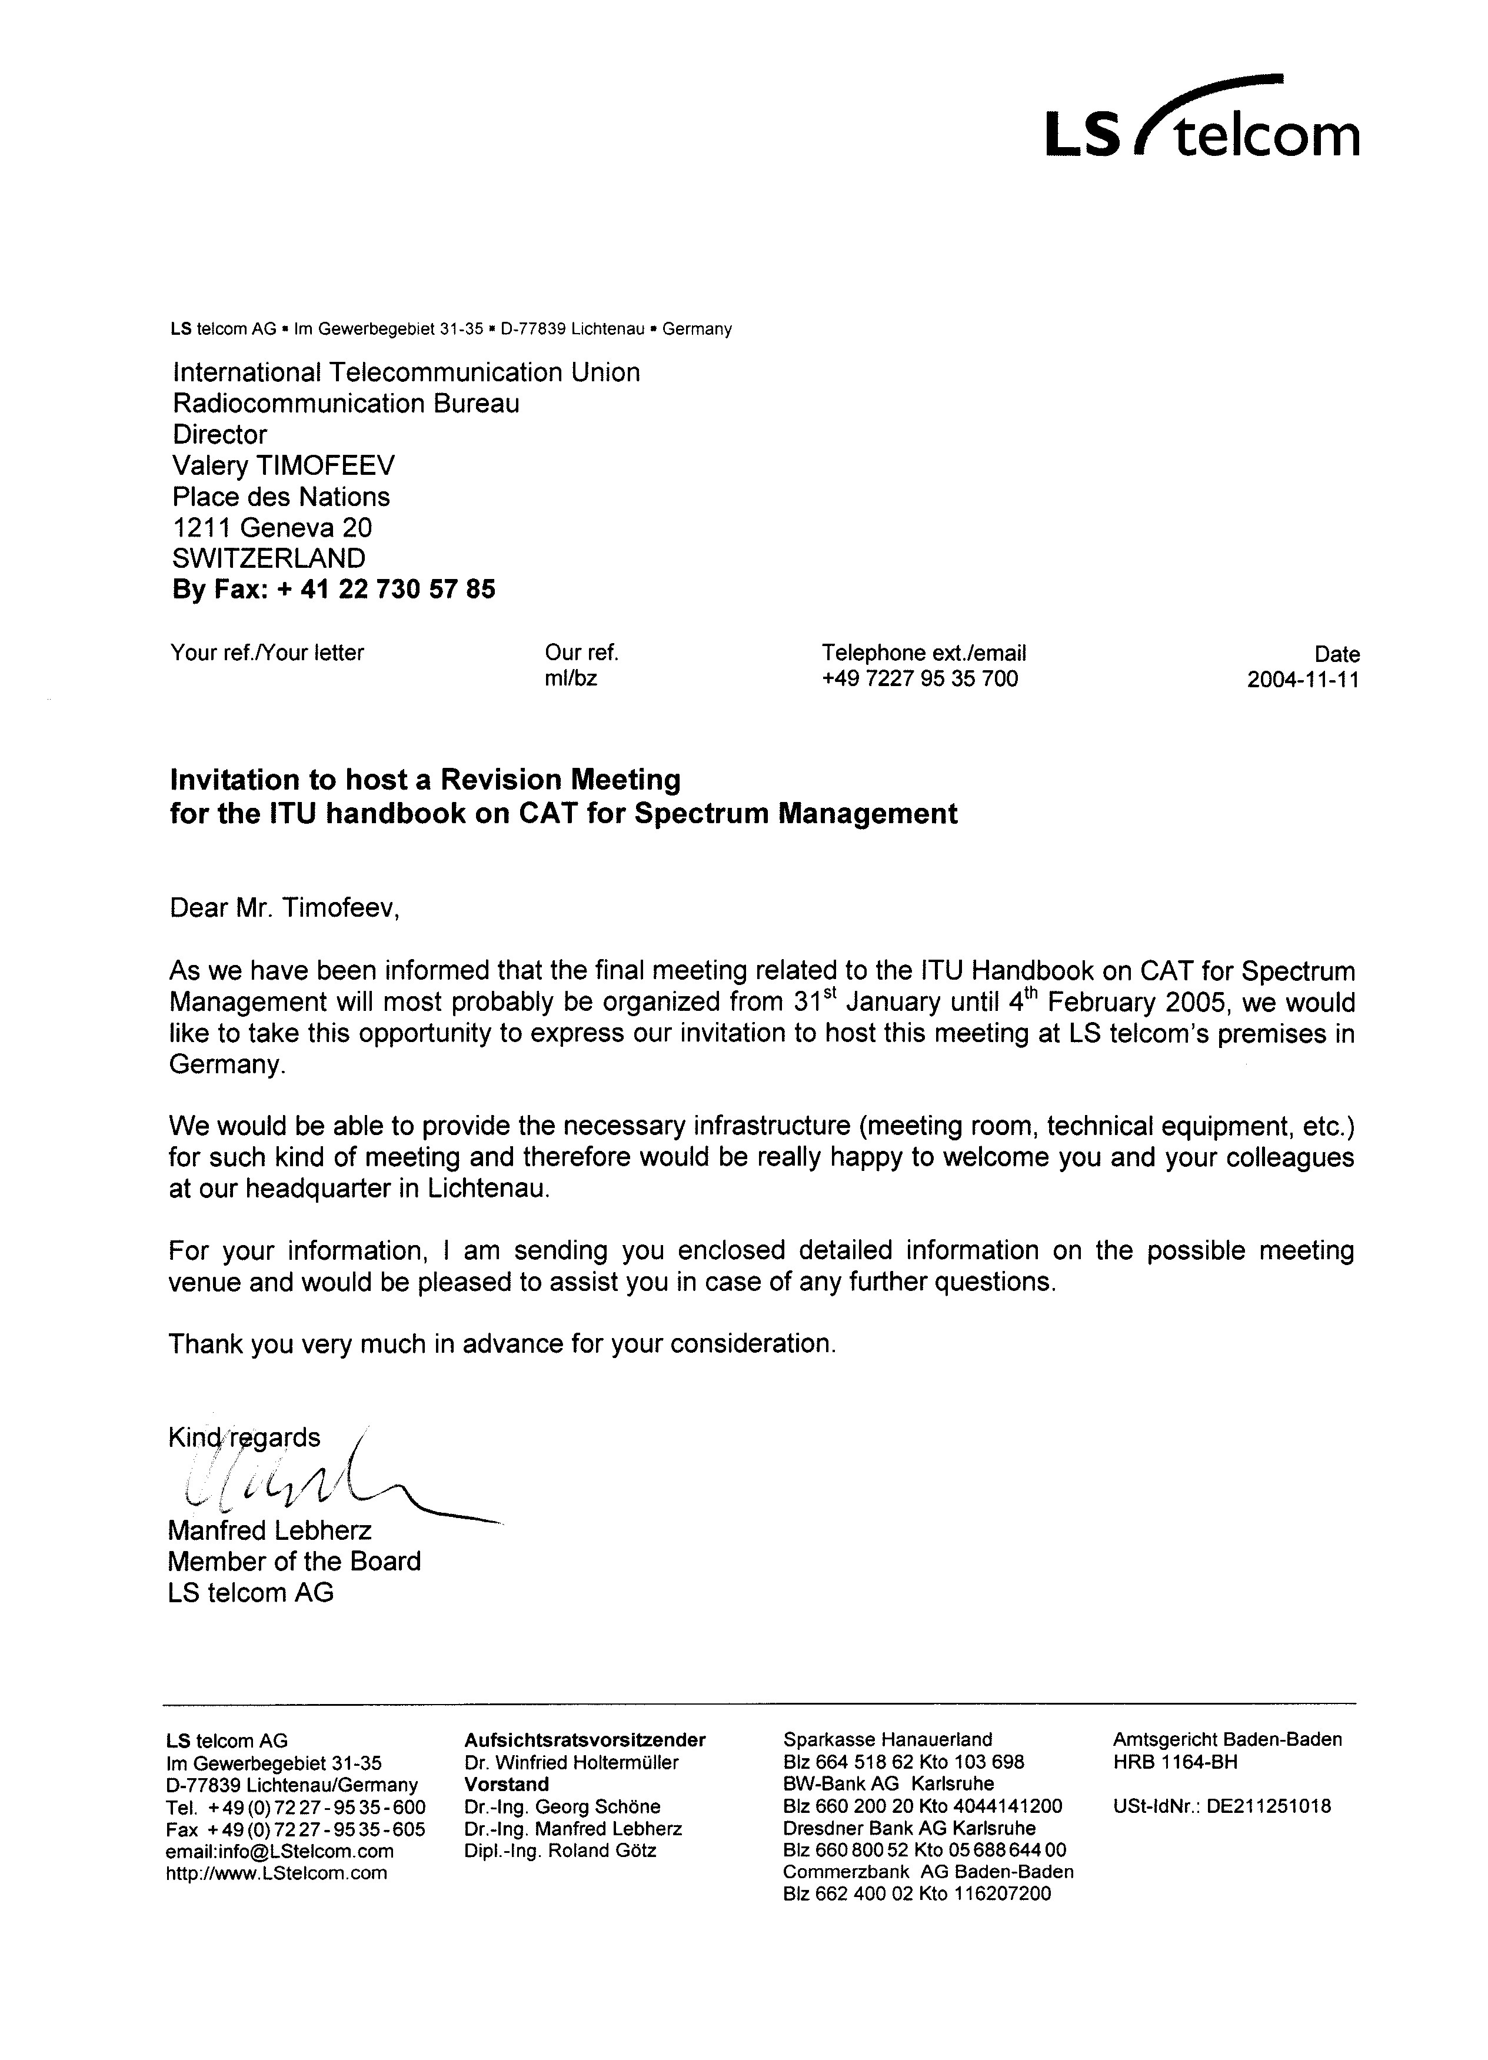

- 4 -
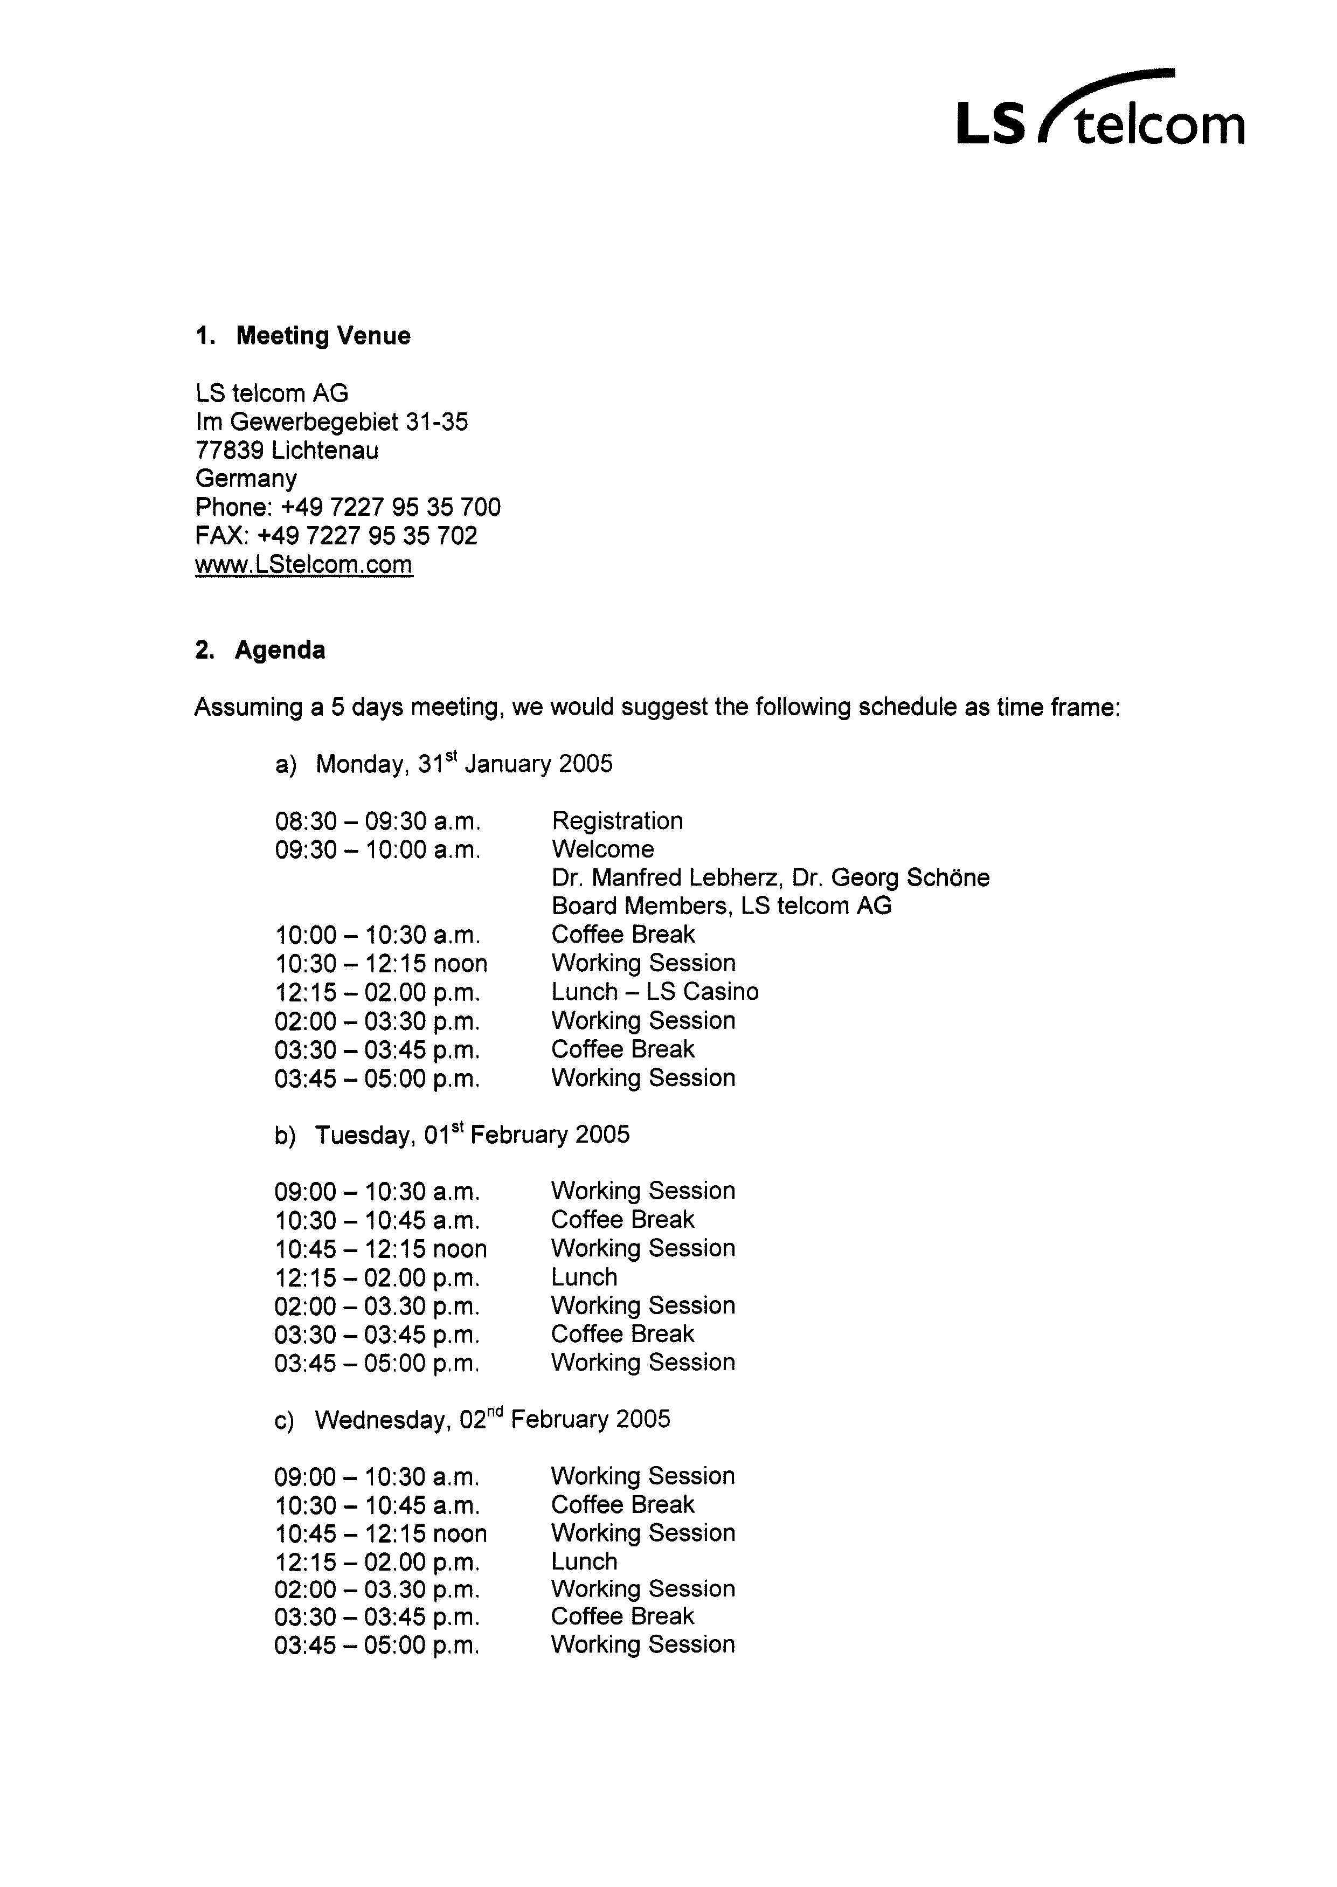

- 5 -
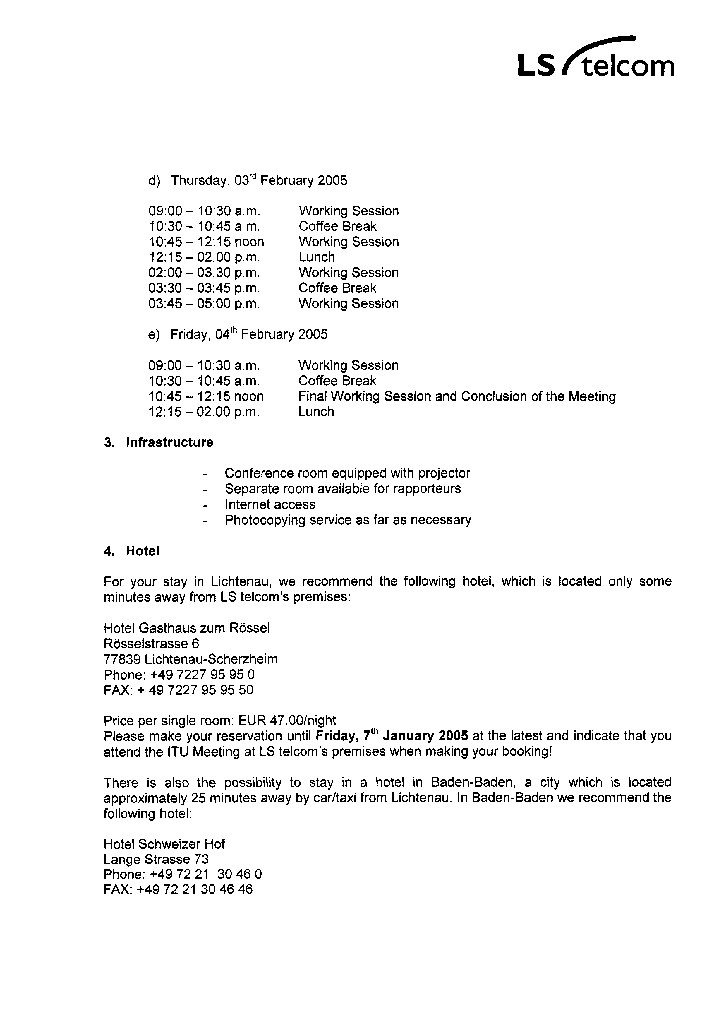

- 6 -

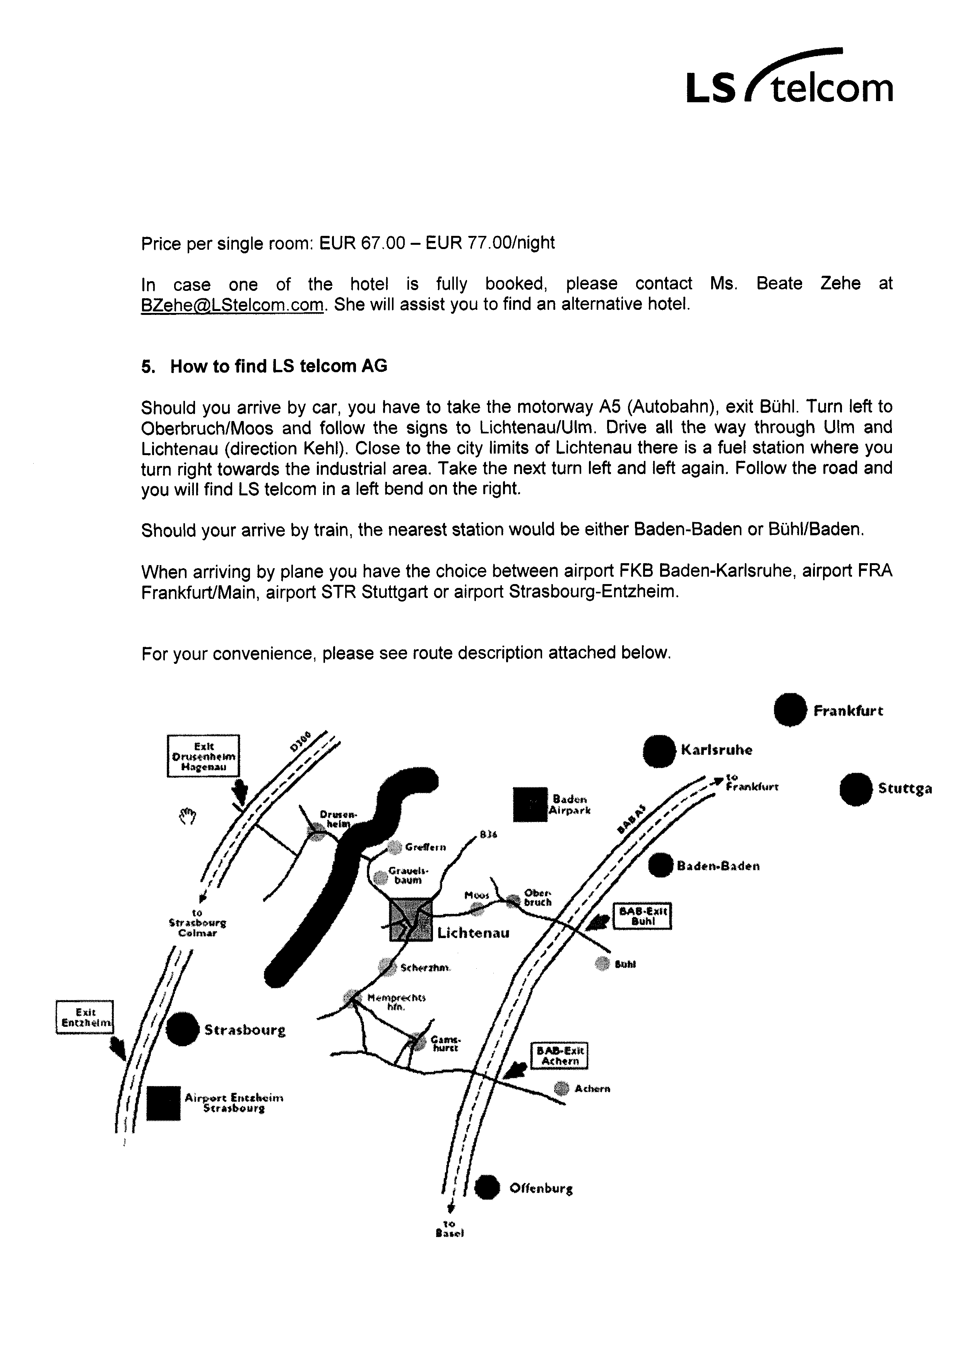

ANNEX 2
Hotel reservation form
ITU-R Rapporteur Group on Computer- aided techniques for Spectrum Management
31 January - 4 February, LICHTENAU, Germany

Hotel Gasthaus zum Rössel

Rösselstrasse 6
77839 Lichtenau-Scherzheim
Tel. : +49 7227 95 95 0
Fax : +49 7272 95 95 50

Name  ........................................ | Initials  ........................................

Company/Organisation
........................................

Business address
........................................

Postcode and City
........................................

Country
........................................

Credit card number  ........................................ | Exp. date  ........................................

Telefax  ........................................ | Telephone  ........................................
E-mail

Date of arrival  ........................................ | Approximate time of arrival at hotel  ........................................................

Date of departure
........................................

Signature

Hotel reservation form must be returned before 7 January 2005 directly to the hotel

* English only.

