Key points highlighted during the meeting

- National Cooperation
- A focal point should be identified for ICT statistics to coordinate among national agencies involved with ICT and coordinate national and international data requests. The focal point may be trained by the National Statistical Office.
- The regulator needs to work closely with the National Statistical Office (NSO), particularly in the area of demand-side statistics (collected through surveys), which are of increasing importance
- Regulators have to work closely with operators to ensure the availability and quality of data while at the same time, limiting the burden of data collection on operators. Regulators should publish country level aggregated data in those cases where confidentiality is a barrier to providing data. When needed, regulators might wish to provide training to operators to help collect timely and relevant data.

- International and Regional Cooperation
- ITU and regional organizations should work closely with the identified focal point in charge of collecting telecom/ICT statistics to build statistical capacity. Knowledge transfer could be achieved through workshops, seminars, and training.
- Best practice in the area of data collection can be chaired, for example, through ITU case studies, or bi-lateral cooperation between countries.
- Coordination between ITU headquarters and regional offices should be strengthened to avoid duplication of data requests and to speed up the data collection.
- Regional cooperation between regulators helps to pool resources and strengthen statistical work, for example through harmonized definitions and regional capacity building.

- New indicators
- New indicators are needed to reflect changes in the mobile and Internet sectors, particularly to reflect new applications. Surveys are important to validate administrative data. Definitions need to be revised to accurately monitor the market.
- ITU has developed a list of Indicators on Community access to ICTs, which countries should start to collect. This will also be important to measure the progress made towards the World Summit on the Information Society (WSIS) Plan of Action’s targets.
- There is a growing need to develop “Impact indicators” to measure the impact of ICTs on the Millennium Development Goals (MDGs) in particular and on social and economic development in general.

- Methodological issues related to data collection
- New indicators need to be clearly defined and existing indicator definitions may need to be revised (in accordance with ongoing ITU efforts) and provided to countries to increase international comparability of data and ensure adherence to ITU standards.
- The definitions of the ITU’s Key Telecom Indicators will be sent to countries for comments by end of February 2005.
- Surveys are increasingly important to measure ICT developments and trends and to increase the analytical value of information. They also complement and help verify administrative data.

- Policy for information and analysis
ICT/telecommunication statistics are used to analyze market developments, estimate market potential (e.g. to plan future network needs), identify barriers and user needs, and evaluate and monitor the effect of policy decisions.

- Policy Issues
- International, regional and national policy makers should promote the value of and need for ICT statistics.
- Governments should create a favourable legal basis for collecting ICT statistics. Rules on timely and comparable data can improve national collection efforts.
- Top-level policy makers need to formulate the demand for ICT statistics to monitor ICT developments and identify barriers.
- ICT Policy and Strategy should define clear targets and indicators to measure progress.
- Countries are encouraged to increase their efforts to answer the ITU questionnaire and return it on time.

- The meeting recommended holding the next World Telecommunication/ICT Indicators Meeting in the second half of 2006 for a period of three days. This will allow ITU to review the indicators and discuss indicator-related issues raised by WSIS and the World Telecommunication Development Conference (WTDC). The list of indicators should be sent to participants for revision before the meeting.

Conclusions

The fourth World Telecommunication/ICT Indicators Meeting—organized by the International Telecommunication Union (ITU)—took place in Geneva, Switzerland, from 10-11 February 2005. There were 125 participants, including 47 women, from 66 countries. A total of 11 international organizations were represented. The meeting was chaired by Mr. Sam Paltridge (OECD) and vice-chaired by Ms. Aurora Rubio from the Philippines, who also acted as the meeting’s rapporteur. The meeting was divided into eight sessions

The purpose of the meeting was to discuss topics related to the identification, definition, collection, processing, dissemination and use of telecommunication/ICT indicators and to enhance collaboration between the different parties involved. The meeting brought together entities responsible for telecommunication/ICT statistics and analysis, including telecommunication ministries, regulators and operators; national statistical offices (NSO); international organizations and researchers. Presentations were made on the following topics: ITU indicator activities (data collection and dissemination); the Millennium Development Goals (MDG), New Indicators (mobile, Internet and Community Access to ICTs indicators), Research and Analysis, Gender Statistics, and Telecom Indicators. A number of country experiences from telecommunication regulators and National Statistical Offices (NSO) were also presented.

The Opening and overview of the meeting put the statistical work of the ITU into a broader perspective. This is particularly important today in the light of the discussion on the information society. ITU is increasingly working with other international partners and organizations in an effort to help measure the information society and to identify appropriate indicators to measure “ICT for development”. The role of the ITU in this week’s “WSIS Thematic meeting on Measuring ICT for Development”, which took place from February 7-9, was highlighted.

ITU data processing

As the United Nations specialized agency for telecommunications, the ITU is responsible for producing statistics covering its sector. By means of an annual questionnaire the ITU collects data for around 100 indicators from more than 200 countries and territories. Data providers include telecom ministries, regulators and operators. The first presentation highlighted the reliance of the ITU on national entities (regulators and ministries) to collect ICT statistics. The presentation emphasized the main challenges of the ITU’s statistical work, including the diminishing response rate to the questionnaire and non-response to some questions. A major barrier to timely and relevant statistics is
the reluctance of operators to provide regulators with (what operators consider confidential) data. In 2004 less than half of all countries returned the questionnaire (see slide Data Collection - Challenges).
The clear and harmonized definition of indicators and reliability of statistical information remains a major issue and it was noted that organizations involved with telecommunication/ICT indicators need to agree on basic definitions. ITU data are at times not comparable because the definitions of the indicators vary across countries. ITU stressed the need for increased cooperation between national agencies involved in the collection and dissemination of ICT statistics, including the regulators, the ministries and the NSOs. Participants supported this point and suggested to appoint a national statistical focal point to collect information from different players, to harmonize results and to be the ITU contact. Ideally, NSOs may help the focal point to build statistical capacity through knowledge transfer. ITU presented the recommendations from the “Joint ITU/ECA regional workshop on Information and Communication Technologies (ICT) Indicators” that took place in Botswana in October 2004. There are many parallels between regional and global data collection issues, including the need for national cooperation on ICT statistical work, clear definitions, and the need to overcome the problem of data confidentiality.
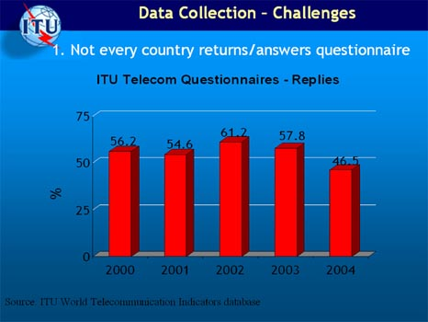

In an effort to increase the availability and quality of data to be published in the upcoming Yearbook of Statistics, the ITU provided copies of country pages, featuring the main data available for each country. Participants were asked to verify and complete their country’s data and to submit the updated information to ITU by mid-March 2005. Participants supported the idea of appointing a statistical focal point in the regulator or the ministry (whoever is in-charge of ICT data collection in the country).

MDG Goals, Trends, and Indicators

The ITU summarized its contributions towards monitoring the UN Millennium Development Goals (MDG). Given its specific area of competence, the ITU’s focus is mainly on Goal 8: “Develop a global partnership for development”, which in turn has eight targets. One of these targets (# 18) focuses on making available the benefits on new technologies, particularly ICTs. With a view to monitoring this target, ITU provides three indicators that it collects: total telephone penetration, Internet penetration and PC penetration. Access to Information and Communication Technologies (ICT) has been growing, always exceeding global economic growth. Besides the global trends (see slide MDG trends and the digital divide), the presentation further showed some of the regional results for the MDG indicators.
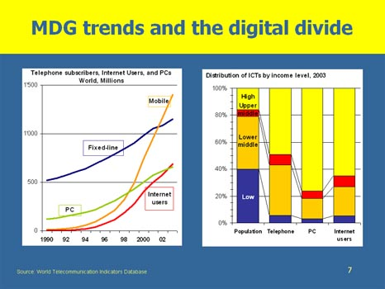
It was also noted that there is today an increasing focus on “ICT for development”. Given the growing emphasis to go beyond measuring ICT developments and trends it is important to identify “impact” indicators to measure and monitor in which way ICTs are affecting the other MDGs, as well as social and economic development in general. The discussion highlighted that while there are no concrete targets and objectives attached to the ITU’s target 18, specific targets are outlined in the WSIS Plan of Action. These targets, including the one to provide access to ICTs to half of the world’s population, should be reached until the year 2015 and are as such a useful complement to the MDGs.

Country experiences

The country experiences highlighted a number of difficulties as well as the successes in collecting national telecom/ICT statistics.
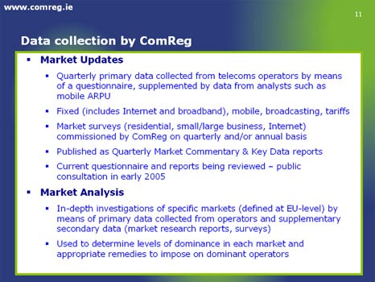
Ireland’s Communication Regulator provided an overview of the structure of the country’s telecommunication market, including the regulatory aspects. It outlined data collection efforts, including its questionnaires and survey, which have allowed it to provide an in-depth picture of the country’s market. The regulator carries out detailed studies of specific market segments and functions as a market analyser (see slide Data Collection by ComReg). The regulator pointed to the cumbersome task of collecting data particularly from smaller operators who do not have streamlined procedures or structured databases for collecting statistics.
This can lead to “information gaps” in the regulators’ collection efforts. Another issue is that of confidentiality since operators are often reluctant to provide market information. This problem can be partly solved if data are published in aggregated form only. Data collection efforts are also hindered by limited accuracy of data, for example, when subscribers are double counted.

The Uganda Communications Commission showed in how far the telecommunication market has improved since its liberalization and the introduction of private sector participation in 1996. Following a structural overview of the regulatory sector, the presentation highlighted the lack of clear policy statements with regard to defined targets that should be achieved over time. The current telecom policy review process, which is to create a new and revised policy document, will try to incorporate such specific targets and indicators to help evaluate future developments and trends (see slide TARGETS/Indicators for short-term 2007). This includes, for example, a universal service tele-density target of 20 percent, up from currently 4.2 percent. With regard to data collection, processing and dissemination the presentation highlighted a number of challenges, including inadequate human resources and funding for the UCC, the inability to verify the data provided by the operators, and problems with data definitions. Also, some operators report irregularly, and are unwilling to provide data (confidentiality issue). It was highlighted that the statistical information should be used to analyze in how far the ICT/telecom sector is impacting socio-economic development. As in other presentations and discussion, the need for a national focal point and internal cooperation efforts came up.
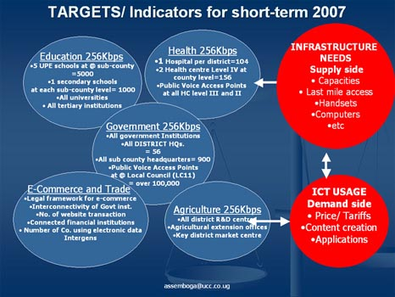

The Malaysian MCMC presented the Mobile user survey that it carried out in 2004 and pointed to the role of the regulator in collecting demand side statistics through surveys. The survey complements the subscriber statistics gathered from telecom operators and at the same time allows to measure the distribution of mobile subscription by provinces. It also highlighted the importance of surveys in analysing user profiles (including gender, see slide Main Findings) as well as consumer behaviour. MCMC will also conduct ICT usage surveys in households and business by April 2005. The regulator works closely with the Malaysia’s Department of Statistics and provides a good example of a country’s close relationship and cooperation between different agencies involved in ICT data collection.
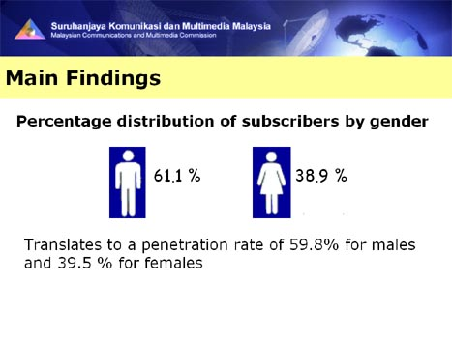

The presentation by REGULATEL (the Latin American Regulator’s Forum, which consists of 19 regulators) showed an example of regional cooperation and association of regulators to improve statistical data collection, including the harmonization of indicators. Issues related to the definition, methodology and dissemination of indicators are addressed through its Regional Indicators System (RIS) as well as at regular workshops and meetings. The presentation highlighted the usefulness of statistical information to make policy decisions and to develop specific projects to overcome shortcomings within the region. The regional experience shows that is mportant to include and use demand side indicators provided by NSOs, as well supply side indicators provided by the regulators. The combination of these data collection mechanisms leads to an improved knowledge base in the region (see slide Indicators – How?). Global efforts to harmonize and define statistical information, such as undertaken by the WT/ICT Indicators Meeting, complements and supports the work carried out within the region.
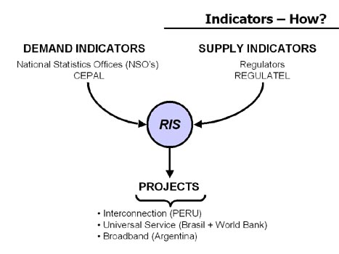

The experience from Hong Kong, China points to the importance of surveys in understanding the telecom/ICT market, in terms of individual, as well as business use. It provided another example of successful coordination between the NSO and the regulator in terms of their data collection efforts. Given new technological developments, a number of new questions on wireless and mobile services were added to the 2004 “IT Penetration in Business Sectors” Survey as well as to the “ Household Survey”, including the type of wireless technology used by mobile devices. Another issue addressed was the impact of ICTs on the economy. There are increasing efforts to understand the macroeconomic impact of the ICT sector, as well as on IT Expenditure. Again, a number of economic surveys were used to this end. Surveys are also used to monitor skills (an important aspect in the ICT market) and the bi-annual Manpower survey on IT sectors provides information on the number of IT employees (by type of employment), academic qualifications, recruitment difficulties in the sector, etc (see slide IT Manpower). Major challenges with regard to Telecommunication Indicators were also presented and include the rapid development of ICT, which can limit the comparability of statistics on PC/Internet/website penetration. E-commerce statistics are still difficult to collect since businesses find it difficult to provide information broken down by electronic sales and customer groups. Another problem is the burden imposed on operators.
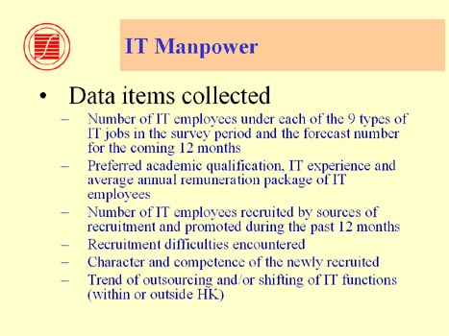
In Slovenia, the Post and Electronic Communications Agency of the Republic of Slovenia (APEK) is responsible for collecting ICT/telecom market statistics. The major problems encountered include the inability of operators to provide data, the lack of historic data (before 2000) as well as the lack of common definitions. APEK also has difficulties in validating the information it receives from the operators (see slide Data Collection - Situation in Slovenia). To overcome these problems, it was suggested that operators should receive training on statistical collection and the regulator should encourage more informal and formal cooperation with the operators; as well as to have seminars and workshops that will serve as training to data providers. The regulator is also missing analytical tools (software) to analyse the data. The presentation from Lao PDR highlighted similar problems in the collection of telecommunication statistics in the country. Faced with the problem of confidentiality of other operators’ data, the Lao regulator strives to provide the aggregated information of all services available in the country. The newly formed regulator still lacks the resources to collect information in the country.
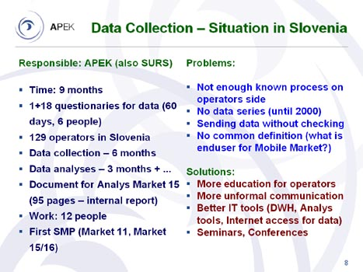

Mobile, Internet and Community access Indicators

The presentation on Mobile Indicators for the Information Society discussed a number of new indicators that should be collected on the national and international level. The adoption of new indicators is the result of new technological and market developments and trends, in particular the fact that there are today more mobile than fixed line subscribers; the increasing focus on mobile termination charges; and the growth of non-voice (multimedia) applications. These changes and developments also call for the review of the mobile indicators collected by ITU. The new proposed list of indicators include high-speed mobile subscribers (by different technologies); the number of SMS users (or percentage of subscribers using SMS), as well as MMS, WAP and Mobile Internet users and “Mobile termination rate”. The presentation also suggested disaggregating the percent coverage of mobile cellular networks by the type of network (1G, 2G, 3G). The presentation highlighted some of the problems in collecting subscriber numbers, such as the inclusion of non-active prepaid cards or the inclusion of second subscriber accounts. It also pointed to the importance of surveys in verifying administrative data. Surveys should be carried out to increase the reliability of statistical information. Similar problems appear in the monitoring of traffic, where Minutes of Use (MOU), a standard way of measuring mobile traffic, may be defined in various ways so that results from different operators are not always comparable (see slide Mobile usage).
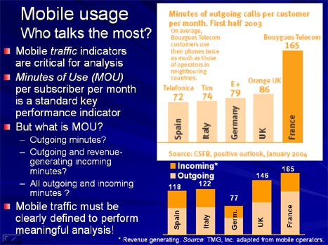

The presentation made by TeleGeography raised some of the issues related to measuring the volume of international voice and data traffic between geographic locations. The company’s existing data set includes Internet traffic, which measures the performance of networks and shows how much
Internet capacity is being used between two points during a given period of time as well as international bandwidth (see slide Major International Internet Routes). It also collects VoIP traffic by tracking international phone calls that transit public or private IP networks at some point but ultimately terminate on traditional fixed or mobile networks. The main challenges facing the company are data confidentiality and the large number of providers. It is difficult for TeleGeography to convince carriers to contribute their data each year and given the large number of carriers (over 400) it is impossible to collect data from all of them. Some of the data is therefore estimated. The presentation further showed that the origin and destination of Internet traffic couldn’t be identified through today’s data collection methods.
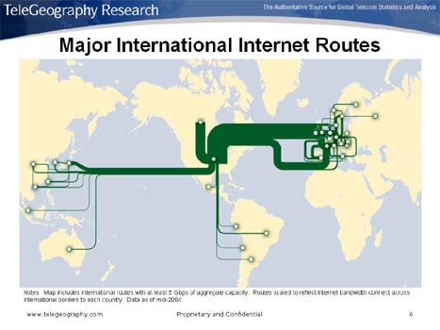

An indicator that is important in providing access to ICTs but that has until recently not received due attention is community or public access. It has been widely acknowledged that traditional indicators alone — such as the number of fixed telephone lines — are not sufficient to identify the extent of the digital divide. The vast majority of households in developing countries do not have modern ICT facilities, such as computers and the Internet and community access will play an important role in expanding access to ICTs (see slide Why community access matters…). The presentation proposed a set of community access to ICT indicators, based on the recommendations made by ITU member states, at the 2004 Global Indicators Workshop on Community Access to ICTs. The ITU has agreed upon a clear term for community access centres, which is Public Internet Access Centres (PIAC). It has also identified a definition for Digital Community Centres (DCC), which is a type of PIAC that offers affordable access, and fulfils a number of minimum requirements, such as a minimum connection speed to the Internet. A DCC is typically subsidized by the government (or others) and represents an effort to expand access to ICTs to otherwise unconnected areas. This list of indicator to measure community access inlcludes the Number of villages with access to a Public Internet Access Centre (PIAC), the Percentage of localities with PIACs by number of inhabitants (rural/urban), and the Target population for DCC services. Current research suggests that very little information is available and that only few countries collect data on community access to ICTs. It will be crucial to overcome this lack, also with regard to the WSIS Plan’s of Action, which includes a target on providing access to ICTs to half of the population by 2015. To achieve this goal and to measure progress towards it, community access to ICTs and relevant indicators, will play an important role. The presentation pointed to the urgent need for countries to start collecting the proposed indicators.
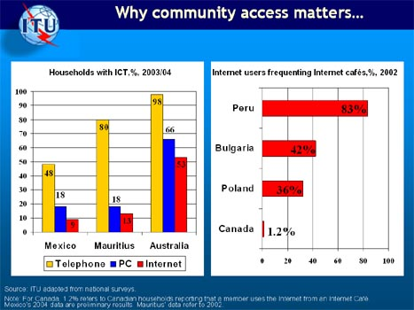

Research and Analysis
The session on research and analysis showed how ICT statistics in general and the ITU’s World Telecommunication Indicators Database in particular are used for research and for analysing market trends and developments. A presentation made by the International Teletraffic Congress (ITC) demonstrated the application of WTI/ICT Indicators provided by the ITU for Telecom Network
Planning. Particularly, it showed how far telecommunication indicators are used to plan and predict future network needs. Saturation limits are an important indicator to calculate approximately network needs and to do so it is important to estimate the potential user base for fixed and mobile networks. Today it is also important to take into consideration the impact that developments in the mobile sector will have on the fixed line market and to analyze saturation limits in highly developed markets, including teledensity by household and the ratio of residential to business users. The presentation highlighted the importance of ITU data to analyze market developments, measure the impact of cellular mobile on fixed line market, and to understand the availability of services in rural and large cities (see slide Application of the WT/ICT indicators in Telecom Network Planning). It further highlighted the new indicators that should be collected to reflect developments specifically those related to broadband services and suggested that ITU include the indicators in its data collection.
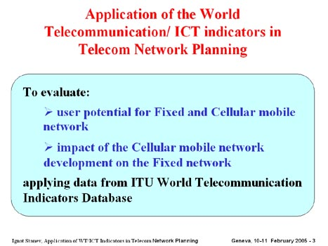

The presentation from Research ICT Africa emphasized that effective regulation depends on good statistics and analysis and is important to inform policy makers. Data and analysis also help countries identify barriers and react to specific problems. Research ICT Africa developed some studies to show the correlation between ICT policy regimes and their regulatory practice, pricing of telecommunications and Internet/telephone services and Internet/telephone penetration rates (see slide Main reason why a public phone is used more than others). Supply side analysis is too limited on its own to provide a useful understanding of ICT developments and more surveys, and qualitative research is needed to complement existing data and studies. The presentation also highlighted the need for public access to ICTs and emphasized the importance of indicators that will measure the availability and usage of such facilities.
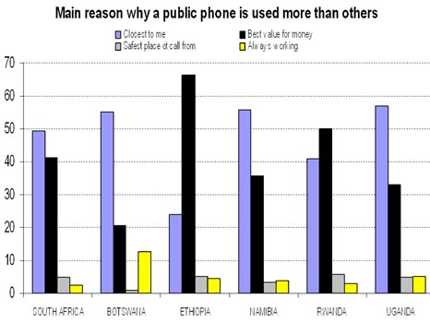

EUROSTAT’s experience in collecting data shows that it is very important to set rules on timely and comparable data and to harmonize data. The European Statistical Office is currently working on a legal act to facilitate the collection of telecom statistics. The presentation also highlighted the need for surveys to get more in-depth information on use and impact of ICTs.

Over time the ITU’s indicators have become an important tool for benchmarking countries and for constructing national and international indices. The presentation made by the Association of Telecommunication Companies of the Andean Community (ASETA) and International Telecommunication Academy (ITA) highlighted a mathematical model to quantify and evaluate the digital gap within a country, province, or organization. They higlighted the importance of statistical information for analysis, to identify the digital divide and to eventually impact and improve policies.

GENDER STATISTICS
Collecting sex-disaggregated statistics is an important part of understanding the digital divide (between women and men) and to tackle and respond to development challenges. Despite international and national commitments, there is still today a paucity of sex-disaggregated data on the Information Society. Existing sex disaggregated data, mostly collected through household surveys, focus on documenting and analyzing access to, and use and knowledge of, ICTs by women and men. Some few countries have carried out highly specialized ICT surveys that document frequency of use, location of access, types of activities, and purposes of use. The presentation pointed to the usefulness of household surveys in collecting more and better gender-disaggregated ICT data. The limited availability of such surveys also partially explains the remaining lack of data in this field. While ITU currently collects data on the number of female Internet users and on the numbers of male and female telecommunication staff within Member-States, it is important to go beyond the numbers of women and men employed to documenting the posts they hold and analyzing changes over time. ITU has recently embarked on a project to compile and analyse quantitative and qualitative gender-sensitive information from national and international sources. This information, which includes developed and developing countries and which could eventually be compiled into a database, would provide an important source of gender-disaggregated ICT statistics.

KEY TELECOM INDICATORS

ITU presented the list of telecom indicators that it plans to include in the next data collection process, schedule for mid 2005. The list included the new indicators presented in previous sessions such as broadband, community access and mobile indicators (see slide Mobile cellular indicators). The presentation was supported by a document containing the indicators agreed during the 2003 WTI meeting as well as their definitions. Participants agreed to the list noting that the new indicators are subject to data collection success. Participants decided to retain some indicators referring to older ICTs (such as the number of telex subscribers). These will be revisited in the next WTI meeting and depending on the number of countries that continue to collect this data, they might eventually be deleted from the list. Some participants suggested deleting the indicators on radio and television sets, given the difficulty in collecting this information. However, since both indicators are included in the core list agreed upon during the WSIS Thematic Meeting on Measuring the Information Society (organized by the “Partnership on Measuring ICT for Development”), they will remain part of the ITU list. ITU promised to send the definition of new indicators as well as revision to old indicators (if any) to countries for comments by end of February 2005.
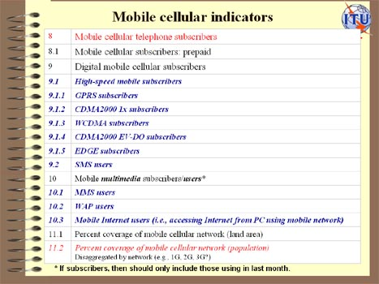

The programme and background documents are available at the following web site: http://www.itu.int/ITU-D/ict/WICT05/index.html

