Бюро стандартизации  электросвязи | 
Женева, 13 июля 2011 года
Осн.: | Циркуляр 204 БСЭ | – Администрациям Государств – Членов Союза  – Членам Сектора МСЭ-Т  – Ассоциированным членам МСЭ-Т  – Академическим организациям − Членам МСЭ-Т
Тел.:  Факс:  Эл. почта: | +41 22 730 6301  +41 22 730 5853  cristina.bueti@itu.int | Копии:  – Председателю и заместителям председателя 5-й Исследовательской комиссии МСЭ-Т  – Директору Бюро развития электросвязи  – Директору Бюро радиосвязи

Предмет: | Симпозиум на тему ‎"Активизация работы по повестке дня в области  климата с помощью стандартов на экологически чистые ИКТ"  Сеул, Корея, 19 сентября 2011 года
Уважаемая госпожа,
уважаемый господин,
1 Хотел бы сообщить Вам, что симпозиум на тему ‎"Активизация работы по повестке дня в области климата с помощью ‎стандартов на экологически чистые ИКТ"‎ состоится 19 сентября 2011 года с 13 час. 30 мин. до 18 час. 00 мин. в зале международных конференций Пресс-центра Кореи, Сеул, Корея. Симпозиум пройдет непосредственно накануне собрания 5-й Исследовательской комиссии МСЭ-Т (Окружающая среда и изменение климата), которое состоится в Сеуле, Республика Корея, с 20 по 28 сентября 2011 года включительно (см. Коллективное письмо 8/5 БСЭ).
2 Обсуждения будут проходить только на английском языке.
3 В симпозиуме могут принять участие Государства – Члены МСЭ, Члены Сектора, Ассоциированные члены и академические организации, а также любое лицо из страны, являющейся Членом МСЭ, которое пожелает внести свой вклад в работу симпозиума. К таким лицам относятся также члены международных, региональных и национальных организаций. Участие в симпозиуме является бесплатным.
4 Проект программы симпозиума приводится в Приложении 1 к настоящему документу.
5 Практическая информация о собрании, предоставленная принимающей организацией, содержится в Приложении 2.
6 Информация о симпозиуме будет размещена на веб-сайте МСЭ-Т по следующему адресу: http://www.itu.int/ITU-T/worksem/climatechange/201109/index.html.
7 С тем чтобы БСЭ могло предпринять необходимые действия в отношении организации этого симпозиума, был бы признателен Вам за регистрацию с использованием онлайновой формы по адресу http://www.itu.int/cgi-bin/htsh/edrs/ITU-T/workshop/edrs.registration.form?_eventid=3000286 в максимально короткий срок, но не позднее 10 сентября 2011 года. Обращаем Ваше внимание на то, что предварительная регистрация участников симпозиума проводится только в онлайновом режиме.

8 МСЭ-Т предоставит в рамках имеющегося бюджета ограниченное количество частичных стипендий только для одного участника из каждой страны, относящейся к Азиатско-Тихоокеанскому региону и отвечающей установленным критериям. Кандидатуры участников должны быть должным образом одобрены соответствующими администрациями МСЭ из наименее развитых стран и развивающихся стран с уровнем дохода на душу населения менее 2000 долл. США. Хотя стипендии предоставляются только одному участнику из соответствующей страны, число делегатов из какой-либо страны не ограничивается, при условии что связанные с дополнительными делегатами расходы несет сама страна. Просим участников, нуждающихся в стипендии, заполнить форму запроса на предоставление стипендии, которая содержится в Приложении 4, и направить ее в МСЭ по электронной почте: bdtfellowships@itu.int или по факсу: +41 22 730 5778 не позднее 19 августа 2011 года.
9 Хотели бы напомнить Вам о том, что для въезда в Республику Корея и пребывания в ней в течение любого срока гражданам некоторых стран необходимо получить визу. Визу следует запрашивать не менее чем за четыре (4) недели до даты начала собрания и получать в учреждении (посольстве или консульстве), представляющем Республику Корея в вашей стране, или, если в вашей стране такое учреждение отсутствует, в ближайшем к стране выезда.
Участникам, которым необходимо получить пригласительное письмо и/или письмо с визовой поддержкой для въезда в Республику Корея, рекомендуется обратиться к контактному лицу в Республике Корея:
г-жа Хе Ён (Грэйс) Хван (Ms Hye Young (Grace) Hwang)
Тел.: +82 2 338 1082;
факс: +82 2 338 1083;
эл. почта: sg5_visa@kcc.go.kr.
10 Для Вашего удобства в Приложении 3 содержится форма для бронирования номеров в гостиницах.
С уважением,
Малколм Джонсон
Директор Бюро
стандартизации электросвязи
Приложения: 4

ANNEX 1
(to TSB Circular 204)
Draft programme for the Symposium on progressing the Climate Agenda
through Green ICT Standards
(Seoul, 19 September 2011)

Monday, 19 September 2011
13:30 - 13:45 | Opening Session  Moderator: Dr. Hye Joo Yoon, KCC  - Dr. Yong-Sup Shin, Standing Committee Commissioner, KCC (Republic of Korea)  - Ms. Judit Katona Kiss, Counsellor, Study Group 5 (on behalf of Malcolm Johnson, Director, Telecommunication and Standardization Bureau, ITU)  - Mr. Ahmed Zeddam, ITU-T SG5 Chairman
13:45 -14:00 | Keynote Speaker: Ms. Cristina Bueti, Programme Coordinator, ITU activities on ICTs, the Environment and Climate Change
14:00 - 15:30 | Session I : Roadmap: “ICTs and Environmental Sustainability”  This session will provide an overview of ongoing activities and efforts to reduce GHG emissions and energy consumption through the use of ICTs and will shed light on national and regional policies and best practices on how ICTs can help to address climate change.
15:30 - 16:00 | Coffee Break
16:00 - 17:30 | Session II : Can the ICT Sector Save the Planet and Humanity?  It is estimated that the ICT sector produces directly some 2-2.5 per cent of total emissions of greenhouse gases, and this share will increase as ICTs make a larger contribution to the global economy. What ICT manufactures and service providers have done so far to reduce their own carbon footprint and energy consumption?
17:30 - 18:00 | Questions & Answers, Review and Wrap-up  This session will provide an opportunity for participants and speakers to share their views which will be summarized in the outcome of the symposium.  The outcome of the symposium will be a set of recommendations and actions which will be submitted for consideration to the upcoming UNFCCC conference of parties-17 which will be held in Durban, South Africa in December 2011 as well as to the next TSAG (ITU Telecommunication Standardization Advisory Group which will be held in Geneva in January 2012.

ANNEX 2
(to TSB Circular 204)
Practical Information
(Republic of Korea, 19-28 September 2011)

INFORMATION ABOUT THE MEETING AND SYMPOSIUM

- Venue

ITU-T SG5 Meeting
The ITU-T SG5 will be held from 20th of September to 28th of September 2011 at ‘Sapphire Ballroom’(3F) and meeting rooms on the 36th floor of Lotte Hotel, Seoul, Korea.
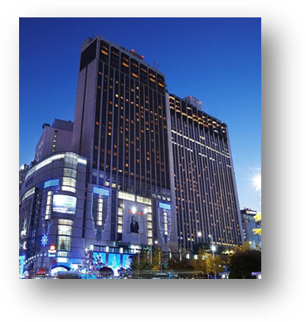
Address | 1, Sogong-Dong, Jung-Gu, Seoul, Korea 100-721
Facilities | Club Floor, Fitness Club, Business Center, Duty Free Shop
Telephone | +82-2-771-1000
Fax | +82-2-752-3758
Website | www.lottehotelseoul.com

Symposium on “Progressing the climate agenda through green ICT standards”
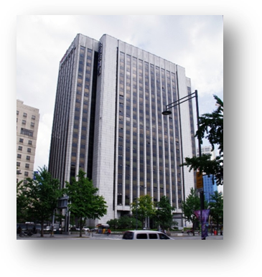
The Symposium will be held on 19th of September 2011 at ‘International Conference Hall’(20F) in Korea Press Center, Seoul, Korea.
Address | 33, Taepyeongro, Jung-Gu, Seoul, Korea 100-721
Facilities | VIP Room, Press Room
Telephone | +82-2-2001-7114
Fax | +82-2-2001-7770
Website | www.kpf.or.kr

How to get from Lotte Hotel to Press Center
It takes 10 minutes by walk and 5 minutes by taxi as below map.
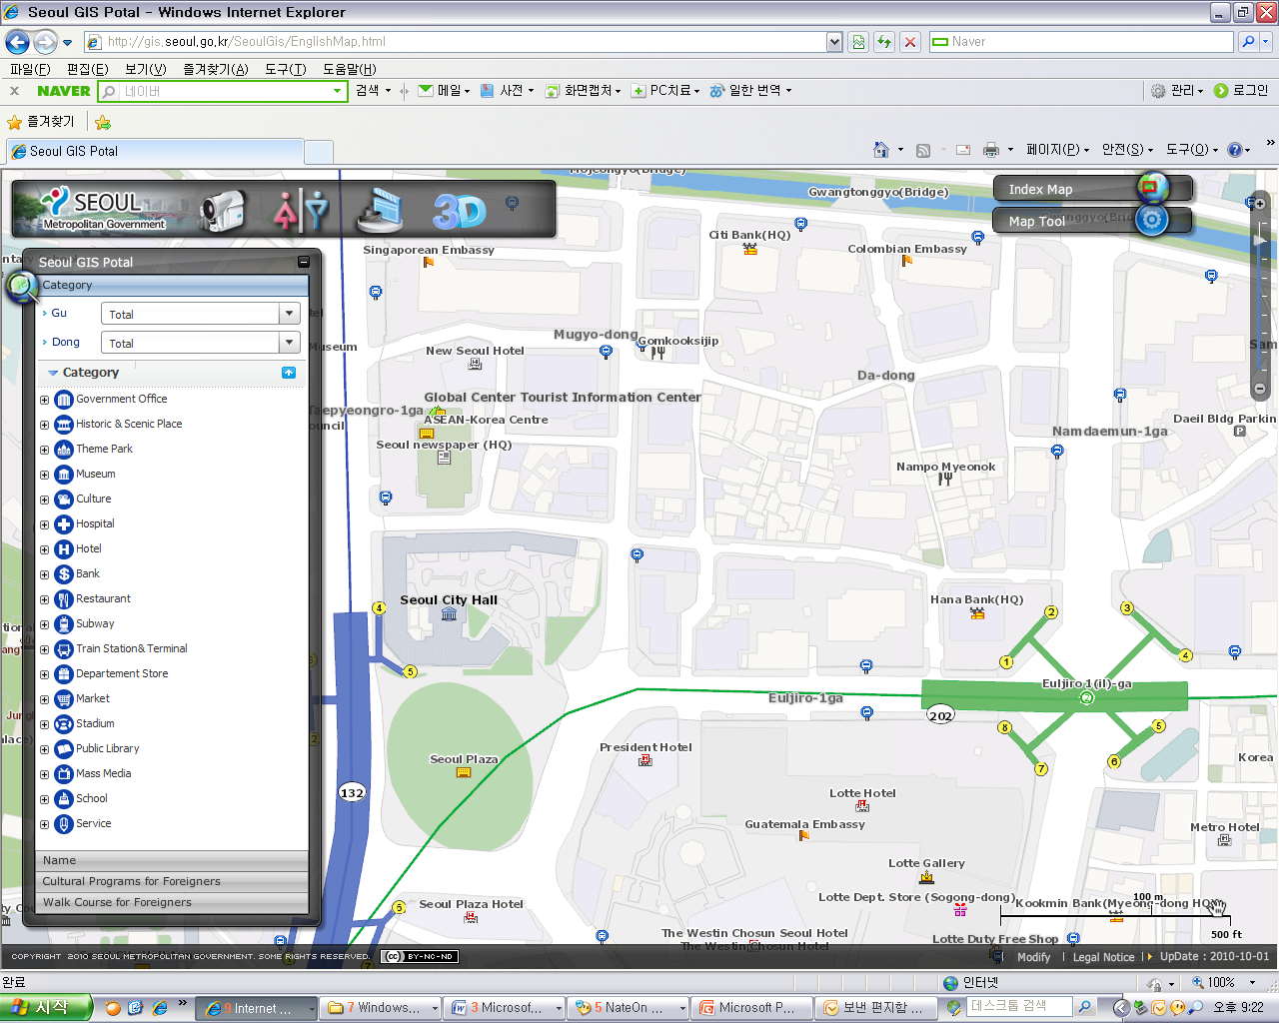
Lotte
Hotel
Press
Center
Press Center

Lotte Hotel

- National Coordinator

Dr. Sam Young CHUNG
Tel: +82 2 710 6595
Fax: +82 2 710 6639
E-mail: sychung@kcc.go.kr

Ms. Hye Young (Grace) Hwang
Tel: +82 2 338 1082
Fax: +82 2 338 1083
E-mail: sg5_general@kcc.go.kr

- Accommodation and hotel reservations
The Korea Administration has obtained special rates in different downtown hotels. Next page shows a map indicating each hotel’s proximity to the meeting venue together with a chart including the corresponding hotel rates.
Delegates are kindly requested to fill out the corresponding reservation form, send it directly to the hotel, copy to Ms. Grace at: sg5_general@kcc.go.kr or fax. +82 2 338 1083.
It is important to make your reservation as soon as possible. All reservations must include a credit card number. You shall receive a confirmation message once your reservation has been accepted by the hotel. In case of failure to attend the meeting, all reservations must be cancelled well in advance.

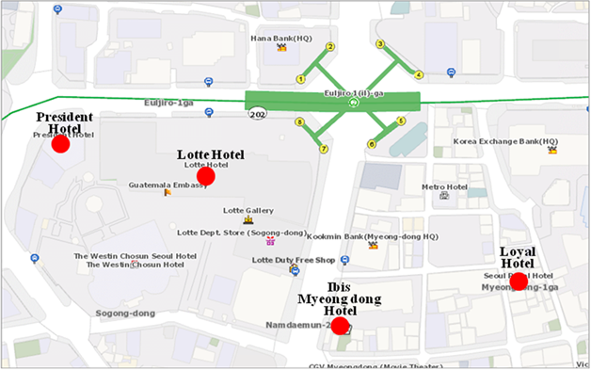

HOTEL | CATEG. | ROOM | RATE | NOTES
(1) Lotte Hotel (Venue)  1 Sogong-dong Jung-gu Seoul  Tel: +82. 2-759-7311~6  Fax: +82. 2-773-4910  Check-In: 2:00 PM  Check-Out: 12:00 PM  reservation@hotellotte.co.kr www.lottehotelseoul.com/index.asp | Standard  (Basis on Single Occupancy) | Superior  Deluxe | KRW 254,100 (≒USD 234)  KRW 278,300 (≒USD 257) | Included Taxes  buffet breakfast  : KRW 30,250 (≒USD 29)  Double occupancy charge will be added KRW 24,200 (≒USD 25)
 | Deadline of Reservation |  | 1st of August
 | Cancelation Policy |  | Inform to the hotel of any cancellations by 6:00 pm on the date of arrival or be charged for one night.
(2) Ibis-Myeongdong Hotel  59-5 Myeongdong 1ga Jung-gu Seoul  Tel: +82. 2-6361-8888  Fax: +82. 2-6361-8050  Check-In: 2:00 PM  Check-Out: 12:00 PM  ibismres@ambatel.com  ibis.ambatel.com/FrontSite/ibis/myeongdong/Default.aspx | Standard | Double  Twin | KRW 172,480 (≒USD 159)  KRW 188,650 (≒USD 174) | Included Taxes  buffet breakfast  : KRW 16,500 (≒USD 15)
 | Deadline of Reservation |  | 29th of August
 | Cancelation Policy |  | 50% penalty fee from 14days prior to check in date.  100% penalty fee from 7days prior to check in date.
(3) Hotel President  188-3 Euljiro 1ga Jung-gu Seoul  Tel: +82. 2-753-3131  Fax: +82. 2-752-7417  Check-In: 2:00 PM  Check-Out: 12:00 PM  marketing@hotelpresident.co.kr  www.hotelpresident.co.kr/english | Standard | Twin or Double | KRW 165,000 (≒USD 152) | Included Taxes  buffet breakfast  : KRW 22,000 (≒USD 20)
 | Deadline of Reservation |  | 19th of August
 | Cancelation Policy |  | 100% penalty fee from 7days prior to check in date.
(4) Royal Hotel  6 Myeongdong 1ga Jung-gu Seoul  Tel: +82. 2-2129-5754~7  Fax: +82. 2-2129-5880  Check-In: 2:00 PM  Check-Out: 12:00 PM  reser@royal.co.kr  www.royal.co.kr | Standard | Double  Twin | KRW 187,000 (≒USD 173)  KRW 203,500 (≒USD 188) | Included Taxes  buffet breakfast  : KRW 15,400 (≒USD 14)
 | Deadline of Reservation |  | 19th of August
 | Cancelation Policy |  | 50% penalty fee from 28th of August  75% penalty fee from 5th of September  100% penalty fee from 12nd of September

Participants are requested to reserve a hotel on a first-come-first-served basis through E-mail or Fax. Please note that there is a limit of the number of available rooms of Hotels. Therefore, if the reservations are full, it will be shifted to nearby Hotel and the reservation counter of the hotel will inform the corresponding participants about the situation

- Flights and transportation

Incheon International Airport handles all international air traffic and is 60 minutes away from the Seoul. Delegates have several transfer options from the airport to their hotel in the city of Seoul:
ITU-T SG5 and Symposium on “Progressing the climate agenda through green ICT standards” Information desk: Korea Secretariat will open the Information desk for participants’ convenience at arrivals (see below map). It will be opened from 18th of September to 19th of September at 7:00AM to 7:00PM. (Operating hours can be changed to depend on the participant's schedule) If you need to help to go to Seoul, drop by the information desk and get information.

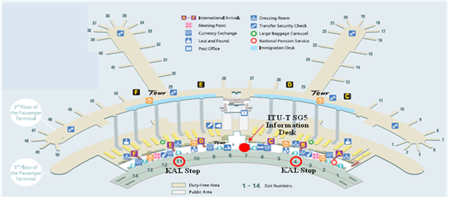

Car services and private taxis: taxi is recommended if you arrive late at night and buses are no longer operating or if you have heavy baggage or there are many members in your party. If you go to Myeong-dong (near the main venue) by a deluxe taxi late at night, you need to pay about 100,000 won. The fare varies depending on distance (meters).
Airport Bus: Airport buses run from Incheon Int'l Airport to various parts of Seoul. You can buy a ticket for your destination at the ticket desk on the arrival floor (1st floor). You can get information on bus routes and bus stops at the Airport Information Desk. Also Korea Secretariat will be operating the ITU-T SG5 and Symposium Information desk for participants’ convenience. If you would like to go from Incheon International Airport to the Lotte Hotel (main venue) you can use a KAL limousine bus.
Airport Railroad Express and Seoul Metro: Incheon International Airport Station of AREX is located on the first underground level of the Transportation Center at Incheon International Airport. You can get to Seoul and Lotte Hotel (main venue) using Airport Railroad Express and Seoul Metro.
How to get from Incheon Int’l Airport to Lotte Hotel :
- Get on the Airport Railroad Express on 1st floor of Incheon International Airport
- Transfer to line number 2 (green line) at the Hongik University station
- Get off the train at the Uljiro1(il)-ga station
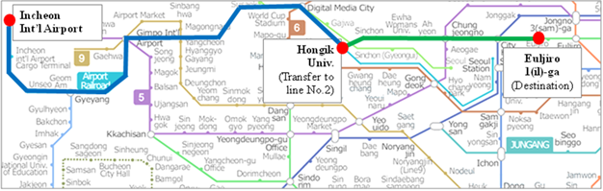

If you want to further information, please visit below website :
Airport Railroad Express : http://www.airport.kr/iiacms/pageWork.iia?_scode=C1203020000&fake=1308136787130
Seoul Metro :
http://www.seoulmetro.co.kr/eng/

Information for KAL limousine bus from Incheon Int’l Airport to the Lotte Hotel
- Course Time : About 1 hour and 20 min / Adult(15,000won), Child(10,000won)
- Boarding : KAL Stop - 4B or 11A
- Ticket Office : ITU-T SG 5 and Symposium Information desk at Incheon International Airport
(Ticket for the Bus departure from the entrance of the Hotel is sold at Front desk of Main building and New Wing)
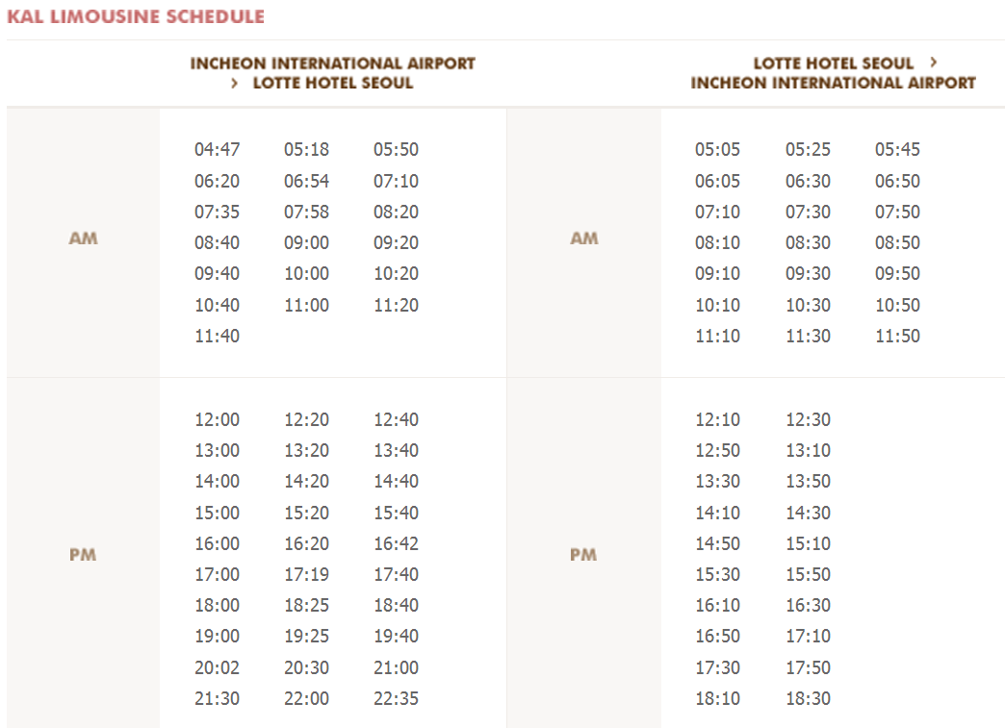
For further information, please visit the following web page: http://english.visitkorea.or.kr/enu/GK/GK_EN_2_2_2_3.jsp

- GENERAL INFORMATION

Introduction

The Korean Peninsula is located in North-East Asia and roughly 1,030 km (612 miles) long and 175 km (105 miles) wide at its narrowest point. Korea's total land area is 100,140 sq km, and it has a population of 48.7 million people (2009). Korea is a culturally diverse and economically advanced country full of dynamism. Building upon incredible post-war economic growth, Korea is the 12th largest economy in the world, and is becoming a powerful focal point of the Asian economic block. With a history tracing back more than 5,000 years, Korea is also rightly proud of its dazzling culture. It possesses 8 UNESCO cultural heritage sites, which compares favourably with any other nation in the world.

- The City of Seoul
Seoul is the capital and largest city of the Republic of Korea (South Korea). With a population of over 10 million, it is one of the world's largest cities and is by far the most densely populated city among OECD nations. The Seoul National Capital Area, which includes the Incheon metropolis and most of Gyeonggi province, has 24.5 million inhabitants, and is the world's second largest metropolitan area. Almost half of South Korea's population lives in the Seoul National Capital Area, and nearly a quarter in Seoul itself, making it the country's foremost economic, political, and cultural center

- Visa
Most delegates do not require a visa to enter Korea. You can check all visa requirements at http://www.mofat.go.kr/english/visa/apply/index.jsp. However, for more certainty we recommend you consult your embassy or consulate.
Those who require a visa to enter Korea should contact Ms. Ellva or Grace at sg5_visa@kcc.go.kr in order to request a personalized letter of invitation addressed to the petitioner via e-mail. This letter shall then be delivered to the petitioning country’s Korea Embassy in order to get the visa.

- Language
Korean is the official language (English, Japanese and Chinese are also spoken).

- Power
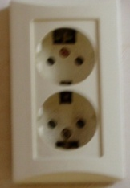
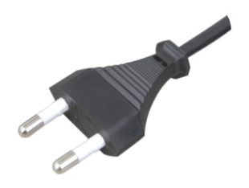
Supply voltage is 220V, 50Hz~60Hz. Participants are requested to bring the A-type adapter which is two parallel pronged and requested to bring the electric transformer, if necessary, for your equipments

Electrical Outlet

- Climate
The month of September is autumn that is well and truly in Seoul. In the mid September, Korea will be hot but less humid than August. Temperature is between 17 °C ~ 25°C.

- Currency
The unit of Korean currency is Korean Won (KRW). Also the most widely accepted credit cards are American Express, VISA and Master card.
Examples of exchange rates as of 10 June, 2011 is US$1= 1083.00 KRW
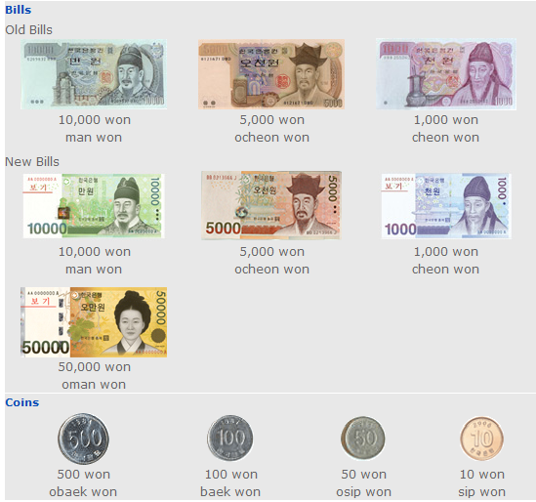

- Tax Refund
At the airport, passengers can get a 10% refund of the amount paid for Value Added Tax (VAT), if they have bought national products for amounts over $ 30 (per purchase slip) at the shops and within 3 months of departure from Korea adhered to the “Global Refund” system.
For further information, please visit: http://english.visitkorea.or.kr/enu/SH/SH_EN_7_1_4.jsp
- Business hours
Banks, post offices, and public offices generally open from 09:30 to 16:00 on weekdays but are closed on Saturdays and Sundays. Most of the shops are open from 10:00 to 22:00 through the entire week. However, some shops in Itaewon and Dongdaemon Shopping Mall are opened all night.
- Customary Tip
It is not customary tip in Korea. However, a 10% service charge and 10% taxes is added to your bill at all tourist hotels and some larger restaurants.

- Useful Information
For further information on the city of Seoul, please visit the following web page: http://english.seoul.go.kr

- Attire
Formal attire is recommended for officials attending the Meeting of Study Group 5 and the Symposium, on “Progressing the climate agenda through green ICT Standards” throughout the event.

- Invitation to the Welcome Dinner

The Communications Secretary of the Republic of Korea are pleased to invite the officials attending the meeting to the Welcome Dinner to be celebrated on Tuesday 20 September 2011 at 6.30 pm at the Sapphire Ballroom of the venue.

Suggested attire: Formal

ANNEX 3
(to TSB Circular 204)
ITU-T Study Group 5 meeting and Symposium
Seoul, Republic of Korea, 19-28 September 2011
*****

HOTEL RESERVATION

Please type or print clearly. Retain a copy for your records. Please send this form to the Hotel and one copy to Grace, e-mail address: sg5_general@kcc.go.kr Tel: (+82 2) 338-1082, Fax: (+82 2) 338-1083

Last Name: |  |  |  |  |  |  |  | First Name:
Organization-Company:
Address: |  |  |  |  |  |  |  |  |  |  |  | Country
Tel.: |  |  |  | Fax: |  |  |  |  |  | E-mail:
Hotel Information |  |  |  |  | Please choose type of room |  |  |  |  |  |  |  | Remarks
Hotel Name |  |  | Number |  | Room Type |  |  |  |  | Breakfast |  |  | Remarks
 |  |  |  |  | Double |  |  |  |  | Included |  |  | e.g. Smoking or  Non-Smoking
 |  |  |  |  | Twin |  |  |  |  | Excluded |  |  | e.g. Smoking or  Non-Smoking
Shared with:
Arrival date and time:
Airline and flight No.:
Departure date and time:
I authorize the use of the following credit card to guarantee my hotel reservation:
Type of Card: |  | Number:
Name on Card : |  | Expiration Date:

ANNEX 4
(to TSB Circular 204)

 |  | Symposium on Progressing the Climate Agenda Through Green ICT Standards  Seoul, Republic of Korea, 19 September 2011 |  |  |  |  |  | 
Please return to: |  |  | ITU/BDT  Geneva (Switzerland) |  | E-mail : bdtfellowships@itu.int  Tel: +41 22 730 5487  Fax: +41 22 730 5778
 | Request for a partial fellowship to be submitted before 19 August 2011
 |  |  |  | Participation of women is encouraged
Country: _____________________________________________________________________________________________________
Name of the Administration or Organization: ______________________________________________________________________

Mr. / Ms. _______________________________________(family name) ______________________________________(given name)

Title: ____________________________________________________________________________________________________

Address: ____________________________________________________________________________________________________
______________________________________________________________________________________________________________

Tel.: ____________________________ Fax: ____________________________ E-Mail:_________________________________

PASSPORT INFORMATION :
Date of birth: _______________________________________________________________________________________________

Nationality: __________________________________________ Passport number: ________________________________________

Date of issue: ___________________ In (place) : _____________________________Valid until (date): _______________________

CONDITIONS (Please select your preference in “condition” 2 below)
- One partial fellowship per eligible country.
- ITU will cover either one of the following:
□ Economy class air ticket (duty station / Seoul / duty station).
□ Daily subsistence allowance intended to cover accommodation, meals & misc. expenses.
- It is imperative that fellows be present from the first day to the end of the meeting.
Signature of fellowship candidate: |  |  |  |  |  | Date:
TO VALIDATE FELLOWSHIP REQUEST, NAME, TITLE AND SIGNATURE OF CERTIFYING OFFICIAL DESIGNATING PARTICIPANT MUST BE COMPLETED BELOW WITH OFFICIAL STAMP.

Signature |  |  |  |  |  | Date

