Бюро стандартизации  электросвязи | 
Женева, 10 августа 2009 года
Осн.: | Дополнительный документ 1  к Коллективному письму 3/11 БСЭ
Тел.:  Факс:  Эл. почта: | +41 22 730 5866  +41 22 730 5853  tsbsg11@itu.int | – Администрациям Государств – Членов Союза, Членам Сектора МСЭ-Т и Ассоциированным членам МСЭ-Т, принимающим участие в работе  11-й Исследовательской комиссии

Предмет: | Собрание 11-й Исследовательской комиссии Мар-дель-Плата, Аргентина,  2−10 сентября 2009 года
Уважаемая госпожа,
уважаемый господин,
1 Как указано в Коллективном письме 3/11 от 4 июня 2009 года, в настоящем документе приводится дополнительная информация, касающаяся собрания ИК11 МСЭ-Т, которое состоится в Мар-дель-Плата, Аргентина, с 2 по 10 сентября 2009 года.
2 Практическая информация, предоставленная принимающей организацией, содержится в Приложении 1. Форма для бронирования номеров в гостиницах представлена в Приложении 2.
С уважением,
Малколм Джонсон
Директор Бюро
стандартизации электросвязи
Приложения: 2

ANNEX 1
(to Addendum 1 to TSB Collective letter 3/11)
Practical information

1 Venue of the meeting
HOTEL HERMITAGE
Av. Colón and Boulevard Marítimo P.P. Ramos 2657 - Mar del Plata

2 National Coordinator
Mr Luis Carranza
Tel: +(54) (11) 4347-9454
Fax: +(54) (11) 4347-9546
E-mail: lcarranza@cnc.gov.ar

3 Accommodation and hotel reservations
The Argentine Administration has secured special rates with several hotels in Mar del Plata, details of which are given in the table on the next page, where there is also a map showing the proximity of each hotel to the meeting venue (Hotel Hermitage).
Delegates are kindly requested to inform us of the reservations made by sending an e-mail message to lcarranza@cnc.gov.ar, attaching a copy of the reservation forms provided.
It is important that reservations be made as early as possible. All reservations must include a credit card number. You will receive a confirmation message once your reservation has been accepted by the hotel. Should you subsequently find that you will be unable to attend the meeting, the reservation must be cancelled sufficiently in advance.

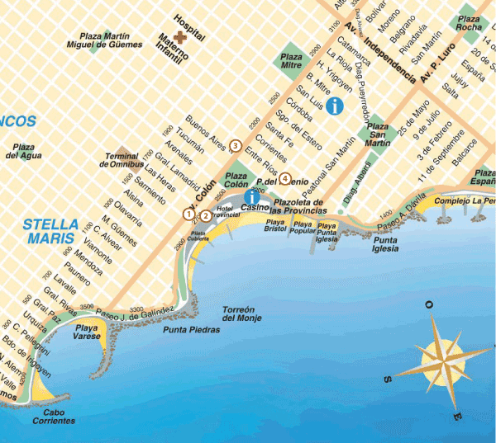

Hotel | Category |  | Type of room |  | Rate |  | Remarks
(1) Hotel Hermitage  Av. Colón 1643 and Blvard. Marítimo. P.P. Ramos 2657  Mar del Plata - Argentina  Tel: (54) (0223) 451-9081/86  Fax: (54) (0223) 451-7235  Check-in: 1400 hours  Check-out: 1100 hours  www.hermitagehotel.com.ar  reservas@hermitagehotel.com.ar | * * * * * |  | Double or standard single  (with view over the city) |  | USD 150 |  | Includes VAT and buffet breakfast
(2) Apart Hotel Avenida del Mar  Las Heras 2128  Mar del Plata – Argentina  Tel: 54 0223 451-2125  Check-in: 1400 hours  Check-out: 1100 hours  reservas@apart-avenidadelmar.com.ar | * * * * |  | 1 room  (2 persons)  2 rooms  (2 or 3 persons)  3 rooms  ( 4 or 5 persons) |  | USD 74  USD 104  USD 144 |  | Includes VAT and buffet breakfast
(3) Hotel Dos Reyes  Av. Colón 2129  Mar del Plata – Argentina  Tel : 54 0223 491-0383/0037  Check-in: 1400 hours  Check-out: 1100 hours  www.dosreyes.com.ar  info@dosreyes.com.ar |  | * * * * |  | Single  Double |  | USD 75  USD 85 |  | Includes VAT and buffet breakfast
(4) Argentino Hotel  Belgrano 2225  Mar del Plata – Argentina  Tel/fax : 54 0223 493-0091/2/4  Check-in: 1400 hours  Check-out: 1100 hours  www.argentinohotelmdp.com.ar  info@argentinohotelmdp.com.ar |  | * * * |  | Single  Double |  | USD 40  USD 55 |  | Includes VAT and buffet breakfast

4 Flights and transportation
Ezeiza International Airport: Located 40 minutes from the centre of Buenos Aires and served by international flights.
Delegates have the following options for travelling from Ezeiza airport to the Buenos Aires Aeroparque airport, from where there are domestic flights to the city of Mar del Plata:
Chauffeured cars (remises) and private taxis: Ezeiza airport is served by a large number of taxis and remises, which can be found outside the arrivals hall. Approximate fare from Ezeiza to Aeroparque: $ 145 (USD 38)
Minibuses: A more economical alternative, these leave Ezeiza airport every hour for the Aeroparque de Buenos Aires. Approximate fare from Ezeiza to Aeroparque: $ 45 (USD 12)
Mar del Plata airport: The only airline offering flights to Mar del Plata, with two flights a day (except for Saturdays, when there is only one), is Aerolíneas Argentinas (www.aerolineas.com.ar).
Chauffeured cars (remises) and private taxis: The distance from Mar del Plata airport to the city centre is 12 km, the fare by taxi or remis being approximately $ 35 (USD 9).
Another option: Delegates arriving at the Ezeiza International Airport may, if they prefer, use the bus service to Mar del Plata provided by the Manuel Tienda de León company (www.tiendaleon.com.ar). The 400 km journey from Buenos Aires takes approximately six hours
and there are seven departures every day. The fare is $ 130 (USD 34). Buses leave Ezeiza for Mar del Plata at 0230, 0530, 1000, 1230, 1430, 2130 and 2330 hours.
Further information may be found on the following website: Aeropuertos Argentina 2000 - Aeropuerto de Ezeiza Ministro Pistarini (http://www.aa2000.com.ar).

A. GENERAL INFORMATION

1 City of Mar del Plata
Located 400 km from Buenos Aires by highway No. 2, Mar del Plata is the country's largest seaside beach resort. A first-class tourist area, the city combines its charm and natural beauty with a wide selection of hotel, service and gastronomic facilities. Visitors will find excellent business outlets, coffee houses, shopping centres, bookshops, etc.

2 Entry formalities
The following countries do not require visas for stays of less than 90 days: The
European Union and Switzerland, the United States of America, Australia, Canada,
Japan, Korea, South Africa and the following Latin American countries: Bolivia, Brazil,
Chile, Paraguay, Uruguay, Colombia, Costa Rica, Dominican Republic, Ecuador, El
Salvador, Guatemala, Honduras, Mexico, Nicaragua, Panama, Peru and Venezuela.
All other countries should consult with consular representatives in Argentina
www.mrecic.gov.ar/portal/
Requirements:
• Valid passport or other travel document recognized by the Republic of Argentina.
• Application form (provided by the consulate).
• 1 photograph 4 x 4.
• Roundtrip ticket.
• Payment of consular fee (USD 50 .-)
• Letter of invitation (please contact Mr. Luis Carranza at: lcarranza@cnc.gov.ar).
No vaccination certificate is required for entering the country, except in the case of cholera and yellow fever for passengers arriving from countries in which those diseases are endemic.

3 Language
Spanish is the official language. However, most people in the central area have a working knowledge of English.

4 Electric current
Alternating current is used throughout Argentina. The voltage is 220V. Most hotels can provide 110-volt adaptors.

5 Climate
Mar del Plata has a mild and humid climate. The heat in summer is moderate, while the winters are windy and cold. The normal temperature range is from 5 to 25°C. At this time of year, the average temperature lies between 15 and 23°C.

6 Currency
The peso ($) is the official currency of Argentina. While the dollar is generally accepted, foreign currency can be exchanged into pesos in banks and other authorized establishments. The most commonly accepted credit cards are American Express, VISA, Diners Club and MasterCard.
Exchange rates are liable to fluctuate. At 02.07.2009, the dollar exchange rate was USD 1 = $ 3.80.

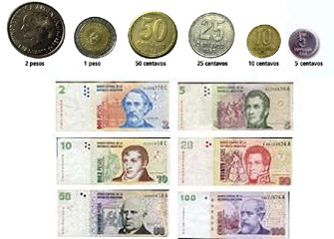

7 Shopping – VAT refunds
At the airport you can receive a refund of the value added tax (21 per cent) levied on domestic products purchased from outlets belonging to the “Global Refund” system, provided the amount paid (per invoice) is over $ 70.

8 Business hours
Banks and exchange offices: Monday to Friday from 1000 to 1500 hours.
Company offices: Generally from 0900 to 1300 and 1700 to 2000 hours.
Shops and businesses: In the major cities, from 0900 to 2000 hours (in the country’s interior there is normally a midday break), and Saturdays from 0900 to 1300 hours.
Cafes, patisseries, pizzerias: Almost always open, with a break from 0200 to 0600 hours.
Restaurants: Lunch is served from 1230 hours and dinner from 2000 hours. Many fast-food establishments are open around the clock.

9 Tipping
It is customary to leave a 10 per cent gratuity in coffee bars and restaurants and to tip porters, doormen and cinema/theatre ushers.

10 Further useful information
You can find further information on the city of Mar del Plata on the following webpage: http://www.mardelplata.gov.ar/IndexNw.htm.
B. COMMUNICATION ON HUMAN INFLUENZA A(H1N1)
On the basis of bulletins issued by the Ministry of National Health of the Argentine Republic, the following information is provided to delegates attending the ITU-T KALEIDOSCOPE and NGN-GSI events to be held in Mar del Plata concerning the measures and recommendations being adopted to prevent the spread of human influenza A(H1N1).
Through an intense national campaign, the Ministry of Health has taken the necessary measures to minimize the risks of contagion of the virus, and most cases have been successfully and quickly cured, through simple and safe treatment.
Any additional information that delegates might require can be obtained on the webpage of the Ministry of National Health at: www.msal.gov.ar/.
Recommendations regarding the new human influenza A(H1N1)
What is influenza A(H1N1)?
It is a very contagious acute respiratory infection of viral origin.
How is it transmitted?
• From person to person.
• Through drops of saliva which travel through the air when a person coughs, sneezes or spits.
• It is not transmitted through the consumption of pork or pork derivatives.
What are the symptoms?
• Temperature over 39ºC.
• Cough.
• Sore throat.
• Blocked nose.
• Headache.
• Muscular pains.
How can it be prevented?
• When coughing or sneezing, use a disposal tissue.
• When coughing without a tissue, cover your mouth with your forearm (never with your hands).
• Wash your hands often with soap and water.
• Avoid treating yourself.
• Use of a mask is recommended only if you show symptoms.
ANNEX 2
(to Addendum 1 to TSB Collective letter 3/11)
PLEASE COPY Mr. Luis Carranza BY E-MAIL WHEN MAKING BOOKING
(lcarranza@cnc.gov.ar)
Kaleidoscope Event, IPTV-GSI and Meetings of Study Groups 11 and 13
Hotel booking form

Reservation details
Reservation made on ____________________ to hotel ___________________________________
at ITU preferential tariff
___________single/double room from _________________________ time of arrival ____________to_____________

Personal Details
Name___________________________________________________________________________________________
First name_______________________________________________________________________________________
Address_________________________________________________________________________________________
________________________________________________________________________________________________
________________________________________________________________________________________________
Tel : +___________________________________ Fax : +________________________________
(country code area code phone number) (country code area code fax number)

Credit card details
Top of Form
Credit card to guarantee this reservation |  | AX |  | VISA |  | DINERS |  | EC/Mastercard

Number _____________________________________ Validity____________________________________________
Date______________________ Signature ___________________________________________________________

