INTERNATIONAL TELECOMMUNICATION UNION |  | Focus Group On  Car Communication
TELECOMMUNICATION  STANDARDIZATION SECTOR  STUDY PERIOD 2009-2012 |  | FG CarCOM-ADM-9
English only
Original: English
 |  | Kiel, 9-10 March 2011
ADMIN DOCUMENT
Source: | FG Chairman
Title: | Invitation to the 5th Focus Group Meeting CarCOM

Kiel, 28 July 2026
Invitation to the 5th Focus Group Meeting to be held
9-10 March 2011 in Kiel, Germany
Link to registration & meeting documents
http://www.itu.int/ITU-T/focusgroups/carcom/
Dear Colleagues,
On behalf of the ITU-T Focus Group CarCOM I have the pleasure of informing you of the arrangements for the above-mentioned meeting hosted by the Christian-Albrechts-Universitaet zu Kiel.
Address of the meeting |  | Christian-Albrechts-Universitaet zu Kiel (CAU)  Faculty of Engineering  Digital Signal Processing and System Theory  Prof. Dr.-Ing. Gerhard Schmidt  Kaiserstr. 2, 24143 Kiel, Germany  Tel.: +49 431 880 – 6125 or 6126  Fax.: +49 331 880 – 6128  E-Mail: gus@tf.uni-kiel.de  Web : www.dss.tf.uni-kiel.de
mEETING SCHEDULE |  | The meeting will start on 9 March 2011 at 09.00 h.  The meeting will end on 10 March, 2011 at 18.00 h.
REGISTRAtion |  | Please register at the focus group website before 24 February 2011.
Documents for the meeting |  | Please send meeting documents in advance of the meeting to TSB for uploading to the Focus Group website.
Hotel Information |  | http://www.maritim.de/de/hotels/deutschland/hotel-bellevue-kiel  - luxury hotel, bears the name “Bellevue” with good reason  http://www.steigenberger.com/Kiel  - higher price level, nice water view  http://www.intercityhotel.com/Kiel  - is located very close to the main station, use of local transport for free  http://www.berlinerhof-kiel.de/  - is located close to the main station  http://www.am-segelhafen-hotel.com/  - has been tested by Gerhard Schmidt who liked it
How to find the meeting place | By airplane:  Fly to Hamburg, take the “Kiellius” bus (every hour, takes 1:20 h [airport Hamburg to hotel/meeting place in Kiel], is usually faster than train connections).  By train:  Travel to Kiel mainstations. Then, use one of the following buses that connect the Faculty of Engineering to the main railway station of Kiel: #11, #100, #200 and #201 (stop "HDW"). Takes about 10 minutes.  By car:  Follow the motorway A215 in the direction "Kiel". Take the exit "B76 in Richtung Lübeck" ("B76 - direction Lübeck"). Follow the B76 in the direction "Schönberg/Laboe/Ostufer". Take the exit "HDW/Gaarden" and turn left into the Sörensenstraße (direction "HDW"). Follow the Sörensenstraße until you get straight into the Werftstraße. On the left side of the Werftstraße, you can see the the shipyard HDW after some time with its two blue cranes. When you have passed the main gate of HDW, turn right into the Kaiserstraße. To arrive at the Faculty of Engineering (tf), immediately right again. The institute for digital signal processing and system theory (DSS) is located in building D.  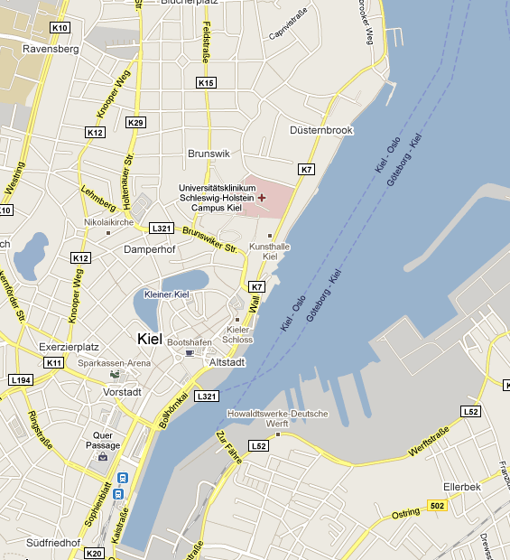  1 Intercity Hotel am HBf  2 Hotel Berliner Hof  3 Steigenberger Conti Hansa  A Kiel Hbf  B ZOB / Kielius  C Technische Fakultät der CAU  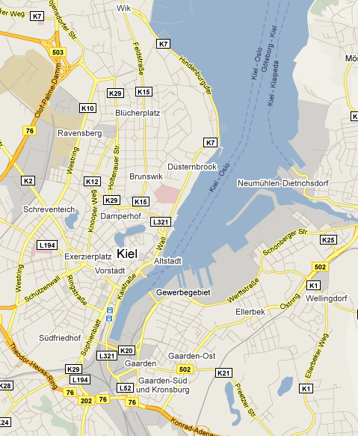  4 Maritim Hotel Bellevue  5 Am Segelhafen Hotel  C Technische Fakultät der CAU
Further information you can find:

http://www.dss.tf.uni-kiel.de/workshops/2011/workshop_itu_fg_carcom_2011.html

I look forward to seeing you in Kiel,

Yours sincerely
Hans W. Gierlich

