Geneva, 16 December 2005
INTERNATIONAL TELECOMMUNICATION UNION
Telecommunication
Standardization Bureau

 | Ref:  Tel:  Fax: |  | TSB Circular 62  TSB Workshops/X.Y.  +41 22 730 6206  +41 22 730 5853 | - To Administrations of Member States of  the Union;  - To ITU-T Sector Members;  - To ITU-T Associates;
 | E-mail: |  | tsbworkshops@itu.int | Copy:  - To ITU-T Study Group Chairmen and Vice-Chairmen;  - To the Director of the Telecommunication Development Bureau;  - To the Director of the Radiocommunication Bureau  - ATIS
Subject: |  | Workshop on Next Generation Network Technology and Standardization  Las Vegas, USA, 19 -20 March 2006

Dear Sir/Madam,
1 I would like to inform you that a joint ITU-T/ATIS workshop on Next Generation Network Technology and Standardization will take place at the Mandalay Bay Convention Centre in Las Vegas, USA, from 19 to 20 March 2006 inclusive, at the kind invitation of ATIS.
2 Discussions will be held in English only.
3 Participation is open to ITU Member States, Sector Members and Associates and to any individual from a country which is a member of ITU who wishes to contribute to the work. This includes individuals who are also members of international, regional and national organisations. The workshop is free of charge but no fellowships will be granted.
4 NGN Standardization work is now well underway in the ITU-T, ATIS and other SDOs. Following the success of the ITU-T’s Focus Group on NGN (FGNGN), the establishment of the NGN Global Standards Initiative (NGN-GSI) in ITU-T and the activities within the ATIS NGN Focus Group and Technical committees, this workshop will be an opportunity to review the status of the work, identify technology trends, and seek to identify areas where the ITU-T and ATIS together with regional experts can further coordinate their standardization work.
5 We would like to solicit voluntary contributions from our members to sponsor coffee breaks, lunch, evening meals/cocktails etc. If you wish to sponsor any of the above during this workshop, kindly contact tsbdir@itu.int at your earliest convenience.
6 Updated information relating to the workshop including the program, presentations as well as details and practical information will be available on Addendum 1 to this Circular, as well as on the ITU-T Workshop website at the following address:
http://www.itu.int/ITU-T/worksem/ngn/200603/index.html.
7 We would like to remind you to reserve your hotel rooms as soon as possible since this workshop will be held during the TelecomNEXT event in Las Vegas. For your convenience, a map of hotels located around the Mandalay Convention Centre on the Strip in Las Vegas is set out in Annex 1 hereto.
8 In order to enable us to make the necessary arrangements concerning the organization of the workshop, I should be grateful if you would register via the on-line form at http://www.itu.int/ITU-T/worksem/ngn/200603/registration.html or using the registration form in Annex 2 duly completed (one per participant) by fax (No.: +41 22 7305853), as soon as possible, but not later than 1 March 2006.
9 We would remind you that citizens of some countries are required to obtain a visa in order to enter the USA. The visa must be requested and obtained from the office (embassy or consulate) representing the USA in your country or, if there is no such office in your country, from the one that is closest to the country of departure. Please be aware that it may take up to 6 to 8 weeks for visa approval so kindly make your request for the invitation letter as soon as possible.
Participants who need an invitation letter and/or a visa supporting letter are advised to get in touch with Ms. Susan Carioti via email at scarioti@atis.org.
Your e-mail must include the following information in order for it to be processed:

Family name (last name): Forename (first name): Birth date (month/date/year): Passport number and issuing country: Gender: Company Name: Occupation/Position: Company/Mailing address: Postal Code: Country: Telephone Number: Fax Number: Name of Meeting:

In addition, you may be asked for specific documentation showing strong social, economic, and other ties to your home country.

Letters of invitation will be sent to you via fax and only sent via Federal Express mail upon request. Letters will be processed within 7 days of receiving an email request, with the exception of the following dates: December 22, 2005 through January 3, 2006 due to the upcoming holiday season. If you have not received your letter within 7 days or have any changes after receiving a faxed copy, please contact Ms Susan Carioti.
Yours faithfully,
H. Zhao
Director of the Telecommunication
Standardization Bureau
Annexes: 2
ANNEX 1
(to TSB Circular 62)

Hotels located around the Mandalay Convention Centre on the Strip in Las Vegas

Workshop venue:
The Mandalay Bay Convention Center (# 43 on the map below)
3950 S. Las Vegas Boulevard
Las Vegas, NV 89119

You may book your hotel rooms through the Telecom-NEXT package at the workshop venue http://www.telecom-next.com/hotel.html or through the following web site where a complete list of hotels in Las Vegas is listed: http://www.vegas.com/resorts/?vc1=2&vc2=tabs_gph_htl_2

For reservations in any of the hotels numbered in the map below, please call: 800 851 1703 from within the USA or +1 800 851 1703 from abroad (callers accessing 800 numbers will be charged the international direct dialling rates).

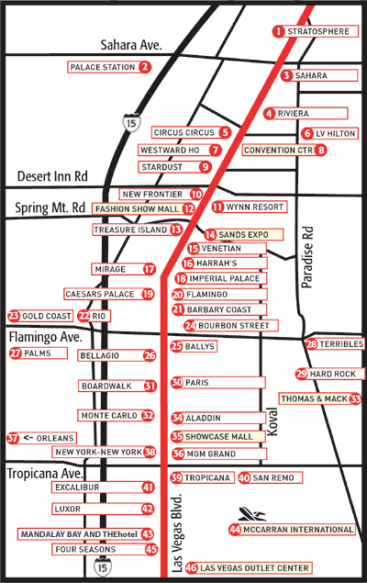

ANNEX 2
(to TSB Circular 62)
ITU-TSB | Workshop on Next Generation Network Technology and Standardization  (Las Vegas, 19 – 20 March 2006)
REGISTRATION FORM
To be returned to (Fax: + 41 22 7305853) by 1 March 2006

Mr. Mrs. Ms. Miss |  |  |  | Administration of ITU Member State
____________________________________________  Family Name |  |  |  | ITU Sector Member
 |  |  |  | ITU Associate
____________________________________________  First Name |  |  |  | ITU Associate
 |  |  |  | Non-Member
Name and complete address of Administration or Organization:
______________________________________________ |  |  | Tel: _____________________________________________
______________________________________________
______________________________________________ |  |  | Fax :_____________________________________________
_________________________________________ |  |  | E-mail : _________________________________________
Hotel :
________________________________________________ |  |  | Tel. : _______________________________________
Date: ___________________________ | Signature: ______________________________________

