INTERNATIONAL TELECOMMUNICATION UNION
Radiocommunication Bureau
(Direct Fax N°. +41 22 730 57 85)

Circular letter  CR/313 | 27 April 2010
To Administrations of Member States of ITU
Subject: Implementation of Appendix 30B in accordance with Resolution 149 (WRC-07)

References: 1. Circular letter CR/278 of 15 February 2008
2. Circular letter CR/280 of 4 March 2008
3. Circular letter CR/299 of 27 March 2009
4. Circular letter CR/302 of 19 May 2009

To the Director-General
Dear Sir/Madam,
1. In the Circular letters referenced 1 to 4 above, the Radiocommunication Bureau informed administrations of the actions which had been taken to implement Resolution 149 (WRC-07), especially the status and schedule to develop and test the necessary software for application of technical examinations under Appendix 30B (Rev.WRC-07).
2. Since then the Bureau has processed pending submissions under Article 7 of Appendix 30B received before and after WRC-07 and has resumed the examination of submissions received under Article 6 of Appendix 30B. Annex 1 to this letter shows the statistics of Appendix 30B submissions to be treated under §6.1 up BR IFIC 2667 of 20.04.2010.
3. In accordance with resolves 6 of Resolution 149 (WRC-07), administrations were invited to review their submissions, with a view to reducing their number, and were requested to indicate to the Bureau the networks which were no longer required to be considered and processed under Article 6 of Appendix 30B (Rev.WRC-07). The Bureau reminded administrations of this invitation in its Circular letter referenced 1 above. The Bureau has received a fairly encouraging response with some administrations responding positively by requesting the deletion of obsolete submissions. Despite this effort, the number of Article 6 submissions is still numerous and may not correspond to the real requirements of administrations.
4. The Bureau would therefore be grateful for all administrations, particularly those having submitted multiple satellite networks (see Annex 2), to consider reducing the number of their submissions under Article 6 of Appendix 30B. By cooperating in these efforts to employ the scrupulous and diligent application of the principles and provisions of the ITU Constitution, Convention and Radio Regulations, you will allow reducing, and to the extent possible removing, the obstacles impeding the development and bringing into operation of new satellite networks in Appendix 30B.

Yours faithfully,
Valery Timofeev
Director, Radiocommunication Bureau

Attachments: 2 pages

Distribution:
– Administrations of Member States of ITU
– Members of the Radio Regulations Board
ANNEX 1
Statistics of Appendix 30B submissions
to be treated under §6.1 after WRC-07
(Up to BR IFIC 2667 of 20.04.2010)

 | Received  before WRC-07 | Received  after WRC-07 | Total
Published* | 67 | 0 | 67
Not Published | 26 | 48 | 74
Summary | 93 | 48 | 141
*Publication of 30B/A6A/1 (UKR00001) is not included since it is submitted under Article 7 of AP30B.

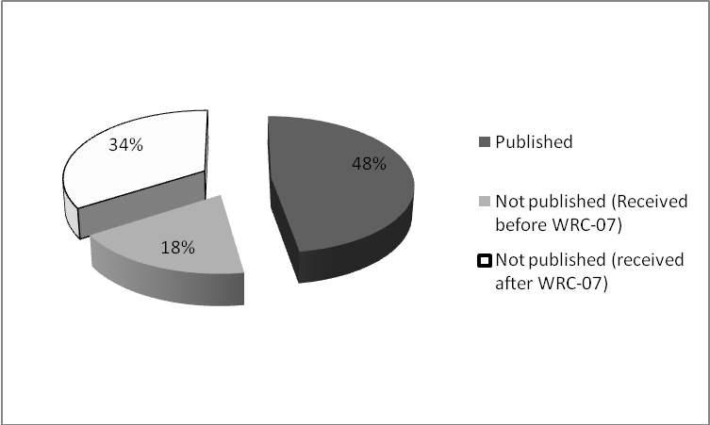

ANNEX 2
Statistics of Appendix 30B submissions
to be treated under §6.1 after WRC-07
(Up to BR IFIC 2667 of 20.04.2010)
Administrations |  | Numbers of Submissions |  | Published  Submissions | Orbital Positions
LUX |  | 27 |  | 17 | 19
CHN |  | 16 |  | 16 | 13
RUS |  | 14 |  | 8 | 13
F |  | 11 |  | 5 | 11
KOR |  | 10 |  | 10 | 10
IND |  | 8 |  | 0 | 8
G |  | 7 |  | 1 | 3
S |  | 6 |  | 3 | 4
ARS |  | 6 |  | 1 | 5
HOL |  | 5 |  | 0 | 5
CAN |  | 3 |  | 1 | 2
PNG |  | 3 |  | 0 | 2
TUR |  | 3 |  | 0 | 3
USA |  | 3 |  | 1 | 3
CYP |  | 3 |  | 0 | 2
MCO |  | 2 |  | 2 | 2
NOR |  | 2 |  | 1 | 1
UAE |  | 2 |  | 0 | 1
BLR |  | 1 |  | 0 | 1
BUL |  | 1 |  | 1 | 1
E |  | 1 |  | 0 | 1
GRC |  | 1 |  | 0 | 1
HNG |  | 1 |  | 0 | 1
ISR |  | 1 |  | 0 | 1
MEX |  | 1 |  | 0 | 1
MLA |  | 1 |  | 0 | 1
VEN |  | 1 |  | 0 | 1
VTN |  | 1 |  | 0 | 1
TOTAL |  | 141 |  | 67 | 117

